**ENGLISH I**

**(1) How to use monolingual, bilingual and multilingual dictionaries**

1. **CAMBRIDGE DICTIONARY: You can use it to find whether you use the word and the preposition that goes with it correctly; e.g. impact …on**

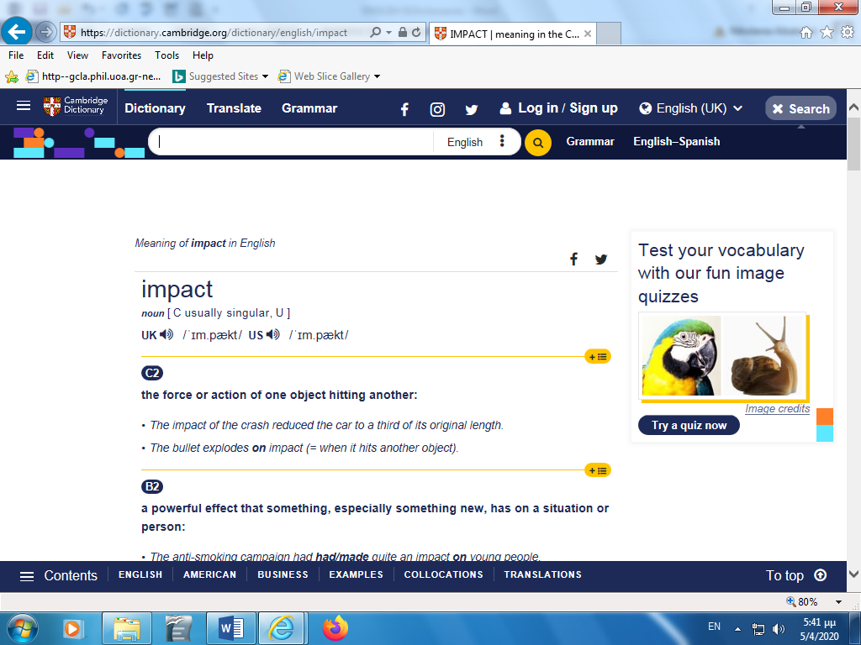

INSTRUCTOR’S NOTE: This dictionary is one sample of the English/American dictionaries you can find on the Internet.

**(b)** **WordReference:** A bilingual dictionary (English: Greek and/or Greek: English)

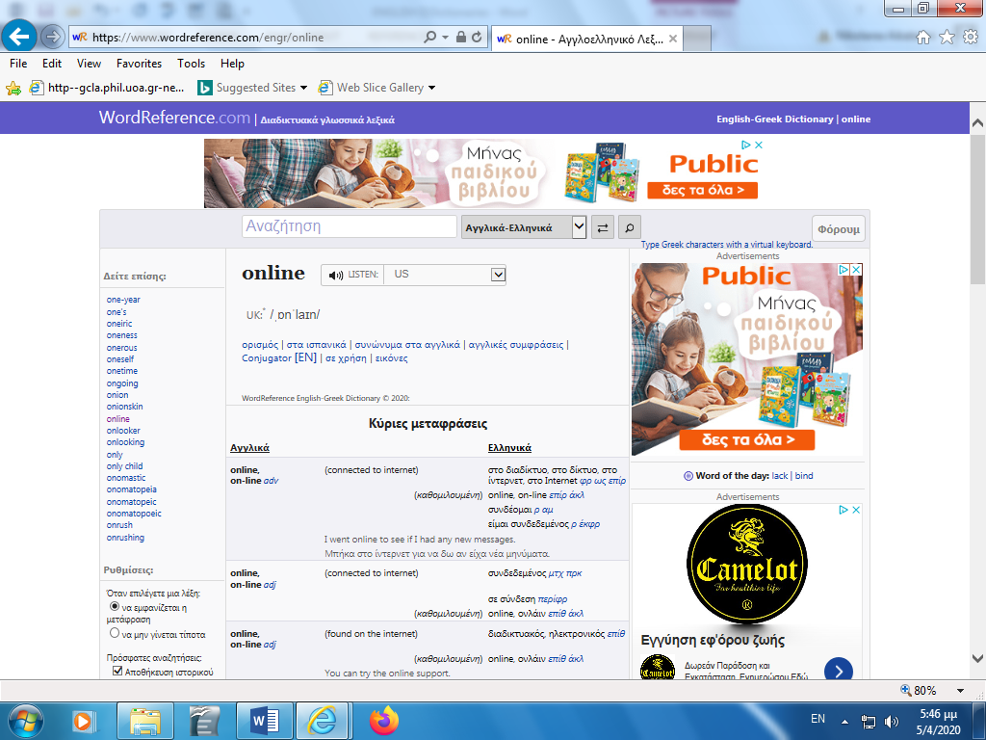

INSTRUCTOR’S NOTE: This dictionary is one sample of the bilingual (English: Greek: English) dictionaries you can find on the Internet.

**(c) IATE: A multilingual dictionary useful primarily for Geographers, Economists, Statisticians, Oceanographers and Scientists in general.**

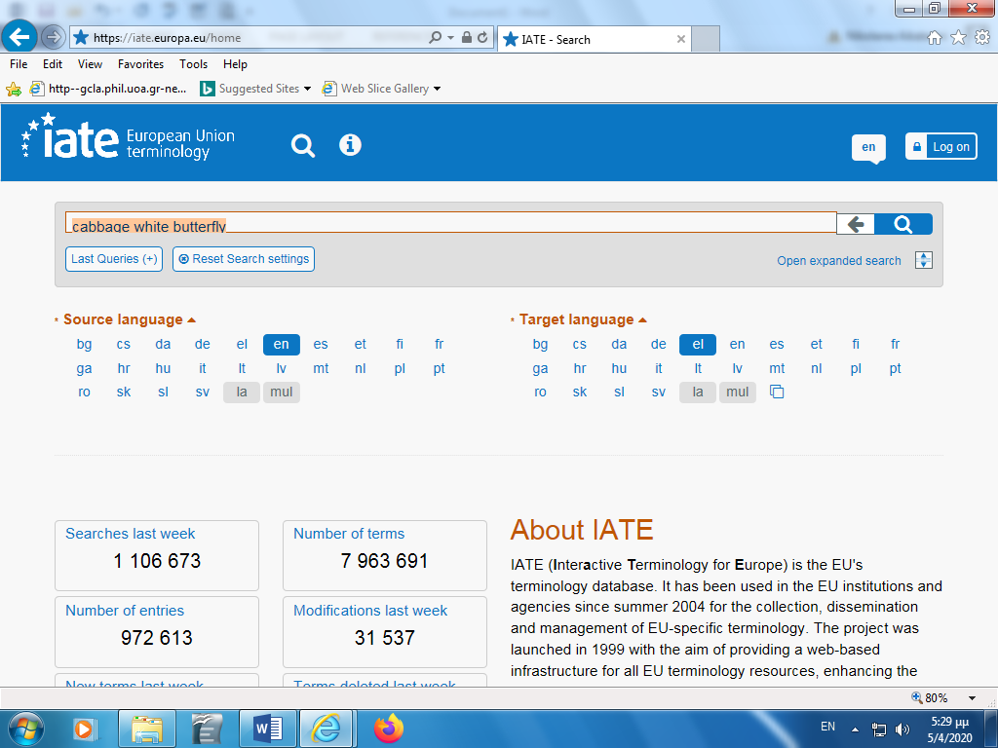

INSTRUCTOR’S NOTES:

1. This dictionary is not so useful for Social Anthropologists and Historians, unless they study Economics or Statistics.
2. Social Anthropologists and Historians either use (a) and (b) of this section or they create their own TDB (Terminological Data Bank) so to store the difficult terms they encounter during their studies.

**(2) How to create a TDB (: Terminological Data Bank)**

INSTRUCTOR’S ADVICE:

1. You can read my articles on how to construct and organize at TDB (Terminological Data Bank -Λεξιλόγιο in the following links for your future references:

<https://www.translatum.gr/journal/3/translator-glossary-en.htm> (in English)

<https://www.translatum.gr/journal/3/translator-glossary.htm> (in Greek)

1. Look at the sample below. This bilingual TDB was constructed and organized by a Geography student years ago.

