OBSERVATORY FOR SUSTAINABLE TOURISM
THE CASE OF THE AEGEAN REGION

Dr. Ioannis Spilanis
Professor, University of the Aegean
Director of the Observatory

Mytilini

……………… 2020

Forward

The first Sustainable Tourism Observatory in Europe opened in the Aegean Islands, the main archipelago of Greece, in early 2013, under the auspices of UNWTO. It is established by the University of the Aegean in collaboration with UNWTO. A first report was published in 2016 and here is the second report.

Even if we can consider the whole region as a sub-national destination at the national and the global level, every island considers itself as a distinct one. For sure, even if there is a lot of interference between the islands of the region (i.e common transport network, island hopping, common tourism marketing plan, common financial resources within the EU financial programs etc), there are also many disparities among them concerning the basic components of the Observatory as the supply and demand, the social and the environmental pressure, the impact of tourism to the destination.

Nevertheless we use also regional data for two main purposes:
- for a significant number of variables there is not data at the island level. So we are obliged to use regional data (NUTS 2) or data at the level of department (NUTS 3)
- for comparison reasons between different Greek regions in order to make obvious the spatial differentiations of tourism development

For all these reasons it is necessary to proceed to a presentation not only at the regional but also to the island level when the data allow it.

Mytilini, …………….2020

Ioannis Spilanis
Professor
University of the Aegean
Director of the Observatory

Contents
Forward 2
1. The Methodology - The operational definition of sustainability for measuring the tourism performance and impacts 4
2. The Destination 5
3. The Tourism activity: Supply and demand 5
3.1. Supply 5
3.2 Demand 9
4. The results of the tourism activity at the Aegean islands 10
4.1 Economic results: tourism expenditure 10
4.2 Social Results: Employment 12
4.3 Environmental results: resources consumption and waste production 14
5. The impact of tourism development to the destination’s sustainability 15
5.1 The impact of tourism development to the Aegean islands at the regional level 16
5.2. The impact of tourism development to the Aegean islands at the island level 18
6. Conclusions – Propositions 22
6.1. Basic Outcomes and proposals for discussion with the stakeholders 22
6.2. Further steps in order to address problems 23
6.2.1. The creation of permanent structures and procedures in order to complete the lack of information necessary for decision making 23
6.2.2. Ameliorating tourism governance by the creation of permanent structures and procedures for decision making involving stakeholders by the creation of DMO 23
6.2.3 Amelioration of Tourism Policy Planning 24
Annex 1: The Methodology 25
Annex 2: Maps 29
Annex 3: Data 35

The Methodology - The operational definition of sustainability for measuring the tourism performance and impacts

Tourism development, in itself, should not be the main goal of a destination. Successes in tourism development should not only be examined by the number of tourist beds and visits to the area - even though these are important indicators - but by its impact on the economic welfare of the host population. This welfare is based on the performance of tourism activities, tourism expenditure, and employment generated in the area. According to conventional economics, the direct effects of tourism, as in any other sector, on GDP and total employment of an area, are the basic indicators for the evaluation of a destination's level of development.
The worldwide emergence of the term “sustainable development”, as a framework for the assessment of human welfare (social and environmental, leads to two critical changes to the existing approach:
- Firstly, the assessment of impacts due to any tourism activity cannot be based solely on the estimation of its impacts on the area's economic development but also on its contribution to social and environmental development and conservation efforts.
- Secondly, the assessment must not only consider short term effectiveness (e.g. annual increase of the product and the employment), but focus on long-term prospects. This will help ensure better conditions of development for future generations, in generating not only and but also natural and social capital.
But how can someone measure and evaluate tourism performance and link it to the sustainable development of a destination? Within the proposed approach (Figure 1) and based on an extended version of Driving force Pressure State Impact and Response (DPSIR) approach, tourism activity is presumed as a driving force that has to first be described in terms of supply and demand in order to have a clear understanding of it. The second step is to consider and measure its results and performance within the three pillars of sustainability, in order to evaluate its footprint. Thirdly, the estimation should be focused on the changes that tourism footprint results in the “Sustainability State” of the destination. Finally, policy measures need to be described and assessed based on their efficiency to resolve issues in order to ameliorate tourism performance and impacts on the destination. Then, new measures can be proposed.
A more analytical presentation of the used approach is presented at the Annex.

The Destination

The Aegean Islands (Map 1) are composed of two NUTS 2 EU regions, the Region of Notio Aigaio (RNA) and the Region of Vorio Aigaio (RVA) out of the 13 regions composing Greece. The first has in 2019 an estimated population of 344.027 inhabitants (in comparison with 308.975 in 2011 –cencus data) living on 5.316,15 sq.km. and the latter has 2211.098 inhabitants (199.231 in 2011) living on 3.839,2 sq.km. The RNA is composed of two NUTS 3 areas: Kyklades is composed of 24 inhabited islands and has an administrative status (LAU 1 or 2), while Dodecanissos is composed of 15 inhabited islands. The RVA is composed of three NUTS 3 areas: Lesvos, Samos and Chios, all of which have 3 islands each. In the Appendix 1, there is a complete list of the islands, their population (2011) and their surface.
In the Aegean Sea is located also a number of coastal islands that are part of continental regions and are not included in the study.

The Tourism activity: Supply and demand

Supply

The number of beds determines the capacity of tourism in a destination. They fall into three categories: the beds in hotel accommodations and camp sites (main accommodation), beds in non-main accommodation (bed and breakfast, villas, apartments etc); the two categories are classified as commercial accommodation. There are also beds in private homes (non-commercial accommodation).

66,1% of available hotel beds at the national level are concentrated in the Greek islands at 2019 (565.950 of 856313 hotel beds in total compared to 512.033 of 765.715 for 2012)- an increase of 10,5% over 7 years. The RNA has 2154 hotels with 223691 beds, representing 39,5% of beds on islands and 26,1% of the national total. The RVA has only 387 hotels with 23006 beds or 2,7% of the national total (Table 2).

The majority of the beds are concentrated to a few number of islands: Rodos has 84.942 beds (16,6% of the regional total), Kos 45.097 (8,8%), Thira 12.562 and Mykonos (10.852) are the islands with more than 10.000 beds each, all in the RNA. In the RVA the island of Samos has 9.650 beds (2012).

The majority of the islands recorded an increase of the number of commercial tourism beds that are especially large in small islands that have experienced tourism development since the 2000s as Koufonisi, Astypalea, Tilos, Lipsi and Kastelorizo ​​(over 200%). In contrast, on the smaller islands of Oinousses, Psara, Kythnos, Nisyros, there has been a reduction of beds. On the larger island of Samos, the number of hotel units that have ceased to operate is larger than those that were created during the same period.

There is also a difference between the size and class of bed units between the islands. These parameters are highly correlated: the islands which recorded the largest size of units, observed to have higher classes of units. For example: Rhodes - with 173 beds per unit - and Kos - with 169 beds per unit – exceeded the average countrywide size of 79,5 beds per unit. As for the beds of higher class (i.e. hotels with 4 or 5 stars), it was observed that the entire country has 305 362 beds or 39.8% of the total number of hotel beds. Islands with the highest number of high class beds occur in the Dodecanese – 82.047 beds (or 57,7% of all hotel beds in the RVA). Rhodes and Kos, however, have the highest rates of high class beds with 63% and 60% respectively. Cyclades also had a high number of high class beds with 14.234 (or 29,8%) with Mykonos and Santorini at 51,6% and 39% respectively, in beds of high class.

Regarding camp sites, in Greece, they do not constitute a large part of the total capacity of 297 units (80.000 locations), which is approximately 10% of total number of hotel beds in the country. Camp sites have had a record of continuous decline for 15 years. Of these 297 units, 85 with 21.300 locations (26.6% and 28.6% respectively of the national total) are located in 28 of the 80 islands of the country. The RNA has 33 (3 in Dodecanese and 30 in Cyclades - a traditional destination of free camping in the first phase of development of tourism in Greece) with 9.056 locations (8.860 in Cyclades) which constitute 46% of the island camp sites, but only 11% of the country (289 and 81.549 respectively). Paros with 7 units and 1.974 locations is the island with the highest number camp sites. In the RVA there is no camping.

Concerning the ​​non-main accommodation (rooms and apartments to let), there is less data available, although they constitute a large part of the total available number of commercial beds in the country. Based on the data of the Confederation of Entrepreneurs of Tourist Accommodation Greece Apartments (SEEDDE), the official number of available beds for 2013 was 366.121, (an approximated figure as methods for recording and modes of licensing are limited). Of these available beds, 252.072, or 68,9%, are on islands: the RNA has 6.317 units with 99.198 beds (22.768 beds in Dodecanese, and 76.430 beds in the Cyclades), which constitute about 27% of the available relevant facilities in Greece for 2013. The RVA has a total of 14.188 beds. At the island level Santorini has 17.544 beds, Rhodes has 14.395 beds and Paros has 10.185 beds - which constitute the highest numbers of beds per island in the RNA. In the RVA, Lesvos island has the higher number of beds: 6.416.

The above analysis shows the approximate number of commercial tourist accommodation (Map 2). Beds in private houses (holiday dwellings, rented dwellings but also houses of relatives and friends’ houses) should also be analyzed. Private houses are traditionally used by domestic tourists but more and more are being used by international tourists as either they have bought one, or they hire them instead of going to a hotel. The assessment of these categories of beds is based on the housing inventory, and mainly concern "vacant homes” which covers both “holiday” and “under lease” houses. Based on the data from the 2010 census, there is a significant increase in both total and vacant homes on the islands, creating a housing stock for tourist use of 519.440 units compared to 354.795 in the year 2000 as their number has increased much quicker than the population. Based on a realistic assumption that every house has on average 3 beds, the total number of beds in private homes are estimated at about 1,5 million additional beds. A small portion of these homes (approximately 20.000) as of 2014 now have authorization as tourist villas or houses, and act as legitimate businesses.

From the total number of private beds almost 1/3 is located in the Aegean Islands: 203.703 in Kyklades, 136.167 in Dodekanissos in the RNA and 214.919 in the RV. Nisyros (1,52 dwellings per inhabitant), Serifos (1,47), Kythnos (1,43), Anafi (1,24) and Kea (1,12) are the islands with the higher number of empty dwellings in relation to the resident population.

Based on data of available beds, we can classify the islands in 3 categories:
- The “hotel” islands: islands where the number of hotel beds is higher from the other categories and are the main, organized, tourism islands such as eg. Kos, Rhodes, Karpathos, Samos.
- The islands «room to let»: islands with a large number of complementary accommodation in relation to the total commercial beds. Generally, these are middle and small or non-tourist islands (eg. Kimolos, Iraklia, Sikinos, Kythnos, Anafi) but also some popular tourist islands such as Paros and Thira.
- The "holiday" islands: islands with a larger number of private-holiday homes than professional ones. It concerns many categories of islands: those that are close to the capital mainly in Kyklades considerd as “attractive” for development as secondary housing for private use, and those with high rates of emigration over the past few decades. As a result, there are many empty houses, sometimes more than the occupied ones, used as holiday homes nowadays.

The increase in supply and demand of such accommodation is reflected in (Table 2):
- The indicator “tourist beds / inhabitant”: indicates the maximum pressure on the resident population from "foreigners" - short-stay, Greeks and international tourists - when all the beds are full, i.e. in the high season. For 25 islands, this ratio has exceeded the ratio 1:1 (one bed per inhabitant) with greater pressure exerted on Koufonissi (2,65), followed by tourist islands of medium and small size such as Ios (2,65) Santorini (2,39), Folegandros (2,30), Skiathos and Folegandros (2,26), Mykonos (2,22), and Antiparos (2,11), which exceed the ratio 2:1. The limit of 1:1 is not overpassed by the big tourist islands as they have the infrastructure due to their larger resident populations (Map 3).
If we added holiday beds to the tourist beds, then only two islands remain below the ratio of 1:1 and 4 Islands (Serifos, Kythnos, Antiparos and Nisyros) record more than 5: 1 beds compared to their population.

- The indicator “tourist beds / area (surface)”: indicates the maximum pressure on the environment both by permanent constructions created to meet the needs of tourists, but also the consumption of resources in combination with the production of waste generated by tourists. Of course it should be stressed that this environmental pressure adds to the pressure coming from the residents which provides the following data:
- The "tourist density" is particularly high in 3 islands where there are more than 200 beds per sq.km: Santorini with 480, Mykonos with 262 and Koufonissi with 251. Two other tourist islands (Kos and Paros) exceed 100 beds per sq.km (Map 4).
- When at the “tourist density” we add the density created by the holidaymakers, the number of islands with a density of more than 100 beds per sq.km is 18 with Santorini reaching 790 beds per sq.km and another 9 islands exceeding 300 beds per sq.km.
- Finally when we accumulate the pressure coming from the residents of Santorini onto the above pressures, it adds to 991 beds/sq.km. having a density of construction making it to look like more to a big city than to an island; Syros has 598 beds/sq.km, Mykonos 583, and only 18 out 48 islands have a bulk density below 100 people per sq.km.

Of course, the density can increase within a day due to tourists who do not stay on the island, but who are visiting through marine tourism (cruise ships and yachts) or through day trips. Santorini is an extreme example as 582 cruise ships with 778.054 visitors anchored to the island in 2013 and it often happens to welcome more than 10.000 cruise visitors in one day. Mykonos and Rhodes are also hot spots for cruise ships that are berthing in total at 15 islands (10.715 ship arrivals and 2.074.338 passengers). Nisyros and Symi, located closed to the highly developed islands of Kos and Rhodes receive every day an important number of day trips. These two categories of tourists-visitors are creating an additional expenditure locally (it is estimate to be around 40 euros per capita for cruise visitors), but also a higher pressure as they have to be added to “normal” tourists creating overcrowding and negative experience.

Demand

The registration of arrivals and overnight stays of tourists is used only in hotels and camp sites. Therefore the relative figures are exclusively towards this segment of tourism demand. Furthermore, there are a small number of islands that do not have hotels, so no information is available for them.

We consider this information in order to have a first estimation on the demand, but for a more accurate approach in covering all kinds of accommodation is needed. An approach is applied combining hotel data (number of arrivals and nights spent of foreigners and national tourists, their duration of stay and the occupation rate) with the number of arrivals on an island by air and sea in order to estimate the number of tourists arriving per type of accommodation (hotels, bed and breakfast and secondary houses) and the total number of nights spent.

For example in the case of Santorini where the arrivals for 2012 were 865.380 people (204.794 by charter flights, 191.700 by internal flights and 468886 by ship), it is estimate that 88.884 of the passengers are locals traveling out of the island and the rest are tourists with 3.634.100 nights spent (879.000 to hotels, 1.664.500 to bed and breakfast (with an average length of stay of 3,9 days) and 1.090.200 to private accommodation with an average stay per year of 30 days. This estimation, which has to be confirmed by local surveys, corresponds to almost 10.000 additional inhabitants (unequally distributed over the year as more than 75% of overnights concern the period between June and September – Table 2); this is an important “overloading” for an island that has 15.231 permanent inhabitants.

Some general remarks based on data concerning per month arrivals at hotels for the different islands:
- Unequal distribution of arrivals and overnights between islands following the allocation of beds, professional and non-professional.
- High seasonality: in the vast majority of the islands, there is over 75% of overnights –and in many cases, over 90%- which are concentrated between the months of June and September.
- The distinction of islands to those of the 'foreigners' and those of the Greeks: with few exceptions major tourist islands (Rhodes, Kos, Samos, Mykonos, Santorini) are dominated by international tourists. The number of overnights spent by residents in hotels is around 10% of the total. Of course, in reality, this “primacy” of foreigner tourists is less important if we take into account not only the nights spent in hotels but also those spent in to non-principal accommodation and holiday homes (for which there is no information) used mainly by Greeks.
- The Average Length of Stay (Map 5):
  - Is much higher for foreigners (6.7 days on average) than for Greeks (3.2)
  - Is higher during the peak season
  - Is higher on islands characterized by mass beach tourism and international tourists travelling on organized flights and staying for a week in the same establishment (and island). Examples include: Rhodes, Kos, Samos, Karpathos, etc. However, this is not the case on islands such as Mykonos, Paros, Santorini and other Cycladic islands, where visitors stay on average 3 up to 4 days on the same island and visit one or two more islands.

4. The results of the tourism activity at the Aegean islands

4.1 Economic results: tourism expenditure

Information on the performance of tourism activities including, overnight stays, arrivals and accommodations used, are mostly derived from the border survey of the Bank of Greece. However, this information applies only to international tourists. Based on the 2013 survey, for which data have been published at the regional level, SETE (Greek Tourism Confederation) (2014) shows:

- Arrivals of tourists: were estimated at 4,1 million tourists for RNA (23,1% of the national total of 17,9 million tourists), placing the region as the second most visited region in Greece behind the Region of Kentriki Makedonia (Central Macedonia) that totalized 4,3 million tourists. In RVA, approximately 101,800 arrivals were estimated for 2013, (0.6%) placing it as the 13th and least visited region in Greece. The Region of Kriti had 3,6 million tourist arrivals (20,1%) placing it as the 3rd most visited region. For the Region of Ionia Nissia, 1,8 million tourist arrivals were recorded (10%), making it the 5th most visited region in Greece. These four island regions total to 53,8% of the international tourist arrivals for Greece in 2013.
- Overnight stays: for the two regions were 39,5 million (24,7% of the foreigners total overnight stays in Greece – 160,2 million), for RNA and 1,3 million (0,8%) for RVA. In comparison Kriti accounts for 35,7 million (or 22,3% in the second place) and Ionia Nissia (RIN) 17,1 million (10.7% at the forth place)
- Total tourism expenditure: for RNA was €3,49 billion (29.8%) and for RVA was €0.07 billion (0.6%) for a total of €11,71 billion. The tourism expenditure for Kriti Region came to 24.7% (€2,89 billion) and 10.1 % for RIN (€1,2 billion). It is important to notice that the island regions total 65,2% of national tourist expenditure and that RNA was ranked in 1st place for tourist expenditures out of all the Greek regions for expenditures and overnights and RVA in the last.
- Average expenditure per trip: of international tourists in Greece was 653,3 € in 2013. In 2008, it was 730 € and, in 2011 it was 639,5€. There are significant differences between regions. RNA has the highest efficiency per trip (842,9 €) nationwide, the Region of Kriti in 2nd with 801,9 €, the Region of Vorio Aigaio with 671,9 € in 3rd, and the Region of Ionia Nissia with 659,8 € in 4th.
- Per night expenditure: at the national level, has increased since 2010 from 68,6 € to 73,1€. However, this rate is still lower than in 2008 (76,3 €). RNA continues to be in the first place among all greek regions with 88,2 €, Kriti with 81,0€ is in 3rd place, the Ionia Nissia with 69,0 € in 6th place, and RVA with 52,6 € is in 10th place.
- Average length of trip: in Greece was 8,9 days compared to 9,6 in 2008. RVA has a greater duration nationally with 12,8 days. Kriti, with 9,9 days is in 3rd position, and RNA Ionia Nissia have 9,6 in 4th place.
- Seasonality: as we previously mentioned is high in Greece with 73,9% of overnight stays taking place from June to September. Ionia Nissia had 85,1% of nights during this period, RNA 78,8%, and Kriti 76,2%. RVA was below the national average with 65,9%.
- High seasonality determines the average revenue per room, where the units operate throughout the year. The Region of Attiki (including Athens) performed up to twice the national average with 22.134,8€ compared to 12.626,8 €. The island regions had a revenue of 13.943,3 € for Kriti, 11.605,7 € for RNA, 9.838,8 € for the Ionian and 7.591 € for the RVA.
- Occupancy of hotel establishments: was in decline across Greece from 2008 (56,7%) to 2012 (43,2%). However, they seemed to be marginally improving in 2013 (45,2%). For 2013 at the NUTS3 level Dodecanissos performed 71,9% (2008) and 58,5% (2012), Samos 57,0% and 35,9%, Kyklades 50,1% and 38,5%, Lesvos 48,6% and 26,6% and Hios 43,2% and 24,8% respectively.

The data regarding domestic tourism unfortunately does not have a regional analysis. However, some non-comparable information should be added to that of international tourism, which was previously discussed in order to give a general idea:
- Tourism expenditure: According to the World Travel and Tourism Council (WTTC), the spending of domestic tourists for 2014 was 43% of total tourism spending (7,9 billion €). In 2009, before the crisis, it exceeded 50% of total tourism expenditure: it was 10,8 billion € compared to 10,2 billion € expenditure of international tourists.
- Overnight stays: For 2012 the total number of nights spent (trips over 4 days) in Greece was 45 million. About 35% of these overnights concern trips effectuated by sea or by air (mainly islands) and 90% had used complementary accommodation and private houses meaning that there were not recorded at the destination (Survey on Domestic tourism, Greek Statistic Authority).
- Average daily expenditure: of nationals for 2012 with a duration of more than 4 days, was 28,6€: it was 59,1€ when they use professional accommodation and 18,6€ when they use private houses. The corresponding expenditure for 2008 was 38,4€, 66,8€ and 29,5€. For travels with a duration of 1to 3 days, the average expenditure was 51,3€ for 2012 and 59,4€ for 2008.

Concerning the income of hotels (2012):
- Seasonality: at the beginning of the season (May) the average daily room rate in RNA was 60,27€, ranking lower than the national average (63,72€) and lagging behind the other four regions. During the pick of the season (August) it was ranked at third place with 111,86 € with a national average of 102,16 €. For RVA, prices in May and August were 51,54€ and 77,36€ respectively.
  - The significant increase in prices between May and August throughout the country and particularly in the island regions, except RVA, confirms the high seasonality of tourism in the country, and particularly, in island regions. In contrast, prices in Athens were decreasing during the summer.
- Average annual revenue per room: for RNA was 11.605€ (13.755€ in 2011) placing the region in 3rd and recording a relatively good combination of daily income and occupancy at the national level. Attica had a very high annual income per bed (22.134 € compared to 27.517 in 2011). Kriti was placed 2nd with 13.943€ each year. For the RVA the annual income was 7.591€ (7.931€ in 2011), while the national average was 12.626€ (14.491€ in 2011).
  - the results per hotel class are more or less the same: the 5 star accommodations have a very high average return in comparison to other hotel classes. There is a significant price difference between 5 star and 4 star hotels across the country. This shows the significant impact of Tour Operators and the different types of revenue contracts (such as All Inclusive, which often relates to 4 star hotels) that heavily influence sustainability. Less clear are the differences between accommodations of different sizes among regions following to different structure of tourism. The large units (over 100 rooms, which are usually that are 4 and 5 star hotels) did not record large price differences in all the greek regions except Attica in comparison to the medium size hotels (50-100 rooms). Family units (with less than 20 rooms) perform better than small units (21-50 rooms), in RNA with 6.623€ in comparison to 6.502 (per bed and per year).

4.2 Social Results: Employment

Due to the complexity of tourist activity, employment in tourism can be more difficult to approach. The high seasonality, the importance of family and undeclared work, but also the employment of internationals, who are non-residents of the country, make it a more complex system to measure.

Based on research from ITEP (Research Institute for Tourism), the employment in hotels (2012-13) is in proportion to the existing number of beds, which is highly influenced by the class of the unit (0,12 employees per bed for 1*star hotel and up to 0.62 employees for 5 star hotels during August) and the seasonality. The ITEP survey´s estimation for employment to hotels across the country generated very low numbers of jobs: 121557 nationally (or 0,16 employees per bed for August), 29.644 for RNA (0,18) and 3012 for RVA (0,13).

Presence of female employees: is high in hotels and even higher when the unit is of a lower class and / or small. Female employment in lower class hotels is surpassing 70% of the total employment. This is most likely due to the majority of maintenance tasks being occupied by female employees. However, more male employment is also increasing in proportion to the size of the hotel as more services are added (restaurant, bar, pool, etc). In RNA, women occupy about 58% of jobs, ranging from 51% in 5 star hotels to 80% in 1 star accommodations, and from 70% in family units to 52,5% in hotels with more than 100 rooms. In the RVA, the average female employment is 61,1%, fluctuating between 58% to 81,5%, according to the class of hotel, and from 53,5% in family owned units to 67% in the small units (21-50 rooms).

International employment: in hotels at the national level is relatively high, reaching 20% of the total number of employees. There is no specification if this number accounts for only permanent residents, or also seasonal workers that are arriving under different schemes, but, mainly, as low- paid students. The distribution by class and size of unit follows the same pattern as for female employees. We can, therefore, assume that most international employees may be women. Regarding international employment per region, in RNA their share is much higher than the average of the country (32,16% vs. 20.76%) - ranging from 27,64% in 5 star hotels to 54,47% in 1 star hotels. In RVA, the employment of international workers is much lower - less than half compared to RNA (15,92%).

Based on data from WTTC total employment in tourism activity was about 319.500 of direct employees in 2013, (about three times higher than the estimation of ITEP for people working in hotels) If the figures reflect reality, this means that for 1 job in a hotel there are 2 more jobs in other tourism-related activities.

Of the total number of employees in tourism, and the number of tourist beds in Greece (1,139,566), the average total employment by public accommodation is 0,28 workers per bed; if it concerns only hotel beds it is 0,41. If this ratio applies to the RNA, the total number of workers in tourism should be between 68.211 and 81.758 employees, respectively, and for the RVA between 9.130 and 10.215 respectively.

The number of employees in tourism fluctuates from 2004 onwards. For 2013-14, it is almost as high as it was in 2004 despite the increase of hotel beds by 17% and the number of nights spent in the hotels by 35%. While a percentage of total employment is the same across the years, it may be more than one percentage point higher (8,9% vs. 7,6%) due to the significant decrease of total employment in the country during the crisis (2009-today)

4.3 Environmental results: resources consumption and waste production

The environmental effects of tourism are two-fold:
- Permanent, which relates to changes in natural landscape and land use as a result of tourism development for: accommodation, marinas, convention centers, transportation networks, etc. It can significantly alter the environment for an immeasurable amount of time.
- Periodical, which concerns the operation of tourist facilities and depends on the number of tourists, as well as the consumption pattern of water or energy, and the production of waste, or even noise pollution.

Data on tourism infrastructural development is not available. However we can reasonably assume that, for the majority of the islands, infrastructural development has occurred since the 1970’s, for which there have been direct, indirect and induced consequences. This is absolutely true for islands with a large number of tourist beds and holiday houses as well as for islands where tourism is monoactivity (it concerns the majority of RNA islands). On other islands, such as Chios and Lesvos, where tourism is less developed, there may be less negative impact realized on the environment. Based on data from the European Environmental Agency, Mykonos displayed the highest percentage of man-made infrastructure covering 11.25% of the total surface of the island. Santorini follows with 6.15%, Kos with 2.3%, Paros with 1.47%, Rodos with 1,27%, Patmos with 1,13% and Samos with 1,12%. The majority of the islands have less than 1% of the soil is sealed. The role of secondary houses is important for this situation, as a bed in a private house occupies more space than a bed in a hotel room or a B&B (bed/m2) and it is used less during the year (occupancy rate estimated at 8% or 30 days per year). However, their economic and social result is very low (low daily expenditure and very low direct employment).

Unfortunately, there is no data for the consumption of resources, such as water and energy, nor for the production of solid and liquid wastes. There is also no data, for daily consumption and production, nor estimation about annual consumption and production. Therefore, no direct assessment of the environmental pressure can be derived based on real data. Indirect estimates will be assessed based on the pressure indexes such as total beds / inhabitants and total beds / sq.km, which have already been presented. From the first index, it can be estimated that the maximum daily pressure (that can happen if all the beds are occupied) as well as the equivalent population on an annual basis can be used to calculate the additional demand for resources and production of waste. For instance, in Santorini, where there is 36.341 professional beds, we can estimate 23.562 more beds in the 7854 residential homes and houses used for rental; so an additional population of 59.903 persons can be added to the 15.231 permanent inhabitants (seasonal workers and daily visitors are not included) giving an estimation that the consumption of resources and the production of wastes is multiplied by 4. The second index can give an estimation of the pressure on the environmental resources, keeping in mind that the land surface area of a destination gives an approximation of its carrying capacity.

Regarding environmental standards that can be used for estimations when real data is missing, we have at least two types:
- The "institutional“standards: i.e. standards contained in the legislation as a maximum allowed resource consumption and waste production for each type of tourism business. These standards are based on certain characteristics and must be included in the environmental impact study submitted for the acquisition of the license. An important part of the licensing procedure is the approval of location, because it concerns the land use changes that are permanent and mainly affect the biodiversity of the area and groundwater. So, the daily consumption of water per capita measures to: 150 lt. for a 1* hotel, and 450 lt for a 5* hotel; for energy a hotel up to 50 beds has 0,8 kwh/person for a 1 or 2 star hotel, but 2,8kwh for a 5 star hotel.
- The "ideal" standards: are different figures based on scientific approaches and real data to what constitutes the "ideal" resource consumption and waste production concerning, specifically: energy, water, wastewater and solid waste. For solid waste, the production of less than 0,6kg per day per capita is an excellent performance for all classes of hotels, but the satisfactory level is less than 1,2 kg for luxury, fully serviced, hotels; less than 1kg for mid-range hotels; and 0,8 kg for low budget hotels.

5. The impact of tourism development to the destination’s sustainability

Based on what has been reported previously, regarding the various degrees of tourism development between the two regions, and between islands in the same region, assessing the impacts of tourism to island destinations has to be divided into two levels:
- Benchmarking between the two regions; which mainly concerns the economic and social impact of tourism development. The environmental impact is related more to the specific characteristics of each island.
- Grouping the islands depending on their level of tourism development.

5.1 The impact of tourism development to the Aegean islands at the regional level

Regarding the overall progression of the economy of the RNA throughout the postwar period, it is mostly affected by tourism development. However, this is not the case for RVA, even though Samos´ tourism activities have a significant impact. Based on the data of value added created in 2010, the branch of "Activities of accommodation and food service" has a distinct role in RNA, since it produces 27.4% of the total Gross Value Added in the Region (27.1% in the Dodecanese and 27.7& in Cyclades). In RVA, this branch represents only 11.7% in the economy (10.3% in Lesvos, 8.3% in Chios and 18.4% in Samos). For the whole country, the figure is only 6.8%, reflecting unbalanced tourism development and the important role of islands. If the Ionian Islands (24.8% of GDP is created by tourism) and Kriti (16.3%) are taken under consideration, the presence of tourism in the GDP creation is high. If the above activity is added to the transport branch (15.2% in RNA and 7.6% in RVA compared to 6.6% in the whole country), wholesale and retail trade branch (10.1%, 10.3% and 12.2% respectively), the branch of property management (10.3%, 12.7% and 14.0% respectively) and the construction branch (4.3%, 4.3% and 3.4% respectively), we realize that tourism activity dominates the economy of the RNA and has provoked the increase in total regional GDP at levels higher that the average national one (103 in 2012 and 112 in 2000). On the other hand, the per capita product of RVA is only 77% of the national; in this region the economy is based more on the public sector (29.7% of its GVA is produced by this sector, compared to 15.3% in RNA and to 20.3% in the whole country).

This high specialization of the economy of RNA has delivered significant economic benefits as mentioned previously, but has also created a dependence on a single activity that is considered as vulnerable to exogenous parameters. A second negative factor is that a large part of tourism expenditure is leaking outside the islands: (a) for purchasing goods and services that are not produced on the islands as the local economy cannot satisfy the indirect and induced demand created by the tourism activity, due to monoculture and (b) as income leakages of non-resident entrepreneurs and workers. However, a more positive element is observed through the significant changes in the preferences of tourists as consumers increasing the demand for local products - mainly for agricultural products and food and beverage industry (e.g. cheese, honey, wine, olive oil, herbs, capers, meat, etc.). This increased demand cannot always be satisfied, as the agriculture sector was quasi-abandoned in many islands as a non-competitive industry during the period 1960-1990.

Since 1951, the demographic evolution is recording an entirely different evolution between tourist and non-tourist islands and regions in general (Table 4): Rodos -and the Dodecanese NUTS3 area as a whole- has the most diverse demographics from all regions of the country. Their population doubled during the period of 1951 to 2011 (from 58.946 to 115.490 for Rodos). The birth rate, average age of residents, and immigration also increased. A similar development is recorded in the other tourist islands (Kos, Mykonos, Santorini, Paros). A careful analysis shows that a reversal of population development in the islands started from Rodos (since the 1950s), and extended to other islands in the 1980s when they began to have a significant rise in tourist activity. Hence, job opportunities and income increased which could halt emigration and attract new residents. Kos, Santorini, Mykonos, Paros, Antiparos and Ios, as well as Rodos, now have a more significant population than sixty years ago. The islands of RVA, during the same period, have recorded a loss of population between 20 to 40%. The only exception is the small island of Fourni where the fishing activity has as positive impact on demographic results.

The only negative demographic element recorded in RNA is the low level of education of the workforce. Only 11% of the population has tertiary education diplomas –as local population can easily find a job without a diploma-, when the rate of the country is 15,9% - ranking it in last place of all greek regions. Data from the R. Ionia Nissia (but also from Balearic Islands) confirm the "reproach" for tourism in this low percentage. Lack of proper education impairs the innovation in an activity that is in full transformation as tourism is. Tourism requires significant changes in all phases of the production process - from the development of new resources and comparative advantages to the promotion of the product within the new technological environment. The use of new technologies, tackling competition, etc. is part of this innovation process. Moreover, tourism creates professional mobility difficulties: people who moved from agriculture to tourism without knowledge and skills (general or specific to the sector), taking advantage of the rapid growth in demand they cannot find work when there is a decline in tourism demand. This is observed especially on islands like Rhodes where the crisis in tourism and the decline in employment described earlier are "translated" now into unemployment and low wages, since residents do not have necessary qualifications for other employment. RVA holds the percentage of the population with the highest level of education closer to the national average: 12,4%. Studies were an “antidote” to the lack of employment locally, and very often, educated people didn’t return to the island of origin.

5.2. The impact of tourism development to the Aegean islands at the island level

The diversified tourism development between islands, that has already been presented, has different impacts to their socio-economic and environmental aspects.

Information at the island level concerning their economy can be provided only by data on employment per branch as GDP data are on NUTS level. The employment to the islands of the two regions per main sector is: 8,3% for the primary, 16,1% for the secondary and 75,6% for the tertiary with high differentiation between islands (Table 5).
- 32 small and non-touristic islands have a level of employment in the primary sector above the national average. Lesvos is the biggest one with 18,1%. All the touristic islands have a lower share, with Mykonos at the lowest (2,7%).
- 33 islands have a secondary sector above the average because of the significance of the construction branch
- As it concern the tertiary sector, the islands can be classified in to 3 sub-groups:
  - The islands that have a significant “accommodation and restaurants” sector. Only 3 out of 48 islands have a presence of this sector lower than the national average (7,8%), while 14 of them (the most touristic), have a larger share than 20% with Kos as the leading island (36%).
  - The islands that have presence significant commerce sector that is highly related to tourism, but also depends of the population’s size.
  - The islands that have a significant public sector, alongside with teaching, health and other personnel facilities, as well as military presence..
Even if the above data give information only about the situation of resident population and underestimates the total employment in tourism, which is highly seasonal, and provided also by people who do not live permanently on the islands, they reflect the differences on tourism development mentioned previously.

The state of the labor market (percentage of active population and percentage of unemployment) presents good scores in two categories of islands: the popular tourist islands ones and some less popular ones. Even if, for the first group that includes Mykonos, Kos, Ios, Santorini, Rodos and Paros, having a high percentage of active (employed and unemployed) people seems normal, it is more abnormal for the small islands (Koufonissi, Schinoussa, Iraklia, Halki etc). The fact is, that in the small islands, young and unemployed people do not stay. Between the islands with high percentages of people younger than 15 years old, it is found that all the touristic islands, showing a high population dynamism.

Concerning the environment, the situation can be described as follows:

Soil, landscape and Biodiversity: concerns the impact of land use changes by general and tourism development. Such development is necessary to satisfy tourism demand, which decreases available natural land. This development can lead to definitive loss of soil, loss of biodiversity, loss of habitat, and degradation of the landscape. We have presented the islands that have the highest pressures from urban development, but the ability to make any is impossible estimation on the degradation of the landscape and the biodiversity is not yet available.
The main policy tool to manage development sustainably is in regional planning. The Ministry of Environment and Energy is responsible for the physical planning at the national and regional level (law 2742/99 on physical planning and sustainable development). They provide guidelines, while the communities are responsible for the urban and spatial planning on the municipality level in order to translate the guidelines into action plans.
The national master plan and the sectoral plans on tourism, industry and aquaculture has been adopted since then, as well as the strategy for biodiversity and landscape, while the regional plans, that had been adopted in 2003, are now under review. The main problem for the application of any policy is that the implementation plans at the local level are too slow to complete, so there is no protection of the resources. One of the reasons that urban plans are difficult to adopt and implement is that the local population usually does not want to restrict “development” that is related to the opportunity to build on their land (mainly tourism buildings and private dwellings) whatever located.
Pressure from tourism and other activities is also affecting the areas under different systems of protection, such as: NATURA 2000 areas, wetlands, dunes, forests, etc. Usually there are limited management plans, but plans that do exist do not have the institutions to implement them.

Energy management and air quality: tourism requires a significant amount of energy consumption of electricity (produced on islands from fuel in local plants) and other fuel - mainly for transport, agriculture production and heating. There are different policies in order to increase energy efficiency (energy controls in old private and public buildings, new regulations for energy efficiency for newly constructed buildings), to promote the production and the use of renewable energy and to promote of green cars and home appliances, such as refrigerators, air-conditions etc.
Even if tourism increases energy consumption there is no impact to air quality as the concentration of people is still rather low and the climate conditions prevailing in islands do not have negative influence. Even though the contribution of islands to global warming is almost nonexistent, there is the capacity for better energy efficiency.

Water management and quality: the economic change on the islands (from low input agriculture to the tourism economy), in combination with the changes in rainfall and the high percentage of leakages in the water supply system, creates increasing problems to the quantity and the quality of drinking water. The quality of the water is also threatened by pollution coming from manufacturers (mainly of the agro-food sector as olive mills, dairies, abattoirs, wineries), livestock and agriculture holdings, mining activities, and units of waste water treatment. Untreated waste water from settlements or isolated houses, leaks from landfills, etc. are also problems to consider.
The traditional ways for supplying water (wells and cisterns) is not possible to satisfy the new consumption patterns anymore even for the local population. even drillings that 20-30 years ago were the main source of supplying water, are now causing salinization problems as reported for a significant number of islands. The construction of open air water reservoirs and dams in 10 islands, of desalinization plants in 16 islands but 10 more are under construction and the transportation of water by ship, are the principal measures used to cope with the problem of accruing demand and diminishing supply from natural resources. The use of bottled mineral water that is transported from other areas of Greece, but also from abroad, is a common practice for international tourists but also for Greeks who do not trust tap water.
Even if the problems are reported as crucial and have direct impact on the quality of tourism services, a monitoring system, nor a management plan, exists in order to address quantity and quality problems. The effort is focused on complying with the EU regulation 2000/60, concerning the protection and the management of water resources and the increase of water supply rather than an effort to decrease its consumption.

Waste water management: There are plants on 19 islands covering part of the permanent and seasonal population and another 6 under construction. Problems exist in relation to the operation of many of the units, mainly in the RVA.

Quality of coastal sea water: There are 542 quality control points of bathing water on all islands. Despite the problems reported above concerning the management of waste water from settlements and different activities, no problems were reported. Instead the quality of coastal sea water is considered very good, as evidenced by the number of “blue flags”.

Solid waste management: Every region has a management plan elaborated by the regional authority in collaboration with the municipalities that reflects the principles and the goals of the national management plan. The actual plan, established in 2008, is under consideration in order to be harmonized with the new national plan released on July 2015 and up-grated European legislation. The 2008 plan included goals concerning biodegradable municipal waste, recycling (packaging materials, wheels, cars, inert waste, lubricants, oils, batteries, electronic material, etc.), hospital waste and restoration of old landfills.
Even if there is progress in shutting down and restoring the old landfills (in a few islands, the old landfills are still operational), less progress is made concerning the amount of waste that is rejected in the new and the old areas. This is because the actions concerning recycling and composting are lacking, mainly due to the inability of local authorities to organize such activities, mobilizing local people. Furthermore, the national operators in charge of picking up recycled material are not very active in the islands due to the significant additional financial costs involved in this process due to transport.
This delay in meeting commitments risks creating a double problem: the saturation of the new installations at a faster rate than planned; as the goals of reducing waste are not met plus the maintain of an inefficient process of waste collection. The delays observed have already led the European Commission to impose fines.

As described above there are different policies in order to deal with pressures created by the different economic activities and the population. In these policies, tourism generally is included as an additional population pressure based on an estimation of the supplementary people living on the islands for a short period of time. There is no specific environmental policy for tourism; destination management plans as local agenda 21, destination 21 etc and environmental quality schemes as ISO 14001 and EMAS (environmental management scheme) and other voluntary policies at the level of particular business has till now very penetration to local management practices. In particular situations the pressure of tour operators for greening and personal motivation of the owners have given limited results

The lack of policy for sustainable tourism at the regional and local level was also confirmed by the analysis of the tourism policies plans that are published and from the responses received from 18 mayors on the UNWTO questionnaire for tourism destinations. Regions and Municipalities concentrating their efforts for the marketing of the destination through typical actions as publishing promotion material, participation to tourism exhibitions, organizing field trips with journalists etc.

Instead, there are no actions concerning the management of the destination as described in the UNWTO questionnaire concerning actions as the implementation of destination strategy, the creation of destination management organization, the monitoring of tourism activity, the development of system for assessing and coping with seasonality, climate change, sustainability standards, safety and security, crisis management, economic monitoring, public participation, local awareness and education, attraction protection and site interpretation, visitor satisfaction, behavior and management, energy conservation, water quality and management, waste reduction, light and night pollution, low impact transportation etc.

6. Conclusions – Propositions

6.1. Basic Outcomes and proposals for discussion with the stakeholders

The two regions they have a lot of similarities, as island regions, but also a lot differences; so they have to be treated separately:
- As they are the two of them insular RNA has 46 inhabitant islands (39 administrative units) and RVA has only 10 inhabitant islands (9 administrative units) it is rather difficult to treat each of them as an entity (one destination), as every island consider that it is a different destination. As there are very important intra-region disparities, we tried to do an analysis on island level -when data was available- in order to give the clearest picture as possible.
- RNA has, as a whole, a very strong tourism development (high number of beds, high number of tourist arrivals, overnights and income, high percentage of GDP and employment provided by tourism) even if it is unequally distributed among the islands; in the contrary in RVA tourism activity is low and only Samos island has an significant development.
- The tourism product of the islands (and of the whole country) is mainly based on the 3S (sea, sand and sun) product (organized as a mass product in most of the principal destinations) which is under pressure from other competing destinations with lower production cost (south and east Mediterranean, over-seas destinations). This is principal reason for the reduction of receipts per tourist observed in the recent years (there is no series of data at the regional level).
- The increasing seasonality of tourism due to the features to the tourism product which is related to the weather conditions and the increasing antagonism is leading to lower receipts per bed to the hotels that impacts important financial problems to them implying lower quality to the services offered by them.
- The increasing influence of Tour Operators and the all Inclusive contracts that encourages tourists to stay in the hotels does not allow the diffusion of the benefice of tourism development to the local economy.
- The insignificant part of tourism companies that are involved to different quality management projects, including environmental management. The latter is more important for the sustainable development of island destinations than continental areas, as their resources are limited and islands are characterized as environmentally vulnerable areas.
- The inexistence of integrated management plans on islands has as goal the sustainable development as local agenda 21 schemes.

6.2. Further steps in order to address problems

An important evolution that has influenced already tourism in some of the islands (mainly Lesvos, Chios, Samos, Kos and Leros) is the migration problem that during 2015 took an important dimension. Apparently is going to be an important problem also for 2016 as many airlines have cut down their flights in destination to these islands and there is a significant diminution of early booking from tourists.

6.2.1. The creation of permanent structures and procedures in order to complete the lack of information necessary for decision making

The analysis till now is based on secondary data that are collected mainly from the Hellenic Statistic Authority (ELSTAT), the Bank of Greece (BoG) and other sources. These data have a lot of gaps concerning:
- the analysis of tourism activity related to the specificity of the place of tourism within the system of national accounts and mainly to the existing information on the regional and local level. Some information provided from surveys organized by the Chamber of Hoteliers to its members cannot complete this gap.
- the fact that the national surveys for the inbound and domestic tourism don’t produce till now even basic data for the analysis on regional level as they have non be planned to provide this kind of information
- there is no regional or local survey either to tourists or to stakeholders that could complete a lot of gaps concerning mainly the information on the complementary and the non-commercial accommodation, the characteristics, the consumption pattern and the level of satisfaction of tourists, the production pattern (including environmental information) and the satisfaction level of the local producers

The above problems are related to the fact that there is no national Tourism Observatory and Tourism Satellite Account that could help filling the gap (a) by a closer collaboration with the bodies collecting information for their one purpose (ELSTAT, BoG, different Chambers) in order to produce the lacking information for the different spatial levels and (b) by doing surveys to tourists and entrepreneurs on a permanent basis in order to collect data that cannot be provided by other sources in collaboration with the regional/local structures

6.2.2. Ameliorating tourism governance by the creation of permanent structures and procedures for decision making involving stakeholders by the creation of DMO

Even if the existing information is incomplete, there is enough space to improve governance procedures necessary step for achieving the goals of sustainable development as described by UNWTO. The responses received by the tourism responsible of different destinations to the UNWTO Questionnaire there is an absence of management of the destinations in order to be sustainable. In most of the cases there is a Board for Tourism working almost exclusively for the marketing of the destination without any evaluation of the already undertaken actions, without a well-defined “tourism product” and with actions based on “ideas” of the participants and “experts”. The creation of a DMO that will be used as the basis for the evaluation of situation of the and for further action concerning all the phases of production and promotion of tourism product, seem to be the best solution as international experience shows and UNWTO recommends

6.2.3 Amelioration of Tourism Policy Planning

As mentioned, till now policy making from regional and local authorities is almost absolutely concentrated to the marketing of the destinations and never to their management. In order to address the problems listed, our proposals are:
- The promotion of a quality label, i.e. "Aegean quality" in order to improve services provided from public and private sector. The goal of a “particular” scheme is to combine local cultural, environmental and production characteristics with the global principles of quality and sustainability for companies and destinations
- The shift from passive, massive, generic and low added value to active, qualitative, selective and high added value experience.

Annex 1: The Methodology

At the first level, tourism has to be considered as one of the driving forces for economic, social and environmental pressures for changes affecting the sustainability state of the destination area. These changes depend on the intensity of the activity and on its level of performance that determines the tourist footprint. In the case of tourism the intensity can be measured by:
- the number, type and size of the tourist infrastructure (hotels, restaurants, spas, marinas, golf fields, conference centers, etc.) and other relevant infrastructure (roads, ports, airports, energy production, telecommunications, etc.), that satisfies tourism demand, and influences land use of the area. This infrastructure creates temporary economic output and employment at the destination
- the number of tourists visiting the area, which is measured by nights spent in the different types of accommodation available.

Absolute figures cannot give a clear image on the intensity of tourism activity independently of the size of the destination and its population; so different indicators have to be calculated (i.e beds or nights spent per sq.km and per inhabitant).

Tourists, in order to satisfy their needs:
- spend money for the purchase of goods and services such as accommodation, transport, recreation activities, commerce, banking and any other service that can be included in the tourism product,
- “use” human resources that are supplying these services, so they provoke new jobs. These jobs have different characteristics related with the gender of the employees, the duration of the employment, the qualification needed, the employee’s position in the enterprise etc,
- use natural resources (energy, water …) and produce different kinds of waste.
These are direct effects that each tourist generates in an area, its footprint. Of course, all tourists do not have the same needs and the same behavior, so they do not produce the same outcome per capita. The sum of these outcomes constitutes the overall performance (total tourism footprint): the result of the tourism activity that depends, not only on the number of tourists, but also on their daily behavior. The latter (per capita and per night spent performance) can be considered as the basic unit of measurement, facilitating spatial and temporal comparisons.
Secondly, the economic, social and environmental direct effects (the overall result) of the economic activity have an impact on the destination:
- Total tourism expenditure can generate a number of changes in the local economy, which can be measured by: the change in GDP; the induced and indirect demand for goods and services in other sectors; the emergence of new activities, and the decline of existing ones, directly or indirectly related to tourism; the diversification of private and public investment; etc. These changes are affecting the economic efficiency of the area and contribute to the long term economic welfare.
- Total, direct, tourism employment can also affect: the population structure of the area - the percentage of active and employed population, the percentage of female and youth employment, migration flows, the total income, the income distribution in the area, etc., which, in turn, affects the social equity, the social welfare of the area.

Figure 1. The Tourism Sustainability Assessment and Policy Approach
General infrastructure & services
Sports and recreational services
Environmental – Natural
Assets
Cultural
services
Tourism infrastructure & services
Cultural
Assets
Land use changes
Water, energy & other resources consumption
Solid and water waste production
Air, Noise, Light etc pollution
Unemployment & income distribution (poverty level)
Drinking water availability & quality
Sea quality
Soil quality
Biodiversity
Air quality
Landscape quality
Urban quality
Employment
Production / receipts
Life expectancy
Population size & structure
GDP
Capacity to provide economic welfare
Capacity to provide social welfare
Capacity to provide ecosystem goods & services
D
P
S
I
Other resources quality and availability

- Finally, tourism´s demand on the environment can affect the environmental health of the area and, more precisely, its capacity to produce environmental goods and services to the population. Such goods and services concern globally human well-being as the provision of drinking water and sea food, absorption of wastes and UV radiation, pollination, erosion prevention etc but also affecting the tourism product as the aesthetic information, recreation, inspiration for culture and art, spiritual experience etc. The main concerns in assessing the environmental health of the area are the quality of sea water, the quantity and the quality of drinking water, the area’s biodiversity, the quality of the soil, of the atmosphere, of the landscape, and of the urban environment.

However, if the results in two destinations are the same, the impact is probably going to be different on their respective economic, social and environmental structure as well as their carrying capacities. For instance, hotel capacity of i.e. 1000 beds creating employment of 500 people has a bigger socio-economic impact in a small city of 5.000 people than in a city of 1 million. The same is true for a daily water consumption of i.e. 25.000 litres; the impact would be higher in a desert area than in a place where rain is abundant and where there are large water reserves.
Based on the above analysis, when tourism has low economic, social and environmental performances, it is not sustainable. "Sustainable tourism" is tourism that can generate high economic, social and environmental benefits (measured as high expenditure and employment and low environmental consumption per night spent, consequently as high performance), contribute to higher welfare, and create long-term effectiveness of minimizing monetary and non-monetary costs and maximizing benefits at a destination. While this is an ideal state of the tourism activity, being able to fully meet these criteria is a major challenge for all destinations. Based on the ensuring literature, it can be argued that mass sand, sea and sun tourism –that is the most frequent type of tourism development on islands- is not sustainable because the economic profits for the host region tend to be low, while the negative social and environmental impacts are usually high. Any place in the system of axes - as a result of the effort to move away from the beginning of axes, either by the improvement of the 3S performance, or by its replacement by other tourist products having better performance - is preferable, since it improves the existing situation, while it moves towards a more desirable situation.
In the beginning of the axes of the Diagram 1 the situation is characterized by low level of welfare and is considered as a non-sustainable situation (since economic, social and environmental performances are low). Improvement is made as long as the region is removed from this point, by ameliorating its performances. When the improvement is focused exclusively on the economic performances (the movement is parallel to the horizontal axis), the region improves its economic sustainability, while it is also moving to a higher welfare level. Correspondingly, the improvement of the social performances, leads to higher level of social welfare. Finally the amelioration of the environmental situation in a destination that can be the result of the activity’s greening is recorded on the diagram as a parallel movement to the vertical axis. If the improvement concerns, in a certain degree, all three dimensions, then the level of welfare is higher and the movement (diagonal to the axes) leads the region to a better sustainable level towards sustainable development (from curve S1 to the curve Sn); on the diagram this evolution is represented by a shift from the beginning of the axes on the diagonal.
Based at the figure 1 and the analysis preceded, the tourism performance could to be estimated on the per capita expenditure and the per bed employment concerning the socio-economic dimension; the environmental performance has to be estimated in a composite index based on i.e (a) the soil consumption per bed, (b) the water consumption, (c) the energy consumption and (d) the waste production per night spent.

Diagram 1: Evaluation of tourism sustainability
S_{n}

S₂

VSS
SS
WS
VWS
Environmental performance
Sustainable situation
Non-sustainable situation
Socio-economic performance
S₁

Annex 2: Maps

Map 1: Aegean Islands. The RVA and the RNA
Map 2: Commercial beds (2013)
Map 3: Commercial beds/inhabitant (2013)
Map 4: Commercial beds/sq.km (2013)
Map 5: Average length of stay in hotels (2012)

Map 1: Aegean Islands. The RVA and the RNA
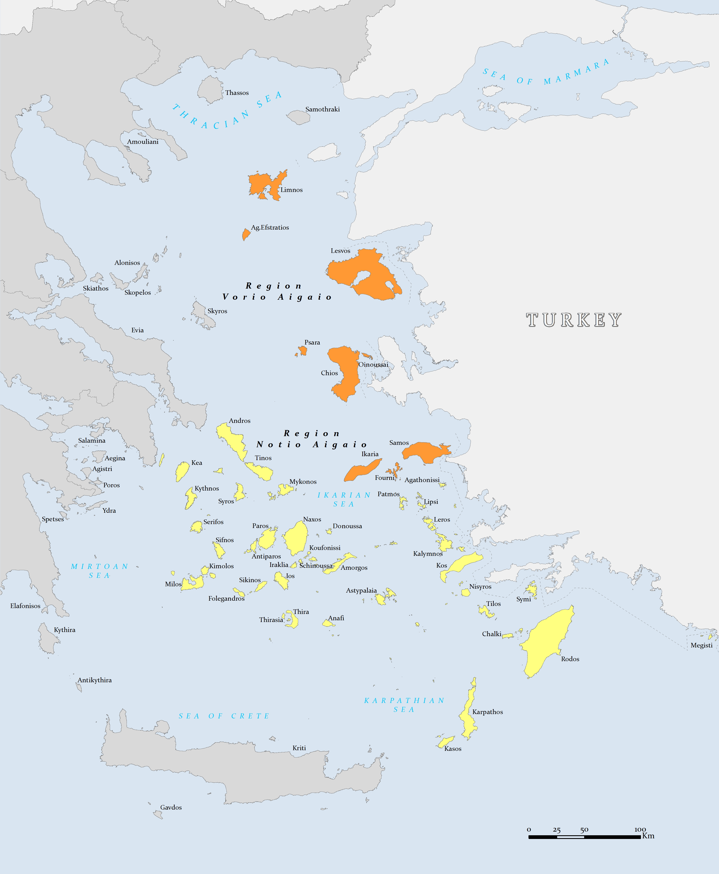

Map 2: Commercial beds (2013)
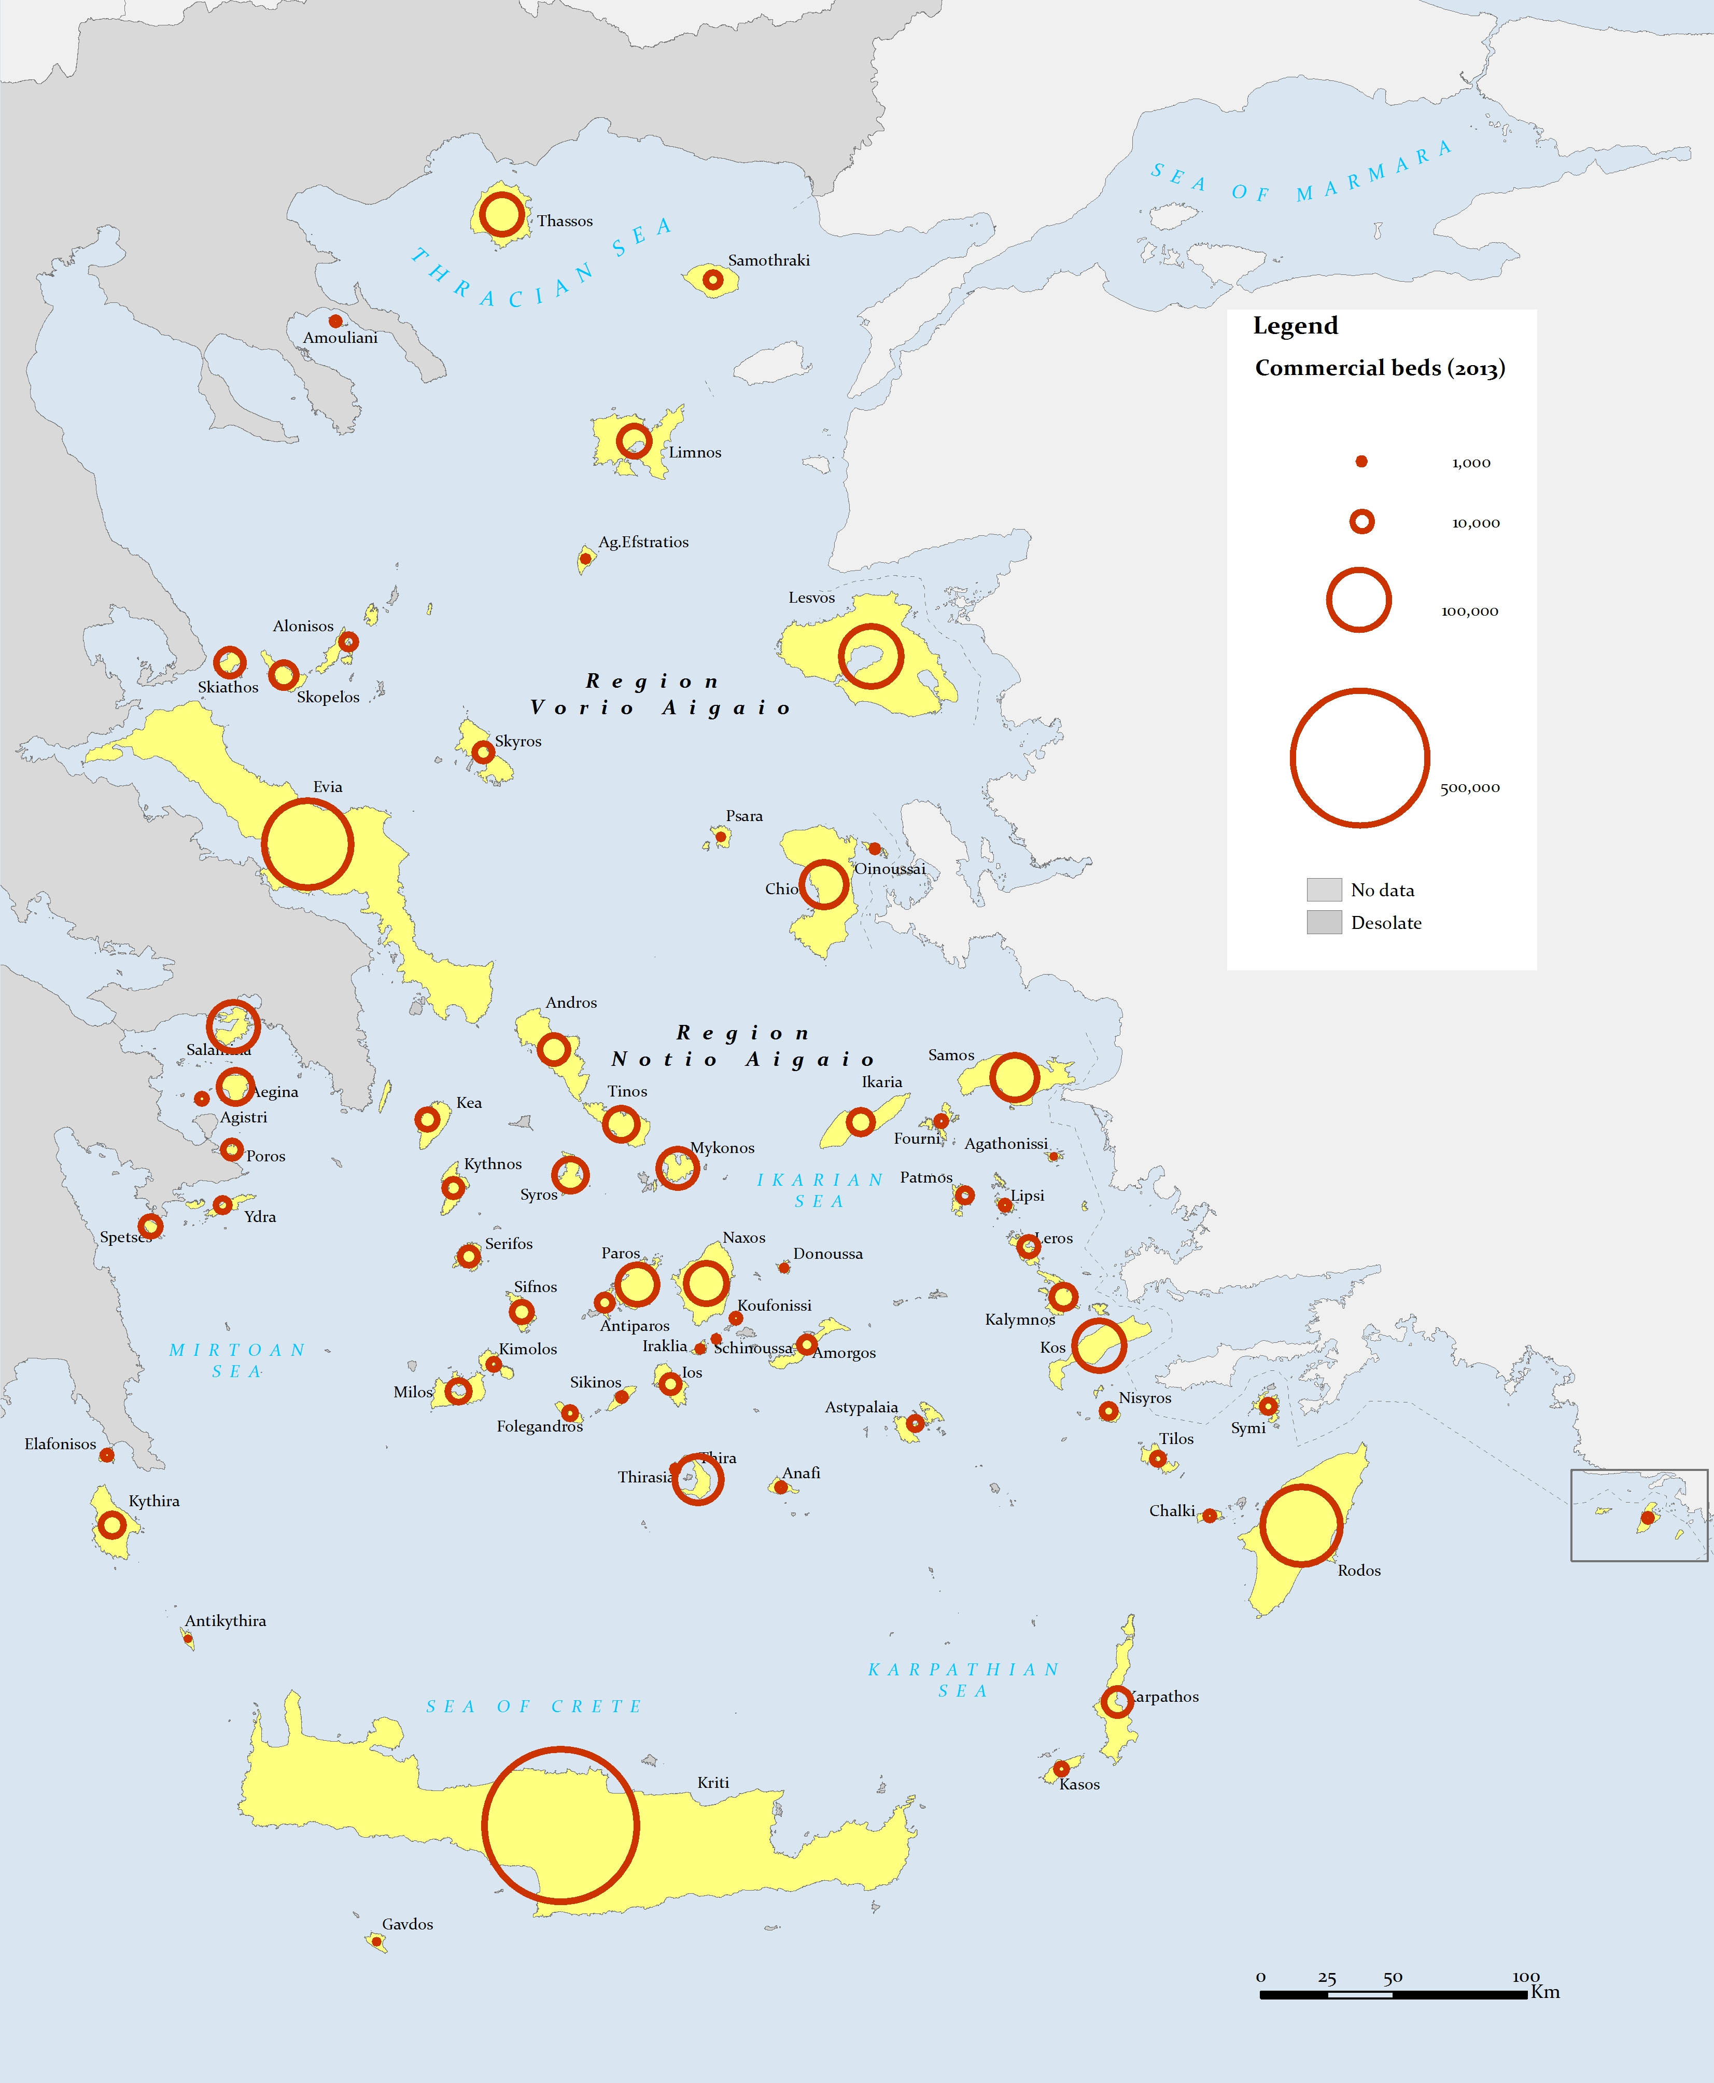

Map 3: Commercial beds/inhabitant (2013)
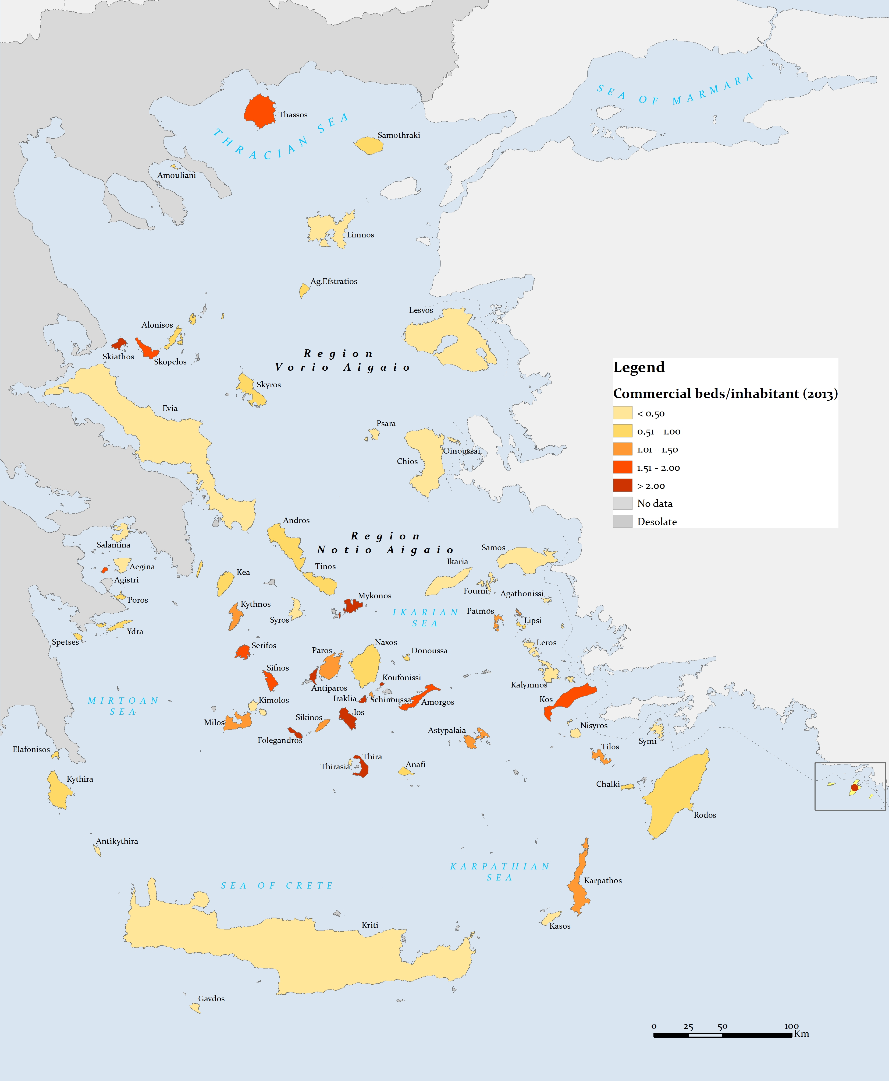

Map 4: Commercial beds/sq.km (2013)
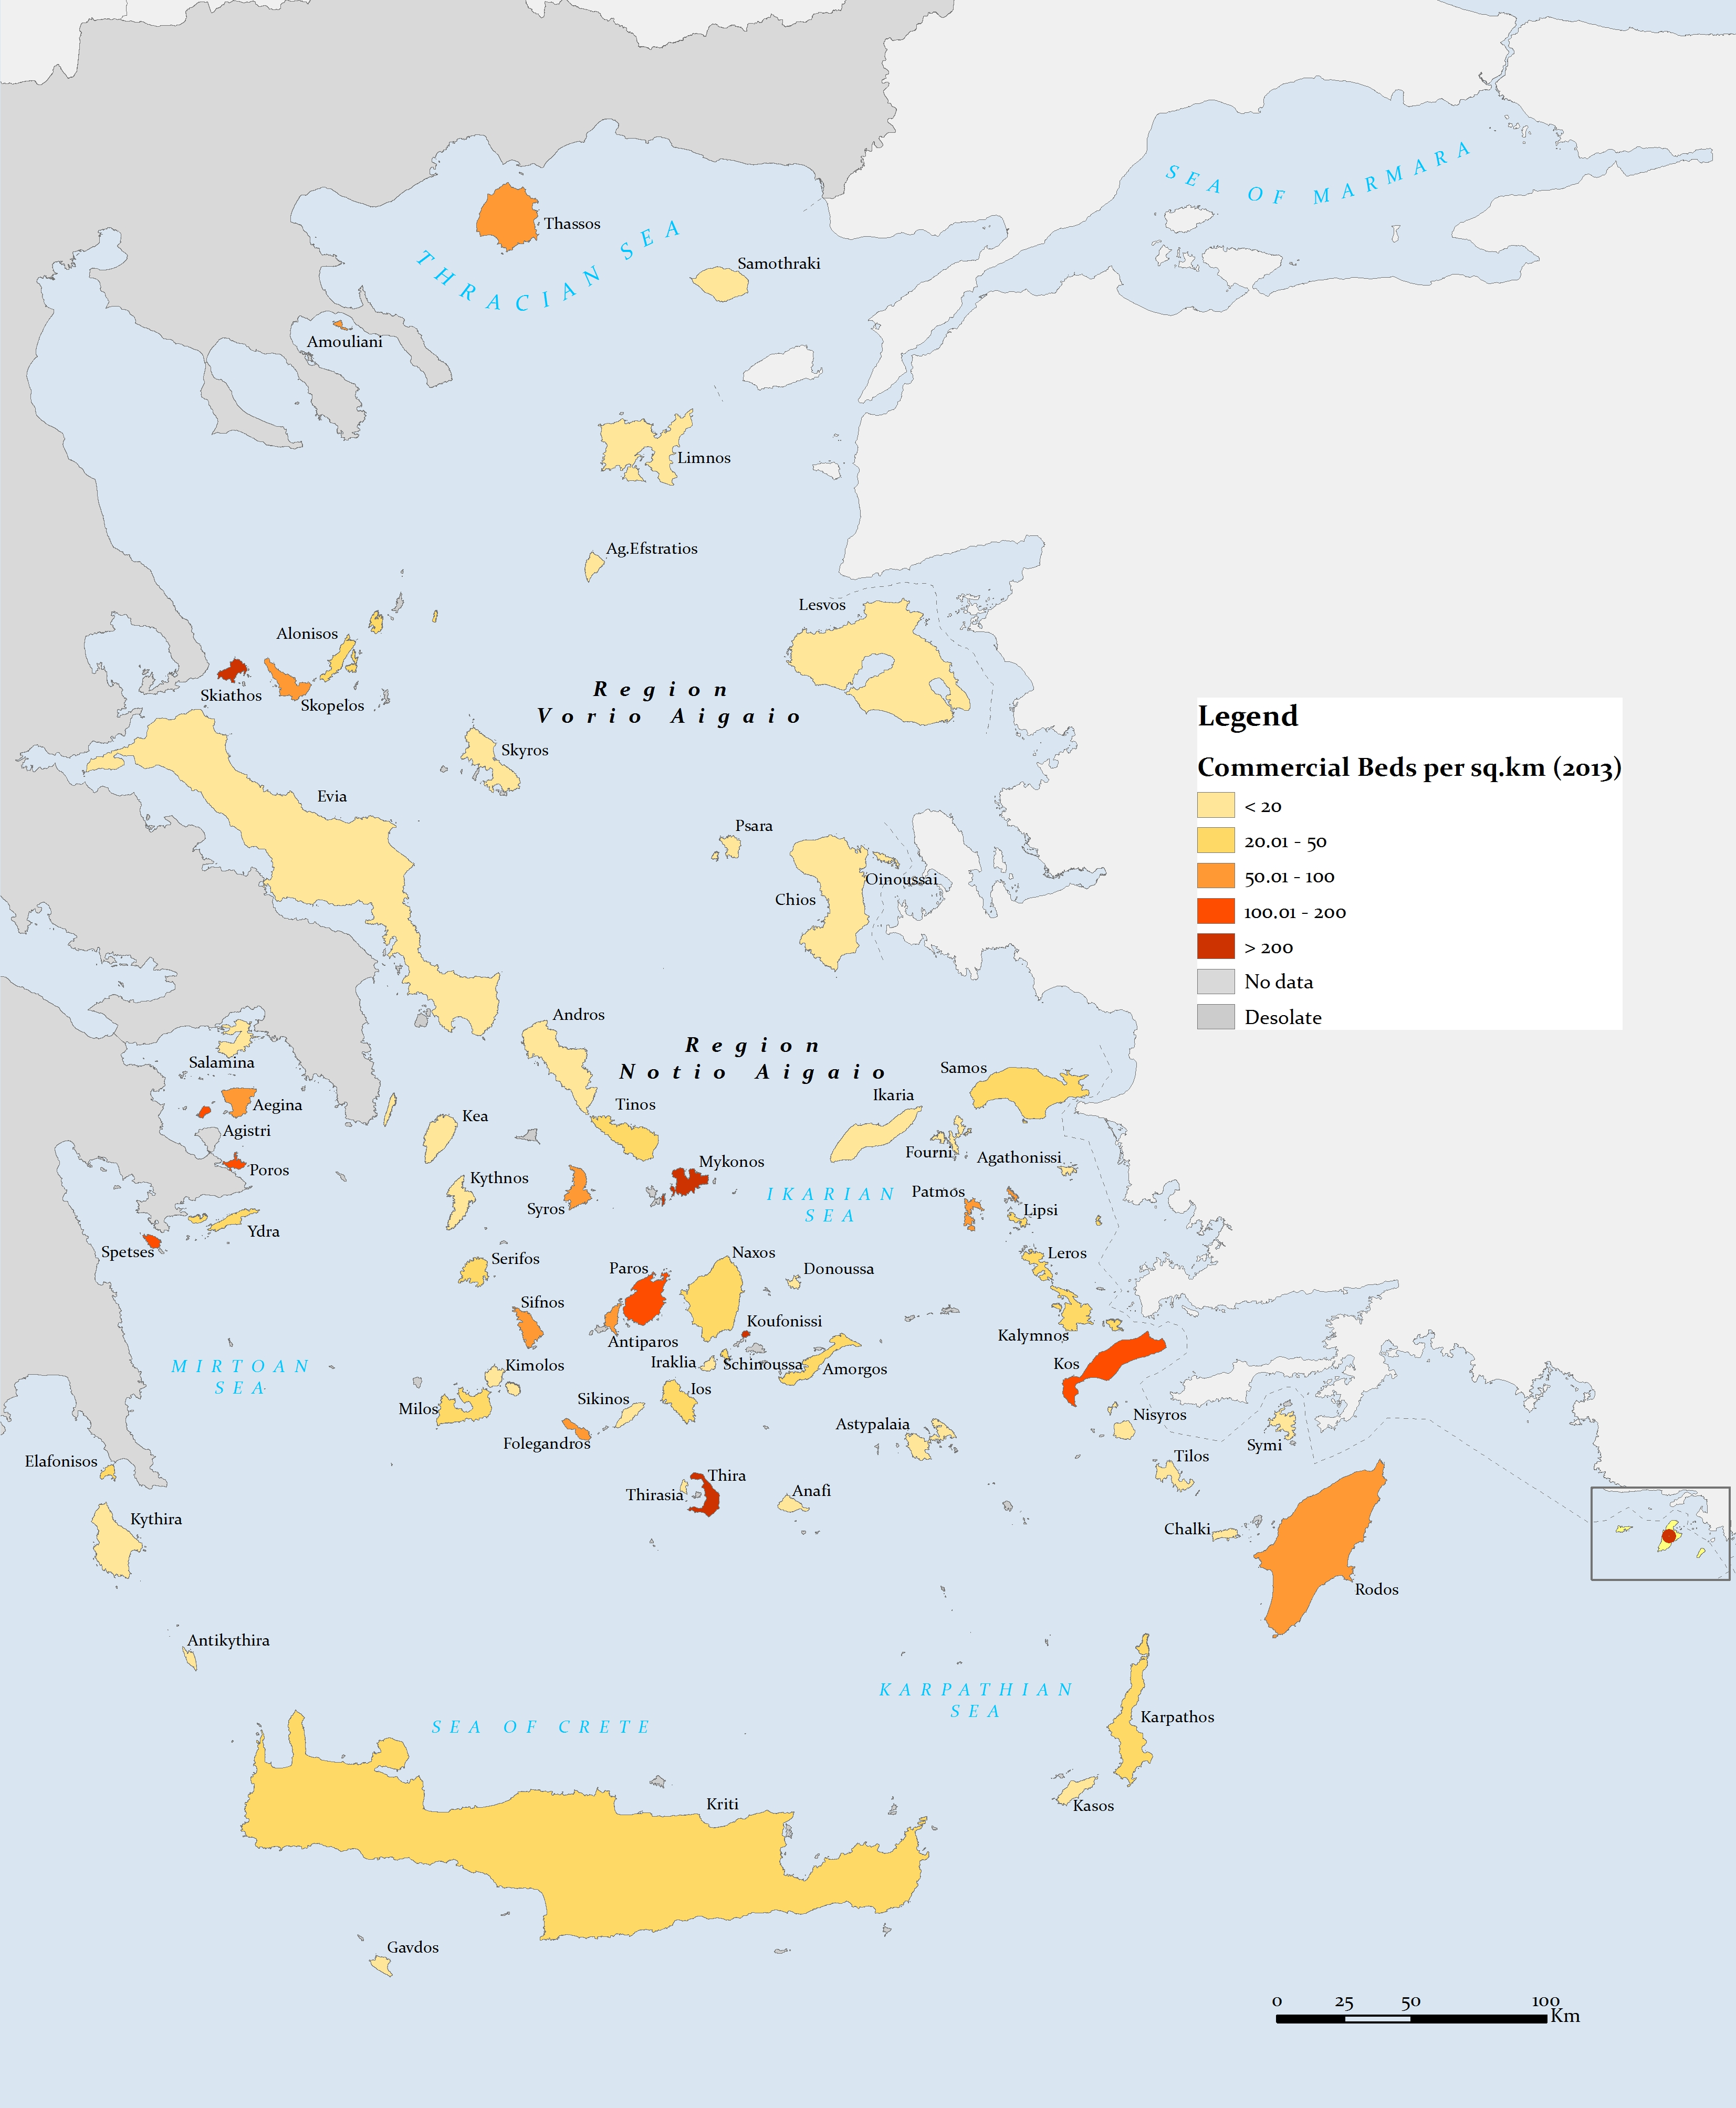

Map 5: average length of stay in hotels (2012)
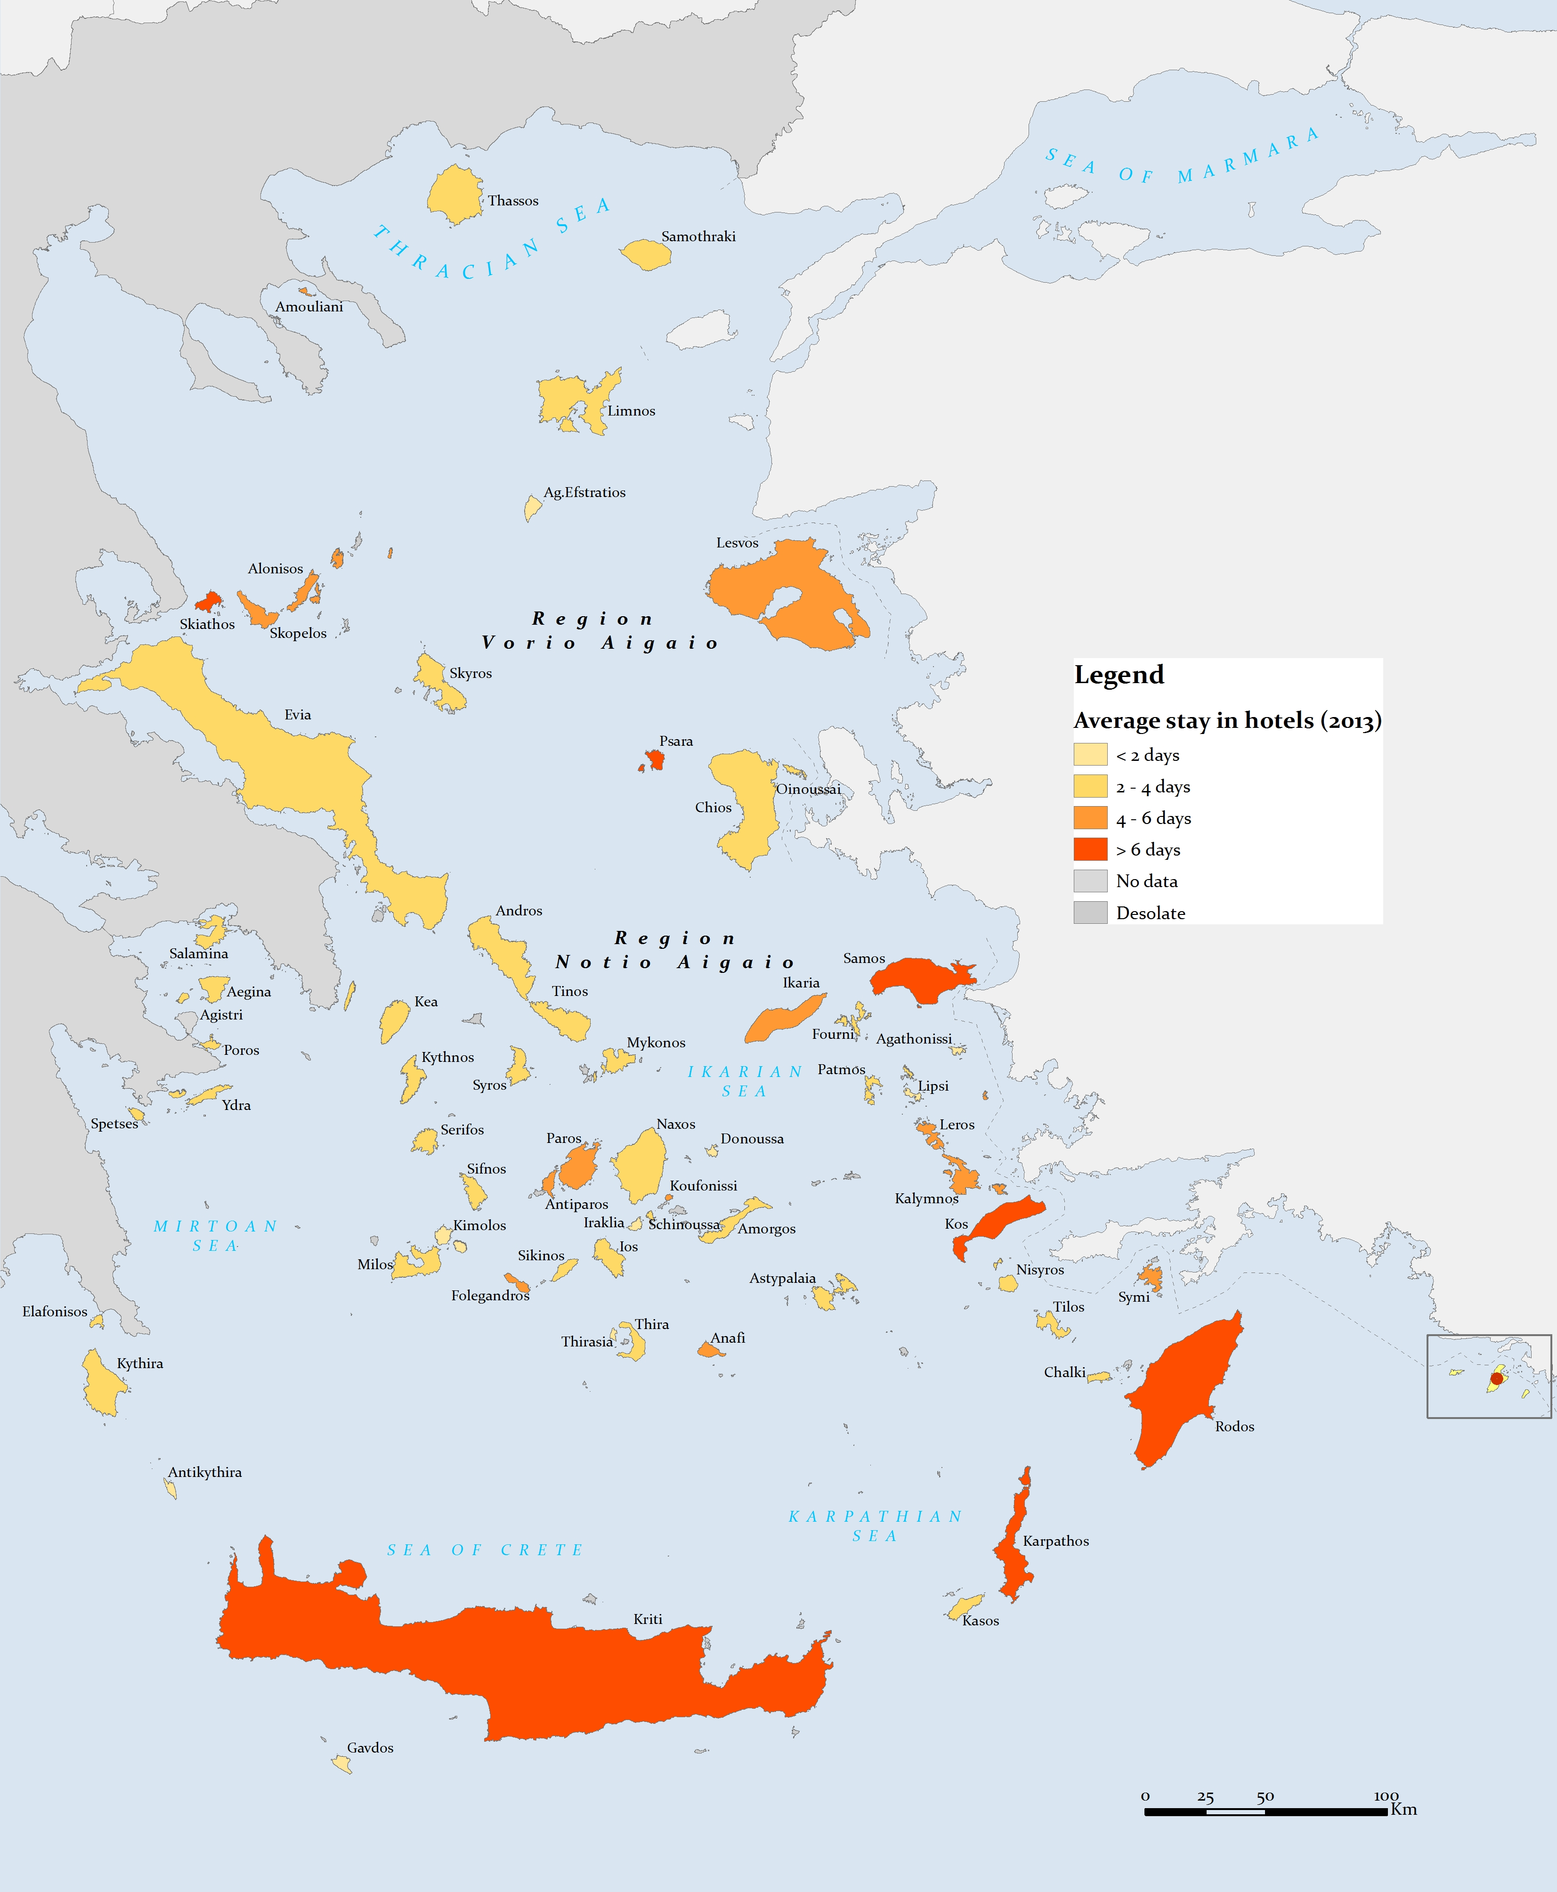

Annex 3: Data

Table 1: The Aegean Islands, administrative division, size and population (2011)
Table 2α: Commercial and non-commercial beds per island (2013)
Table 2β: Tourism pressure indexes
Table 3α : Tourism Demand: arrivals, overnights spent and average length of stay in hotels of greek and foreigner tourists (2012)
Table 3b: Tourism Demand: Arrivals by ship and airplane per island (2012) – Evaluation of arrivals of tourists
Table 4: Population evolution 1951-2011
Table 5: Employment per branch (employees and % of the total employment- 2011)
Table 6: Active population, employment and unemployment (2011)
Table 7: Gross Added Value per branch

Table 1: The Islands of RVA and RNA
islands | surface | Population (2011) |  | Estimated population (2018/19)
R. VORIO AIGAIO (RVA) | 3836 | 199231
D. LESVOS | 2154 | 103698
Ag.Efstratios | 43.23 | 270
Lesvos | 1630.38 | 86436
Limnos | 475.61 | 16992
D.SAMOU | 778 | 42859
Ikaria | 255.28 | 8423
Fourni | 30.27 | 1459
Samos | 476.2 | 32977
D.CHIOS | 904 | 52647
Chios | 841.58 | 51390
Oinoussai | 14.2 | 826
Psara | 39.77 | 458
R. NOTIO AIGAIO (RNA) | 5286 | 308975
D.DODEKANISSOS | 2714 | 190988
Agathonissi | 13.5 | 185
Astypalaia | 96.85 | 1334
Kalymnos | 110.88 | 16179
Karpathos | 301.18 | 6226
Kasos | 65.98 | 1084
Kos | 290.28 | 33388
Lipsi | 15.98 | 790
Leros | 52.95 | 7917
Megisti | 9.13 | 492
Nisyros | 41.4 | 1008
Patmos | 34.05 | 3047
Rodos | 1398.08 | 115490
Symi | 58.1 | 2590
Tilos | 62.83 | 780
Chalki | 28.13 | 478
D. KYKLADON | 2572 | 117987
Amorgos | 120.67 | 1973
Anafi | 38.35 | 271
Andros | 379.67 | 9221
Antiparos | 34.83 | 1211
Donoussa | 13.48 | 167
Iraklia | 17.6 | 141
Thira | 75.79 | 15231
Thirasia | 9.3 | 319
Ios | 107.8 | 2024
Kea | 103.58 | 2455
Kimolos | 35.71 | 910
Koufonissi | 5.7 | 399
Kythnos | 99.26 | 1456
Milos | 150.6 | 4977
Mykonos | 85.48 | 10134
Naxos | 428.13 | 17930
Paros | 194.52 | 13715
Serifos | 73.23 | 1420
Schinoussa | 7.78 | 227
Sikinos | 41.03 | 273
Sifnos | 73.18 | 2625
Syros | 83.63 | 21507
Tinos | 194.21 | 8636
Folegandros | 32.07 | 765

Table 2: Supply: Commercial and non-commercial accommodation (2012)
 | population | surface | hotel beds | beds in complementary establishment | camping posts | total commercial accommodation - beds | non commercial accommodation | beds in non commercial accommodation | general total of accommodation beds
RVA | 199231 | 3806.52 | 22296 | 14188 | 0 | 36484 | 71643 | 214929 | 251413
Ag.Efstratios | 270 | 43.23 | 0 | 144 | 0 | 144 | 163 | 489 | 633
Lesvos | 86436 | 1630.38 | 6757 | 6416 | 0 | 13173 | 29189 | 87567 | 100740
Limnos | 16992 | 475.61 | 1921 | 1037 | 0 | 2958 | 6932 | 20796 | 23754
Ikaria | 8423 | 255.28 | 1026 | 1040 | 0 | 2066 | 4447 | 13341 | 15407
Fourni | 1459 | 30.27 | 24 | 156 | 0 | 180 | 679 | 2037 | 2217
Samos | 32977 | 476.2 | 9650 | 4581 | 0 | 14231 | 13060 | 39180 | 53411
Chios | 51390 | 841.58 | 2839 | 717 | 0 | 3556 | 16776 | 50328 | 53884
Oinoussai | 826 | 14.2 | 23 | 49 | 0 | 72 | 261 | 783 | 855
Psara | 458 | 39.77 | 56 | 48 | 0 | 104 | 136 | 408 | 512
RNA | 308975 | 4984.92 | 192826 | 115829 | 7635 | 316290 | 113290 | 339870 | 656160
Agathonissi | 185 | 13.5 | 0 | 28 | 0 | 28 | 35 | 105 | 133
Astypalaia | 1334 | 96.85 | 459 | 1056 | 60 | 1575 | 754 | 2262 | 3837
Kalymnos | 16179 | 110.88 | 1,547 | 944 | 0 | 2491 | 4097 | 12291 | 14782
Karpathos | 6226 | 301.18 | 6,026 | 1335 | 0 | 7361 | 4182 | 12546 | 19907
Kasos | 1084 | 65.98 | 66 | 146 | 0 | 212 | 850 | 2550 | 2762
Kos | 33388 | 290.28 | 46,007 | 5599 | 0 | 51606 | 5828 | 17484 | 69090
Lipsi | 790 | 15.98 | 125 | 345 | 0 | 470 | 386 | 1158 | 1628
Leros | 7917 | 52.95 | 1,185 | 764 | 60 | 2009 | 2325 | 6975 | 8984
Megisti | 492 | 9.13 | 96 | 189 | 0 | 285 | 300 | 900 | 1185
Nisyros | 1008 | 41.4 | 142 | 177 | 144 | 463 | 1530 | 4590 | 5053
Patmos | 3047 | 34.05 | 1,856 | 1372 | 0 | 3228 | 658 | 1974 | 5202
Rodos | 115490 | 1398.08 | 85,297 | 13315 | 0 | 98612 | 21962 | 65886 | 164498
Symi | 2590 | 58.1 | 482 | 443 | 0 | 925 | 1163 | 3489 | 4414
Tilos | 780 | 62.83 | 480 | 490 | 0 | 970 | 822 | 2466 | 3436
Chalki | 478 | 28.13 | 96 | 231 | 0 | 327 | 497 | 1491 | 1818
Amorgos | 1973 | 120.67 | 395 | 1829 | 984 | 3208 | 1097 | 3291 | 6499
Anafi | 271 | 38.35 | 24 | 177 | 0 | 201 | 335 | 1005 | 1206
Andros | 9221 | 379.67 | 1,404 | 3704 | 189 | 5297 | 5471 | 16413 | 21710
Antiparos | 1211 | 34.83 | 343 | 1917 | 300 | 2560 | 1192 | 3576 | 6136
Donoussa | 167 | 13.48 | 0 | 111 | 0 | 111 | 125 | 375 | 486
Iraklia | 141 | 17.6 | 28 | 290 | 0 | 318 | 125 | 375 | 693
Thira | 15231 | 75.79 | 12,562 | 23254 | 525 | 36341 | 7854 | 23562 | 59903
Thirasia | 319 | 9.3 | 6 | 10 | 0 | 16 | 271 | 813 | 829
Ios | 2024 | 107.8 | 2,056 | 2892 | 414 | 5362 | 926 | 2778 | 8140
Kea | 2455 | 103.58 | 282 | 1569 | 183 | 2034 | 2743 | 8229 | 10263
Kimolos | 910 | 35.71 | 8 | 242 | 0 | 250 | 878 | 2634 | 2884
Koufonissi | 399 | 5.7 | 343 | 1088 | 0 | 1431 | 141 | 423 | 1854
Kythnos | 1456 | 99.26 | 193 | 1458 | 0 | 1651 | 2077 | 6231 | 7882
Milos | 4977 | 150.6 | 1,258 | 4228 | 225 | 5711 | 2465 | 7395 | 13106
Mykonos | 10134 | 85.48 | 10,852 | 10843 | 765 | 22460 | 5765 | 17295 | 39755
Naxos | 17930 | 428.13 | 5,898 | 8704 | 912 | 15514 | 10040 | 30120 | 45634
Paros | 13715 | 194.52 | 6,306 | 12254 | 1974 | 20534 | 7295 | 21885 | 42419
Serifos | 1420 | 73.23 | 395 | 1477 | 309 | 2181 | 2085 | 6255 | 8436
Schinoussa | 227 | 7.78 | 93 | 225 | 0 | 318 | 128 | 384 | 702
Sikinos | 273 | 41.03 | 37 | 325 | 0 | 362 | 289 | 867 | 1229
Sifnos | 2625 | 73.18 | 992 | 3586 | 0 | 4578 | 2031 | 6093 | 10671
Syros | 21507 | 83.63 | 2,300 | 4302 | 210 | 6812 | 7245 | 21735 | 28547
Tinos | 8636 | 194.21 | 2,190 | 4298 | 231 | 6719 | 6847 | 20541 | 27260
Folegandros | 765 | 32.07 | 997 | 612 | 150 | 1759 | 476 | 1428 | 3187

Table 2b: Supply: Pressure indicators (2012)
 | commercial beds/pop | non-commercial bedss/pop | commercial beds beds/surface | total beds/pop | total beds/surface | total beds + pop/surface
RVA | 0.18 | 1.08 | 9.58 | 1.26 | 66.05 | 118.39
Ag.Efstratios | 0.53 | 1.81 | 3.33 | 2.34 | 14.64 | 20.89
Lesvos | 0.15 | 1.01 | 8.08 | 1.17 | 61.79 | 114.81
Limnos | 0.17 | 1.22 | 6.22 | 1.40 | 49.94 | 85.67
Ikaria | 0.25 | 1.58 | 8.09 | 1.83 | 60.35 | 93.35
Fourni | 0.12 | 1.40 | 5.95 | 1.52 | 73.24 | 121.44
Samos | 0.43 | 1.19 | 29.88 | 1.62 | 112.16 | 181.41
Chios | 0.07 | 0.98 | 4.23 | 1.05 | 64.03 | 125.09
Oinoussai | 0.09 | 0.95 | 5.07 | 1.04 | 60.21 | 118.38
Psara | 0.23 | 0.89 | 2.62 | 1.12 | 12.87 | 24.39
RNA | 1.02 | 1.10 | 63.45 | 2.12 | 131.63 | 193.61
Agathonissi | 0.15 | 0.57 | 2.07 | 0.72 | 9.85 | 23.56
Astypalaia | 1.18 | 1.70 | 16.26 | 2.88 | 39.62 | 53.39
Kalymnos | 0.15 | 0.76 | 22.47 | 0.91 | 133.32 | 279.23
Karpathos | 1.18 | 2.02 | 24.44 | 3.20 | 66.10 | 86.77
Kasos | 0.20 | 2.35 | 3.21 | 2.55 | 41.86 | 58.29
Kos | 1.55 | 0.52 | 177.78 | 2.07 | 238.01 | 353.03
Lipsi | 0.59 | 1.47 | 29.41 | 2.06 | 101.88 | 151.31
Leros | 0.25 | 0.88 | 37.94 | 1.13 | 169.67 | 319.19
Megisti | 0.58 | 1.83 | 31.22 | 2.41 | 129.79 | 183.68
Nisyros | 0.46 | 4.55 | 11.18 | 5.01 | 122.05 | 146.40
Patmos | 1.06 | 0.65 | 94.80 | 1.71 | 152.78 | 242.26
Rodos | 0.85 | 0.57 | 70.53 | 1.42 | 117.66 | 200.27
Symi | 0.36 | 1.35 | 15.92 | 1.70 | 75.97 | 120.55
Tilos | 1.24 | 3.16 | 15.44 | 4.41 | 54.69 | 67.10
Chalki | 0.68 | 3.12 | 11.62 | 3.80 | 64.63 | 81.62
Amorgos | 1.63 | 1.67 | 26.58 | 3.29 | 53.86 | 70.21
Anafi | 0.74 | 3.71 | 5.24 | 4.45 | 31.45 | 38.51
Andros | 0.57 | 1.78 | 13.95 | 2.35 | 57.18 | 81.47
Antiparos | 2.11 | 2.95 | 73.50 | 5.07 | 176.17 | 210.94
Donoussa | 0.66 | 2.25 | 8.23 | 2.91 | 36.05 | 48.44
Iraklia | 2.26 | 2.66 | 18.07 | 4.91 | 39.38 | 47.39
Thira | 2.39 | 1.55 | 479.50 | 3.93 | 790.38 | 991.34
Thirasia | 0.05 | 2.55 | 1.72 | 2.60 | 89.14 | 123.44
Ios | 2.65 | 1.37 | 49.74 | 4.02 | 75.51 | 94.29
Kea | 0.83 | 3.35 | 19.64 | 4.18 | 99.08 | 122.78
Kimolos | 0.27 | 2.89 | 7.00 | 3.17 | 80.76 | 106.24
Koufonissi | 3.59 | 1.06 | 251.05 | 4.65 | 325.26 | 395.26
Kythnos | 1.13 | 4.28 | 16.63 | 5.41 | 79.41 | 94.08
Milos | 1.15 | 1.49 | 37.92 | 2.63 | 87.03 | 120.07
Mykonos | 2.22 | 1.71 | 262.75 | 3.92 | 465.08 | 583.63
Naxos | 0.87 | 1.68 | 36.24 | 2.55 | 106.59 | 148.47
Paros | 1.50 | 1.60 | 105.56 | 3.09 | 218.07 | 288.58
Serifos | 1.54 | 4.40 | 29.78 | 5.94 | 115.20 | 134.59
Schinoussa | 1.40 | 1.69 | 40.87 | 3.09 | 90.23 | 119.41
Sikinos | 1.33 | 3.18 | 8.82 | 4.50 | 29.95 | 36.61
Sifnos | 1.74 | 2.32 | 62.56 | 4.07 | 145.82 | 181.69
Syros | 0.32 | 1.01 | 81.45 | 1.33 | 341.35 | 598.52
Tinos | 0.78 | 2.38 | 34.60 | 3.16 | 140.36 | 184.83
Folegandros | 2.30 | 1.87 | 54.85 | 4.17 | 99.38 | 123.23

Table 3α : Tourism Demand: arrivals, overnights spent and average length of stay in hotels of greek and foreigner tourists
Islands | arrivals hotels | nights spent hotels | average stay | seasonality | arrivals hotels Gr | nights spent hotels GR | average stay GR | arrivals hotels FOR | nights spent FOR | average stay FOR | FOR/GR arrivals | FOR/GR nights spent | arrivals by boat
RVA
Ag.Efstratios |  |  |  |  |  |  |  |  |  |  |  |  | 5372
Lesvos | 95625 | 394727 | 4.13 | 0.77 | 48669 | 126479 | 2.60 | 46956 | 268248 | 5.71 | 0.964803 | 2.12089 | 184138
Limnos | 11853 | 45849 | 3.87 | 0.76 | 8790 | 28880 | 3.29 | 3063 | 16969 | 5.54 | 0.348464 | 0.587569 | 73508
Ikaria | 6028 | 28885 | 4.79 | 0.83 | 4932 | 22197 | 4.50 | 1096 | 6688 | 6.10 | 0.222222 | 0.301302 | 58709
Fourni | 95 | 225 | 2.37 | 0.72 | 64 | 126 | 1.97 | 31 | 99 | 3.19 | 0.484375 | 0.785714 | 15678
Samos | 99561 | 656947 | 6.60 | 0.85 | 19661 | 68189 | 3.47 | 79900 | 588758 | 7.37 | 4.063883 | 8.634208 | 103498
Chios | 46600 | 143760 | 3.08 | 0.66 | 26578 | 73385 | 2.76 | 20022 | 70375 | 3.51 | 0.75333 | 0.958983 | 204616
Oinoussai | 47 | 79 | 1.68 | 0.54 | 46 | 77 | 1.67 | 1 | 2 | 2.00 | 0.021739 | 0.025974 | 16493
Psara | 110 | 960 | 8.73 | 0.44 | 104 | 954 | 9.17 | 6.00 | 6.00 | 1.00 | 0.057692 | 0.006289 | 8203
RNA
Agathonissi |  |  |  |  |  |  |  |  |  |  |  |  | 3920
Astypalaia | 847 | 3259 | 3.85 | 0.99 | 665 | 2626 | 3.95 | 182 | 633 | 3.48 | 0.273684 | 0.241051 | 11090
Kalymnos | 9440 | 44307 | 4.69 | 0.76 | 4503 | 11265 | 2.50 | 4937 | 33042 | 6.69 | 1.09638 | 2.933156 | 145984
Karpathos | 36678 | 254929 | 6.95 | 0.89 | 3401 | 16403 | 4.82 | 33277 | 238526 | 7.17 | 9.784475 | 14.54161 | 23893
Kasos | 334 | 1259 | 3.77 | 0.61 | 302 | 1116 | 3.70 | 32 | 143 | 4.47 | 0.10596 | 0.128136 | 7915
Kos | 606392 | 4522125 | 7.46 | 0.83 | 34567 | 166645 | 4.82 | 571825 | 4355480 | 7.62 | 16.54251 | 26.13628 | 243319
Lipsi |  |  |  |  |  |  |  |  |  |  |  |  | 13930
Leros | 2499 | 14870 | 5.95 | 0.86 | 1484 | 8640 | 5.82 | 1015 | 6230 | 6.14 | 0.683962 | 0.721065 | 45458
Megisti | 1173 | 4595 | 3.92 | 0.87 | 402 | 1682 | 4.18 | 771 | 2913 | 3.78 | 1.91791 | 1.731867 | 2886
Nisyros | 1603 | 5847 | 3.65 | 0.75 | 1165 | 4178 | 3.59 | 438 | 1669 | 3.81 | 0.375966 | 0.399473 | 10066
Patmos | 14176 | 47943 | 3.38 | 0.83 | 7254 | 23984 | 3.31 | 6922 | 23959 | 3.46 | 0.954232 | 0.998958 | 57316
Rodos | 1384269 | 8815271 | 6.37 | 0.78 | 104505 | 398904 | 3.82 | 1279764 | 8416367 | 6.58 | 12.24596 | 21.09873 | 246767
Symi | 7747 | 31744 | 4.10 | 0.83 | 2795 | 6880 | 2.46 | 4952 | 24864 | 5.02 | 1.771735 | 3.613953 | 139013
Tilos | 878 | 3472 | 3.95 | 0.71 | 142 | 376 | 2.65 | 736 | 3096 | 4.21 | 5.183099 | 8.234043 | 7642
Chalki | 667 | 2062 | 3.09 | 0.75 | 332 | 808 | 2.43 | 335 | 1254 | 3.74 | 1.009036 | 1.55198 | 8505
Amorgos | 1644 | 6357 | 3.87 | 0.96 | 443 | 1931 | 4.36 | 1201 | 4426 | 3.69 | 2.711061 | 2.292077 | 52161
Anafi | 188 | 850 | 4.52 | 0.98 | 79 | 295 | 3.73 | 109 | 555 | 5.09 | 1.379747 | 1.881356 | 12049
Andros | 16004 | 44201 | 2.76 | 0.92 | 12649 | 31649 | 2.50 | 3355 | 12552 | 3.74 | 0.265238 | 0.3966 | 265664
Antiparos | 2144 | 10365 | 4.83 | 0.98 | 875 | 3186 | 3.64 | 1269 | 7179 | 5.66 | 1.450286 | 2.253296 | 173810
Donoussa |  |  |  |  |  |  |  |  |  |  |  |  | 10431
Iraklia |  |  |  |  |  |  |  |  |  |  |  |  | 7792
Thira | 105112 | 404243 | 3.85 | 0.83 | 12039 | 37993 | 3.16 | 93073 | 366250 | 3.94 | 7.730958 | 9.639934 | 468886
Thirasia |  |  |  |  |  |  |  |  |  |  |  |  | 297
Ios | 22314 | 88862 | 3.98 | 0.96 | 5037 | 20401 | 4.05 | 17277 | 68461 | 3.96 | 3.430018 | 3.355767 | 94218
Kea | 786 | 1496 | 1.90 | 0.85 | 741 | 1386 | 1.87 | 45 | 110 | 2.44 | 0.060729 | 0.079365 | 130552
Kimolos |  |  |  |  |  |  |  |  |  |  |  |  | 31820
Koufonissi | 619 | 3153 | 5.09 | 1 | 502 | 2443 | 4.87 | 117 | 710 | 6.07 | 0.233068 | 0.290626 | 33907
Kythnos | 1392 | 4558 | 3.27 | 0.97 | 1352 | 4346 | 3.21 | 40 | 212 | 5.30 | 0.029586 | 0.04878 | 59995
Milos | 9628 | 35484 | 3.69 | 0.93 | 4454 | 15666 | 3.50 | 5174 | 19818 | 3.80 | 1.161652 | 1.265033 | 108783
Mykonos | 168131 | 629303 | 3.74 | 0.86 | 32624 | 100259 | 3.07 | 135507 | 529044 | 3.90 | 4.153599 | 5.276773 | 400410
Naxos | 17764 | 69645 | 3.92 | 0.88 | 7451 | 23237 | 3.12 | 10313 | 46408 | 4.50 | 1.38411 | 1.99716 | 327157
Paros | 57402 | 234305 | 4.08 | 0.91 | 20738 | 81310 | 3.92 | 36664 | 153305 | 4.18 | 1.767962 | 1.885438 | 573347
Serifos | 2170 | 7489 | 3.45 | 0.97 | 1596 | 5545 | 3.47 | 574 | 1944 | 3.39 | 0.359649 | 0.350586 | 52492
Schinoussa | 8 | 26 | 3.25 | 1 | 5 | 18 | 3.60 | 3 | 8 | 2.67 | 0.6 | 0.444444 | 10390
Sikinos | 289 | 1067 | 3.69 | 1 | 192 | 734 | 3.82 | 97 | 333 | 3.43 | 0.505208 | 0.453678 | 9181
Sifnos | 6059 | 19636 | 3.24 | 0.93 | 3824 | 11484 | 3.00 | 2235 | 8152 | 3.65 | 0.584467 | 0.709857 | 86126
Syros | 19951 | 59657 | 2.99 | 0.83 | 15006 | 45219 | 3.01 | 4945 | 14438 | 2.92 | 0.329535 | 0.319291 | 285969
Tinos | 42822 | 95519 | 2.23 | 0.86 | 39941 | 87199 | 2.18 | 2881 | 8320 | 2.89 | 0.072131 | 0.095414 | 410321
Folegandros | 3066 | 13851 | 4.52 | 0.99 | 1037 | 6830 | 6.59 | 2029 | 7021 | 3.46 | 1.956606 | 1.027965 | 34066

Table 3: Demand: Arrivals by ship and airplane (2012)
Islands | arrivals by airplane internal flights | arrivals by airplane international (charter) flight | total arrivals | arrivals hotels/arrivals island | arrivals FOR hotels/arrivals charters | correction arrivals by ship | correction arrivals by air | total corrections | arrivals hotels/corrected arrivals island
RVA
Ag.Efstratios |  |  | 5372 | 0.00 |  | 2228 |  | 2228 | 0.00
Lesvos | 155168 | 48435 | 387741 | 24.66 | 96.95 | 109618 | 35996 | 194049 | 49.28
Limnos | 33870 | 7220 | 114598 | 10.34 | 42.42 | 53072 | 6678 | 66970 | 17.70
Ikaria | 18799 | 0 | 77508 | 7.78 |  | 39005 | 7951 | 46956 | 12.84
Fourni |  |  | 15678 | 0.61 |  | 8310 |  | 8310 | 1.14
Samos | 72686 | 108151 | 284335 | 35.02 | 73.88 | 62638 | 19826 | 190615 | 52.23
Chios | 82004 | 8433 | 295053 | 15.79 | 237.42 | 98524 | 12164 | 119121 | 39.12
Oinoussai |  |  | 16493 | 0.28 |  | 5069 |  | 5069 | 0.93
Psara |  |  | 8203 | 1.34 |  | 5215 |  | 5215 | 2.11
RNA
Agathonissi |  |  | 3920 | 0.00 |  | 2192 |  | 2192 | 0.00
Astypalaia | 6080 | 0 | 17170 | 4.93 |  | 8462 | 3764 | 12226 | 6.93
Kalymnos | 9028 | 0 | 155012 | 6.09 |  | 72508 | 3184 | 75692 | 12.47
Karpathos | 24442 | 59845 | 108180 | 33.90 | 55.61 | 16849 | 10882 | 87576 | 41.88
Kasos | 1764 | 0 | 9679 | 3.45 |  | 5263 | 468 | 5731 | 5.83
Kos | 93412 | 802760 | 1139491 | 53.22 | 71.23 | 131863 | 24592 | 959215 | 63.22
Lipsi |  |  | 13930 | 0.00 |  | 10078 |  | 10078 | 0.00
Leros | 13561 | 0 | 59019 | 4.23 |  | 29114 | 5041 | 34155 | 7.32
Megisti | 1764 | 0 | 4650 | 25.23 |  | 342 | 1764 | 2106 | 55.70
Nisyros |  |  | 10066 | 15.92 |  | 2182 |  | 2182 | 73.46
Patmos |  |  | 57316 | 24.73 |  | 45520 |  | 45520 | 31.14
Rodos | 294635 | 1606843 | 2148245 | 64.44 | 79.64 | 152507 | 82235 | 1841585 | 75.17
Symi |  |  | 139013 | 5.57 |  | 125441 |  | 125441 | 6.18
Tilos |  |  | 7642 | 11.49 |  | 2398 |  | 2398 | 36.61
Chalki |  |  | 8505 | 7.84 |  | 5529 |  | 5529 | 12.06
Amorgos |  |  | 52161 | 3.15 |  | 44013 |  | 44013 | 3.74
Anafi |  |  | 12049 | 1.56 |  | 10273 |  | 10273 | 1.83
Andros |  |  | 265664 | 6.02 |  | 163232 |  | 163232 | 9.80
Antiparos |  |  | 173810 | 1.23 |  | 136874 |  | 136874 | 1.57
Donoussa |  |  | 10431 | 0.00 |  | 9315 |  | 9315 | 0.00
Iraklia |  |  | 7792 | 0.00 |  | 5980 |  | 5980 | 0.00
Thira | 166786 | 200271 | 835943 | 12.57 | 46.47 | 419062 | 129586 | 748919 | 14.04
Thirasia |  |  | 297 | 0.00 |  | 189 |  | 189 | 0.00
Ios |  |  | 94218 | 23.68 |  | 84138 |  | 84138 | 26.52
Kea |  |  | 130552 | 0.60 |  | 127120 |  | 127120 | 0.62
Kimolos |  |  | 31820 | 0.00 |  | 24380 |  | 24380 | 0.00
Koufonissi |  |  | 33907 | 1.83 |  | 30379 |  | 30379 | 2.04
Kythnos |  |  | 59995 | 2.32 |  | 42643 |  | 42643 | 3.26
Milos | 16608 | 0 | 125391 | 7.68 |  | 88275 | 4860 | 93135 | 10.34
Mykonos | 106254 | 140131 | 646795 | 25.99 | 96.70 | 339546 | 83250 | 562927 | 29.87
Naxos | 9982 | 455 | 337594 | 5.26 | 2266.59 | 243961 | 3982 | 248398 | 7.15
Paros | 20417 | 0 | 593764 | 9.67 |  | 444287 | 12953 | 457240 | 12.55
Serifos |  |  | 52492 | 4.13 |  | 40384 |  | 40384 | 5.37
Schinoussa |  |  | 10390 | 0.08 |  | 7942 |  | 7942 | 0.10
Sikinos |  |  | 9181 | 3.15 |  | 7633 |  | 7633 | 3.79
Sifnos |  |  | 86126 | 7.04 |  | 72086 |  | 72086 | 8.41
Syros | 4818 | 0 | 290787 | 6.86 |  | 146721 | 990 | 147711 | 13.51
Tinos |  |  | 410321 | 10.44 |  | 329081 |  | 329081 | 13.01
Folegandros |  |  | 34066 | 9.00 |  | 31090 |  | 31090 | 9.86

Table 4: Population evolution 1951-2011
 | 1951 | 1961 | 1971 | 1981 | 1991 | 2001 | 2011
RVA | 281172 | 254328 | 210298 | 194872 | 199072 | 206121 | 199231
Ag.Efstratios | 3849 | 1061 | 422 | 296 | 286 | 371 | 270
Lesvos | 126924 | 117371 | 97008 | 88601 | 87151 | 90643 | 86436
Limnos | 24016 | 21808 | 17367 | 15721 | 17645 | 18104 | 16992
Ikaria | 10608 | 9577 | 7702 | 7559 | 7546 | 8312 | 8423
Fourni | 1105 | 1170 | 1195 | 1203 | 1233 | 1469 | 1459
Samos | 47865 | 41124 | 32664 | 31629 | 33032 | 33814 | 32977
Chios | 64672 | 60061 | 52487 | 48700 | 51060 | 51936 | 51390
Oinoussai | 1433 | 1580 | 966 | 703 | 681 | 1050 | 826
Psara | 700 | 576 | 487 | 460 | 438 | 422 | 458
RNA | 235043 | 222150 | 206944 | 233162 | 257258 | 302810 | 308975
Agathonissi | 196 | 189 | 160 | 133 | 112 | 158 | 185
Astypalaia | 1797 | 1539 | 1139 | 1030 | 1073 | 1238 | 1334
Kalymnos | 13387 | 14017 | 13097 | 14295 | 15706 | 16441 | 16179
Karpathos | 7053 | 6689 | 5420 | 4645 | 5323 | 6511 | 6226
Kasos | 1388 | 1422 | 1353 | 1184 | 1088 | 990 | 1084
Kos | 19076 | 18187 | 16650 | 20350 | 26379 | 30947 | 33388
Lipsi | 885 | 724 | 597 | 574 | 606 | 698 | 790
Leros | 7049 | 6611 | 8494 | 8127 | 8059 | 8123 | 7917
Megisti | 574 | 476 | 264 | 222 | 275 | 430 | 492
Nisyros | 2327 | 1788 | 1253 | 916 | 913 | 948 | 1008
Patmos | 2613 | 2564 | 2432 | 2534 | 2663 | 2984 | 3047
Rodos | 58946 | 63951 | 66606 | 87831 | 98175 | 117007 | 115490
Symi | 3978 | 3123 | 2489 | 2273 | 2332 | 2606 | 2590
Tilos | 1052 | 789 | 349 | 301 | 279 | 533 | 780
Chalki | 580 | 501 | 387 | 334 | 281 | 313 | 478
Amorgos | 2505 | 2096 | 1822 | 1718 | 1630 | 1859 | 1973
Anafi | 532 | 471 | 353 | 292 | 261 | 273 | 271
Andros | 14705 | 12928 | 10457 | 9020 | 8781 | 10009 | 9221
Antiparos | 680 | 631 | 538 | 635 | 819 | 1037 | 1211
Donoussa | 272 | 210 | 149 | 116 | 111 | 163 | 167
Iraklia | 189 | 155 | 129 | 95 | 115 | 151 | 141
Thira | 9332 | 7751 | 6196 | 7083 | 9360 | 13670 | 15231
Thirasia | 501 | 399 | 291 | 245 | 233 | 268 | 319
Ios | 1753 | 1343 | 1270 | 1451 | 1654 | 1838 | 2024
Kea | 3108 | 2361 | 1666 | 1648 | 1787 | 2417 | 2455
Kimolos | 1536 | 1412 | 1086 | 786 | 728 | 769 | 910
Koufonissi | 282 | 277 | 238 | 232 | 275 | 366 | 399
Kythnos | 2536 | 2064 | 1586 | 1502 | 1632 | 1608 | 1456
Milos | 5586 | 4910 | 4499 | 4554 | 4390 | 4771 | 4977
Mykonos | 3391 | 3633 | 3823 | 5503 | 6170 | 9320 | 10134
Naxos | 18593 | 16703 | 14201 | 14037 | 14838 | 18188 | 17930
Paros | 9022 | 7830 | 6776 | 7881 | 9591 | 12853 | 13715
Serifos | 1851 | 1878 | 1083 | 1133 | 1095 | 1414 | 1420
Schinoussa | 226 | 196 | 197 | 140 | 122 | 206 | 227
Sikinos | 590 | 453 | 331 | 290 | 267 | 238 | 273
Sifnos | 2773 | 2258 | 2043 | 2087 | 1960 | 2442 | 2625
Syros | 23130 | 19570 | 18642 | 19668 | 19870 | 19782 | 21507
Tinos | 10187 | 9273 | 8232 | 7730 | 7747 | 8574 | 8636
Folegandros | 862 | 778 | 646 | 567 | 558 | 667 | 765

Table 5: Employment per branch (employees and % of the total employment- 2011)
 | primary sector | % primary sector | secondary sector | % secondary sector | tertiary sector | % tertiery sector | public sector (+education and health) | % public sector (+education and health)
RVA | 8861 | 14.16 | 9139 | 14.60 | 44596 | 71.25 | 19801 | 31.63
Ag.Efstratios | 26 | 33.77 | 12 | 15.58 | 39 | 50.65 | 15 | 19.48
Lesvos | 4823 | 18.09 | 3791 | 14.22 | 18048 | 67.69 | 8172 | 30.65
Limnos | 744 | 13.25 | 793 | 14.13 | 4077 | 72.62 | 2303 | 41.02
Ikaria | 661 | 30.21 | 426 | 19.47 | 1101 | 50.32 | 441 | 20.16
Fourni | 30 | 9.06 | 49 | 14.80 | 252 | 76.13 | 73 | 22.05
Samos | 1215 | 11.14 | 1348 | 12.36 | 8346 | 76.49 | 3578 | 32.80
Chios | 1320 | 8.00 | 2678 | 16.22 | 12512 | 75.78 | 5123 | 31.03
Oinoussai | 26 | 14.29 | 33 | 18.13 | 123 | 67.58 | 56 | 30.77
Psara | 16 | 13.01 | 9 | 7.32 | 98 | 79.67 | 40 | 32.52
RNA | 6175 | 5.22 | 20030 | 16.93 | 92120 | 77.86 | 23292 | 19.69
Agathonissi | 24 | 33.80 | 7 | 9.86 | 40 | 56.34 | 25 | 35.21
Astypalaia | 62 | 19.25 | 19 | 5.90 | 241 | 74.84 | 88 | 27.33
Kalymnos | 499 | 10.50 | 942 | 19.81 | 3313 | 69.69 | 1029 | 21.64
Karpathos | 175 | 7.95 | 389 | 17.68 | 1636 | 74.36 | 431 | 19.59
Kasos | 41 | 15.53 | 53 | 20.08 | 170 | 64.39 | 48 | 18.18
Kos | 423 | 2.77 | 1546 | 10.13 | 13292 | 87.09 | 3232 | 21.18
Lipsi | 37 | 13.07 | 57 | 20.14 | 189 | 66.78 | 64 | 22.61
Leros | 169 | 6.49 | 385 | 14.79 | 2049 | 78.72 | 1188 | 45.64
Megisti | 14 | 7.49 | 47 | 25.13 | 126 | 67.38 | 51 | 27.27
Nisyros | 70 | 5.89 | 259 | 21.80 | 859 | 72.31 | 182 | 15.32
Patmos | 14 | 5.41 | 44 | 16.99 | 201 | 77.61 | 87 | 33.59
Rodos | 1290 | 2.78 | 6222 | 13.42 | 38837 | 83.79 | 9612 | 20.74
Symi | 44 | 4.86 | 189 | 20.88 | 672 | 74.25 | 189 | 20.88
Tilos | 23 | 8.95 | 41 | 15.95 | 193 | 75.10 | 71 | 27.63
Chalki | 11 | 5.88 | 38 | 20.32 | 138 | 73.80 | 43 | 22.99
Amorgos | 120 | 19.23 | 141 | 22.60 | 363 | 58.17 | 106 | 16.99
Anafi | 28 | 29.47 | 15 | 15.79 | 52 | 54.74 | 17 | 17.89
Andros | 479 | 16.56 | 775 | 26.80 | 1638 | 56.64 | 420 | 14.52
Antiparos | 46 | 11.65 | 81 | 20.51 | 268 | 67.85 | 40 | 10.13
Donoussa | 15 | 24.19 | 13 | 20.97 | 34 | 54.84 | 10 | 16.13
Iraklia | 25 | 40.32 | 8 | 12.90 | 29 | 46.77 | 11 | 17.74
Thira | 213 | 3.33 | 1061 | 16.58 | 5124 | 80.09 | 669 | 10.46
Thirasia | 9 | 13.24 | 6 | 8.82 | 53 | 77.94 | 20 | 29.41
Ios | 73 | 9.59 | 179 | 23.52 | 509 | 66.89 | 91 | 11.96
Kea | 143 | 16.42 | 269 | 30.88 | 459 | 52.70 | 108 | 12.40
Kimolos | 21 | 10.66 | 71 | 36.04 | 105 | 53.30 | 39 | 19.80
Koufonissi | 38 | 19.49 | 48 | 24.62 | 109 | 55.90 | 27 | 13.85
Kythnos | 131 | 24.62 | 144 | 27.07 | 257 | 48.31 | 67 | 12.59
Milos | 58 | 3.39 | 518 | 30.26 | 1136 | 66.36 | 280 | 16.36
Mykonos | 135 | 2.75 | 1005 | 20.47 | 3769 | 76.78 | 516 | 10.51
Naxos | 785 | 13.03 | 1281 | 21.26 | 3959 | 65.71 | 1068 | 17.73
Paros | 338 | 6.34 | 1363 | 25.56 | 3631 | 68.08 | 761 | 14.27
Serifos | 43 | 9.31 | 144 | 31.17 | 275 | 59.52 | 66 | 14.29
Schinoussa | 24 | 25.00 | 27 | 28.13 | 45 | 46.88 | 16 | 16.67
Sikinos | 15 | 17.86 | 17 | 20.24 | 52 | 61.90 | 17 | 20.24
Sifnos | 74.00 | 8.38 | 249 | 28.20 | 560 | 63.42 | 116 | 13.14
Syros | 208 | 2.79 | 1499 | 20.12 | 5743 | 77.09 | 1981 | 26.59
Tinos | 223 | 7.87 | 807 | 28.50 | 1802 | 63.63 | 471 | 16.63
Folegandros | 35 | 11.74 | 71 | 23.83 | 192 | 64.43 | 35 | 11.74
RVA+RNA | 15036 | 8.31 | 29169 | 16.12 | 136716 | 75.57 | 43093 | 23.82

Table 6: Active population, employment and unemployment (2011)
islands | population | active pop | % of actives/pop | employed | % of employed | unemployment | % of unemployment to the actives | non actives | % of non actives to the total pop
Ag.Efstratios | 270 | 87 | 32.22 | 79 | 29.26 | 8 | 9.20 | 183 | 67.78
Lesvos | 86408 | 32076 | 37.12 | 27296 | 31.59 | 4780 | 14.90 | 53684 | 62.13
Limnos | 16928 | 6578 | 38.86 | 5742 | 33.92 | 836 | 12.71 | 10202 | 60.27
Ikaria | 8370 | 3251 | 38.84 | 2713 | 32.41 | 538 | 16.55 | 5119 | 61.16
Fourni | 1459 | 428 | 29.34 | 332 | 22.76 | 96 | 22.43 | 1031 | 70.66
Samos | 32977 | 13074 | 39.65 | 11303 | 34.28 | 1771 | 13.55 | 19764 | 59.93
Chios | 51377 | 19468 | 37.89 | 16912 | 32.92 | 2556 | 13.13 | 31540 | 61.39
Oinoussai | 826 | 243 | 29.42 | 219 | 26.51 | 24 | 9.88 | 583 | 70.58
Psara | 458 | 159 | 34.72 | 130 | 28.38 | 29 | 18.24 | 299 | 65.28
Agathonissi | 185 | 87 | 47.03 | 75 | 40.54 | 12 | 13.79 | 98 | 52.97
Astypalaia | 1334 | 516 | 38.68 | 438 | 32.83 | 78 | 15.12 | 818 | 61.32
Kalymnos | 16179 | 5882 | 36.36 | 4754 | 29.38 | 1128 | 19.18 | 10297 | 63.64
Karpathos | 6139 | 2698 | 43.95 | 2262 | 36.85 | 436 | 16.16 | 3441 | 56.05
Kasos | 1084 | 334 | 30.81 | 267 | 24.63 | 67 | 20.06 | 750 | 69.19
Kos | 33388 | 17295 | 51.80 | 15359 | 46.00 | 1936 | 11.19 | 16093 | 48.20
Lipsi | 790 | 321 | 40.63 | 285 | 36.08 | 36 | 11.21 | 469 | 59.37
Leros | 7917 | 3113 | 39.32 | 2632 | 33.24 | 481 | 15.45 | 4804 | 60.68
Megisti | 492 | 213 | 43.29 | 199 | 40.45 | 14 | 6.57 | 279 | 56.71
Nisyros | 1008 | 441 | 43.75 | 327 | 32.44 | 114 | 25.85 | 567 | 56.25
Patmos | 3047 | 1337 | 43.88 | 1200 | 39.38 | 137 | 10.25 | 1710 | 56.12
Rodos | 115490 | 54536 | 47.22 | 46874 | 40.59 | 7662 | 14.05 | 60811 | 52.65
Symi | 2590 | 1073 | 41.43 | 941 | 36.33 | 132 | 12.30 | 1517 | 58.57
Tilos | 764 | 299 | 39.14 | 273 | 35.73 | 26 | 8.70 | 465 | 60.86
Chalki | 478 | 234 | 48.95 | 191 | 39.96 | 43 | 18.38 | 244 | 51.05
Amorgos | 1973 | 825 | 41.81 | 737 | 37.35 | 88 | 10.67 | 1148 | 58.19
Anafi | 271 | 111 | 40.96 | 99 | 36.53 | 12 | 10.81 | 160 | 59.04
Andros | 9209 | 3482 | 37.81 | 3024 | 32.84 | 458 | 13.15 | 5657 | 61.43
Antiparos | 1211 | 456 | 37.65 | 396 | 32.70 | 60 | 13.16 | 755 | 62.35
Donoussa | 167 | 76 | 45.51 | 69 | 41.32 | 7 | 9.21 | 91 | 54.49
Iraklia | 141 | 70 | 49.65 | 64 | 45.39 | 6 | 8.57 | 71 | 50.35
Thira | 15097 | 7508 | 49.73 | 6555 | 43.42 | 953 | 12.69 | 7589 | 50.27
Thirasia | 319 | 94 | 29.47 | 72 | 22.57 | 22 | 23.40 | 225 | 70.53
Ios | 2024 | 986 | 48.72 | 880 | 43.48 | 106 | 10.75 | 1038 | 51.28
Kea | 2452 | 985 | 40.17 | 893 | 36.42 | 92 | 9.34 | 1467 | 59.83
Kimolos | 910 | 219 | 24.07 | 199 | 21.87 | 20 | 9.13 | 691 | 75.93
Koufonissi | 399 | 208 | 52.13 | 198 | 49.62 | 10 | 4.81 | 191 | 47.87
Kythnos | 1456 | 599 | 41.14 | 551 | 37.84 | 48 | 8.01 | 857 | 58.86
Milos | 4839 | 1904 | 39.35 | 1737 | 35.90 | 167 | 8.77 | 2935 | 60.65
Mykonos | 10134 | 5555 | 54.82 | 4943 | 48.78 | 612 | 11.02 | 4579 | 45.18
Naxos | 17970 | 7283 | 40.53 | 6101 | 33.95 | 1182 | 16.23 | 10648 | 59.25
Paros | 13715 | 6082 | 44.35 | 5376 | 39.20 | 706 | 11.61 | 7633 | 55.65
Serifos | 1420 | 543 | 38.24 | 484 | 34.08 | 59 | 10.87 | 877 | 61.76
Schinoussa | 227 | 115 | 50.66 | 103 | 45.37 | 12 | 10.43 | 112 | 49.34
Sikinos | 273 | 101 | 37.00 | 86 | 31.50 | 15 | 14.85 | 172 | 63.00
Sifnos | 2625 | 983 | 37.45 | 903 | 34.40 | 80 | 8.14 | 1642 | 62.55
Syros | 21507 | 9034 | 42.00 | 7525 | 34.99 | 1509 | 16.70 | 12473 | 58.00
Tinos | 8592 | 3648 | 42.46 | 3149 | 36.65 | 499 | 13.68 | 4944 | 57.54
Folegandros | 765 | 346 | 45.23 | 314 | 41.05 | 32 | 9.25 | 419 | 54.77

Table 7: Gross Added Value per branch
Regions and Departments | Agriculture, forestry and fishing |  | Mining and quarrying - Manufacturing - Electricity, gas, steam and air conditioning supply |  | Water supply, sewerage, waste management and remediation activities |  | Construction |  | Wholesale and retail trade, repair of motor vehicles and motorcycles |  | Transportation and storage |  |  | Acommodation and food service activities | Information and communication | Financial and insurance services
Greece | 6,325.9 |  | 17,031.0 |  | 2,218.2 |  | 4,428.5 |  | 19,598.3 |  | 13,220.7 |  |  | 7,774.1 | 5,951.4 | 8,292.9
Region Ionia Nissia (RIN) | 114.4 |  | 75.2 |  | 42.7 |  | 109.1 |  | 307.8 |  | 427.0 |  |  | 502.9 | 34.5 | 62.0
Region Vorio Aigaio (RVA) | 125.4 |  | 103.7 |  | 24.2 |  | 84.2 |  | 240.2 |  | 204.9 |  |  | 167.6 | 47.2 | 62.2
Lesvos departement | 67.5 |  | 55.4 |  | 8.2 |  | 26.6 |  | 125.6 |  | 76.7 |  |  | 80.9 | 30.2 | 29.1
Samos Departement | 19.4 |  | 21.9 |  | 1.5 |  | 17.0 |  | 55.3 |  | 51.9 |  |  | 58.3 | 5.5 | 14.1
Chios Departement | 38.4 |  | 26.5 |  | 14.5 |  | 40.6 |  | 59.3 |  | 76.3 |  |  | 28.4 | 11.5 | 18.9
Region Notio Aigaio (RNA) | 154.5 |  | 219.1 |  | 70.6 |  | 285.1 |  | 500.7 |  | 836.7 |  |  | 1,143.4 | 59.8 | 105.2
Dodecanissa Departement | 81.3 |  | 111.1 |  | 57.4 |  | 135.0 |  | 288.7 |  | 460.0 |  |  | 654.4 | 37.1 | 69.0
Kyklades Departement | 73.2 |  | 108.0 |  | 13.2 |  | 150.2 |  | 212.0 |  | 376.7 |  |  | 489.0 | 22.7 | 36.1
Region Kriti | 540.5 |  | 555.0 |  | 74.3 |  | 255.6 |  | 903.3 |  | 503.8 |  |  | 1,057.4 | 169.0 | 246.1
Regions and Departments | Real estate activities | Professional, scientific and technical activities |  | Administrative and support service activities |  | Public administration and defence - Compulsory social securtiy |  | Education |  | Human health and social work activities |  | Arts,entertainment and recreation-Other service activities-Activities of households as employers; undifferentiated goods and services producing activities of households for own use | Total gross value added
Greece | 33,413.1 | 6,115.4 |  | 2,292.8 |  | 17,230.1 |  | 10,532.2 |  | 9,241.1 |  | 7,549.9 | 171,215.6
Region Ionia Nissia (RIN) | 533.8 | 68.1 |  | 31.4 |  | 197.8 |  | 182.5 |  | 115.3 |  | 194.9 | 2,999.5
Region Vorio Aigaio (RVA) | 430.9 | 53.3 |  | 15.6 |  | 488.0 |  | 199.9 |  | 120.7 |  | 86.6 | 2,454.7
Lesvos departement | 216.6 | 32.3 |  | 5.7 |  | 267.0 |  | 108.7 |  | 63.7 |  | 53.3 | 1,247.6
Samos Departement | 89.5 | 9.2 |  | 5.0 |  | 102.4 |  | 38.6 |  | 25.6 |  | 18.2 | 533.1
Chios Departement | 124.9 | 11.9 |  | 4.9 |  | 118.6 |  | 52.7 |  | 31.5 |  | 15.0 | 673.9
Region Notio Aigaio (RNA) | 818.5 | 75.8 |  | 64.3 |  | 471.5 |  | 311.4 |  | 174.6 |  | 210.0 | 5,501.3
Dodecanissa Departement | 391.0 | 48.4 |  | 42.1 |  | 350.2 |  | 198.1 |  | 127.1 |  | 101.9 | 3,152.9
Kyklades Departement | 427.6 | 27.5 |  | 22.1 |  | 121.3 |  | 113.3 |  | 47.4 |  | 108.1 | 2,348.4
Region Kriti | 1,210.9 | 207.1 |  | 103.7 |  | 662.1 |  | 570.3 |  | 516.8 |  | 417.7 | 7,993.6

Based on the report I. Spilanis, J. Le Tellier “Towards an observatory and a quality label of tourism sustainability in the Mediterranean”, Plan Bleu, UNEP/MAP Regional Activity Center, June 2012.
http://ia2dec.pbe.eea.europa.eu/knowledge_base/Frameworks/doc101182
Within the EU statistical system: NUTS= Nomenclature of Territorial Units for Statistics, NUTS2 for regions and NUTS 3 for departments. LAU=Local administrative unit
Greece has 114 inhabitant islands; 80 of them have an administrative status; 39 of them are belonging to the RNA and 9 to the RVA. There are two more island regions with 14 islands (Region of Kriti with 2 islands and Region of Ionia Nissia with 12 islands); the rest of the islands belong to continental regions
Actually there is a joined effort between the local authority, the boatmen and the cruise companies in order to regulate the arrivals in order to limit the number of cruise tourists under the limit of 8.000 people at the same time.
Cappato A., 2001, Cruises and Recreational Boating in the Mediterranean, Plan Bleu UNEP/MAP Regional Activity Centre
Main data concerning demand parameters as arrivals by air or sea, arrivals and nights spent in hotels per island are provided at the table 3
The data provided is an estimate as data are not provided from all the hotels
Based on the assumption that the number of passengers on February and November -when there is almost no tourists travelling on the islands- concerns only local people traveling for different purposes out of the island, this number is considered as the number of locals that are travelling every month.
This variable has not to be confused with the “average length of stay” used above that concerns the duration of stay in a hotel and not the average duration of the whole trip (the kind and number of accommodation used).
Data from the survey for national tourism effectuated by the Greek Statistic Authority for EUROSTAT
WTTC, Travel and Tourism Economic Impact for 2014, Greece
We can assume that in these islands, as there is development of other activities, all the new constructions are directly or indirectly related to tourism.
The figures are contained in the greek legislation
Hamele H., Eckardt, S., (2006), Environmental initiatives by European tourism business, ECOTRANS, Saarbrucken
The year 2010 is the last year for which the Greek Statistical Authority has published analytical data for the GVA where the branch "Activities of accommodation and food service" is separate from other services.
Natura 2000 is the centerpiece of EU nature & biodiversity policy. It is an EU wide network of nature protection areas established under the 1992 Habitats Directive.
Included in the UNWTO “Global Observatories of Sustainable Tourism: Program Operations and Management (draft), 7/2014
Agriculture, manufacture and population needs are other main driving forces.
At the beginning of the axes the socio-economic performance of tourism is low (low tourism expenditure per night spent and low employment per bed) and so is the environmental performance (high consumption of water, of energy and high production of waste per night spent)
In order the figure and the various movements to be simpler the economic and social parameters are represented in the same axis.

