The 10 Most Bizarre Correlations
One of the first things you learn in any statistics class is that correlation doesn’t imply causation. Nonetheless, it’s fun to consider the causal relationships one could infer from these correlations. posted on April 11, 2013 at 9:56am EDT
Ky Harlin BuzzzFeed Data Scientist posted about 7 months ago

Share

2K

Tweet

382

Email

Pin it

I know, right? Now tell your friends!
The 10 Most Bizarre Correlations
Ky Harlin

Share

Tweet

Stumble

Email

1. Ice cream consumption leads to murder.

badpsychologyblog.org

2. A pirate shortage caused global warming.
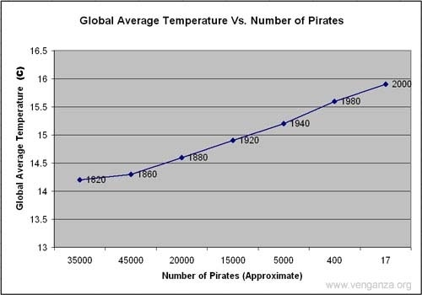

venganza.org

3. Living in a poor country increases penis size.
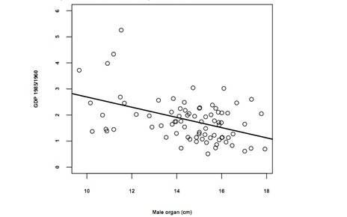

nerve.com

4. Eating organic food causes autism.
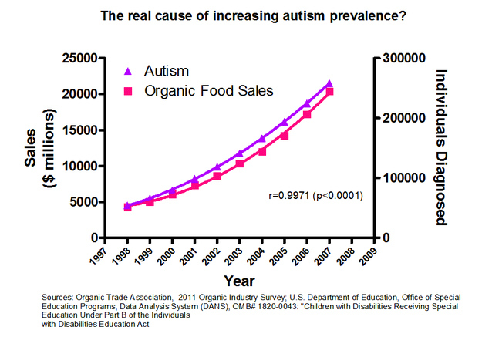

boingboing.net

5. M. Night Shyamalan makes bad movies because people don’t buy newspapers.
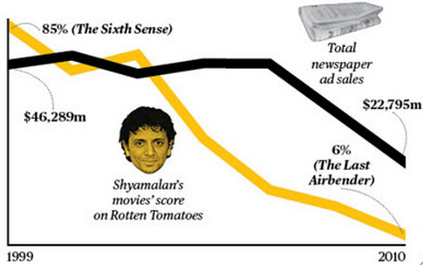

businessweek.com

6. Using Internet Explorer leads to murder.
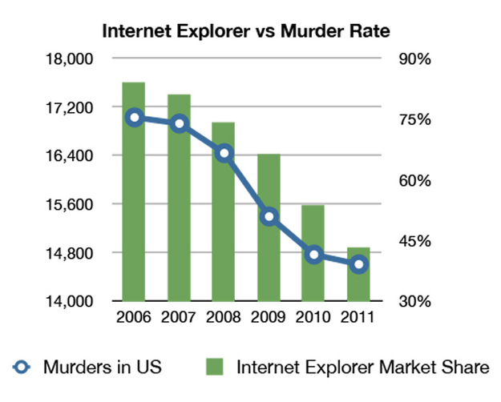

gizmodo.com

7. Mexican lemon imports prevent highway deaths.
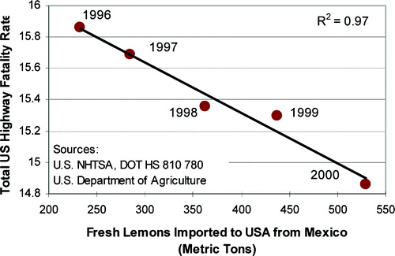

pubs.acs.org

8. Obesity caused the debt bubble.
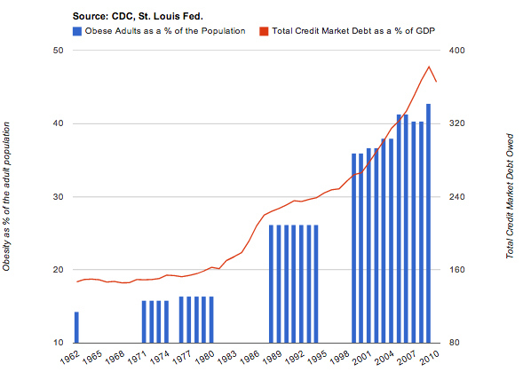

theburningplatform.com

9. Facebook caused the Greek debt crisis.
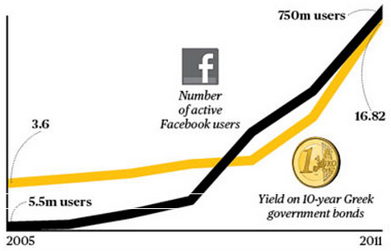

businessweek.com

10. Facebook also cancelled out the cholesterol-lowering effects of Justin Bieber.
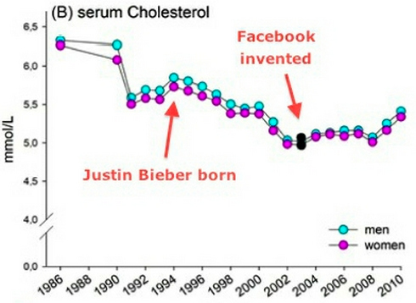

marksdailyapple.com
http://www.buzzfeed.com/kjh2110/the-10-most-bizarre-correlations

