SPURIOUS CORRELATIONS
Letters in Winning Word of Scripps National Spelling Bee
correlates with
Number of people killed by venomous spiders
Upload this image to imgur
 | 1999 | 2000 | 2001 | 2002 | 2003 | 2004 | 2005 | 2006 | 2007 | 2008 | 2009
Letters in Winning Word of Scripps National Spelling Bee  Letters (Scripps) | 9 | 8 | 11 | 12 | 11 | 13 | 12 | 9 | 9 | 7 | 9
Number of people killed by venomous spiders  Deaths (US) (CDC) | 6 | 5 | 5 | 10 | 8 | 14 | 10 | 4 | 8 | 5 | 6
Correlation: 0.8057

Marriage rate in New York
correlates with
Murders by blunt object
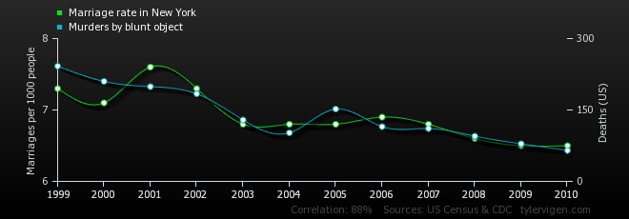
Upload this chart to imgur
 | 1999 | 2000 | 2001 | 2002 | 2003 | 2004 | 2005 | 2006 | 2007 | 2008 | 2009 | 2010
Marriage rate in New York  Marriages per 1000 people (US Census) | 7.3 | 7.1 | 7.6 | 7.3 | 6.8 | 6.8 | 6.8 | 6.9 | 6.8 | 6.6 | 6.5 | 6.5
Murders by blunt object  Deaths (US) (CDC) | 242 | 210 | 199 | 184 | 129 | 102 | 152 | 115 | 111 | 95 | 79 | 65
Correlation: 0.879854

Suicides by hanging, strangulation and suffocation
correlates with
Number of lawyers in North Carolina
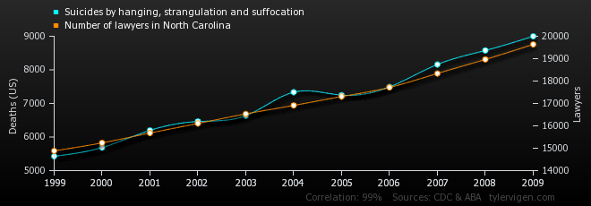
 | 1999 | 2000 | 2001 | 2002 | 2003 | 2004 | 2005 | 2006 | 2007 | 2008 | 2009
Suicides by hanging, strangulation and suffocation  Deaths (US) (CDC) | 5,427 | 5,688 | 6,198 | 6,462 | 6,635 | 7,336 | 7,248 | 7,491 | 8,161 | 8,578 | 9,000
Number of lawyers in North Carolina  Lawyers (ABA) | 14,881 | 15,239 | 15,678 | 16,105 | 16,534 | 16,912 | 17,308 | 17,717 | 18,339 | 18,966 | 19,637
Correlation: 0.993796

Honey producing bee colonies (US)
correlates with
Marriage rate in Vermont
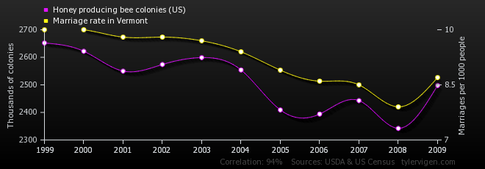
Upload this chart to imgur
 | 1999 | 2000 | 2001 | 2002 | 2003 | 2004 | 2005 | 2006 | 2007 | 2008 | 2009
Honey producing bee colonies (US)  Thousands of colonies (USDA) | 2,652 | 2,622 | 2,550 | 2,574 | 2,599 | 2,554 | 2,409 | 2,394 | 2,443 | 2,342 | 2,498
Marriage rate in Vermont  Marriages per 1000 people (US Census) | 10 | 10 | 9.8 | 9.8 | 9.7 | 9.4 | 8.9 | 8.6 | 8.5 | 7.9 | 8.7
Correlation: 0.937689

Math doctorates awarded (US)
correlates with
Uranium stored at US nuclear power plants
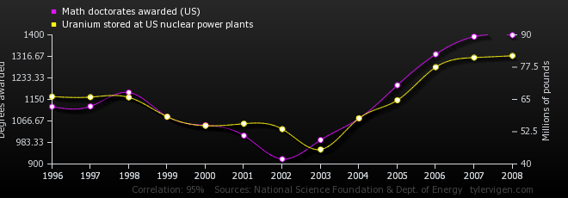
Upload this chart to imgur
 | 1996 | 1997 | 1998 | 1999 | 2000 | 2001 | 2002 | 2003 | 2004 | 2005 | 2006 | 2007 | 2008
Math doctorates awarded (US)  Degrees awarded (National Science Foundation) | 1,122 | 1,123 | 1,177 | 1,083 | 1,050 | 1,010 | 919 | 993 | 1,076 | 1,205 | 1,325 | 1,393 | 1,399
Uranium stored at US nuclear power plants  Millions of pounds (Dept. of Energy) | 66.1 | 65.9 | 65.8 | 58.3 | 54.8 | 55.6 | 53.5 | 45.6 | 57.7 | 64.7 | 77.5 | 81.2 | 81.9
Correlation: 0.952257

Sociology doctorates awarded (US)
correlates with
Deaths caused by anticoagulants
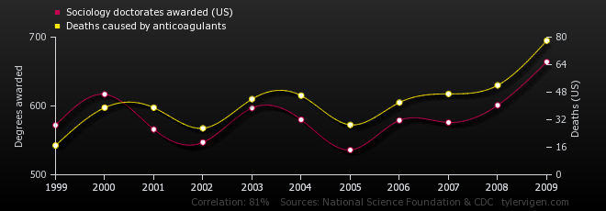
Upload this chart to imgur
 | 1999 | 2000 | 2001 | 2002 | 2003 | 2004 | 2005 | 2006 | 2007 | 2008 | 2009
Sociology doctorates awarded (US)  Degrees awarded (National Science Foundation) | 572 | 617 | 566 | 547 | 597 | 580 | 536 | 579 | 576 | 601 | 664
Deaths caused by anticoagulants  Deaths (US) (CDC) | 17 | 39 | 39 | 27 | 44 | 46 | 29 | 42 | 47 | 52 | 78
Correlation: 0.811086

Number of people who tripped over their own two feet and died
correlates with
Number of lawyers in Nevada
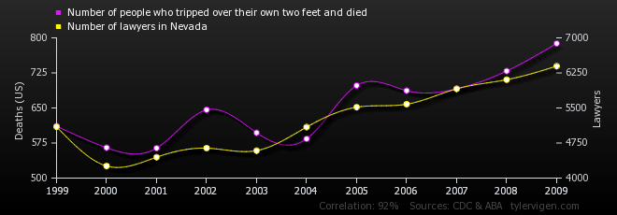
Upload this chart to imgur
 | 1999 | 2000 | 2001 | 2002 | 2003 | 2004 | 2005 | 2006 | 2007 | 2008 | 2009
Number of people who tripped over their own two feet and died  Deaths (US) (CDC) | 611 | 565 | 564 | 646 | 597 | 584 | 698 | 687 | 691 | 729 | 788
Number of lawyers in Nevada  Lawyers (ABA) | 5,098 | 4,257 | 4,447 | 4,640 | 4,587 | 5,091 | 5,517 | 5,580 | 5,909 | 6,105 | 6,395
Correlation: 0.920781

Bicyclists killed in collision with stationary object
correlates with
People who died by falling from a ladder
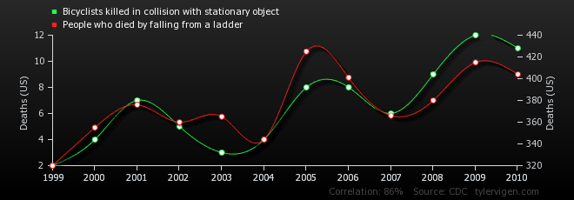
Upload this chart to imgur
 | 1999 | 2000 | 2001 | 2002 | 2003 | 2004 | 2005 | 2006 | 2007 | 2008 | 2009 | 2010
Bicyclists killed in collision with stationary object  Deaths (US) (CDC) | 2 | 4 | 7 | 5 | 3 | 4 | 8 | 8 | 6 | 9 | 12 | 11
People who died by falling from a ladder  Deaths (US) (CDC) | 320 | 355 | 376 | 360 | 365 | 344 | 425 | 401 | 366 | 380 | 415 | 404
Correlation: 0.857363

People who died by falling out of their bed
correlates with
Lawyers in Puerto Rico
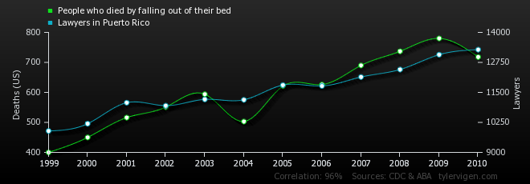
Upload this chart to imgur
 | 1999 | 2000 | 2001 | 2002 | 2003 | 2004 | 2005 | 2006 | 2007 | 2008 | 2009 | 2010
People who died by falling out of their bed  Deaths (US) (CDC) | 400 | 450 | 516 | 551 | 594 | 503 | 621 | 626 | 690 | 737 | 780 | 718
Lawyers in Puerto Rico  Lawyers (ABA) | 9,892 | 10,195 | 11,071 | 10,947 | 11,209 | 11,191 | 11,805 | 11,767 | 12,142 | 12,454 | 13,071 | 13,282
Correlation: 0.957087

Number of people killed by dogs
correlates with
Online revenue on Black Friday
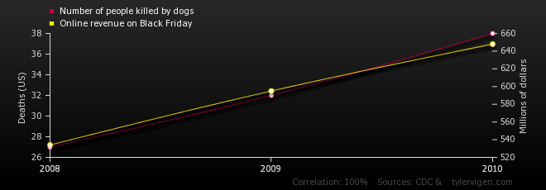
Upload this chart to imgur
 | 2008 | 2009 | 2010
Number of people killed by dogs  Deaths (US) (CDC) | 27 | 32 | 38
Online revenue on Black Friday  Millions of dollars () | 534 | 595 | 648
Correlation: 0.995685

Apple iPhone sales
correlates with
People who died by falling down the stairs
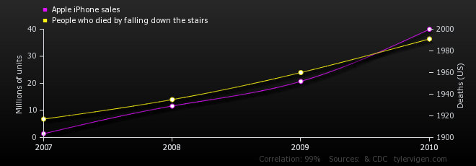
Upload this chart to imgur
 | 2007 | 2008 | 2009 | 2010
Apple iPhone sales  Millions of units () | 1.39 | 11.63 | 20.73 | 39.99
People who died by falling down the stairs  Deaths (US) (CDC) | 1,917 | 1,935 | 1,960 | 1,991
Correlation: 0.994751

Marriage rate in Wyoming
correlates with
Domestically produced passenger cars sold (US)
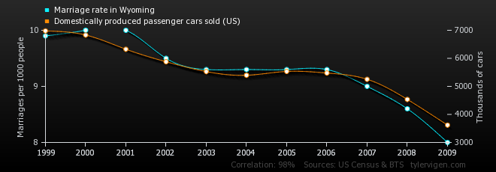
Upload this chart to imgur
 | 1999 | 2000 | 2001 | 2002 | 2003 | 2004 | 2005 | 2006 | 2007 | 2008 | 2009
Marriage rate in Wyoming  Marriages per 1000 people (US Census) | 9.9 | 10 | 10 | 9.5 | 9.3 | 9.3 | 9.3 | 9.3 | 9 | 8.6 | 8
Domestically produced passenger cars sold (US)  Thousands of cars (BTS) | 6,979 | 6,831 | 6,325 | 5,878 | 5,527 | 5,396 | 5,533 | 5,476 | 5,253 | 4,535 | 3,619
Correlation: 0.976233

Number of people who died by being hit by sports equipment
correlates with
Online revenue on Thanksgiving
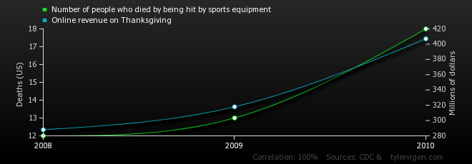
Upload this chart to imgur
 | 2008 | 2009 | 2010
Number of people who died by being hit by sports equipment  Deaths (US) (CDC) | 12 | 13 | 18
Online revenue on Thanksgiving  Millions of dollars () | 288 | 318 | 407
Correlation: 0.996075

Divorce rate in Texas
correlates with
Number of lawyers in the Northern Mariana Islands
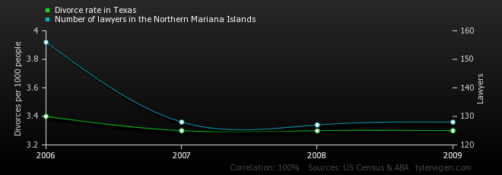
Upload this chart to imgur
 | 2006 | 2007 | 2008 | 2009
Divorce rate in Texas  Divorces per 1000 people (US Census) | 3.4 | 3.3 | 3.3 | 3.3
Number of lawyers in the Northern Mariana Islands  Lawyers (ABA) | 156 | 128 | 127 | 128
Correlation: 0.999447

Per capita consumption of cheese (US)
correlates with
Total revenue generated by golf courses (US)
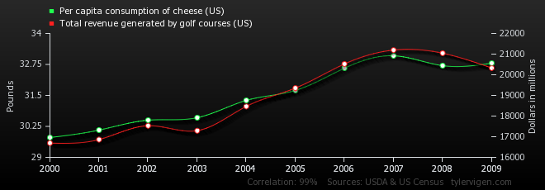
Upload this chart to imgur
 | 2000 | 2001 | 2002 | 2003 | 2004 | 2005 | 2006 | 2007 | 2008 | 2009
Per capita consumption of cheese (US)  Pounds (USDA) | 29.8 | 30.1 | 30.5 | 30.6 | 31.3 | 31.7 | 32.6 | 33.1 | 32.7 | 32.8
Total revenue generated by golf courses (US)  Dollars in millions (US Census) | 16,692 | 16,862 | 17,533 | 17,291 | 18,469 | 19,356 | 20,523 | 21,195 | 21,044 | 20,326
Correlation: 0.989705

Per capita consumption of whole milk (US)
correlates with
Divorce rate in Washington
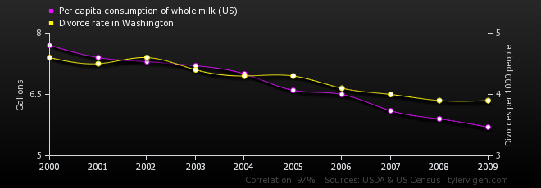
Upload this chart to imgur
 | 2000 | 2001 | 2002 | 2003 | 2004 | 2005 | 2006 | 2007 | 2008 | 2009
Per capita consumption of whole milk (US)  Gallons (USDA) | 7.7 | 7.4 | 7.3 | 7.2 | 7 | 6.6 | 6.5 | 6.1 | 5.9 | 5.7
Divorce rate in Washington  Divorces per 1000 people (US Census) | 4.6 | 4.5 | 4.6 | 4.4 | 4.3 | 4.3 | 4.1 | 4 | 3.9 | 3.9
Correlation: 0.9709

Divorce rate in Maine
correlates with
Per capita conpumption of margarine
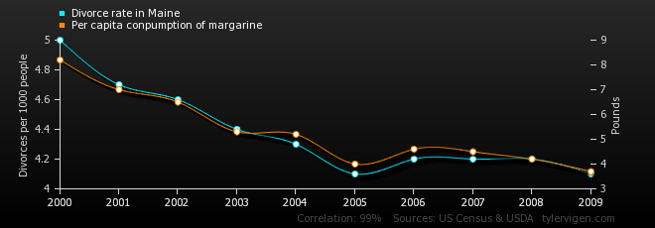
Upload this chart to imgur
 | 2000 | 2001 | 2002 | 2003 | 2004 | 2005 | 2006 | 2007 | 2008 | 2009
Divorce rate in Maine  Divorces per 1000 people (US Census) | 5 | 4.7 | 4.6 | 4.4 | 4.3 | 4.1 | 4.2 | 4.2 | 4.2 | 4.1
Per capita conpumption of margarine  Pounds (USDA) | 8.2 | 7 | 6.5 | 5.3 | 5.2 | 4 | 4.6 | 4.5 | 4.2 | 3.7
Correlation: 0.992558

Money spent on pets (US)
correlates with
Number of lawyers in California
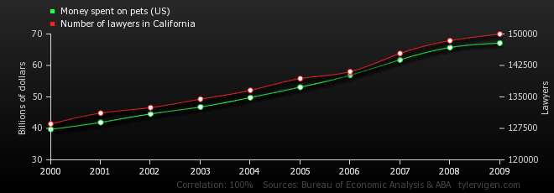
Upload this chart to imgur
 | 2000 | 2001 | 2002 | 2003 | 2004 | 2005 | 2006 | 2007 | 2008 | 2009
Money spent on pets (US)  Billions of dollars (Bureau of Economic Analysis) | 39.7 | 41.9 | 44.6 | 46.8 | 49.8 | 53.1 | 56.9 | 61.8 | 65.7 | 67.1
Number of lawyers in California  Lawyers (ABA) | 128,553 | 131,139 | 132,452 | 134,468 | 136,571 | 139,371 | 141,030 | 145,355 | 148,399 | 149,982
Correlation: 0.998386

Number of people killed by misusing a lawnmower
correlates with
UK: Military defense spending
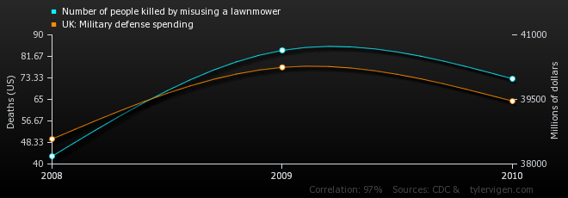
Upload this chart to imgur
 | 2008 | 2009 | 2010
Number of people killed by misusing a lawnmower  Deaths (US) (CDC) | 43 | 84 | 73
UK: Military defense spending  Millions of dollars () | 38,579 | 40,246 | 39,461
Correlation: 0.974155

Marriage rate in Virginia
correlates with
Per capita consumption of whole milk (US)
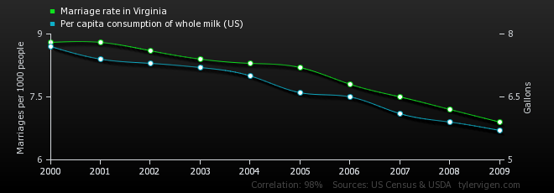
Upload this chart to imgur
 | 2000 | 2001 | 2002 | 2003 | 2004 | 2005 | 2006 | 2007 | 2008 | 2009
Marriage rate in Virginia  Marriages per 1000 people (US Census) | 8.8 | 8.8 | 8.6 | 8.4 | 8.3 | 8.2 | 7.8 | 7.5 | 7.2 | 6.9
Per capita consumption of whole milk (US)  Gallons (USDA) | 7.7 | 7.4 | 7.3 | 7.2 | 7 | 6.6 | 6.5 | 6.1 | 5.9 | 5.7
Correlation: 0.979792

