Case study 1st Draft – the narrative part

Title
Good teamwork, a proper leadership during the Covid pandemic on board

Executive Summary
This case study is about how the situation on board the ship was managed when a few of the crew members were infected with Covid and the others were exhausted by the large volume of work. The most affected of this virus were the AB, the Captain, the Chief Engineer, the 3rd Engineer, one motorman and two cadets. With the crew decimated by the Covid infection and the Puerto Rico Coast Guard’s refusal to help, the ship was forced to leave the US territorial waters and to sail 18 days back to Europe. Even though they were exhausted, due to their professionalism and experience, the rest of the crew managed to sail safely to Rotterdam.

The narration

The scenery
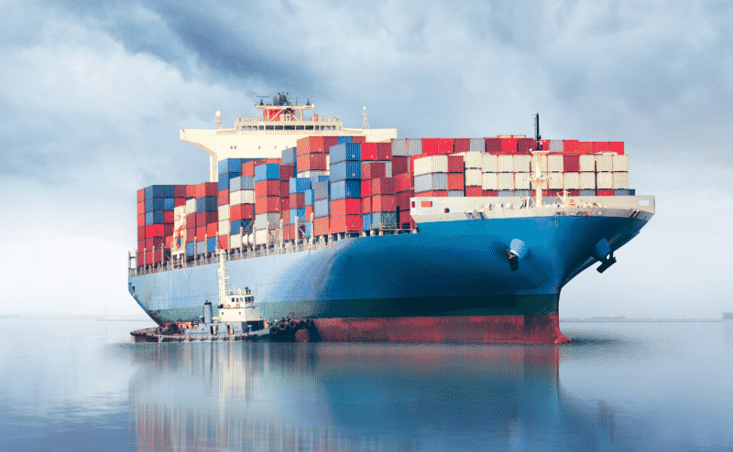
This is a common thing today but at the beginning of the pandemic it was an example of human interaction and survival at sea. Our narrator is Razvan. Razvan remembers one of his voyages as a 3rd Officer back in 2020 on board a container ship.
The ship was built in 2011, so it was like 9 years old. Not so old. At that time, the ship was fully loaded with containers and was carrying dangerous goods, too.
The incident happened in the spring of 2020 and Razvan recalls and describes those moments: “we departed from Panama and the route was to Europe, so we had to cross the Atlantic Ocean”.

Introducing the people involved
The 3rd Officer
Today, Razvan is a third officer. He is 27 years old and he holds a bachelor’s degree from Constanta Maritime University and now he is studying for his master’s degree at the same university. He’s had three contracts as deck cadet and four contracts as third officer. At the time of the incident, he had been on board for three months and he knew his crew well, being on good terms with everyone.
He was not the only Romanian on board. There were two more Romanians on board the ship, the second officer and one deck cadet.
The Captain
The Captain was a Danish woman, aged about 43 years, single and without children. She had no emotional factors to distract her from her work. Razvan remembers that “she was very, very professional and she was friendly. I can say, the only problem she had was the food. But the rest, if you were behaving like you should behave, if you used to be a professional guy, she was friendly with everyone not giving hard time to anyone.”
In her work she gave a touch of professionalism and devotion. For example, “during the search and rescue, the Captain used to be on the bridge most of the time, she used to take very little rest, like 4 hours,…, but the rest of the time she was awake, and if not on the bridge, she was in her cabin waiting for our phone. She was really helpful.” told us Razvan.
She respected her crew and cared about their health. Razvan recalls that “even though she was sick, and she was the second most serious case after the AB whom we disembarked, she used to call me on the bridge and sometimes ask about the people. I think she was… even in this situation, she was concerned about the health of the crew”.
Because she was always calm and gave clear instructions, showing professionalism and experience, the entire crew believed in her and respected her.
The Chief Engineer
The Chief Engineer was a 65 years-old Danish man with a lot of experience on board, 30 years of experience on sailing. He was that kind of guy who didn’t follow the rules or any guidance. He had his own opinion. “You know that old people sometimes are difficult to convince to do things right, to follow the company procedures… I think he had his own standards.”
Even though he did not interact with him in his spare time, Razvan could observe his behavior. “In the free time he was friendly at some point, like if he had an opinion which was contradicting yours, you had to accept his opinion, otherwise he was not friendly anymore and in the engine room he was like that…he used to pass all the things to the 2nd Engineer and he was like out of problem, except on the critical times - if they had a real problem in the engine room then he used to get involved too, but otherwise it was the 2nd Engineer leading the engine crew, with the engine problems.”
The Chief Officer and the Second Engineer
They were both Ukrainians. They were calm and peaceful.
After the Covid infection of some crew members, the 2nd Engineer had to deal with all the situations in the engine room and the Chief Officer took the charge of the bridge under a minimal guidance of the Captain.
As Razvan remembers, the Chief Officer “had everything under control. He never panicked. Or at least he was not showing to us that he’s panicked or something like that. So, during this whole situation, he managed to keep everything smooth and to take care also of the infected people on board. He was professional.” The Chief Officer is also the doctor on board, so he is the one who is giving medicines and signs for this or any treatment if you need and at the same time he was taking care of the ship, for maneuvering the ship.
Even if the rest of the time, the 2nd Engineer was calm, in those moments he was stressed by so much fatigue. “You could see on his face that he was tired and he was asking for help. He had with him some ABs from deck just to try to do his job easier, but it’s a difference when you have an AB with you in the engine room and when you have an engineer with you. He had to take care of everything”, Razvan tells.
The rest of the crew
“The rest of the crew was quite panicked even though we were trying to maintain everything smooth. All the officers were instructed not to give any reasons to the ratings to panic more.” This was a measure taken to protect them and not scare them more, considering that the first infected person was among them, one of the AB, a Filipino.
The officers were more or less professional, but all of them were quite stressed. The most stressed by the situation was the 3rd Engineer, a Chinese guy who started to panic the other telling everyone that they would all get infected and they would die.
The entire crew panicked and feared they would become infected. This fear was general, even if some did not show it.
The crew consisted of 5 nationalities: Danish, Ukrainians, Romanians, Chinese and Filipinos. Even if there were different nationalities, no one felt excluded because the official language on board the ship was English and everyone spoke it quite well.

The challenge
The incident consists of difficulties encountered on board the ship after a part of the crew was infected with Covid and were isolated in their own cabins and the rest of the crew had to take over all the tasks of the others.
The ship’s route was to cross the Atlantic Ocean from Panama to Europe. As Razvan remembers, that was not an easy route. “We had two ports a day or one port, it depends. But mainly the average was one port in one day. And we had had five or six ports there and after these ports in Caribbean area, the route was to proceed to the Mediterranean Sea and there we would have another three ports. And that was the route, back and forth America to the Mediterranean Sea, to Europe.”
They were 180 miles off The Caribbean when they received a distress alert. It was a man overboard from another ship who was declared missing. So, immediately they got involved in that search and rescue operation being coordinated by Puerto Rico Coast Guard. When they arrived on the operation scene it was late at night, almost 11 p.m. and the Captain ordered for all the crew to be on deck. Razvan told us that “we established the plan how everyone would be distributed and we started the search and rescue, for specific pattern, and from that day our fatigue began, because for four days and four nights the crew almost didn’t get any rest. So, everyone was exhausted.”
At the beginning of these days of search and rescue operation, one of Razvan’s crew members, the AB, reported some mild symptoms which were related to Covid and he was put under investigation. Because the SAR operation didn’t reveal any results and because the AB’s health had seriously deteriorated, they stopped the search and rescue operation and focused on the health of the crew.
The situation became even worse than before because after the US Coast Guard took the AB by helicopter to take him to the hospital, the US Coast Guard forced them to pick up the anchor and leave US territorial waters.
From there, they had to sail all the way back to Europe, for like 18 days, on full speed. It was the only option they had.

The dilemma
The situation on board continued to worsen and on the day of departure towards Europe another five crew members were infected with Covid. Razvan remembered that “immediately, the Captain made a meeting on the bridge with all the crew including the infected ones who were separated from us in a corner. The Captain was one of them.” At that meeting we discussed the procedures to be followed and informed the Company of the situation on board the ship. A radio medical advice was involved, but at that time, at the beginning of the pandemic, no one had a clear idea of what Covid meant”.
The new infected members were: the Captain, the Chief Engineer, the 3rd engineer, one motorman and two cadets (one deck cadet and one engine cadet). They were all isolated and not allowed to go outside.
Razvan thinks that the first person who contacted the virus and did not report symptoms and spread it was the Chief Engineer. His opinion is based on the fact that half of the engine crew was infected. And he was the only one the Captain spoke to before he fell ill. He was the only one who didn’t respect the rules. “In New York, we had clear instructions that no one is coming inside the accommodation except the crew, but in New York he accepted this bunker team to discuss with him and all these things, the arrangements for bunkerage. And he was not following any guidance.” To all these actions we can add his attitude and his previous behavior on board.
In these conditions, the rest of the crew had to take over the duties of the sick and isolated.
The 2nd Engineer was alone in the engine room and he had to deal with all the situations and the Chief Officer took the charge of the bridge under minimal guidance of the Captain, because she felt very bad. Being the doctor on board, the Chief Officer was the only one who was allowed to take contact with the infected people. He was the only one taking care of them. He was giving medicine, communicating with the shore and with the radio medical advice. “He was a quite experienced Chief mate” tells Razvan.
As they headed for the Mediterranean Sea, Razvan (the 3rd Officer) and the 2nd Officer helped the Chief Officer with the watch, they used to do 6-on 6-off to give him some rest, so that he could focus on other tasks. But sometimes he was taking also his watch, just to leave time to rest to the 3rd Officer and the 2nd Officer.
The 2nd Engineer, who was usually calm, this time was stressed due to the accumulated fatigue and asked for help. He had a few ABs from deck with him who were trying to make things easier for him. Even so, he had to take care of everything in engine room. He had to do most of the maintenance. But he was lucky because the ship being quite good did not raise any problems in the engine room even if they were going at full speed.

The resolution
Just before they entered the Mediterranean Sea, before they crossed the Gibraltar no one wanted them in their territorial waters because they had some cases of Covid infection on board. In that period no one had a clear idea how to manage this kind of situation. Everything was at the beginning with the Covid pandemic.
The only port that offered them help and accepted them was Rotterdam, a port out of their schedule.
Razvan remembers “They told us:
“Come to us! We will take care of you!”
That was the saving moment when the fatigue accumulated from the crew’s 18 days of continuous work was about to end, as well as the suffering of the infected people who needed specialized monitoring.
The entire period, the team “worked like a clock. Everyone knew exactly his place and what to do and the infected crew just followed what they had to do, just to stay in their cabins and the rest of us, the healthy ones, we did everything from navigation side, from engine side, to bring the ship into port safely. And we did that. The work on deck was minimal because we were short of people and we had to focus on arriving safely.” this is how Razvan describes how they acted to reach the port safely with the ship.

Even before they arrived in Rotterdam, they were assaulted by emails and everyone was willing to help them. In port they were taken over by the pilot who looked like an astronaut in his medical protective equipment. The pilot, knowing their situation, expected to find some zombies on board: people not able to attend to their station.
* * *
- Describe the main emotions manifested by the characters in this case study. Separate the positive emotions from the negative ones.

- Is there a real team on board? What are the elements of characterizing a team that you have identified in this case study?

- Is there a real conflict on board? Identify all conflicting situations if any and suggest solutions of your own.

