Scheme 1: The Analytical Structure of the Model
Charisma
Formal Rationality
The operational requirements of social organization
Internalized code-orientations
Practical / Substantive rationality
Discursive manifestations of culture:
Narratives/Rituals/Performances/social dramas

Actual networks of social power
Ideological networks of power - Theoretical rationality
Institutional ground rules
Ethical orders
Constitutive goods
Scheme 2: The traditional amoral familism

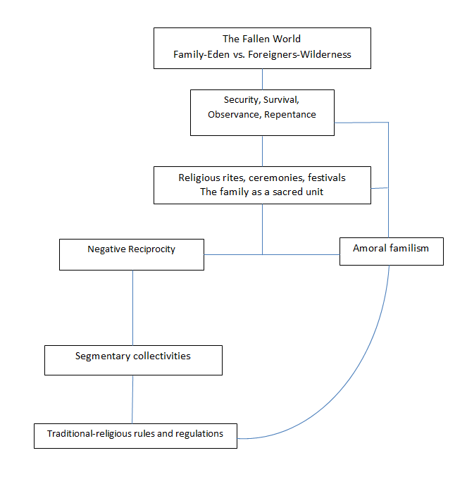

Scheme 3: Mythical Collectivism

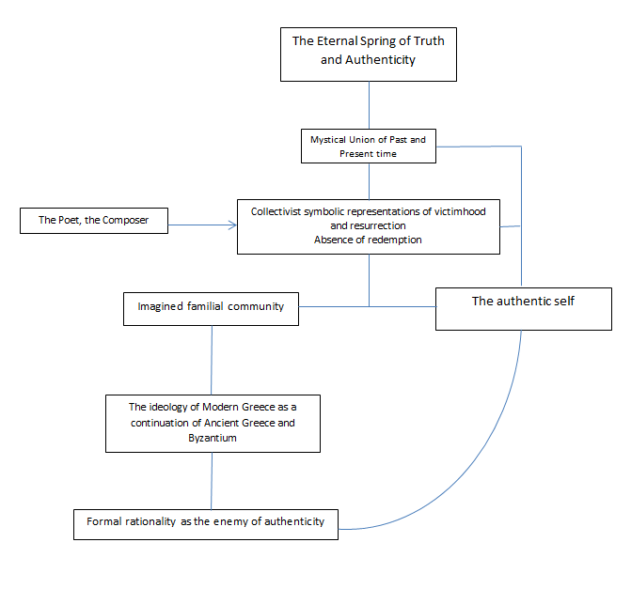

Scheme 4: Secular anarchic individualism

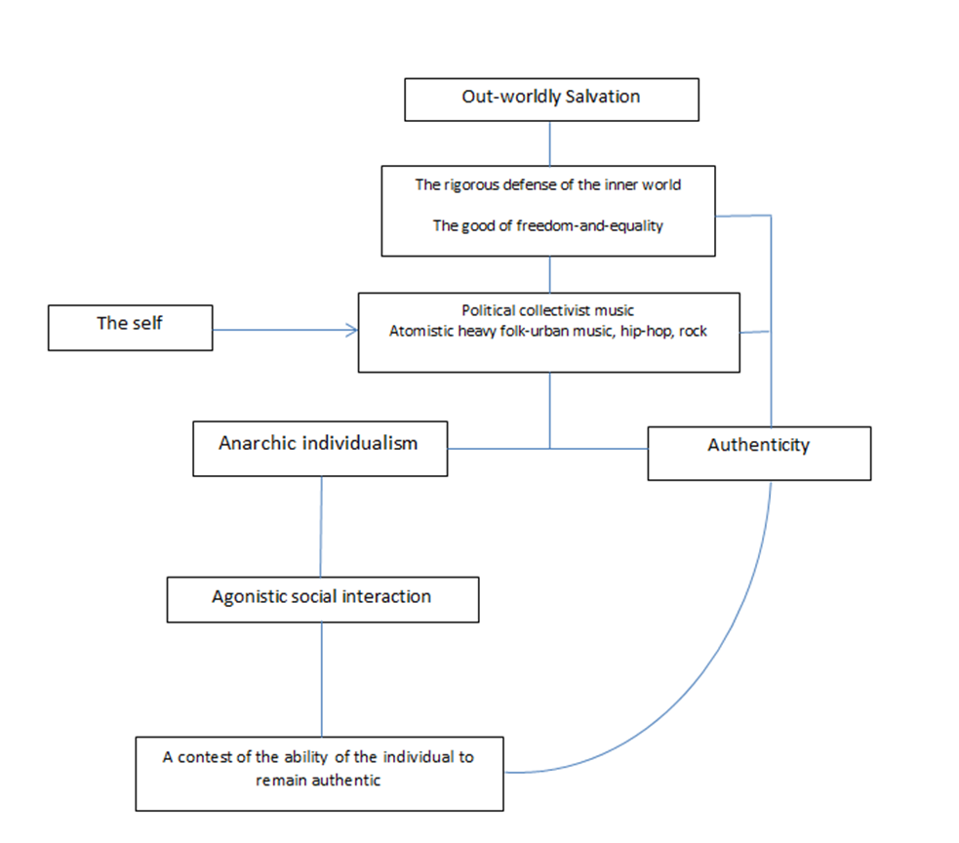

Scheme 5: Clientelism

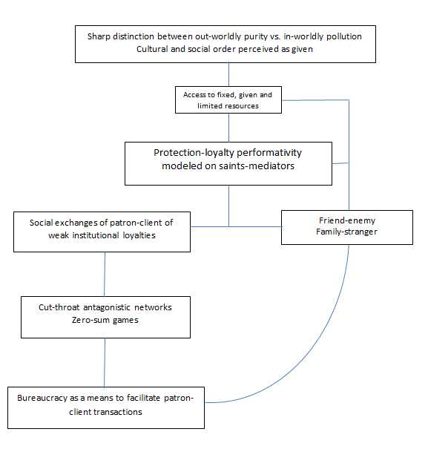

Scheme 6: The Greek Orthodox Salvationist Model

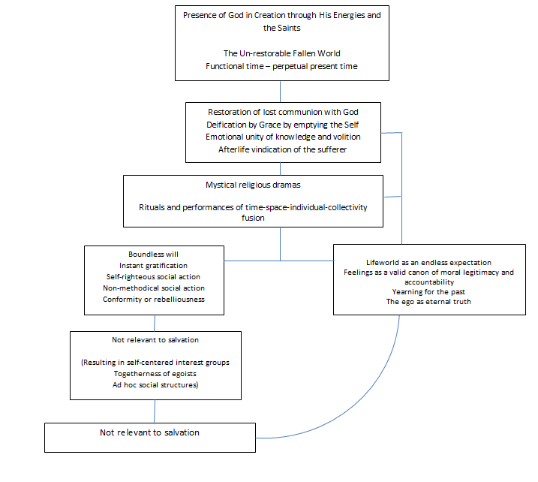

Scheme 7: The symbolic structure of the Metapolitefsis’ Civil Religion

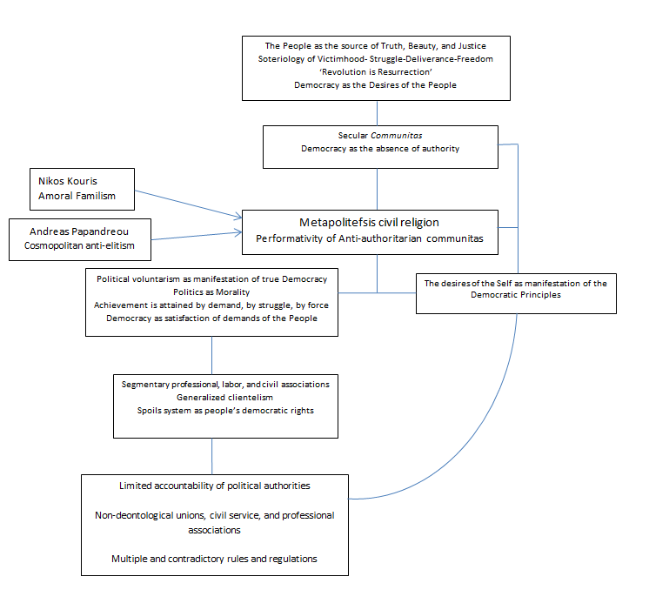

Scheme 8. The Metapolitefsis’ Cultural System

