Bridging 2D Animation and Virtual Reality: Chained Diegetic Displays, Gaze-Driven Montage, and Discoverability
Stefania Symeonidou and Anastasios Theodoropoulos
Department of Performing and Digital Arts, University of the Peloponnese, Nafplio, Greece
ttheodor@uop.gr
Abstract
The animation industry's shift toward real-time engines raises a distinctive challenge: how to carry the expressivity of hand-drawn 2D animation into the interactive space of Virtual Reality without the overhead of full CGI production, and how to make such work discoverable beyond algorithmic gatekeepers. This paper presents a hybrid pipeline that remediates stylised 2D animation into standalone WebXR, together with a spatial narrative framework read through Schell's Elemental Tetrad, Jenkins' narrative architecture and Slater's account of presence. Drawing on the two-screen animated work The Cigar(t) as a case study, we introduce Chained Diegetic Displays, in which the cinematic cut is relocated to the viewer's gaze, and develop mechanics, gaze-directed pacing, spatial audio signposting, a gaze-driven branching ending, and portal transitions, that turn viewing into an active, measurable montage. We argue that attention itself can function as a model of discoverability suited to independent creators, and that the instrumented artefact provides the basis for an empirical user study.
Keywords: 2D Animation; Virtual Reality; Spatial Narrative; Game Mechanics; Discoverability
1. Introduction
The animation industry stands at a point of convergence where real-time game engines increasingly displace traditional rendering pipelines, folding the grammar of interactive media into a craft historically governed by the frame and the cut. For hand-drawn 2D animation this convergence poses a distinctive problem: how can the expressive, gestural qualities of the medium survive translation into the interactive, user-centred space of Virtual Reality (VR), rather than being flattened into video projected onto a virtual wall? The question is not only aesthetic but economic. For independent creators and small studios, the immersive turn has largely meant the prohibitive overhead of full 3D production, while the platforms that distribute flat animation increasingly mediate audiences through algorithmic gatekeeping [1].
Existing responses tend toward two poles. One preserves 2D fidelity by importing finished footage into a virtual room, gaining immersion but forfeiting the spatial, participatory logic that distinguishes VR from cinema. The other commits to volumetric or fully modelled production, achieving spatiality at a cost that excludes most independent practice. What is missing is a principled account of the VR animation as spatial narrative, an environment in which story is embedded in navigable space [2], that remains technically lightweight, and that treats the resulting attentional economy as a matter of discoverability rather than an afterthought.
This paper contributes to such an account on three levels. First, a hybrid production pipeline that remediates [3] stylised 2D animation into browser-based WebXR, sidestepping the rigging and rendering burden of CGI. Second, a spatial narrative framework that reads the experience through Schell's Elemental Tetrad [4], couples it with Jenkins' narrative architecture [2] and Slater's account of presence and the plausibility illusion [5], and instantiates it through a mechanic we term Chained Diegetic Displays, in which the cinematic cut becomes an act of the viewer's own gaze. Third, a reframing of discoverability as an embodied, measurable practice of attention, positioned as a viable alternative to VOD gatekeeping for independent creators. Our case study is The Cigar(t), a two-screen animated work whose narrative unfolds across parallel displays [6].
We pursue three questions.
- RQ1: Can a 2D-to-WebXR pipeline preserve the expressivity of hand-drawn animation while rendering its story spatial and interactive?
- RQ2: Which game-design mechanics convert viewing across multiple diegetic displays into an active, gaze-driven montage?
- RQ3: Can attention itself operate as a model of discoverability suited to independent creators beyond algorithmic intermediaries?
The remainder of the paper develops the theoretical framework (§2), details the hybrid pipeline and WebXR remediation (§3), analyses the mechanics of The Cigar(t) (§4), and draws the connection from attention to discoverability (§5), before concluding with limitations and future work, including a planned user study (§6).
2. Theoretical Framework
2.1 Remediation and transmedia worldbuilding
The migration of 2D animation into VR is best understood not as transfer but as remediation: the representation of one medium within another, whereby the older form is at once honoured and refashioned by the logic of the new [3]. Within this frame, importing finished 2D footage into a virtual room is the weakest case of remediation, the new medium merely hosts the old. A stronger reading treats the virtual environment as an autonomous node in a transmedia world, where each medium makes a distinct experiential contribution rather than duplicating the same content across platforms [7]. Our pipeline pursues this stronger reading: the VR scene is not a projection surface but a reconstituted space in which the animated diegesis is re-authored for a viewer who can look, turn and choose.
2.2 Animation as narrative architecture: the Elemental Tetrad and spatial montage
In cinema and 2D animation, rhythm and plot are governed through montage and the management of time [8]. When content migrates to VR, the governing principles shift toward game-design logic. We analyse The Cigar(t) through Schell's Elemental Tetrad, which holds Aesthetics, Story, Technology and Mechanics in balance so that no pillar overwhelms the experience [4]. Under this lens, narrative is carried by space rather than by the edit: to follow the story the viewer must physically reorient, and montage is redistributed from the cut to the body. This resonates with Jenkins' notion of narrative architecture, in which story is embedded in the design of navigable space [2], and with Pearce's account of narrative environments as authored worlds that stage meaning spatially [9]. It is sharpened by Manovich's concept of spatial montage — the juxtaposition of simultaneous images within a single visual field — and by his database logic, in which a work is experienced as one traversal among many possible orderings of its elements [10]. Chained Diegetic Displays operationalise exactly this: two simultaneous streams whose ordering into a sequence is performed anew by each viewer's gaze.
2.3 Presence, plausibility, and stylised immersion
A reasonable objection is that non-photorealistic 2D content cannot sustain immersion in a 3D environment. Slater's distinction answers it: presence comprises the Place Illusion (being there) and the Plausibility Illusion (that events are really happening), and the latter does not depend on visual realism but on the environment responding coherently to the user [5]. Immersion, on this view, is a function of consistency and agency rather than fidelity, a position anticipated by Murray's account of immersion, agency and transformation as the core pleasures of digital narrative [11]. In our pipeline, spatial audio signposting and the responsive behaviour of the chained displays sustain plausibility even under deliberately abstract, hand-drawn aesthetics, allowing stylisation to become an expressive asset rather than an immersive liability.
2.4 Discoverability and platformisation
Finally, the framework situates the work within the political economy that governs how animation is seen. Platformisation has multiplied the availability of animated works while delegating their circulation to algorithmic gatekeepers whose ranking logics narrow what audiences actually encounter, making discoverability a policy and market concern in its own right [1]. Prior work on 2D animation in 360° and immersive formats has shown the aesthetic potential of the migration [12], but has largely left its distributive dimension unexamined. We connect the two: if VR animation can be produced cheaply and delivered as a lightweight, browser-based experience, then discoverability need not be surrendered to platform intermediaries. Reframed through the mechanics developed here, discoverability becomes an attentional rather than a purely algorithmic phenomenon — a shift we develop in §5. Taken together, these four strands position The Cigar(t) as a case in which remediated 2D animation, organised as spatial montage and stabilised by plausibility rather than realism, models a creator-controlled economy of attention and discovery.
3. Hybrid Pipeline and WebXR Remediation
3.1 From 2D authoring to a first VR proof-of-concept
The pipeline begins in the idiom of the medium it seeks to preserve. The animation for The Cigar(t) was drawn frame-by-frame in Procreate, retaining the hand-gestural line, the limited palette and the deliberate pacing of traditional 2D practice. A first migration into VR was undertaken in the authoring application Tvori, where the animation was staged on parallel displays within a virtual set and captured for viewing [6]. This stage functioned as a proof-of-concept and, equally, as a source of design knowledge: running on a tethered PC-VR configuration, it exhibited intermittent connection instability and remained a stationary, non-distributable experience. These limitations, rather than being incidental, motivated the remediation that follows, clarifying two requirements for independent practice: robustness without a tethered host, and a form that can actually circulate.
3.2 Remediation to standalone WebXR
The second stage re-authors the work in WebXR using the A-Frame framework [13], remediating [3] the 2D material into an immersive scene that runs directly in the headset's browser. Three properties follow, each consequential for the argument of this paper. First, portability: the experience is delivered as a single, self-contained document with no external dependencies, so it runs offline and is not contingent on network conditions in an exhibition setting. Second, distributability: because it is a browser-based artefact, it is playable from a shared URL or through open channels, without passing through the intermediaries of flat video-on-demand, a point we develop in §5. Third, fidelity at low cost: by treating the finished 2D animation as video textures on planar displays within the scene, the pipeline sidesteps the rigging and rendering overhead of CGI production while preserving the drawing exactly as authored (Fig. 1).
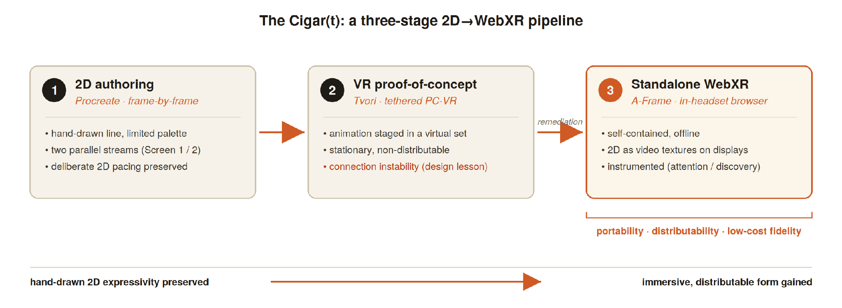
Fig. 1. The three-stage 2D-to-WebXR pipeline: hand-drawn authoring (Procreate), a first VR proof-of-concept (Tvori), and standalone WebXR remediation (A-Frame).
3.3 Synchronisation and spatial staging
The narrative depends on two displays behaving as one system — the “conversation” between screens described in the source work. The two streams (H.264, 1280×720, 24 fps) are staged on a pair of angled displays flanking the viewer, over a darkened platform anchored by a single warm light source that echoes the diegetic ember (Fig. 2). Because the streams differ slightly in length, independent looping would drift them out of phase; the framework therefore drives both from a single master clock, the longer clip, restarting both simultaneously at each loop so that they re-lock at the start of every cycle. Attention is carried across the space by spatial audio signposting: at each narrative hand-off, a positional cue sounds from the direction of the incoming display, reinforced by a visual pulse and, when the relevant screen lies outside the field of view, an on-screen directional indicator. The hand-off points themselves were identified in consultation with the animator.
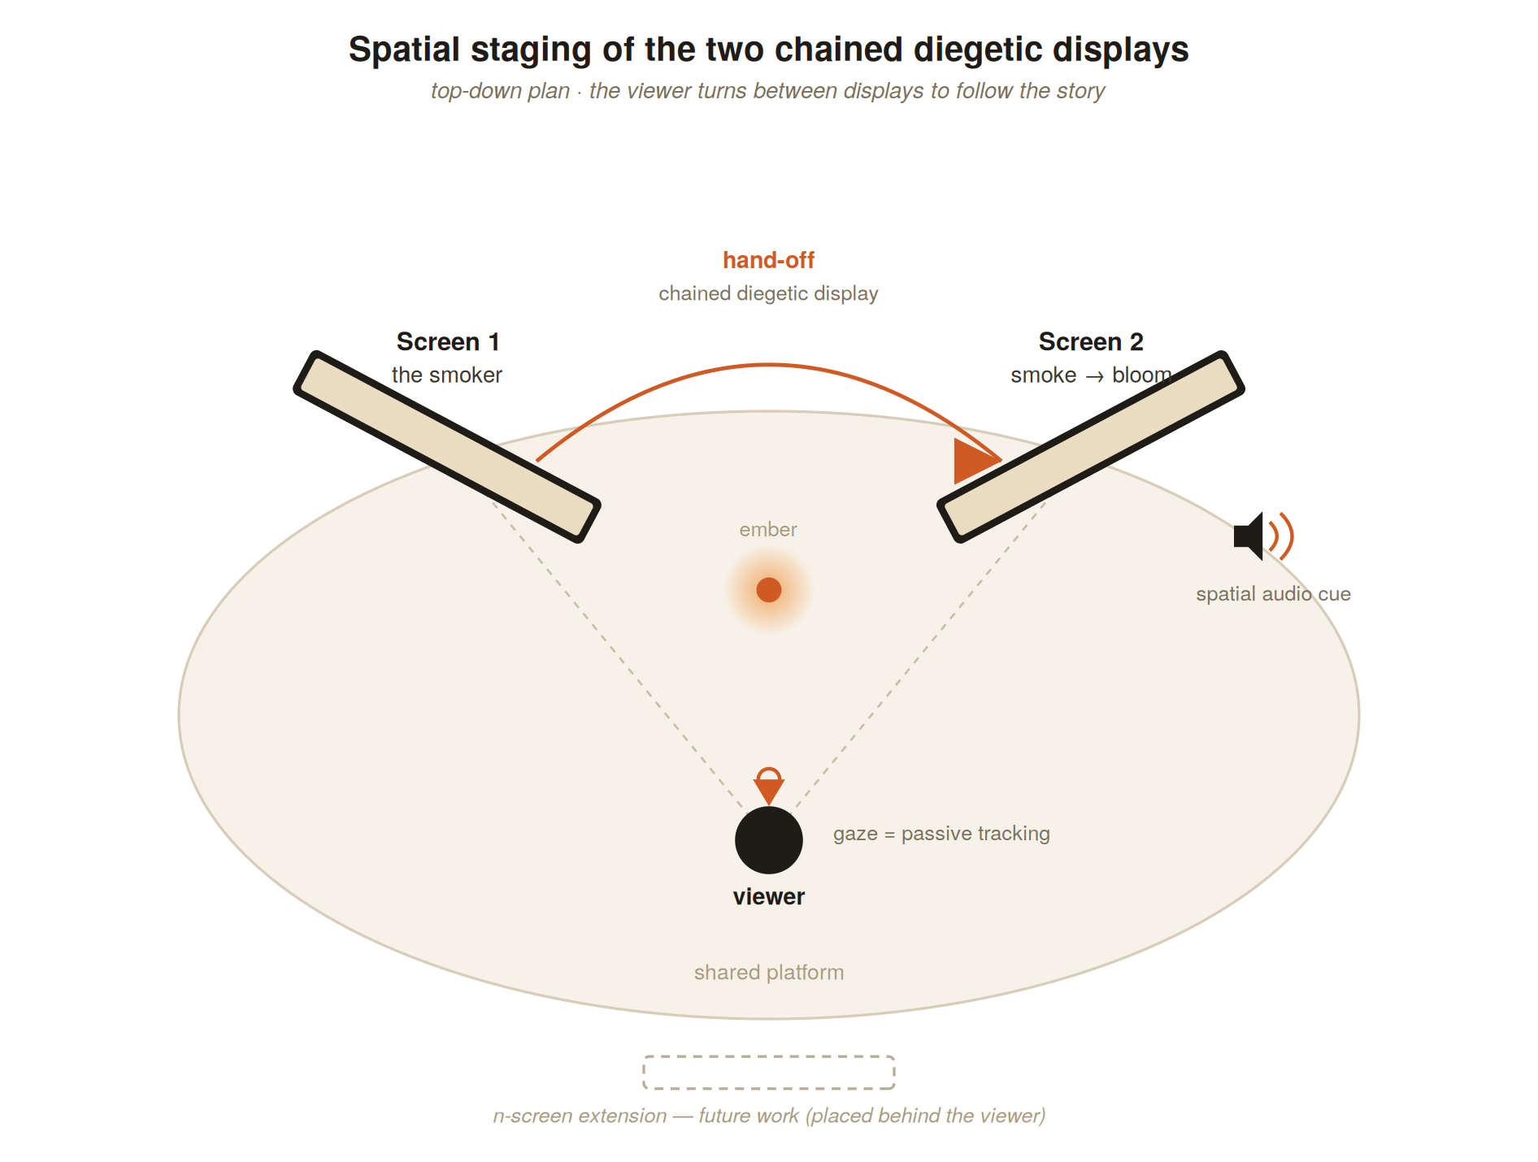
Fig. 2. Spatial staging of the two chained diegetic displays around the viewer, with narrative hand-off, spatial audio signposting, and the n-screen extension reserved for future work.
3.4 Interaction model and instrumentation
A central design decision separates two functions that naive gaze interaction tends to conflate. Looking is passive: a head-centred reticle registers which display the viewer attends to, driving pacing, signposting and, crucially, the work's branching, without ever triggering a transition. Entering a display for an immersive close-up is a deliberate act, bound to an explicit control (a keyboard key at the desktop, the controller trigger on the headset). This separation preserves free, unforced viewing while retaining agency as an option rather than an accident. On this basis the framework implements gaze-as-choice: near the close of the piece, the viewer's accumulated attention determines which of two authored endings is rendered, the divergent, “no-bloom” ending being supplied as a short additional clip substituted at the branch point. Finally, the artefact is instrumented: each session logs the distribution of attention across displays and the hand-offs caught in time, exportable as structured data. This instrumentation is what allows the experiential claims of §5 to be stated as measures rather than assertions, and grounds the user study proposed in §6.
4. Case Study — The Cigar(t): Mechanics
The Cigar(t) stages a single action across two parallel displays: on Screen 1 a figure smokes; the exhaled smoke migrates to Screen 2, where it settles, disperses into seed-like particles and, at the close, blooms into flowers. The work is deliberately minimalist, a restricted palette on a kraft ground, expressive line, unhurried timing and it is precisely this economy that the framework must carry into VR without loss. We read the design through Schell's Elemental Tetrad, taking each mechanic as the point at which one pillar, Story, Mechanics, Technology, Aesthetics, is brought to bear on the experience [4].
Chained Diegetic Displays (Story · Mechanics). The core mechanic relocates the cinematic cut into the viewer's body. Because the two streams run on a shared timeline (§3.3), the causal “conversation” between screens, smoke leaving one display and acting upon the other, is not delivered as an edit but must be assembled by the viewer, who turns to follow it. Space, not montage, becomes the primary carrier of narrative [2], and the sequence a viewer actually experiences is one traversal among many possible orderings of the two simultaneous fields [10]. Each hand-off is a diegetic event that both advances the story and solicits a physical reorientation.
Gaze-Directed Pacing and Spatial Audio Signposting (Mechanics · Technology). For the chained structure to read as authored rather than arbitrary, the work must direct attention without dictating it. A head-centred reticle registers which display the viewer attends to, and in the optional gaze-pacing mode, a beat advances only while its screen is watched, so that pacing becomes a negotiation between author and viewer. Attention is guided across the space by spatial audio signposting: at each hand-off a positional cue sounds from the direction of the incoming display, reinforced by a brief visual pulse and, when that display lies outside the field of view, an on-screen directional indicator. These signposts sustain Slater's plausibility illusion [5], the environment answers the viewer coherently, allowing the abstract 2D aesthetic to remain fully immersive despite its non-realism.
Gaze-as-Choice: the branching close (Mechanics · Story). The framework extends attention from a channel of reception into an instrument of authorship. Throughout the piece the distribution of the viewer's gaze across the two displays is continuously accumulated; at the branch point near the close, this profile selects between two authored endings. A viewer who has attended to the blooming environment on Screen 2 sees the flowers open; a viewer whose attention rested chiefly on the smoker sees the divergent, “no-bloom” ending, supplied as a short clip substituted at the branch point. The mechanic thus binds meaning to attention, the bloom is, in effect, nurtured or withheld by where one chooses to look — and gives the work a minimal but genuine form of player agency in Murray's sense [11].
Portals: displays as spatial level transitions (Technology · Story). Crucially, looking is kept passive: it tracks attention and drives the branch but never triggers a transition. Stepping inside a display is a separate, deliberate act, bound to an explicit control. On this action the chosen display enlarges to envelop the viewer, the counterpart screen recedes, and the ambient staging shifts, the flat diegetic surface becoming, momentarily, an inhabitable world. The screen thereby operates as a spatial “level transition”, extending the two-display grammar toward the walkable environments outlined in §6.
Aesthetics and depth (Aesthetics). Finally, the pillar the whole design serves: the preservation of the hand-drawn image. The 2D animation is carried as video textures on planar displays so that the drawing survives exactly as authored, while the surrounding void, the single warm ember and the layered staging supply just enough spatial depth to situate the flat image within a three-dimensional field without competing with it. Stylisation is treated as an expressive asset rather than an immersive deficit, the argument the framework set out to defend.
Taken together, these mechanics render the Tetrad concrete: a single 2D work becomes a spatial, gaze-driven experience in which story, mechanic, technology and aesthetic are mutually load-bearing, and in which, as the next section develops, the viewer's attention is not only expressive but measurable.
5. From Attention to Discoverability
The preceding mechanics converge on a single claim: in a chained, multi-screen VR animation, the viewer's gaze is not merely a channel for reception but an act of montage. Where classical animation fixes the cut in the edit [8] and screen-based narrative architecture embeds story in navigable space [2], The Cigar(t) relocates the cut to the head, to follow the smoke from one display to the other is to perform the edit oneself. Because the two streams share a common timeline, every viewing yields a different sequence of emphases: a montage authored, in real time, by attention. The framework makes this explicit and measurable, continuously recording the distribution of gaze across the displays (a left/right attention profile) and treating each session as a distinct rendering of the same material.
This measurable attention is then bound to discovery. At each narrative hand-off the moments, identified with the animator, at which action passes between screens, the work opens a brief window in which the incoming display can be “caught” by looking at it in time; caught hand-offs accumulate into a per-session discovery score. Discoverability, in this sense, is enacted at the scale of the single work: the viewer does not have content surfaced for them by an external system but discovers the unfolding story through the timing and direction of their own attention.
We propose this as a deliberate counter-model to the platform condition that frames this symposium. In the video-on-demand economy, discoverability is largely delegated to algorithmic gatekeepers whose ranking logics narrow the range of animated works that are seen [1]. Re-situating animation as a lightweight, gaze-driven XR experience shifts discoverability from the platform to the body. Two properties make this viable for independent creators. First, cost: by remediating stylised 2D animation into VR rather than committing to full CGI production [12], the pipeline sidesteps the rigging and rendering overhead that puts immersive work beyond small studios. Second, distribution: delivered as a browser-based WebXR experience, the piece is playable from a shared URL, or through open channels such as SideQuest, without passing through the algorithmic intermediaries of flat VOD. The unit of circulation becomes a link, and the unit of discovery becomes the viewer's own gaze.
Finally, because the artefact instruments attention, it does more than illustrate the argument; it generates evidence for it. Each session yields exportable data, the attention profile, the discovery score, and whether the gaze-directed pacing mode was engaged, turning the work into an apparatus for studying how audiences attend to, and thereby “find”, spatial animated narrative. A small user study built on these traces is the immediate next step and the basis for the extended treatment prepared for the special issue; here we establish the design rationale and the measures it produces. In sum, the framework reframes discoverability from an algorithmic surfacing performed upon a passive spectator into an embodied, quantifiable practice performed by an active one, aligning the expressive economy of hand-drawn 2D animation with the attentional and economic logics of spatial media.
6. Conclusion and Future Work
This paper set out to bring the expressivity of hand-drawn 2D animation into VR without the cost of full CGI production, and to treat the resulting economy of attention as a matter of discoverability. In response to RQ1, the hybrid Procreate-to-WebXR pipeline (§3) preserves the drawing exactly as authored while re-situating it as spatial narrative, indicating that a lightweight, browser-based remediation can retain 2D expressivity and render it interactive. In response to RQ2, the mechanics of The Cigar(t) (§4) — Chained Diegetic Displays, gaze-directed pacing, spatial audio signposting, gaze-as-choice and portal transitions, convert viewing across multiple diegetic displays into an active, gaze-driven montage, each mechanic load-bearing against a pillar of the Elemental Tetrad. In response to RQ3, the framework reframes discoverability as an embodied, measurable practice of attention (§5), offering independent creators a model of circulation that does not depend on algorithmic intermediaries.
These claims are, at this stage, design-grounded rather than empirically validated, and this is the principal limitation of the present work. The artefact instruments attention — logging the distribution of gaze and the hand-offs caught in time — but we do not yet report data from viewers. Our immediate next step is therefore a small user study (n = 5–10) using these exported traces to examine how audiences attend to, and thereby discover, spatial animated narrative; that study forms the basis of the extended treatment prepared for the special issue. Further limitations include the stationary staging and the slight length mismatch between the two source streams, currently reconciled at each loop.
Three directions follow. First, generalisation: from two displays to an n-screen spatial montage field, testing whether the chained grammar scales without loss of legibility. Second, embodiment: replacing the seated, stationary experience with walkable environments in which portals open into inhabitable diegetic worlds. Third, distribution: releasing the work through open, browser-based channels and studying discoverability in the wild. Together these pursue a single proposition, that spatial, gaze-driven animation can align the expressive economy of 2D craft with a creator-controlled economy of attention.
References
[1] H. Ranaivoson, "Online platforms and cultural diversity in the audiovisual sectors: a combined look at concentration and algorithms," in Audio-Visual Industries and Diversity, Albornoz & García Leiva, Eds. Routledge, 2019, pp. 100–118.
[2] H. Jenkins, "Game design as narrative architecture," in First Person: New Media as Story, Performance, and Game, N. Wardrip-Fruin and P. Harrigan, Eds. Cambridge, MA: MIT Press, 2004, pp. 118–130.
[3] J. D. Bolter and R. Grusin, Remediation: Understanding New Media. Cambridge, MA: MIT Press, 1999.
[4] J. Schell, The Art of Game Design: A Book of Lenses. Boca Raton, FL: CRC Press, 2008.
[5] M. Slater, "Place illusion and plausibility can lead to realistic behaviour in immersive virtual environments," Philosophical Transactions of the Royal Society B, vol. 364, no. 1535, pp. 3549–3557, 2009.
[6] S. Symeonidou, "Transferring 2D animation to virtual reality: tools and implementation techniques," undergraduate thesis, Dept. of Performing and Digital Arts, University of the Peloponnese, Nafplio, Greece, 2025.
[7] H. Jenkins, Convergence Culture: Where Old and New Media Collide. New York, NY: NYU Press, 2006.
[8] S. Eisenstein, Film Form: Essays in Film Theory, J. Leyda, Ed. and Trans. New York, NY: Harcourt, Brace & World, 1949.
[9] C. Pearce, "Narrative environments: from Disneyland to World of Warcraft," in Space Time Play: Computer Games, Architecture and Urbanism — The Next Level, von Borries, Walz & Böttger, Eds. Basel: Birkhäuser, 2007, pp. 200–205.
[10] L. Manovich, The Language of New Media. Cambridge, MA: MIT Press, 2001.
[11] J. H. Murray, Hamlet on the Holodeck: The Future of Narrative in Cyberspace. New York, NY: Free Press, 1997.
[12] M. Young, "Drawn to 360°: how can the aesthetics and qualities of traditional 2D animation storytelling add to the immersive VR projection paradigm?," Animation Practice, Process & Production, vol. 7, no. 1, pp. 11–40, 2018.
[13] A-Frame, "A web framework for building virtual reality experiences," 2024. [Online]. Available: https://aframe.io

