Dr ELENI MOURI
Professor of animation,
University of West Attica,
Department of Graphic Design and Visual Communication
mourye@uniwa.gr

PRODUCTION THROUGH THE EDUCATIONAL PROCESS IN CONTEMPORARY GREEK ANIMATION: ANIMATION AT THE DEPARTMENT OF GRAPHIC DESIGN AND VISUAL COMMUNICATION
Keywords: Narrative /informative animation, animated spots, target group, communication codes, educational process.
ABSTRACT
Animation has been taught uninterruptedly at the Department of Graphic Design and Visual Communication of the University of West Attica since the Department ‘s inception as the Department of Graphic Design at the former KATEE in 1978. Today, undergraduate courses in animation commence in the fifth semester and continue through the eighth, focusing on 2D and 3D animation as well as game design. Concurrently, a Postgraduate Program strictly focused on Animation is also in operation.
This presentation analyzes the methodology of creating animation films within the educational process implemented at the Department. It outlines the development stages, moving from the inception of the core idea and the selection of the target group to the communication of the concept through its gradual expansion from logline to screenplay. Furthermore, it covers the process of selecting the visual style up to the creation of the storyboard, the animatic, and, ultimately, the final animation film.
The core focus lies on the diverse modes of communication achieved through animation filmmaking. In narrative/fiction animation, the creator utilizes the expressive tools of cinematic language to generate a new form of dramatic art, heavily underpinned by the visual arts. Here, the composition of the image is entirely artificial, rendering the concept of a constructed world explicit. Consequently, the narrative can function more implicitly by employing multifaceted symbolism. The central concept develops as a story, projecting the creator’s emotions and ideas regarding a specific theme. Since animation is a medium that dramatizes non-realities, imaginary worlds, and mythical realms, its narrative model remains free and dynamic in its quest for the essence of communication. Emphasis is placed on the development of characters/heroes acting as symbols, devoid of an actor's human flesh, meaning they are not required to behave like human beings. Furthermore, weight is given to the use of expressive mediums through which the creators’ imagination is freely visualized. This overtly non-real world distances the viewer; thus, animation emerges as a domain where we can dramatize far more freely than in live-action cinema.
In informative animation, the creator aims for rapid, clear, and direct communication. Cinematic language is combined primarily with graphic design elements to convey complex information to the viewer. In this sub-genre, the artificial synthesis of images is extreme, utilizing infographics, motion typography, and typically a voiceover. Dramaturgical elements, when utilized, serve to explain, inform, and update. This highly artificial image composition helps highlight data through graphic representations. The narrative function is direct and unfolds mainly through visualized symbols. The decoding of these symbols by the audience is automatic, provided there is a shared cultural identity—namely, common communication codes.
A hybrid of the aforementioned narrative styles is the creation of animated spots. Here, the creator aims to promote a message, which may manifest as an opinion, a social critique on a specific issue, or a product commercial. The common denominator is a very short duration paired with high-density coding. In commercial animation, the goal is to construct a story within an ideal and desirable world in order to transfer this affect to the product. The viewer is meant to project themselves into this desirable world and resonate with the characters. Naturally, to become part of this world, they must purchase the specific product, as the myth can only be experienced through the product itself. Conversely, when the spot does not concern a commercial product, the world depicted is neither ideal nor desirable. The creator addresses the viewer directly and bluntly, forcing them to reflect critically on a specific social issue.
Based on the framework above, a series of undergraduate student animation films will be analyzed to highlight how young adults communicate topics that concern them, whether positively or negatively. Following this, animation films by postgraduate students of the "UNIWA ANIMATION" program will be examined to shed light on the distinct concerns raised by older individuals who have already entered the workforce. A key factor is that the postgraduate creators come from diverse academic backgrounds with varied prior studies and interests. After receiving one year of condensed knowledge in animation, they successfully managed to organize and complete an animation film along with its theoretical support for their master's dissertation.

ANIMATION
at the Department of Graphic Design and Visual Communication

Animation has been taught at the University of West Attica (UniWA), specifically within the Department of Graphic Design and Visual Communication of the School of Applied Arts and Culture, since the department's establishment in 1977. Initially, the course faced numerous adversities due to the technological limitations of film infrastructure. However, following the procurement of the EOS video controller in 1987, and notably since 1999 with the initial introduction of digital technology, the capabilities of both instruction and students expanded rapidly.
Today, curriculum courses pertaining to 2D and 3D Animation are deployed across the final four semesters (5th, 6th, 7th, and 8th). Prior to this, students complete a series of foundational courses in Drawing, Graphic Design, and Visual Communication, which enables them to effectively meet the requirements of the Animation cycle.
Preparatory Phase (Up to the 4th Semester)
Infrastructure Development: Drawing, foundational principles of graphic design, and visual communication.
Understanding Visual Language: How visual arts and composition can subsequently support and enrich the animated image.
5th Semester
Storyboard Creation: Audiovisual content drafting in groups of two or three based on a specific theme.
Social Awareness & Validity: Reflection on social issues, cultivation of critical thinking, cognitive autonomy, and prevention of misinformation (guided by a subject-matter expert).
6th Semester (2D & 3D)
Motion & Environment Exercises: Generation of keyframes / in-betweens (2D) and design of three-dimensional environments (3D).
Technical & Temporal Analysis: Understanding motion quality (timing), the principles of animation, character psychology, and 3D spatial management.
7th Semester (2D & 3D)
Film Production / Integrated Project: Execution of short 2D films (based on the storyboards) and comprehensive 3D motion design projects.
Creative Freedom & Project Management: Decision-making regarding creative techniques, team collaboration, and translating static concepts into a fully realized visual work.
8th Semester
Interactive Animation Applications: Development of integrated project designs for interactive animation based on case studies.
Interactivity & User Experience (UX): Reflection on how motion interacts with the user and functions within contemporary digital environments

Course progression is delivered step-by-step through case study analysis.

Each stage of development and the core reflection required:

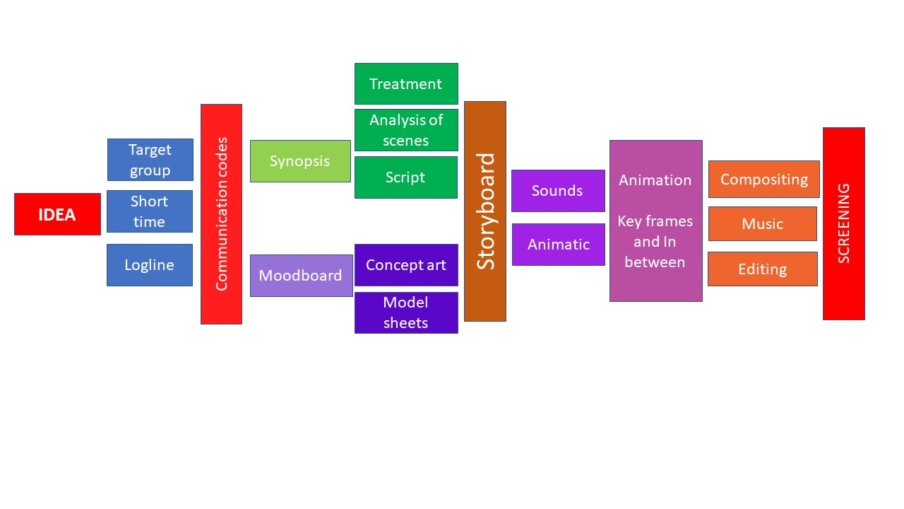
The concept: the core theme of the film. What do I want to communicate?
- Target Audience: Who will my audience be in order to effectively communicate this specific concept? How will the target group be selected? How will the concept be developed specifically tailored to this target group?
- Time Constraints: The communication of the concept must be developed within the limited duration of an animated spot or a very short animated film.
- Concept Communication (Logline Writing): How will I communicate the concept? The logline is a one- or two-sentence summary of the story (typically consisting of 25–50 words)

Plural encoding is a prerequisite element for effective communication through animated spots or very short animated films.
Communication codes

Writing the synopsis (a dense summary of the script) clarifies the communication objectives.
Writing an Extensive Summary (Treatment): Crafting a detailed prose overview of the narrative, characters, and stylistic tone.
Writing a Breakdown (Step Outline): Analyzing the core concept and breaking it down into distinct, sequential scenes.
Scriptwriting (Screenplay): Writing the formal script, incorporating comprehensive descriptions of the shots, framing, and visual action.

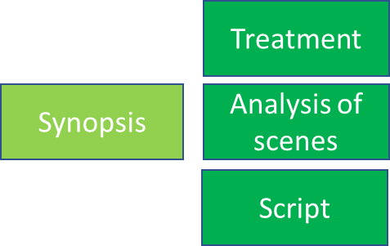

Research into visual styling to dynamically represent the central concept through imagery.


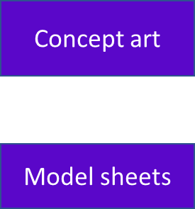
Final Visual Style (Concept Art): Exploring multiple design iterations to systematically construct the background and foreground assets.
Character or Typography Design: Developing character concept art or selecting and designing dedicated fonts.
Initial Storyboard Drafts: Developing the initial storyboard layouts in alignment with the established concept art, while exploring choices within cinematic language.
Progressive Storyboard Development (Framing & Kinematics): Incrementally refining the storyboard by making strategic decisions regarding shot sizes (framing) and camera movements.
Progressive Storyboard Development (Transitions & Continuity): Incrementally refining the storyboard by incorporating shot selection and editing techniques.



Audio Layout and Voice Recording: Recording essential sound effects and temporary dialogue or voice-overs, if applicable.
Storyboard Sequencing and Audio Synchronization (Animatic Creation): Editing the storyboard panels together with the recorded audio tracks to produce the animatic, which serves as the foundational rough cut (blueprint) of the animated spot.

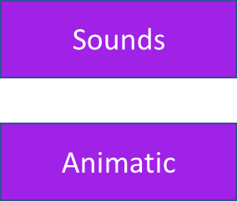
Using the animatic as a structural guide, the motion is generated. Initially, the keyframes are designed to define the core poses and action path. Subsequently, based on the timing reference of the animatic, the in-betweens are drawn to precisely determine the duration and pacing of each individual movement.
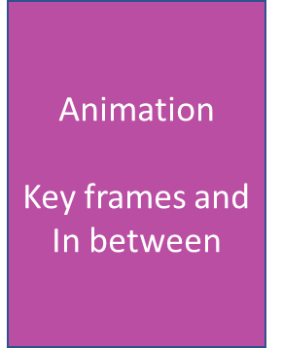
Compositing is the process in which multiple, disparate visual elements are digitally combined to construct a cohesive, single final image. Compositing establishes visual consistency in illumination, generates visual effects, and integrates atmospheric elements.


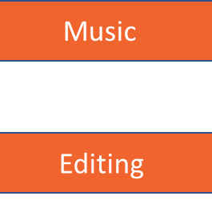
Compositing is the process in which multiple, disparate visual elements are digitally combined to construct a cohesive, single final image. Compositing establishes visual consistency in illumination, generates visual effects, and integrates atmospheric elements.
The last step is the editing

During the 2025–2026 academic year, undergraduate students in the 7th semester were tasked with creating animated spots developed from the concepts they had originally formulated during the 5th semester under the theme of "social media." The rationale behind this selection was that this generation of young adults aged 20 and over has had access to internet-connected smartphones since their pre-adolescent years. Concerns regarding the reckless use of social media by children emerged significantly later. Students were encouraged to represent the theme according to their personal insights and the experiential knowledge they have accumulated through social media usage.
This section presents three animated spots, selected specifically for the distinct reflections they introduce, as well as the varying perspectives of their creators on the subject matter.

The first animated spot to be analyzed is an animated documentary ("doc-animation") focusing on a specific diet that was globally promoted via social media platforms, leading young individuals into life-threatening situations.
In the cotton ball diet, those in search of a smaller waistline eat cotton balls soaked in juice to curb their appetite and dramatically cut their daily calorie intake. But eating cotton balls isn’t just unappetizing. It’s potentially deadly. (Schaefer, 2025)
A second area of reflection concerns the profound influence of social media on adolescents, to the extent that it frequently inflicts severe harm upon both their health and overall well-being
The teen years are a critical time for growth, both physically and emotionally. Rapid changes in body size, hormone levels and self-identity can make teens vulnerable to unrealistic body standards.
Research suggests that social media use increases the risk of eating disorders, especially when focused on weight loss and even when social media is only used for a short period of time. Dangerous trends, such as laxatives, diet pills and detox products, often are promoted and can cause serious health issues. (Collins, 2025)

The concept of linking the theme of social media with diets promoted by individuals lacking medical expertise—which leads many young people to jeopardize their health—was conceived by students Savvina Mouchtari and Zoe Roumelioti. The creation of the animated spot is attributed to Savvina Mouchtari and Christian Ntesagia.
The animated spot is narrative-driven, utilizing an Aristotelian structure. The viewer is invited to immerse themselves in a fictional world and identify with the characters of the dramatic narrative. In animation, unlike live-action cinema, the composition of the image is explicitly and visibly artificial; thus, the world in which the events unfold is a space clearly reconstructed in accordance with script requirements and the creators' aesthetics. Consequently, the viewer is not directly entangled in the occurrences but rather remains detached. Through this fictional universe, the creator reconstructs reality according to their own perspective. They project ideas and viewpoints, exercise criticism, and develop their own worldview within an imaginary and entirely constructed society. Correspondingly, the viewer is aware from the outset that what they are about to watch may, to some extent, resemble the society they inhabit; however, here, the constructed society, the characters, and the events function symbolically, clearly presenting themselves as an fabrication. This allows for harsh truths to be uttered without the viewer overly identifying with the events.
For this reason, animation has emerged as a domain where we dramatize worlds of fantasy and myth, offering greater narrative freedom than live-action cinema due to its capacity for extreme visualization. Through symbolism and abstraction, the creator can pose questions and immerse the viewer in extreme situations. The creator communicates indirectly with the audience, provoking reflection and raising questions, while leaving the viewer free to decode the constructed world and observed events as they see fit. Due to these factors, animation possesses far more liberated narrative capabilities, while technological evolution has granted even greater freedom in both the creative and executive sectors. Today, animation has concurrently swept live-action cinema along into the narration of non-reality.
Through the art of animation, the creator possesses the capability to express their viewpoints by denouncing extreme conditions that would otherwise shock the viewer if presented via a live-action film or, even more harshly, through a documentary. Concurrently, the viewer receives the message filtered through symbolisms, substitutions, and metaphors. The characters function as symbols rather than actors—meaning they are not actual human beings with whom the viewer might personally identify. Correspondingly, the environments are also symbolic, and the audience perceives them as such. They do not represent a specific city or countryside where the viewer resides, which prevents them from associating these spaces with their own lives and subsequently rendering them abhorrent. (Μουρη, 2023, σ. 181)
Logline: A teenage protagonist follows the instructions of a social media post promoting the dangerous "cotton ball diet."
Target Group: The target audience comprises adolescents, primarily young girls, who conform to ideal body image standards propagated through online platforms. Naturally, these standards do not align with the diverse physical structure of young individuals. Consequently, teenagers pursue "diets" absent of any medical consultation, ultimately jeopardizing their very lives.
Synopsis: Believing she is overweight and failing to conform to idealized body standards, a young protagonist comes across the "cotton ball diet" on her mobile phone. She follows the instructions meticulously; however, she does not achieve her desired results immediately. She continues to ingest cotton until she completely transforms into cotton herself. The spot concludes with a call to action, urging the audience to distrust online diets and to consult qualified healthcare professionals.
The concept art semantically reinforces the narrative, ensuring that the visual delivery of the story's progression is aesthetically compelling and easily legible for the specific target audience. It is fully understood that the core concept and the target group are the absolute determinants of any animated film creation.
Visual research is conducted to establish the graphic style for animated films, video game productions, comic books, and more broadly, for any visual or audiovisual content.
In this particular animated spot, the chosen concept art utilizes a clean outline style combined with flat colors. This technique, through its structural clarity, shifts the emphasis entirely to the semantic content. Furthermore, for this specific target group, it was deemed essential that complex designs and intricate color palettes should not distract the adolescents; instead, the visual direction was intentionally kept as neutral as possible.
A series of screenshots:
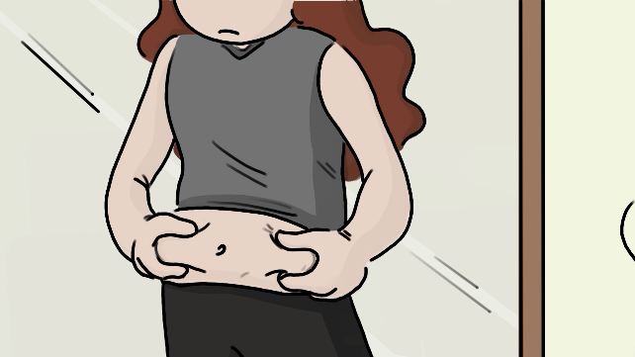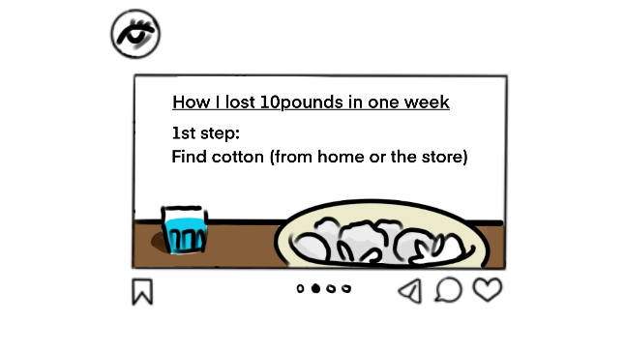
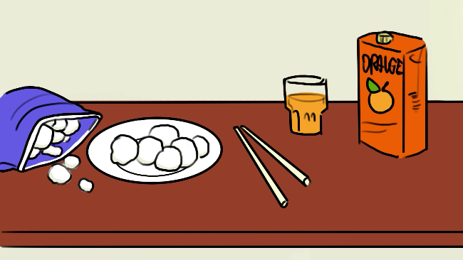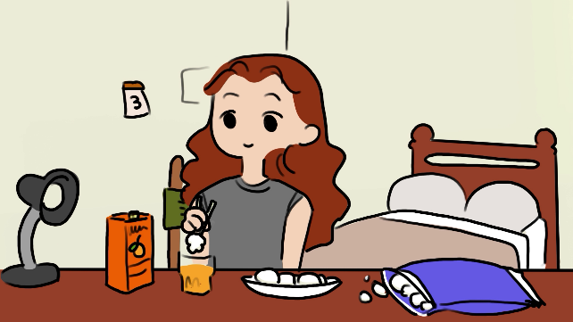
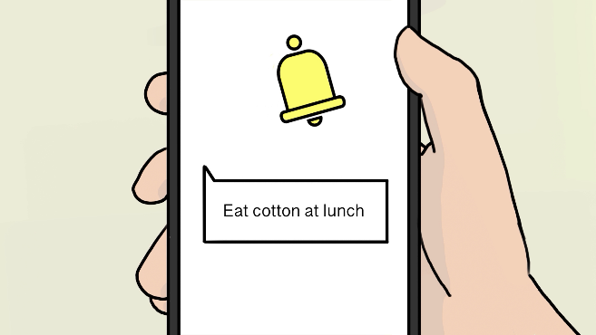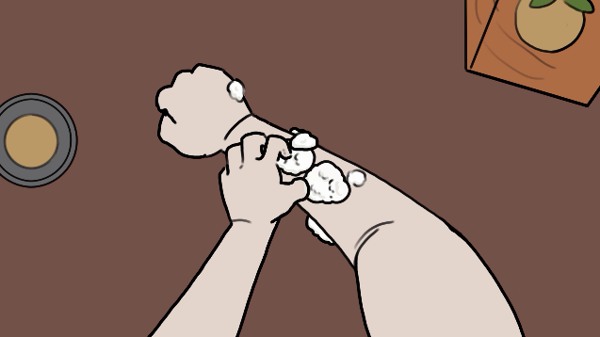
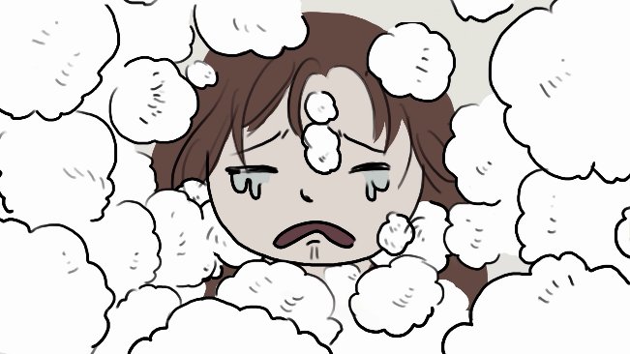
The creation of the motion is entirely 2D animation, designed in the open-source software Krita.

The second animated spot to be analyzed assigns a positive value to social media in a simple and playful manner. It is a cheerful animated spot that critiques and satirizes racism.
The definition of racism according to the United Nations (UN) International Convention on the Elimination of All Forms of Racial Discrimination (1965) states: Racial discrimination is defined as 'any distinction, exclusion, restriction or preference based on race, colour, descent, or national or ethnic origin which has the purpose or effect of nullifying or impairing the recognition, enjoyment or exercise, on an equal footing, of human rights and fundamental freedoms.' (Nations, 2026)
However, the choices regarding how each individual communicates with their fellow human beings directly reflect their personality; correspondingly, personality determines how social media is utilized, leading to either positive or negative outcomes. Social media platforms both influence and are shaped by our personality traits, as the manner in which we interact online is directly linked to our psychological profile. (M. Cox, 2026)
How does personality influence usage among extraverted users? They utilize platforms for social networking and maintaining connections, although they occasionally focus on the passive seeking of likes as well. (Social Media and Personality Types: How Traits Shape Online Behavior, n.d.)

The creators are all ERASMUS students from Spain: Sara Bernal, Alvaro Marques, and Beatriz Pellicer. Within their home institutions' curricula, they had not received prior training in animation. However, they meticulously followed all our instructions and corrections regarding the generation of movement, ensuring the outcome would constitute character animation rather than mere motion graphics. They chose to execute their concept utilizing simplified character and environmental designs, alongside software applications with which they were already familiar.

The animated spot is narrative-driven and similarly conforms to an Aristotelian structure.
Logline: Two victims of racial prejudice utilize social media in a positive manner.
Target Group: A youth and adult audience that rejects racist behaviors and values positive emotions and empathy.
Synopsis: A black sheep finds itself isolated among a flock of white sheep. Despite its efforts to socialize with them, the white sheep conspicuously avoid it. Dejected, it approaches a lake to look at its reflection, realizing its distinctiveness from the others. Correspondingly, a white crow is nonchalantly smoking a cigar on a power line. A group of black crows arrives and expels him due to his difference. Sitting alone on a tree branch, he pulls out his mobile phone to search the platform "TIMBER." He sends a message adorned with hearts to the solitary black sheep, who responds in kind. A great romance begins…
The concept art aligns with the distinctive aesthetics of Adobe Illustrator. Clean, flat, two-dimensional planes are organized in multiple layers to construct both the characters and the environments. Strong color contrasts support the minimalist aesthetic of Adobe Illustrator, while simultaneously reinforcing the playful tone that characterizes the animated spot.
A series of screenshots:
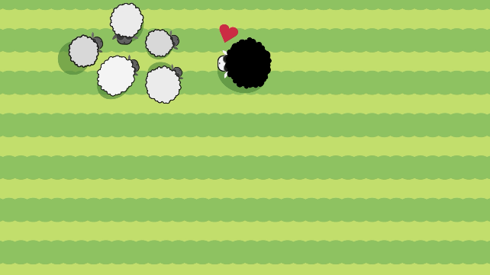



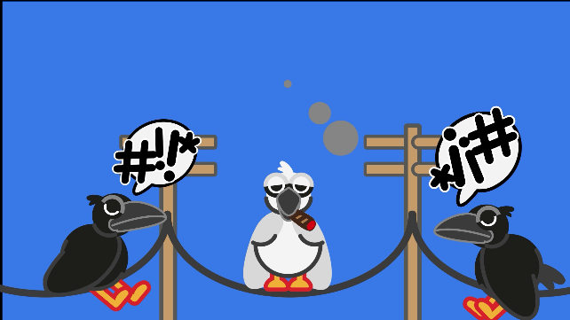

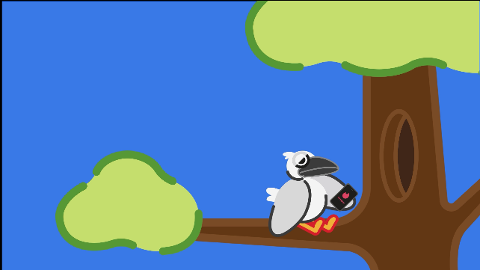

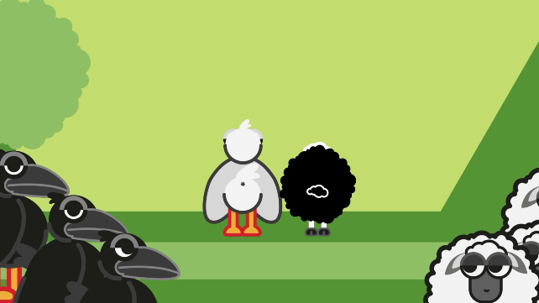
The motion design was executed using Adobe After Effects, given that the entire asset design was developed in Adobe Illustrator. These two software applications feature seamless integration for generating motion, predominantly in motion graphics, as well as in simplified character animations, as demonstrated in this case study.
The third animated spot is an episodic film entitled "Stupid Media." Utilizing parallel editing, it aggressively denounces social media "followers" in an extreme manner. The core concept centers on neurotic and narcissistic users who, addicted to continuous social media consumption, transform into unthinking followers who act without reflection.
Individuals exhibiting high levels of neuroticism tend to utilize social media more frequently in search of validation, while often experiencing anxiety or jealousy stemming from social comparison. (M. Cox, 2026)
Concurrently, they operate narcissistically, seeking the attention of their "followers" to continuously project their superego.
Traits such as narcissism are associated with the exhibition of achievements and the need for validation, particularly on visual platforms like Instagram.(L. Freyth, 2026)
The term "challenge," depending on the context in which it is used, is differentiated as follows:
1. As a Noun (A Challenge)
- Difficult task or trial: A situation, task, or problem that requires significant effort, skills, and mental or physical strength to overcome (e.g., "Learning a new language is a major challenge"). (wiktionary.org, n.d.)
- Invitation to competition: A call to someone to compete in a game, sport, duel, or debate in order to determine who is superior.(Vocabulary-com, n.d.)
- Online "Challenge" (Social Media): A contemporary trend where social media users are invited to perform a specific task (which may be humorous, charitable, daredevil, or creative), record it on video, and "challenge" others to do the same.
2. As a Verb (To Challenge)
- To challenge / To defy: To call upon someone to engage in a contest, confrontation, or competition.
- To question / To dispute: To call into question the validity, truth, or legality of a statement, decision, or theory (e.g., "I challenge the findings of the research").
To stimulate / To test one's abilities: Something that keeps an individual intellectually or physically stimulated, preventing boredom. (Britannica, n.d.)
Logline: Unthinking followers face the grim consequences of their actions.
Target Group: Teenagers and unreflective young adults.
Creators: The spot was created by undergraduate students Angelos Kamarinopoulos and Giorgos Skaligos. The core concept and storyboard were developed during the 5th semester by Angelos Kamarinopoulos, Giorgos Skaligos, and Giorgos Toumpas. The final animation was completed during the 7th semester in 2026 by Angelos Kamarinopoulos and Giorgos Skaligos at the Department of Graphic Design and Visual Communication.
Synopsis: A young man throws away a trash can, blindly following a social media post. Through a newspaper found inside the trash can, the narrative transitions to the second protagonist, who participates in an online challenge and ingests laundry detergent pods. The third protagonist follows a trending photo-challenge involving a gorilla; he rushes to the zoo and confidently enters the gorilla's enclosure, leading to the expected catastrophic results. The fourth protagonist is a misogynist with a large following; naturally, they all end up in prison together. Meanwhile, two "friends" observe these events unfolding and react accordingly. Concurrently, a young girl participates in a challenge and ends up self-harming. The screen is then filled with a social platform named "YURI," displaying various challenges and their outcomes, until a final challenge transitions the narrative into the reality of a hospital room. There, we encounter the young man who ingested the detergent pods as he passes away.
A series of screenshots:
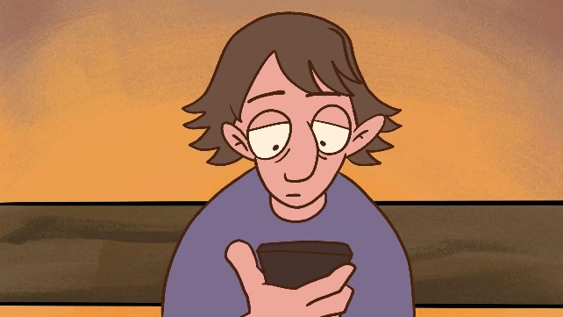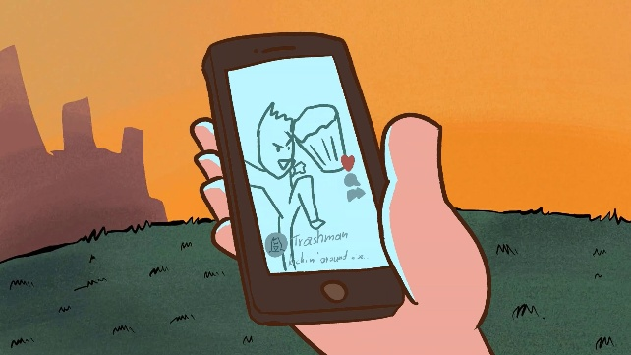

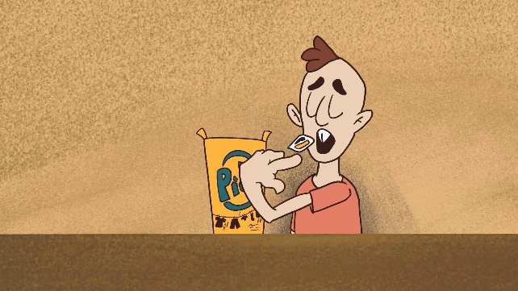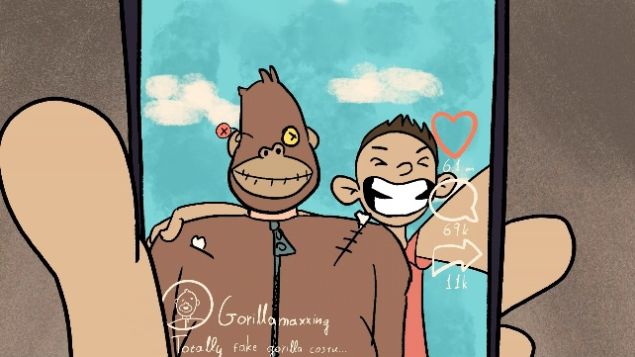

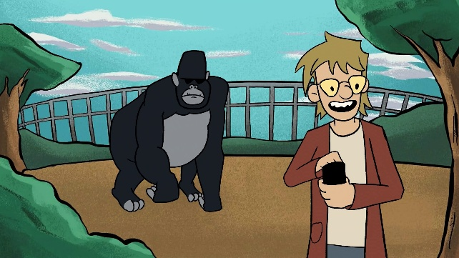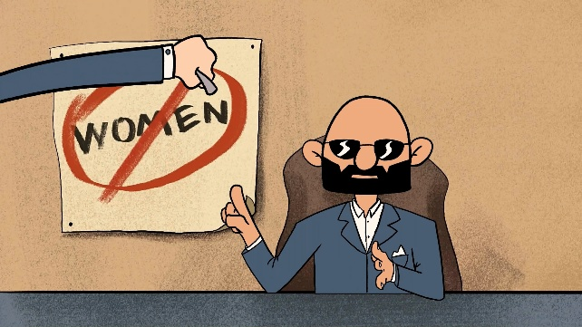
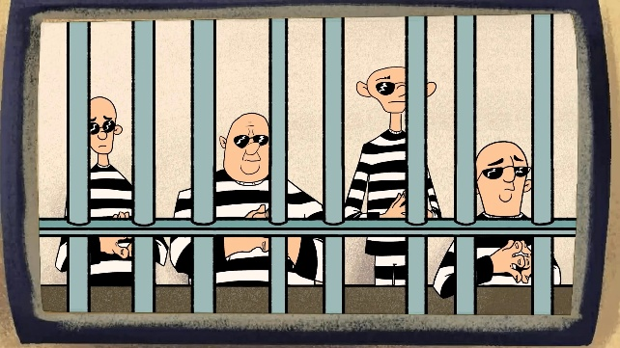

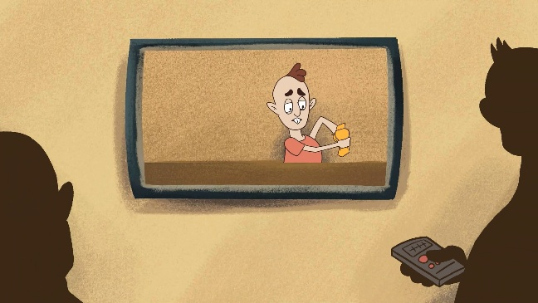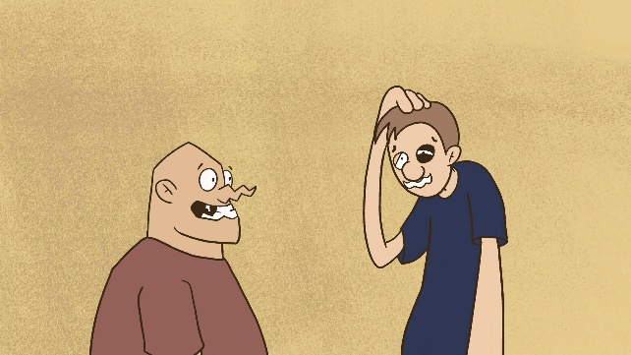

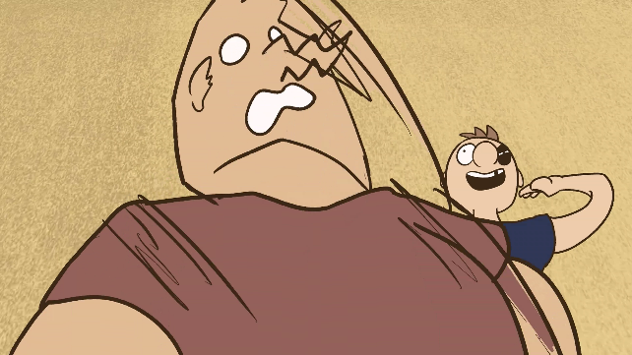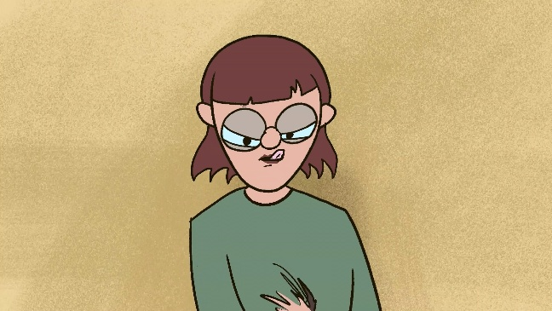

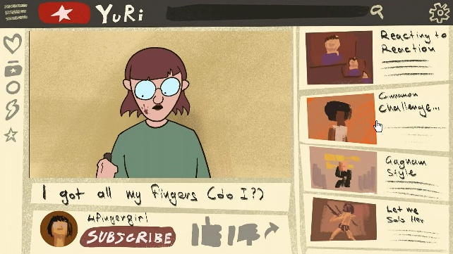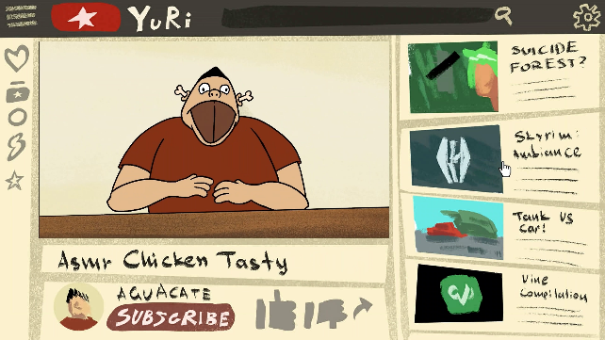

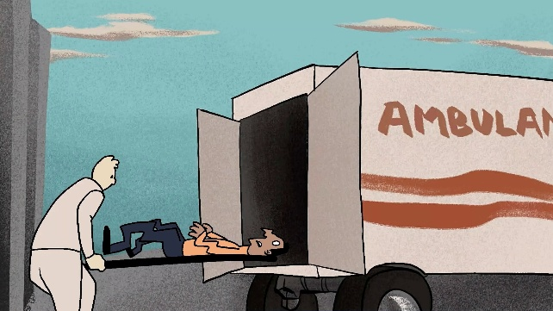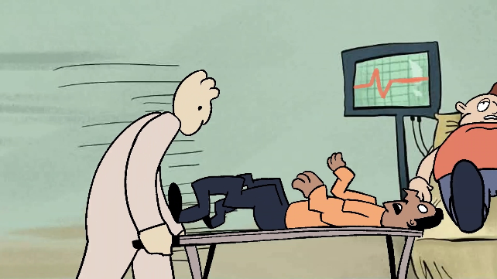

The development of both the illustrations and the animation was executed in KRITA. Editing and sound design were performed using Adobe Premiere, featuring foley sound effects entirely recorded and produced by the two students.

Concurrently, the Department of Graphic Design and Visual Communication operates a postgraduate program entitled "Animation (2D and 3D Animation)"
The selection of this specific animated spot aims to demonstrate that within a master's program—where students are older and already active in the professional arena—the reflections raised are distinct and far more personal. Throughout the curriculum, students receive condensed animation expertise for one academic year, while their postgraduate thesis requires them to organize and complete an animated short film alongside its accompanying theoretical documentation. This case study represents a historical-informational animated short focusing on punctuation marks and their historical context.
In informational and educational animation, the creator aims for rapid, clear, and direct communication. The practitioner utilizes cinematic language combined primarily with graphic design elements to convey complex data to the audience. In this context, the artificial composition of imagery is prominent, heavily relying on infographics, motion typography, and typically, a voice-over narrator. When dramatic elements are employed, their sole purpose is to explain, inform, and educate. This highly artificial synthesis of the image helps highlight the information through the deployment of graphic representations. The narrative function is direct and unfolds primarily through visualized symbols. The decoding of these symbols by the viewer occurs automatically, provided there is a shared cultural identity—meaning, common communication codes (Μουρη, 2023, σ. 109)
The creator is Valeri Papadopoulou, a graphic designer with long-standing professional tenure at the National Printing House. This extensive background prompted her to develop the theoretical framework regarding the semiotics of punctuation, its historical evolution, and the relationship between oral speech and the visual architecture of written text—where punctuation marks actively guide the vocal delivery of prose.
The core research question was established on the occasion of an aphorism by the Portuguese philosopher Fernando Pessoa (1888–1935) in The Book of Disquiet (Livro do Desassossego): "Life is a hesitation between an exclamation point and a question mark. In case of doubt, we place a period."
Subsequently, the framework incorporated the philosophical dimension introduced by Theodor W. Adorno, who characterized punctuation marks as forms of thought—discrete gestures of consciousness within language. The study references his brief yet highly dense essay "Punctuation Marks" included in the volume Notes to Literature, which is widely considered one of the most distinctive texts in twentieth-century philosophy of language. (Adorno, 1991)
Theodor W. Adorno analyzed punctuation marks as if they were the "grimaces" of speech—expressing hesitation, irony, tension, or distance. Punctuation marks are to language what facial expressions are to human communication. In other words, a period, a comma, or a dash does not merely convey logical information; it communicates an attitude toward thought itself. The core thesis of the text posits that punctuation is a historical form of consciousness. Consequently, punctuation marks are not "natural." Each historical era writes differently because it conceptualizes differently. For Theodor Adorno, the decline or oversimplification of punctuation reflects a deeper cultural transformation: the hegemony of speed, instrumental logic, and mass communication. This issue has been highlighted by numerous philosophers, philologists, and educators alike, focusing on the following equation: the continuous reduction and simplification of written and spoken language demonstrably diminishes the capacity for complex and abstract thought.
Ms. Valeri Papadopoulou incorporated this text into her conclusions on page 27 of her theoretical documentation:
"From Scriptio Continua (the absence of punctuation due to a lack of physical tools), we transitioned to Surrealism (the absence of punctuation due to ideological stance), and ultimately arrived at the Digital Era (the redefinition of punctuation due to velocity). Punctuation remains the 'oscilloscope' of our culture. A Concluding Thought: Punctuation is the writer's 'courtesy' toward the reader. It is the promise that speech will not suffocate them, but will instead guide them safely to meaning."
Logline: From ancient Alexandria to the digital era, a poetic audiovisual journey explores how punctuation marks transformed from reading tools into symbols of thought, art, and human expression, delivered through graphic narrative, animation, and motion typography.
Synopsis: The project "Semiotics of Punctuation" explores the evolution of punctuation marks from antiquity to contemporary digital communication. Through motion graphics, dynamic typography, and narrative imagery, punctuation marks are transformed from mere linguistic symbols into carriers of emotion, rhythm, and meaning. The project synthesizes elements of graphic design, visual storytelling, animation, semiotics, and typography art.
Target Group: Adults with a keen interest in the arts and literature.

A series of screenshots:
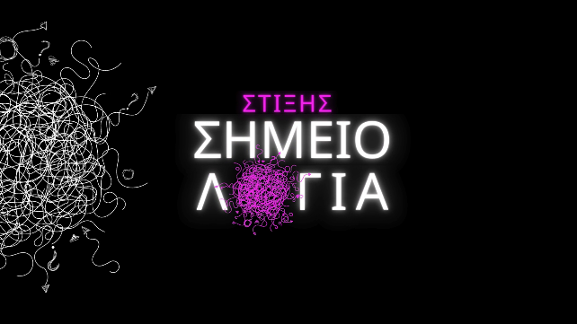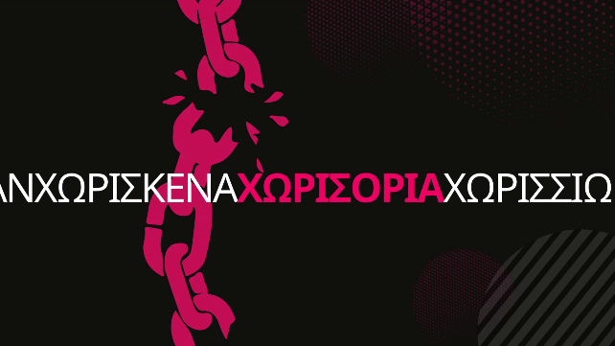

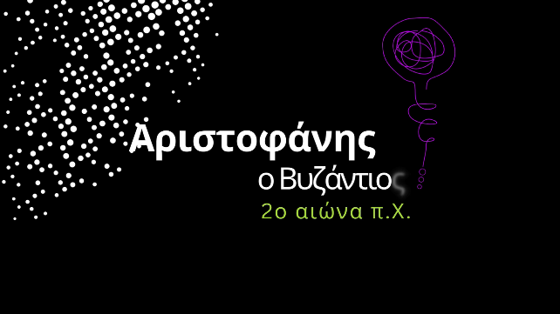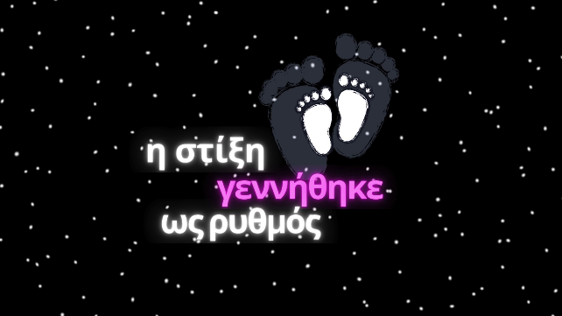
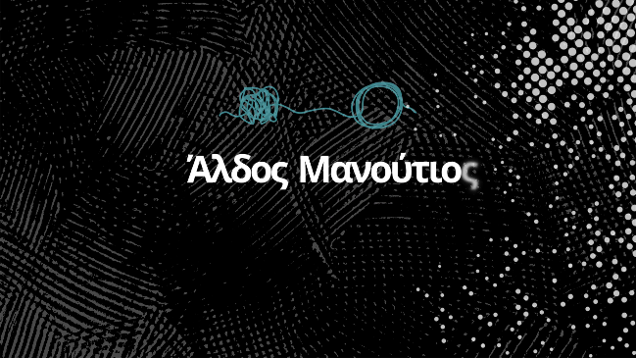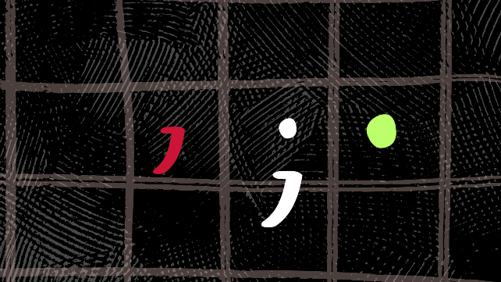
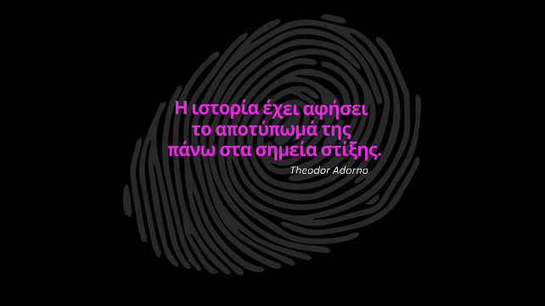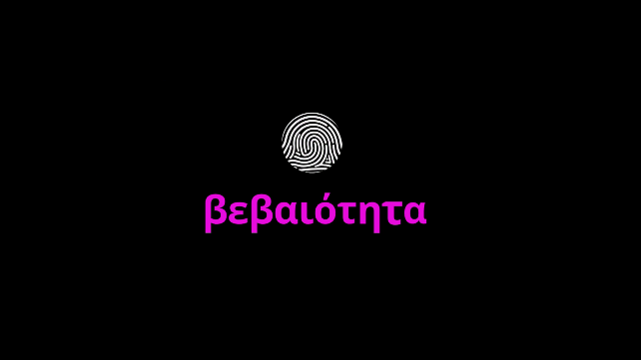
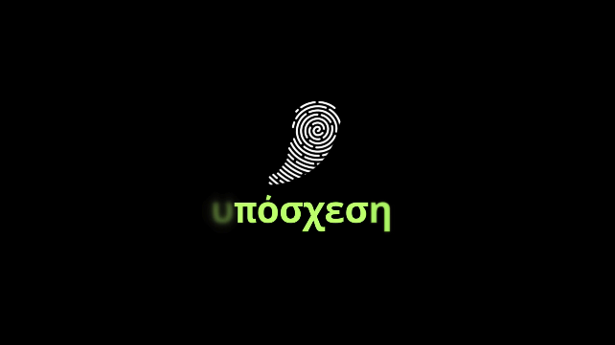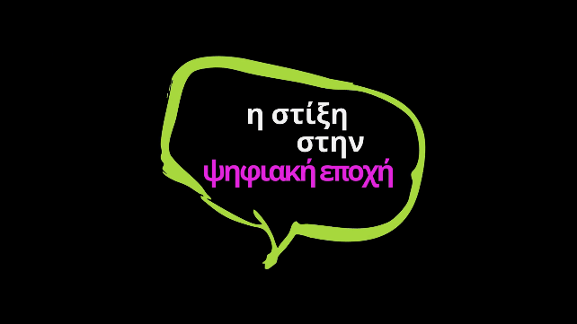
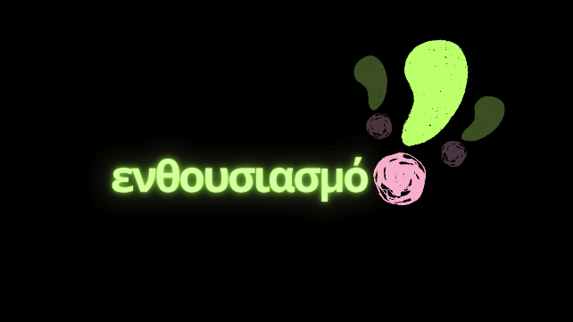

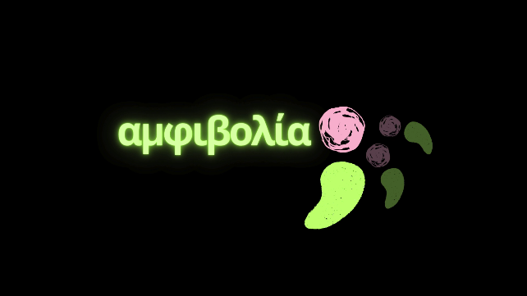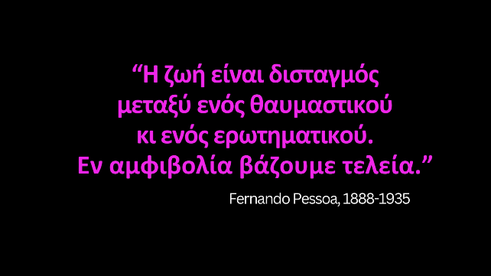

The motion design was executed using Adobe After Effects, given that the entire asset design was developed in Adobe Illustrator and Canva. Emphasis was placed on the chosen color palette, guided by the semiotic function of color, in order to enhance the emotional and symbolic dimensions of the narrative. Colors were not utilized solely as decorative elements, but rather as carriers of meaning that support the dramaturgy of the visual composition.

Conclusions
The progressive development of students into responsible citizens constitutes the fundamental objective of the educational process. This is achieved through the step-by-step acquisition of knowledge and critical thinking, delivered in tandem with instruction on harnessing technological capabilities. This cultivation represents the core pursuit for every educator within the Department of Graphic Design and Visual Communication, and particularly within courses pertaining to the animation cycle. A very concise overview of this instructional methodology and its outcomes was presented in the text above, with emphasis placed on highly recent student productions from 2026.

References

- Adorno, T. (1991). Notes to Literature (Τόμ. Vol. 1.). New York: Columbia University Press.
- Britannica. (χ.χ.). Ανάκτηση από https://www-britannica-com
- Collins, S. C. (2025, May). Scrolling for Health: The Risks Behind Viral Nutrition Fads. Ανάκτηση από eat right.org: https://www.eatright.org/health/wellness/diet-trends/scrolling-for-health
- L. Freyth, B. B. (2026). Personality and Individual Differences. Ανάκτηση από Science Direct: https://www.sciencedirect.com/science/article/pii/S0191886922004652
- M. Cox, B. C. (2026). Personality, opinion strength, and social media use – not such a straightforward relationship. Ανάκτηση από Taylor & Francis online: https://www.tandfonline.com/doi/full/10.1080/00049530.2025.2451156
- Nations, U. (2026, 8). Ανάκτηση από International Convention on the Elimination of All Forms of Racial Discrimination: https://www.ohchr.org/en/instruments-mechanisms/instruments/international-convention-elimination-all-forms-racial
- Schaefer, A. (2025, August). 4 Ways the Cotton Ball Diet Could Kill You. Ανάκτηση από healthline: https://www.healthline.com/health/eating-disorders/ways-the-cotton-ball-diet-could-kill-you
- Social Media and Personality Types: How Traits Shape Online Behavior. (χ.χ.). Ανάκτηση από jobcannon.io: https://jobcannon.io/blog/social-media-personality-types
- Vocabulary-com. (χ.χ.). Ανάκτηση από https://www-vocabulary-com.translate.goog/dictionary/challenge?_x_tr_sl=en&_x_tr_tl=el&_x_tr_hl=el&_x_tr_pto=sge
- wiktionary.org. (χ.χ.). Ανάκτηση από https://wiktionary.org
- Μουρη, Ε. (2023). Το animation ως μέσο πολυσύνθετης επικοινωνίας. Η αφηγηματική, η εικαστική και η κινηματογραφική γλώσσα στη δημιουργία animation. Αθήνα: Κάλλιπος, Ανοικτές Ακαδημαϊκές Εκδόσεις.

