How does my digital character feel? Directing an interactive live performance with biosensors
Vilelmini Kalampratsidou  University of the Peloponnese  vilelmini.kalabratsidou@gmail.com | Katerina El-Raheb  University of the Peloponnese  k.elraheb@uop.gr | Alexandros Zarmakoupis  University of the Peloponnese  alex_decoup@hotmail.com
Katerina Malisova  University of the Aegean  katemalisova@aegean.gr | Giorgos Nikopoulos  Ionian University  giorgos.nikopoulos@gmail.com | Panagiotis Kyriakoulakos  University of the Aegean  pank@aegean.gr
Spyros Vosinakis
University of the Aegean
spyrosv@aegean.gr
Abstract: This paper proposes an innovative workflow that bridges digital animation with interactive media performances through the use of wearables. It explores the translation of biosignals into creative expression within hybrid environments, building upon insights from psychology, philosophy, cognitive science, and media arts. We begin by distinguishing emotions felt—the internal physiological and cognitive experience—from emotions expressed. Building on theories such as the Two-Factor model, the study situates emotion as both a bodily and cognitive process. Next, a technical workflow is proposed for capturing, processing, and mapping biosignals into digital environments using wearable sensors, real-time data processing, and visualization in Unity. Through a workshop with transmedia narratives and design experts, we investigated the use of the proposed framework in interactive media performances and collected evidence of creative possibilities in mapping biosignals to digital worlds. Based on the findings, a five-minute interactive media performance was developed, featuring two performers who composed with their bodily data to create visual and audio elements in the digital world of “Monolove” by G. Nikopoulos. To conclude, biosignals can act as expressive agents, transforming emotion into a shared, hybrid experience across human and digital systems. This is a foundation for future affective, interactive, and performative research.
Key words: biosignals, interactive media performance, felt emotions, live streaming, digital environments

Introduction
In the last decades, motion capture and advancements in animating characters through human performers allowed cost-effective workflows for believable digital characters informed by advancements in relevant Computer Science fields. Directly capturing or streaming human movement bridged different art forms such as acting, performance, dance, and movement analysis with the art of film animation, suggesting a new field for knowledge and experimentation (Dower & Langdale, 2022). In parallel, data in general (Viegas & Watternberg, 2007), and biodata more specifically (Vilelmini et. al., 2024; El Raheb et. al, 2023), have provided versatile raw material for inspiration and implementation of various artistic projects that convey the embodied aspect of everyday experiences to the audiences in direct and/or asynchronous manner. In this work, advancing our Embodied Character Design approach (El Raheb et al., 2025), apart from motion capture, we employ wearables that capture biosignals that can make visible or audible the implied felt emotion of the digital character by directly streaming the biosignals of the performer to the digital avatar and environment. To do this, we study the recent progressions in identifying emotional and physiological signals (Wan, 2022; Valenza, 2010; Villarejo, 2012; Liu, 2012). A gap remains in translating these biosignals into nuanced character behavioral patterns linked to personality traits through systematic methodologies, while studies combining biosignal data, emotion models, and personality traits are rare (Zhao 2018).
This work is part of an interdisciplinary collaborative project, IMAGINE MOCAP, aiming at proposing a framework and innovative workflows for enhancing digital characters' personalities in animation, games, interactive media, and networked environments through motion capture, wearables, and live coding. One of the main objectives of the IMAGINE-MOCAP project is to propose an embodied character design approach with a focus on the nuances of the live, dynamic, non-verbal, and affective expression of the digital character (El-Raheb et al. 2025; Kolokotroni et al. 2025). As such, we investigate how current research and wearable technologies can enrich animation by linking real-time biosignals to character behavior and offering a novel bridge between human affect and digital expression. To succeed in this, our team’s expertise ranges from extended reality and game design/ development to interactive media direction and choreography.
Methodologically, first, we set up a technical workflow that supports a performative demo of live streaming data into the Unity engine from the performer directly to the avatar and environment. The digital character coexists within a digital environment inspired by the “Monolove” piece by George Nikopoulos. Based on this setup, we organized a workshop with experts in interaction design and animation to investigate biosignals mapping possibilities for enhancing the main character's expressivity. Lastly, we used the feedback from the workshop to present a performance evaluated by 14 participants.
From a designer’s perspective, digital characters are conceived as autonomous entities with distinct features, beginning with their visual identity, the core of their digital presence. Based on the theory of Object-Oriented Ontology, every entity, whether living or inanimate, possesses a withdrawn reality, a depth that can never be fully accessed by others (Harman, 2018). Adopting this view, we argue that a digital character manifests object-specific modes of felt experience and emotions according to its own ontological terms, emerging through its encounters with other entities within a media ecosystem. How it interprets and expresses these encounters in context ultimately shapes its personality (Figure 1.B). While this work focuses on enriching digital characters through emotion-related biosignals, we acknowledge broader future directions, including interactions between physical and virtual characters across media such as animation, gaming, and networked environments (Figure 1.A). However, such exploration lies beyond the current scope, which centers on the emotional augmentation of digital characters via human biosignal data.
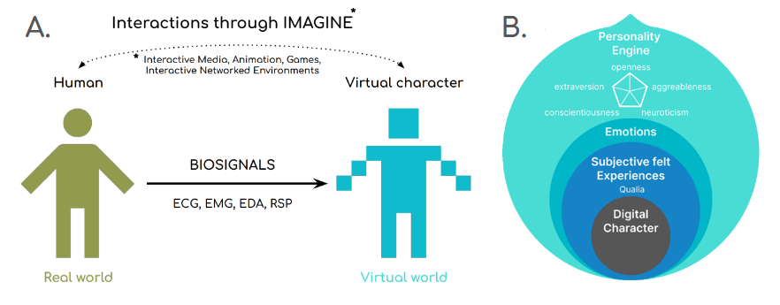
Figure 1: Schema describing different aspects of the background, motivation, and aim of this work

2. Theoretical background: From biosignals to emotions as a bodily expression and emotion felt

2.1 Emotions felt & expressed
The distinction between emotions felt and emotions expressed is a central theme in psychology, highlighting the difference between internal emotional experiences and the way these emotions are outwardly displayed (Lazarus, 1991, and Gross, 1998). This separation can reveal a lot about an individual's personality, cultural background, and coping mechanisms, and it also underscores the complexity of human emotion and social interactions.
Emotions felt are the internal experience of an emotion. These feelings may be complex, intense, and influenced by personal experiences, beliefs, and thoughts. People often process emotions mentally, analyzing why they feel a certain way and deciding whether or not to act on the feeling. As a result, an emotion isn’t always outwardly expressed. Yet, the body experiences physiological responses. These responses could be increased heart rate, muscle tension, and belly discomfort, to name a few.
Expressed emotions are typically conveyed through facial expressions (Ekman, 1992, and Ekman, 2007), body language, tone or pitch of voice, and gestures (El-raheb et al., 2025). Someone feeling happiness might smile, laugh, or display relaxed body language. Social expectations influence emotional expression. In some cultures, people are encouraged to express emotions, while in others, restraint is considered “civilized”. This means that a person’s outward expression may not always match what they feel internally. Even within the same social structure, a person may act differently in different settings, for example, when at home or at work. For instance, in a professional setting, a person might suppress feelings of frustration to display calmness. As such, the decision to control an emotion (limitation or amplification) is often conscious. Understanding the difference between emotions felt and emotions expressed can provide insight into behavioral habits, social interactions, and cultural patterns.

2.2 Philosophical perspective: the felt experience
In philosophy, researchers refer to felt experiences, or qualia, as the subjective qualities of perception and sensation, such as the redness of a rose or the taste of coffee (Nagel,1980, and Chalmers,1997). These internal experiences are deeply tied to emotions, which act as affective responses to stimuli and imbue qualia with valence (positive or negative) and intensity. Emotions serve as a bridge between raw sensory input and higher-order interpretations, making them central to how qualia are felt and remembered (Russell, 2003). While the classical definition of qualia is human-centered, rooted in debates about consciousness and the mind-body problem (Chalmers, 1997), this framing is increasingly being challenged (Sloman, 2007, and Nagel, 1980). If we question this anthropocentric view, the sensory qualities of objects may also be non-human or distributed across different entities. For example, a dog perceives smells with far greater depth than humans, suggesting a different, perhaps richer olfactory world (Bekoff, 2007). Could we think of canine qualia? An animated character, while not conscious, operates in a computationally mediated environment, responding to programmed stimuli in ways that mimic lived experience (Clarke, 2023). These considerations push us to rethink qualia not as an exclusively human phenomenon but as a broader ontological category that accounts for diverse ways of sensing, perceiving, and responding to the world.

2.3 Cognitive Perspective of Emotions
The cognitive perspective of emotions refers to the mental processes involved in interpreting and labeling emotional experiences after perceiving the sensory stimulus. These processes shape how we perceive and react to emotional stimuli and are vital to understanding the complexity of emotions (Egger et al., 2019). Some of the most common theories describing the stages of cognitive processing of emotions from perception to identifying the emotion are demonstrated in Figure 2.
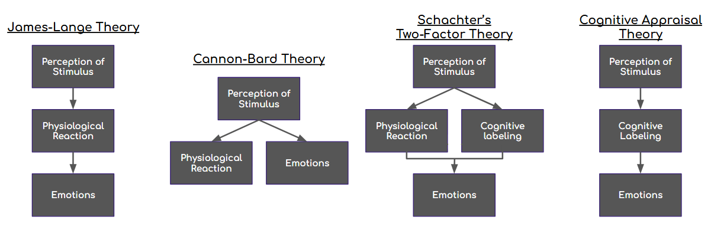
Figure 2: Four models describing the cognitive process of emotion, starting from perceptions of stimulus, all the way to identifying the emotion
The oldest theory is the “James-Lange Theory” (James, 1948), which suggests that physiological reactions come before the emotional experience, meaning the body reacts first, followed by the emotional response and labeling. In contrast, the “Cannon-Bard Theory” (Cannon, 1927, and Cannon, 1987) argues that physiological responses and emotional experiences occur simultaneously and independently, which proposes that physiological reactions to emotions can happen without actually feeling the emotion. Next, the “Two-Factor Theory”(Schachter and Singer, 1962) states that emotions are generated from a combination of physiological responses and their cognitive labeling. This theory is the first to name the idea of “cognitive labeling” before naming the emotion. Finally, the “Cognitive Appraisal Theory” (Lazarus, 1982) suggests that cognitive labeling of a stimulus occurs before an emotional experience. As such, we evaluate a situation before emotion.

2.4 Biosignals: a carrier of emotional information
The inclusion of physiological reactions in the cognitive models of emotions leads us to the connection of emotions with the biosignals, which are measurements of our physiology. As such, researchers have already managed to detect emotions from biosignals. Lindsley (1952) associates electrocardiogram (EEG) patterns with stress. According to Εgger et al. (2019), reduced heart rate variability (HRV) has been linked with depression, anxiety, and alcohol use disorders. Also, heart rate is a natural metric for detecting emotional arousal, as it reflects the balance between the sympathetic and parasympathetic nervous systems. Another valuable tool for determining emotions with high accuracy is the electroencephalogram (EEG). It provides insights into how different regions of the brain respond to emotional stimuli. According to Choppin (2000), it allows for two-dimensional measurements based on valence and arousal. A high valence is associated with increased frontal alpha power and elevated right parietal beta power. In contrast, arousal correlates with high beta power and low alpha power in the parietal lobe. Additionally, skin temperature (SKT) can be used to determine whether a person is relaxed or experiencing stress or anxiety (Εgger, 2019). When measured at the fingertip, blood vessel dilation during relaxation increases skin temperature, while vessel constriction during stress or anxiety causes a decrease in temperature. Moreover, electrodermal activity (EDA), also known as galvanic skin response (GSR), tends to decrease in relaxed states and increase during physical or emotional effort (Villarejo et al., 2012, and Egger, 2019). Key features analyzed include range, amplitude, rise duration, and values from temporal and frequency domains (Rigas et al., 2007, and Wu et al., 2010). Lastly, Respiration (RSP) also plays a critical role in reflecting and influencing emotional states. The way we breathe—the rate, depth, and pattern—often changes in response to emotional stimuli, offering insights into how emotions manifest physiologically (Kim and André, 2008). These changes are regulated by the autonomic nervous system, which is divided into the sympathetic (arousal) and parasympathetic (relaxation) branches. Although the aforementioned studies and their developed computational models for detecting emotions are not yet able to identify emotions with high certainty (Mehmood and Lee, 2016, and Guo, 2016), we acknowledge biosignals as a way to provide physiological indications about embodied experience, such as emotional tension or arousal. In this work, we examine how these indications, in the form of streamed data, can be directly transformed into characteristics of the digital body and environment of the character.

3. Biodata Knowhow: From Collection to Management
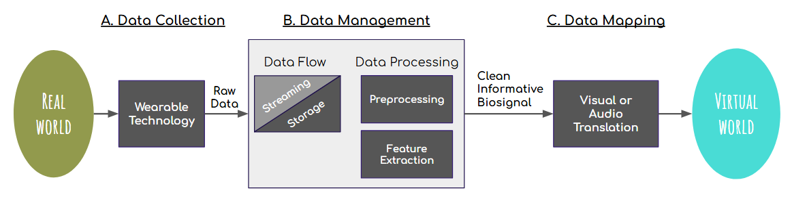
Figure 3: Schema of the presented framework. It visualizes the steps from biosignal collection from the real world to mapping emotionally labeled biodata to the digital world.
This section translates theoretical understanding of emotion into a structured workflow for collecting and interpreting biosignals. The presented framework acknowledges that a significant part of the biosignal recording relates to the physiological reactions after the perception of the stimulus. Building on the distinction between felt and expressed emotions (Section 2.1), and informed by the philosophical notion of qualia as the subjective, embodied texture of experience (Section 2), we adopt cognitive models to interpret physiological signals as indicators of felt emotion—especially in conditions where no physical activity is present. The difference between felt experiences and felt emotions is that in the first case, the physiological reaction is linked to the experience, whereas in the second case, it is cognitively related to an emotion. As such, we argue that:
felt emotion = physiological reaction + emotional labeling
Based on this assumption, the following subsections outline the pipeline that converts unprocessed biodata into insightful knowledge. The pipeline starts by collecting data from wearables, which can be transmitted in real-time or stored for later use. To prepare the data for mapping, preprocessing is frequently necessary to remove noise and inconsistencies. This pipeline ensures that the data are clean and understandable and effectively represent the human’s felt emotions.

3.1 Capturing Biosignals
Wearable technology is used to capture biosignals. Smartwatches and fitness bands are some commercial options. More novel approaches specifically designed for clinical and other research purposes are also available in the market; some examples are Shimmer3 (by ShimmerSensing), Opal (by APDM), Biostamp (by MC10), iCubex, Emotibit, and Biopac. Based on the biosignals they collect, sensors may be positioned in different parts of the body. As such, heart rate, physical activity, and sleep patterns are measured by devices worn on the wrist. Sports and medical applications frequently use chest straps or patches applied to the torso, and are used to record RSP, heart rate, and ECG readings. An EEG is measured by sensors built into headbands, helmets, or earbuds, all placed on the head. EMG, movement, or oxygen saturation are measured by bands or patches applied to the biceps, thighs, or calves (arms and legs). EDA, temperature, and heart rate are recorded by fingertip sensors or rings. Earpieces for earbuds take temperature and heart rate readings. Finally, by placing adhesive patches on the skin surface, the composition of perspiration, moisture levels, and EDA is recorded.

3.2 Data Management
Once the device and the biosignal are chosen, it is crucial to define how the data flows within our system. There are two main ways to handle the data: 1) real-time streaming and 2) storing the data for later use (Figure 3.B). Based on the selection, there are different options for the timing and type of data processing that are available. As such, in the case of real-time streaming, data processing occurs concurrently, ensuring immediate analysis. In contrast, when storing data, processing can be operated at different timings.
Data Flow: The sequence of actions selected depends on the use case, computational resources, and desired outcomes. As explained in our previous works ( Kalampratsidou 2021), in real-time streaming, data is used immediately. It is commonly used in interactive interfaces and systems, where immediate feedback is essential. Some of the advantages of real-time streaming are a) Immediate Feedback, as it enables dynamic responses, b) Continuous Monitoring, because it helps in detecting significant events as they occur, and c) Reduced Storage Needs, because data can be processed and discarded after use. The disadvantages are that real-time streaming requires computational resources, and you lose the ability to re-analyze past data for additional insights. Saving data for later analysis involves storing biosignals for offline analysis (Kalampratsidou et al., 2024; Kalampratsidou and Torres, 2019). This approach is common in scientific research, known as post-experiment analysis, in training Machine Learning Models, and in diagnostics, where reviewing past events is required. The positives of saving data are that it allows for complex processing that may not be feasible in real-time, and b) it enables building libraries or conducting large-scale studies. In opposition, some challenges are that high-quality biosignal data requires significant storage space and that insights are only available after a period, which may be critical in real-time scenarios. Finally, in many scenarios, combining real-time streaming and data saving is the most effective solution, a hybrid approach (Kalampratsidou et al., 2021). In this case, there is streaming for immediate use and storing of raw or preprocessed data for detailed examination or training purposes.
Data preprocessing is often a foundational preparation step for analysis. Raw data often contains noise, missing values, and other inconsistencies that can impact the clarity of the outcomes. As such, preprocessing aims to transform raw data into a clean, structured, and usable format. Depending on the data collected, the data preprocessing could involve several stages. Some examples are data cleaning and noise filtering (using signal processing techniques, e.g., band-pass filtering for EEG), data normalization (to account for individual variability), integration, transformation, and reduction, among others.
Feature extraction in signal processing involves identifying and isolating key characteristics or patterns from a signal to represent it in a more compact and meaningful form. These features preserve the essential information, enabling efficient analysis, interpretation, and use in machine learning or other computational models. A typical example is an ECG signal from which researchers can extract the heart rate, HRV, inter-beat intervals, amplitude, and time of each beat. Features can be extracted in the time (mean, variance, standard deviation, the amplitude and time of the peak values) and frequency domains (power spectral density, dominant frequency components, bandwidth, and spectral entropy). Overall, feature extraction reduces the complexity of signal data while preserving its most relevant information, enabling more accurate and computationally efficient analysis (Kalampratsidou et al., 2024; Kalampratsidou and Torres, 2020).

3.6 Data Μapping
Data mapping is the step of augmenting the clean and informative biodata. Depending on the application and the technologies employed, data mapping can be a very creative step. It can be applied to different and all possible sensory modalities, but most commonly mapped in audio and visual elements. What is challenging in this step is that we need to normalize our biodata so that they can correspond to the range of values that the selected parameter takes. For instance, if we map the skin conductance to the volume of ambient light of a digital world, then we will have to normalize the skin conductance to values from 0 to 1. If we map it to the color of an object, we will have to translate the variations of the biosignal to the 3 RGB parameters, defining color. The next challenge we need to face is the streaming of the biodata to the application we want to use, which differs across software platforms.
In the following section, we present a workshop conducted to investigate the creative interests and needs of designers and directors in mapping biosignals to digital worlds. And then, following their guidelines on creativity, we present our performance along with the steps for technically mapping biosignals to the visual and audio elements of the digital world of “Monolove”.

4. Workshop with Experts
Understanding that this framework is a powerful tool that could be used in different types of interactive and digital environments, such as interactive media, animation, games, and interactive networked environments (IMAGINE), we designed a workshop to study how creators and directors could employ such a tool in an interactive media performance and how they would apply the mapping of biosignals in their digital environments. The workshop took place during the XARTS Summer School (XARTS – Summer School and Conference on Extended Arts, July 2025, Syros, Greece).

4.1 Workshop on Mapping Biosignals to Digital Worlds
Eight people participated, 4 males and 4 females. They ranged from undergraduate students to professors, with ages ranging from 20 to 60 years old. All were experienced professionals in the subjects of scenario scripting, digital animation, dance, design, extended reality design, and development.
First, participants were introduced to the idea of biosignals, the information they carry, and our framework that records, analyses, and streams this information in real-time. Specifically, the research team first described the idea of felt experiences, felt and expressed emotions, and the cognitive model of “Two-factor theory”, as they presented in Section “Theoretical Background”, to relate the embodied experience with the recorded data and value the information the biosignals measure. Next, they were introduced to the tool from data collection to mapping in the digital world in a real-time manner. To properly guide our participants, they were all handed in the schema demonstrated in Figure 3 and were restricted to employing only the real-time streaming of data.
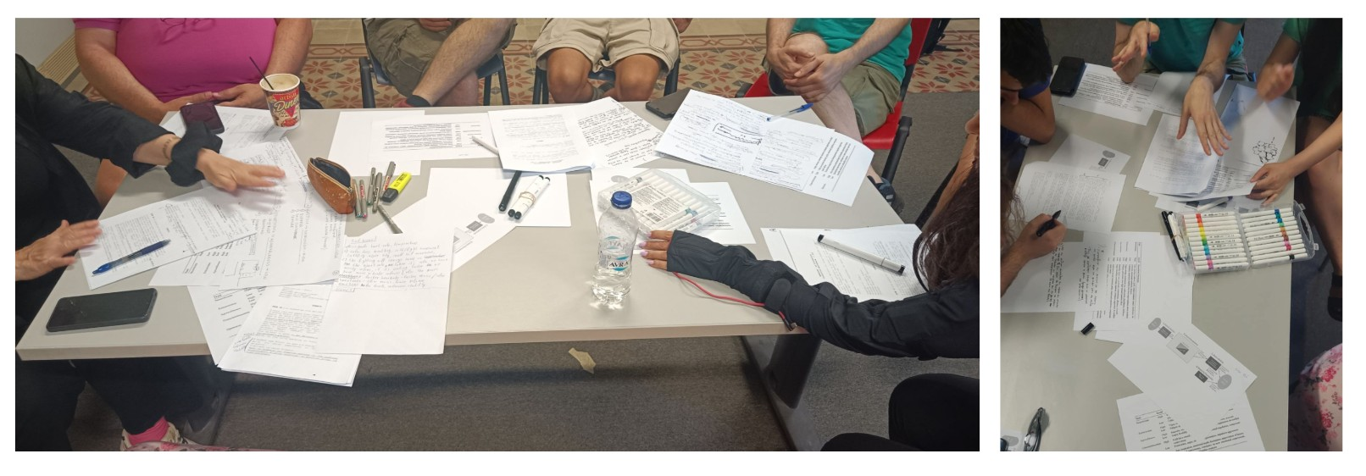
Figure 4: Moments from the workshop with experts. The pictures demonstrate the thinking process of the participants, their handnotes, and the tool provided
Next, participants were divided into groups of two (four groups in total), and each group was given the script “Monolove—An Introduction,” which includes three scenes written by Giorgos Nikopoulos on paper. The writer (who is also an actor) read out loud the script.
Script summary: In the opening scene, two centaurs lie side by side in a cave, wrapped in each other’s arms by the glow of the fire, peacefully asleep. They share a dream. The second scene unfolds their common nightmare: the male centaur is now transformed into a two-legged, human-like figure, unsteady and vulnerable, standing alone and waiting for his partner. In the third scene, the female centaur circles him, revealing a growing emotional and physical distance. A poetic narration accompanies the scenes—spoken by the main centaur—unfolding a stream of thoughts and sensations about their union, separation, and transformation. The voice explores the complexities of desire, loss, and metamorphosis, reflecting on what it means to share a body, to part from it, and to reimagine love through shifting forms.
Using the real-time streaming capabilities of the technical framework, participants were asked to imagine recruiting a performer who would wear the biosensor live and “perform” in dialogue with the digital environment. Based on the centaur’s emotion they wished to augment, each team had to determine a) which biosignals to capture in real-time—heart rate, temperature, and/or skin conductance; and b) how to map the chosen biosignal to a visual parameter (such as color, texture, or light) within the 3D world.

4.2 The workshop outcomes
After the guidelines were given, the teams had approximately one hour to design the use of biosignals in their digital environment. Below are listed the proposals of each team, organized based on the points they selected, which were common in some cases. It is worth noting that Team 4 was able to work on only one point.
Selected Point 1: The two bodies are hugging while sleeping on the floor of the cave.
Team 1 related this scene to emotions of stress resilience and imagined the skin of the centaurs to be transparent and mapped the respiration fluctuations to the inner body liquids, such as blood and pulses.
Team 2 preferred to use the personality traits of extraversion, openness, and agreeableness to describe an umbrella of emotions experienced by the character at this point. And they propose using the respiration rate to map it on the walls of the cave and visualize the humidity lying on them.
Team 3 suggested that this is a scene of highly agreeable emotions and mapped the respiration signal to the fire flames. More precisely, they envisioned that the deeper the breathing, the bigger the flames of the fire, which would also impact the lighting in the cave. Also, they would like to map the connection of the bodies as they are in physical touch (possible measure by GSR or a motion capture system) to the color or ambient light ranging from blue (cold) to more red (warm) light.
Team 4 related this scene to emotions of calmness and mapped the heart rate to lighting and sound. Specifically, the ambient light changes according to the heart rate. When calm (low heart rate), the colors are darker, and when the character is more vivid, the light becomes more vibrant. Also, the music in the beginning will be slower, quieter, and then becomes quicker and more alive and louder as the heart beats faster.
Selected Point 2: Nightmare
Team 3 connected this scene with emotions of high neuroticism and low consciousness. Under this umbrella of emotions, they envisioned employing the temperature of the body to change the colors of the scene, varying from colorful to black and white (greyscale), wanting to indicate the change of emotions during the nightmare. Also, before we see the centaur in its Dali-biped shape, the heart rate is utilized to impact the speed. As a result, the heart rate speeds up due to the nervousness caused by the nightmare, and the scene slows down for the viewer.
Selected Point 3: The narrator talks about the half body.
Team 1 acknowledged that the main character would feel anxiety at this point in the story and decided to make the body of the centaur transparent and connect the parameter of transparency with the breathing rate and breathing volume.
Team 3 changed the lighting of the scene. The scene becomes lighter, and the sound becomes more “empty,” like a water-like sound. The movement of the centaur becomes unstable, like a stilt walker, to demonstrate the uncertainty of the feeling half again.
Selected Point 4: One centaur runs around the other centaur
Team 1 agreed that the scene demonstrates emotions of aggressiveness. As such, the team desires dramatic changes in the environment colors from very bright and intangible or bodiless to shadows and darkness. Specifically, they map the ECG fluctuation to the visual fluctuation from intangible bodies to shadows and darkness.
Team 2 chose extraversion, neuroticism, and low consciousness as personality traits that describe a wide range of emotions. They selected to map skin conductance to ambient colors of lighting and respiration to the movement of visual particles that accompany the movement of the running centaurs.
Selected Point 5: The centaurs sleep after the nightmare.
Team 2 characterized the scene as peaceful and harmonic, and the personality traits expected are openness and agreeableness. They would like to use any biosignal mapped to the clarity of the lines, so the more harmonic and calm the connection, and as such, the measured biosignal the more unclear the lines that separate the bodies from the background.

5. Interactive Media Performance
Maintaining the same technological real-time workflow as in the workshop and preserving the ideas collected from it, the team directed a short experimental intermedia performance of approximately five minutes duration. The core idea of it is to merge live performance and physiology into a single 3D environment in Unity. This allows the audience to simultaneously observe what the body does (movement) and how the body feels (internal state). For movement, we use a Rokoko suit to map the performer's gestures and poses directly onto an avatar in real-time. For physiology, we use Shimmer3 GSR+ Unit sensors that stream biosignals to a computer. A Python program processes these signals and transmits them to Unity over OSC (Open Sound Control), a lightweight network protocol. Unity, with an OSC receiver, translates these signals into changes in light, color, weather, and water. The rendering runs on Unity URP (Universal Render Pipeline), ensuring consistent performance and fine control over lighting and effects.
The performance brings together live performers, digital environments, and real-time interactive technologies. Specifically, the interplay of the performance is shared among five distinct agents:
- A digital character, an avatar named Dali’s Centaur, animated in real-time.
- A performer who wears a Rokoko motion-capture suit (Figure 6), directly animating Dali’s Centaur.
- A biosignal performer who wears a Shimmer wearable unit on her wrist, and her biosignals generate changes in the visual and auditory elements of the digital environment.
- The prerecorded voice of the narrator (performed by the scriptwriter and actor of Monolove) provides the narrative backbone.
- The live director who manages real-time camera control and technical operations within the Unity game engine.
Together, these elements create a hybrid performance that blurs the boundaries between live action, digital media, and immersive storytelling.
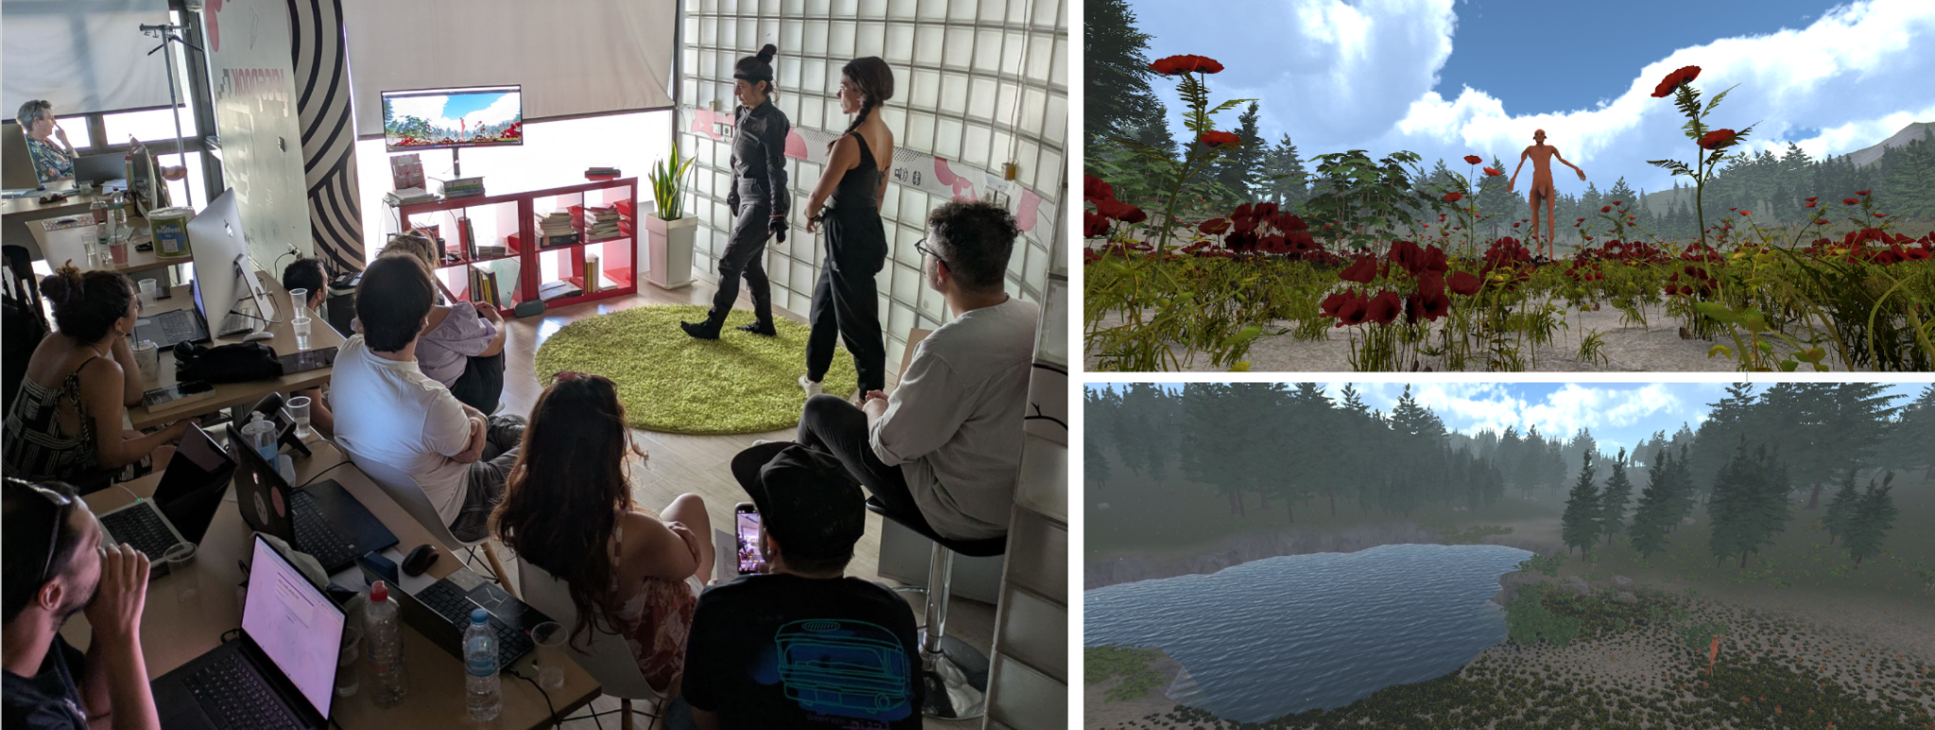
Figure 6: Moments from the interactive media performance. The picture on the left demonstrates: the two performers- one wearing the motion capture costume and the other wearing the biosensor-, the big screen displaying the digital world, and the audience sitting around. The pictures on the right exhibit the character and the surroundings of the digital world (the lake, the flowers, the trees, and the sky).

5.1 Performance Acts
Act 1: The performance starts. The motion-capture performer is on stage. The recorded narrator begins playing in the background. The live director demonstrates the whole digital world to show the digital avatar, Dali’s Centaur, finally. The motion-capture performer moves, and the digital avatar follows her movements. The narrator talks about “my body… I have half of my body… and I feel half as a creation. Only the space around me is full and complete... What keeps me is the body to come… the other half of the body.”
Act 2: At this point, the second performer, the biosignal performer, enters the stage. “Two centaurs are sleeping in their cave, hugging each other. The fire in the cave runs low…” At this point, the two performers act together in the physical world to compose the scenery in the digital world. One defines the movements of the centaur, and the other defines the sounds and visuals of the digital world. The exact mapping of the collected biosignals to the digital world is explained elaborately in the next section.
Act 3: The biosignal performer leaves the stage, and the motion-capture performer stays alone again on the stage. Narrator: “Now again, I have half of my complete body, and I feel half again as a creation. Only the space around me is perfect, united…”

5.2 Mapping Biosignal Data to the Digital Environment
The sensor used for the specific performance was the Shimmer3R GSR+ Unit (by ShimmerSensing). This is a unit that enables the recording of GSR, acceleration, and Photoplethysmography (PPG), which is used to estimate heart pulses, among other parameters. As such, the team decided to utilize the signals in the following way.
Pulse and skin conductance affect ambient light, fog, wind, and rain. In that fashion, a steady pulse and low skin conductance, indicative of calmness, correspond to a bright sky, a clear sky, and a gentle wind. In contrast, quicker pulse and higher skin conductance, indicative of emotional arousal, lead to a darker palette of sky colors, thicker fog, stronger winds, and rain may appear. Using the accelerometer's three axes, we calculated the intensity of the performer's movements, which was mapped to water turbulence: the wave height and particle emission rates, making external physical intensity immediately visible. The audio is used to accompany the physical phenomena of the weather and the waves. As arousal grows, the wind strengthens, and rain or storm layers fade in. More movement brings fuller water sounds. Also, short thunder accents are reserved for the most intense moments.

5.3 Technical Steps for Succeeding Mapping
1. Acquisition and Cleaning (Python): The Python script reads raw Shimmer sensor data, removes artifacts (e.g., unrealistic spikes), filters noise, and computes key metrics: HR from PPG (using peak detection and interval analysis), skin conductance from GSR, and movement intensity from the accelerometer.
2. Normalization and Smoothing: Each metric is normalized to a range of 0 to 1 using realistic bounds and smoothed over time to ensure that visual changes in Unity are fluid and not abrupt.
3. Transport via OSC: The processed metrics are sent to Unity over User Datagram Protocol (UDP) using OSC (e.g., /avatar/gsr, /avatar/hr, /avatar/velocity). OSC is lightweight and ideal for real-time communication between media applications.
4. Mapping in Unity: The OSC Receiver in Unity forwards the incoming values to an Environment Controller. This controller affects the entire scene's lighting, post-processing, fog, weather, wind, and water.
Separating signal processing (in Python) from scene rendering (in Unity) was a crucial step in our application, as it ensures system stability during live performances, simplifies debugging, and allows artistic adjustments without affecting data acquisition. To further ensure stability in our system and independent control of body motion, the avatar was separately animated via Rokoko retargeting.

5.4 Interactive Media Performance Evaluation
A total of 14 people watched the interactive media performance, ranging from 27 to 41 years old. 21.4% of the population were designers, whereas the rest were specialized in performing arts, dance, game design & development, animation, acting, script writing, interactive installations, music & sound compositions, digital storytelling, to name some.
Based on the questionnaire that was shared to the participants 78.6% (11/14) claimed that they considered the performers (live actors) as characters who are part of the play and further explained “the character movement was real-time connected to the performers", “the performers were the ones give life and emotions to the performance through the sounds and their movements”, “they were directing the sound and the environment”.
During the performance, 6 out of 11 participants observed changes in the lake water, 4/11 noticed some environmental changes in general, 4/11 perceived changes in the flowers, trees, and their leaves, 3/11 noticed changes in the light and the weather, 4/11 in the sound, and 2/11 in the wind.
In the question, which of the following biosignals are related to the changes that happened in the virtual world: 14/14 chose movement (speed, acceleration, etc), 9/14 chose heart rate, 5/14 selected the heart rate, 5/14 chose perspiration, and 4/14 chose body temperature. Specifically, 9/11 responded that biosignals impact the digital world, but without suggesting specific correlations. 2/11 noticed the connection between the performer's movement and the motion of the water. Also, the latter group observed the connection of biosignals with the sound and the wind but couldn't precisely connect it with the exact biosignal.

6. Discussion
By combining philosophical, cognitive, and computational perspectives, this work introduces an interdisciplinary workflow that contributes to a deeper understanding of how emotions can be measured, interpreted, and expressed through both biological and digital bodies.
Starting with a philosophical and psychological analysis of emotions, as well as discussing cognitive models of emotions, we provide a useful framework for interpreting biosignals as carriers of embodied information that could be part of a felt experience and, in extension, cognitively labeled as a felt emotion. As such, our approach focuses on internal emotional experiences supporting the theory of embodied cognition, where emotional understanding emerges not only from cognitive labeling but from somatic states.
From a technological perspective, this work presents a framework for collecting, processing, and mapping biosignals into digital environments, mostly in a real-time fashion (the option of pre-recorded data is briefly discussed as a possibility). And it’s important to distinguish the artistic intentionality of it. This is because the system is not designed to detect or classify emotions, but to express them aesthetically. Employing mostly visual and audio possibilities, the research team investigates how such a technological tool could be applied to augment internal emotional experiences in a digital world.
To do this, the team executed the workshop, where they observed participants coming up with various creative possibilities and employing all types of biosignals - heart rate, respiration, temperature, and skin conductance. Surprisingly enough, the participants did not only choose to map the biosignal on the features of the main digital character, the centaur (shape, skin, color, clothes of the avatar), but on visual and audio features of the environment. To be exact, they chose to impact the ambient light color and volume, the shadows of the bodies, the humidity of the cave walls, the fire volume, the color of the scene (from vivid and colorful to grayscale), the speed of the movie (it slows down), the ambient sound, the transparency of the skin, and the movement of the centaurs.
These outcomes guided us in directing interactive media performance without creative limitations. As such, in the presented performance, the felt experiences of the human performer are algorithmically distributed into the digital world, creating a digital character and world that senses in real-time. In this way, the “digital world” functions not as a passive representation but as a co-performer, capable of manifesting and reflecting emotional states in a new visual and auditory manner.
By integrating live biosignals with motion capture for interactive media performance, this study presents a novel approach to bio-interactive performances that could potentially unite real and digital performers. As the performance evaluation demonstrated, 11/14 participants considered the live actor’s part of the performance.
The hybrid architecture (Python for processing and Unity for visualization) provides a replicable model for real-time biosignal-driven systems that balance computational robustness with creative flexibility. Indeed, challenges such as signal noise from significant activity, individual physiological variability, to name a few, remain, and the technical team should be aware of how to limit them.
Ultimately, in this work, emotion becomes a transmedia element spanning physical body, code, and digital environment. The human and digital body emerges as a dynamic interface where affect is generated, perceived, and transformed in various ways (real performers, digital character). By surfacing felt experience through biosignal-driven aesthetics, we possibly move toward a capacity for digital systems to mirror and co-participate in human expression.
7. Conclusion
This study bridges the felt, bodily dimensions of emotion with their external, expressive symbolic representations in digital and performative contexts. This is achieved through a theoretical framework and technical pipeline that enables the real-time mapping of biosignals to the visual and auditory elements of virtual worlds, transforming bodily states into aesthetic experiences. The results demonstrate that although biosignals are not merely indicators of emotion, they can be used as expressive agents, capable of shaping immersive environments. Both the workshop experimentation and performance revealed the artistic potential of physiological data as a creative tool, expanding the language of interactive media performance. This work reimagines emotion as a co-expression that emerges between the body, technology, and digital space, opening new pathways for research and creation in affective computing, embodied interaction, and media art.
Acknowledgements
This research is held in the framework of the funded project IMAGINE MOCAP with ID: 015668 and is supported by the National Recovery and Resilience Plan, Greece 2.0, and the European Union NextGeneration EU Implementation body: HFRI (Hellenic Foundation for Research and Innovation), Greece, 2024–2026. More information can be found in: https://www.elidek.gr/en/homepage/ (accessed on 25 October 2025).
7. References
Bekoff, M. (2007). Animals matter: A biologist explains why we should treat animals with compassion and respect. Shambhala Publications.
Cannon, W. B. (1927). The James-Lange theory of emotions: A critical examination and an alternative theory. The American Journal of Psychology, 39(1/4), 106–124.
Cannon, W. B. (1987). The James-Lange theory of emotions: A critical examination and an alternative theory. The American Journal of Psychology, 100(3/4), 567–586.
Chalmers, D. J. (1997). The conscious mind: In search of a fundamental theory. Oxford Paperbacks.
Choppin, A. (2000). EEG-based human interface for disabled individuals: Emotion expression with neural networks [Unpublished master’s thesis].
Clarke, B. (2023). Animate being: Extending a practice of the image to new mediums via speculative game design [Doctoral dissertation, University of Essex].
Dower, J., & Langdale, P. (2022). Performing for motion capture: A guide for practitioners [Book]. Bloomsbury Methuen Drama.
Egger, M., Ley, M., & Hanke, S. (2019). Emotion recognition from physiological signal analysis: A review. Electronic Notes in Theoretical Computer Science, 343, 35–55. https://doi.org/10.1016/j.entcs.2019.04.009
Ekman, P. (1992). An argument for basic emotions. Cognition & Emotion, 6(3–4), 169–200. https://doi.org/10.1080/02699939208411068
Ekman, P. (2007). The directed facial action task. In Handbook of emotion elicitation and assessment (Vol. 47, pp. 53–70). Oxford University Press.
El Raheb, K., Stergiou, M., Koutiva, G., Kalampratsidou, V., Diamantides, P., Katifori, A., Ioannidis, Y., Issari, P., Georgaca, E., Karydi, E. and Skali, D.,(2023), September. Data and Artistic Creation: Challenges and opportunities of online mediation. In Proceedings of the 2nd International Conference of the ACM Greek SIGCHI Chapter (pp. 1-8).
El-Raheb, K., Kougioumtzian, L., Kalampratsidou, V., Theodoropoulos, A., Kyriakoulakos, P., & Vosinakis, S. (2025). Sensing the Inside Out: An Embodied Perspective on Digital Animation Through Motion Capture and Wearables. Sensors, 25(7), 2314.
Gross, J. J. (1998). The emerging field of emotion regulation: An integrative review. Review of General Psychology, 2(3), 271–299. https://doi.org/10.1037/1089-2680.2.3.271
Harman, G. (2018). Object-oriented ontology: A new theory of everything. Penguin UK.
James, W. (1948). What is emotion? (1884). Appleton-Century-Crofts.
Kalampratsidou, V., & Torres, E. B. (2019, October). Bodily signals entrainment in the presence of music. In Proceedings of the 6th International Conference on Movement and Computing (pp. 1-8).
Kalampratsidou, V., & Torres, E. B. (2020, July). Sonification of heart rate variability can entrain bodies in motion. In Proceedings of the 7th International Conference on Movement and Computing (pp. 1-8).
Kalampratsidou, V., Kemper, S., & Torres, E. B. (2021). Real-time proxy-control of re-parameterized peripheral signals using a close-loop interface. J. Vis. Exp, 171, e61943.
Kalampratsidou, V., Koutiva, G., El Raheb, K., Stergiou, M., Diamantides, P., Katifori, A., ... & Pappas, Y. (2024, May). Here is an episode! Synchronizing and organizing citizens' biosignals for global artistic inspiration. In Proceedings of the 9th International Conference on Movement and Computing (pp. 1-8).
Kim, J., & André, E. (2008). Emotion recognition based on physiological changes in music listening. IEEE Transactions on Pattern Analysis and Machine Intelligence, 30(12), 2067–2083. https://doi.org/10.1109/TPAMI.2008.26
Kolokotroni, A., Stergiou, M., Baltas, D., Kalampratsidou, V., Kyriakoulakos, P., & Vosinakis, S. (2025, September). Expressing Digital Character Personality through Motion capture: A study of body movements and personality traits. In Proceedings of the 3rd International Conference of the ACM Greek SIGCHI Chapter (pp. 71-77).
Lazarus, R. S. (1982). Thoughts on the relations between emotion and cognition. American Psychologist, 37(9), 1019–1024. https://doi.org/10.1037/0003-066X.37.9.1019
Lazarus, R. S. (1991). Emotion and adaptation. Oxford University Press.
Lindsley, D. B. (1952). Psychological phenomena and the electroencephalogram. Electroencephalography & Clinical Neurophysiology. Elsevier Science.
Mehmood, R. M., & Lee, H. J. (2016). A novel feature extraction method based on late positive potential for emotion recognition in human brain signal patterns. Computers & Electrical Engineering, 53, 444–457. https://doi.org/10.1016/j.compeleceng.2015.10.009
Nagel, T. (1980). What is it like to be a bat? In The language and thought series (pp. 159–168). Harvard University Press.
Picard, R. W. (2000). Affective computing. MIT press.
Rigas, G., Katsis, C. D., Ganiatsas, G., & Fotiadis, D. I. (2007). A user-independent, biosignal-based, emotion recognition method. In User Modeling 2007: 11th International Conference, UM 2007, Corfu, Greece, July 25–29, 2007. Proceedings (pp. 314–318). Springer.
Russell, J. A. (2003). Core affect and the psychological construction of emotion. Psychological Review, 110(1), 145–172. https://doi.org/10.1037/0033-295X.110.1.145
Sanz, J., García-Vera, M. P., & Magan, I. (2010). Anger and hostility from the perspective of the Big Five personality model. Scandinavian Journal of Psychology, 51(3), 262–270. https://doi.org/10.1111/j.1467-9450.2009.00766.x
Schachter, S., & Singer, J. E. (1962). Cognitive, social, and physiological determinants of emotional state. Psychological Review, 69(5), 379–399. https://doi.org/10.1037/h0046234
Sloman, A. (2007). Why some machines may need qualia and how they can have them: Including a demanding new Turing test for robot philosophers. In AAAI Fall Symposium: AI and Consciousness (pp. 9–16).
Viégas, F. B., & Wattenberg, M. (2007, July). Artistic data visualization: Beyond visual analytics. In International Conference on Online Communities and Social Computing (pp. 182-191). Berlin, Heidelberg: Springer Berlin Heidelberg.
Villarejo, M. V., Zapirain, B. G., & Zorrilla, A. M. (2012). A stress sensor based on galvanic skin response (GSR) controlled by ZigBee. Sensors, 12(5), 6075–6101. https://doi.org/10.3390/s120506075
Wan, C., Chen, D., Huang, Z., & Luo, X. (2022). A wearable head-mounted display bio-signals pad system for emotion recognition. Sensors, 22(1), 142. https://doi.org/10.3390/s22010142
Wu, G., Liu, G., & Hao, M. (2010). The analysis of emotion recognition from GSR based on PSO. In 2010 International Symposium on Intelligence Information Processing and Trusted Computing (pp. 360–363). IEEE.
Zhao, S., Ding, G., Han, J., & Gao, Y. (2018). Personality-aware personalized emotion recognition from physiological signals. In Proceedings of the 27th International Joint Conference on Artificial Intelligence (IJCAI)

imagine-mocap.aegean.gr
xarts.aegean.gr

