From MoCap to Materiality: A Practice-Based Pipeline for Real-Time Cloth Simulation for digitally enhanced performances

Marina Stergiou Spyros Vosinakis,
University of the Aegean University of the Aegean
mstergiou@aegean.gr spyrosv@aegean.gr

Abstract
In this work, we present a practice-based pipeline for real-time cloth simulation and interaction in a live digital performance context. Using a Rokoko motion-capture suit, we drive a Metahuman character in Unreal Engine and implement physically responsive garments with the Chaos Cloth plugin. While real-time Motion Capture (MoCap) streaming to game engines is established, real-time garment simulation for performance remains under-documented; we therefore report a focused case study with two digital costumes, with different draping abilities, and a mini-experiment using a think-aloud protocol. Results highlight (i) material depiction vs movement perception is an interesting area that requires exploration and focused experiments, (ii) the creative value of “non-realistic” draping as expressive features rather than bugs (iii) responsive cloth simulation can lead to increased performer mobility, and (iv) this pipeline is robust and sufficient for choreographic practices. Finally, we discuss implications for collaborative workflows between choreographers and costume designers, and we conclude with future work in rehearsal and performance settings including future tools that bridge digital costume simulation and choreographic practice.

Key-words: Real-time cloth simulation; Motion capture; Rokoko; Digital costume design; Embodied interaction; Performance technology

- Introduction
The synergy of real-time cloth simulation, motion capture systems, and modern game engines has created new opportunities for live performance, virtual production, and digital costume design. Unlike traditional game development, where cloth simulation primarily enhances pre-rendered content, performance and costume design contexts demand real-time responsiveness. Creative professionals- choreographers, costume designers, and performers- require immediate visual feedback to guide decision-making and enable live interaction during rehearsals and performances (Porterfield 2025; Yu 2019). Meeting these needs requires cloth simulation systems capable of operating with minimal latency while preserving the visual fidelity expected in theatrical and fashion design workflows. Traditional cloth simulation methods can produce highly convincing results but are typically computationally expensive and designed for offline rendering (Choi, 2005). As a result, they are poorly suited to live performance scenarios, where immediacy and interactivity are essential (Porterfield, 2025). Advances in motion capture technologies such as the Rokoko suit, combined with real-time rendering engines like Unreal Engine, now provide the technical foundation to bridge this gap. Nevertheless, the application of real-time cloth simulation to performance practice remains underexplored, despite its potential to reshape costume and choreography workflows.
The value of real-time simulation extends beyond technical achievement. Virtual production workflows increasingly rely on visualizing garment behavior during rehearsals, enabling directors and designers to make informed creative decisions without the time and cost of physical prototyping (Porterfield, 2025). In live theatre, projection mapping and augmented reality can overlay digital costumes onto performers, enabling transformations and variations that physical costumes cannot achieve (Chen, 2019). Such possibilities highlight the growing importance of integrating real-time simulation into performance design.
At the same time, the technical challenges for performance-oriented cloth simulation differ substantially from those in traditional game development. Live contexts require ultra-low latency to maintain synchronization between movement and visual feedback, while also accommodating the unpredictability of performance, from sudden gestures to complex costume–environment interactions. Integration with motion capture introduces additional complexity, as noisy sensor data must be reconciled with physical simulation constraints in real time (Yu, 2019). Game engines such as Unreal and Unity provide sophisticated rendering and physics pipelines but adapting them for performance use requires careful reconfiguration of simulation priorities and accessible toolsets for designers (Va, 2021).
In this paper, we present a pipeline for real-time cloth simulation in Unreal Engine, combining Rokoko motion capture with Metahuman characters dressed in digitally created garments. Rather than introducing a novel algorithm, this work consolidates existing techniques into a robust workflow tailored to performance contexts. We evaluate this approach through a small-scale experiment, where a performer interacted with digital costumes while engaging in choreographic tasks. The two costumes were nearly identical, differing only in the level of draping realism, that is, in how the fabric responded to movement. Our contributions are the following: (i) documenting a practical method for integrating real-time cloth simulation into live performance, (ii) assessing user experience and feedback loops between performer and design team, and (iii) outlining opportunities for future applications in choreography and costume design.

- Theoretical grounding
This study is motivated by the potential applications that digital moving costumes can have in i) dance learning and movement experimentation, ii) assisting choreography, iii) costume design. Below we present some theory on somatic costumes that explain how physical garments have the potential to affect the movement, by shaping it or restricting it. We argue that digital costumes might enhance the above scenarios, especially when combined with imagery practices (Stergiou, 2019).
Somatic costumes are wearable designs created to facilitate body-mind integration and multisensorial awareness, offering dancers new pathways for movement exploration and choreographic creativity. Developed through Sally E. Dean’s Somatic Movement, Costume & Performance Project, these costumes begin not with aesthetic visual design, but with the live, moving, and perceiving body as the foundation of the creative process. Somatic costumes are intentionally designed to alter body schema and image by engaging tactile, kinaesthetic, and spatial perceptions, often leading to novel movement vocabularies and embodied experiences (Dean, 2012; Dean, 2016). This methodology draws heavily on somatic movement practices, particularly the Skinner Releasing Technique, which encourages movement repatterning through guided imagery, touch, and attention to internal sensation. Such costumes are crafted to physically cue sensations like buoyancy or containment, helping performers access experiential qualities that can transform their relationship to their bodies and the environment. Lorraine Smith extends this discourse by advocating for costume as a pedagogical somatic tool in dance education. She argues that costumes can serve as an effective external stimulus for somatic learning, especially for students who may struggle with internal focus. Through structure, texture, and weight, costume offers embodied feedback that bridges internal sensation with external expression, fostering empathy, identity exploration, and performative presence (Smith, 2020). This layered understanding underscores how costumes, especially in digital or augmented environments, can act as agents of transformation- mediating between body, technology, and creative expression.

- Related Work
The field of computer graphics has seen remarkable progress as computational power continues to increase, enabling ever more sophisticated real-time cloth simulation systems. However, as noted earlier, the aim of this work is not to propose a new algorithm or system, but to demonstrate a practical pipeline that integrates live motion capture with real-time cloth simulation. Much of the existing research showcases specific technical developments- often demonstrated on a single piece of fabric- without addressing the full workflow required to create and apply complete digital costumes. Our contribution lies precisely in bridging this gap, by documenting an implementable, end-to-end pipeline for performance applications. Below we present some related work. We divided it into two parts: First we discuss technological achievements in the field of real-time cloth simulation for Performance Applications and afterwards we present applications in performance or costume design.

  - Real-Time Cloth Simulation Advancements for Performance Applications
The development of real-time cloth simulation systems for live performance applications has been driven by the demanding requirements of virtual production, digital theater, and interactive entertainment. However, educational applications that consider cloth simulation as a tool for learning and practicing choreography have been also discussed in prior work (Stergiou, 2022). Unlike traditional offline cloth simulation used in film and animation, performance applications require systems that can respond to live performer input with minimal latency while maintaining visual plausibility and stability.
SimulCap, developed by Yu et al. (Yu, 2019), represents a significant advancement in single-view human performance capture with integrated cloth simulation. Their approach demonstrates how multi-layer performer representations, separating undressed body geometry from clothing meshes, can enable skeleton-driven cloth simulation with iterative depth fitting from a single RGBD sensor. This work is particularly significant for performance applications as it addresses the fundamental challenge of capturing and simulating cloth behavior under occlusion conditions common in live performance scenarios.
The integration of compute shader-based cloth simulation into game engines has proven particularly effective for performance applications. Va et al. (Va, 2021) developed a real-time cloth simulation system using Unity compute shaders specifically designed for AR/VR content creation. Their implementation of Adaptive Constraint Activation and Deactivation (ACAD) techniques addresses the stability issues commonly encountered in mass-spring systems when dealing with the rapid movements typical of live performance. The GPU-parallel implementation achieves the throughput necessary for real-time performance while maintaining the stability required for live applications.
Recent advances in WebGPU technology have expanded the possibilities for high-resolution cloth simulation in performance contexts. Sung et al. (Sung, 2025) demonstrated that WebGPU compute shaders can maintain interactive frame rates for cloth meshes containing hundreds of thousands of nodes, significantly expanding the resolution and detail possible in live performance applications. This scalability is crucial for costume design applications where fine fabric details contribute significantly to the overall visual impact.
More recently, Lucero (Lucero, 2025) demonstrated a complete pipeline integrating Rokoko motion capture with Unreal Engine 5.4 and Chaos Cloth, evaluating its feasibility for real-time visualization in virtual production. While their work focuses on technical implementation and on-set performance capture, it reinforces the potential of cloth simulation as a tool for live creative feedback.

  - Cloth simulation applications in choreography and costume design
Non real time cloth simulation, or pre-rendered cloth behavior can be also very useful for choreography and costume design applications. Porterfield and Oliver (Porterfield, 2025) describe how choreographers and costume designers engage with 3D cloth modeling software (CLO3D) in costume development, highlighting its value as a collaborative tool. Their study shows that digital cloth simulation improves design communication by enabling dancers to give feedback on garments, clarifying silhouette and surface design choices, and ultimately shaping both costume and choreographic decisions. Interestingly, choreographers embraced technology more readily than costume designers, who expressed initial skepticism. Nevertheless, the integration of such tools supports a deeper understanding of the relationship between movement and material in performance.
Similarly, Ilic et al. (Ilic, 2024) investigate the use of digital cloth simulation in theatrical costume design, focusing on how platforms like Marvelous Designer combined with motion-tracking can enrich the creative process. Their findings suggest that virtual costume fitting, and choreography not only inform design decisions but also influence the aesthetic character of live performances, showing that digital cloth environments can significantly affect how movement and material are perceived on stage.

- Methodology
In this section we document the procedure for building our prototype in terms of tools and steps needed. We chose Unreal Engine as our working platform since research showed it is more suitable for handling cloth simulation tasks. For motion capture, we used a Rokoko suit. Finally, we describe the mini experiment where we tested the moving costumes with one user.

  - Technical implementation of the pipeline
Below we present the technical steps taken to implement the presented pipeline and results.

Phase 1: Designing the costumes
To design the costumes, we selected a female Metahuman as a model, that would be used later as the user’s avatar. Metahumans are digital characters of high realism, compatible with Unreal Engine. We imported this metahuman into Marvelous Designer, a 3D software dedicated to designing 3D costumes for digital media, that followed a pattern-based logic (Figure 1).

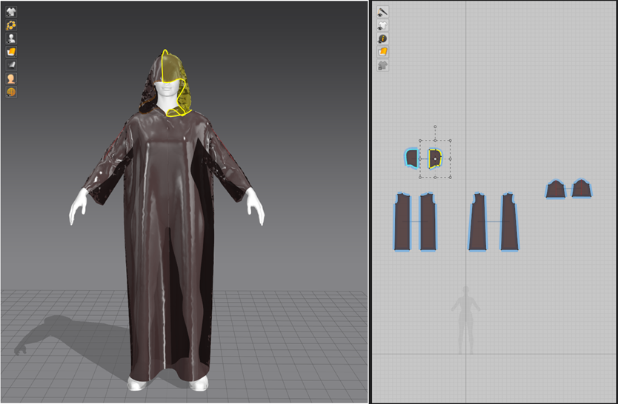
Figure 1 Designing the costumes in Marvelous Designer using 2D pattern logic.

We designed two visually similar costumes; the first one was a very long and very wide dress as shown on the left side of Figure 2 and the second one a less long and wide dress with a hood as shown on the right side of Figure 2. The materials were configured in Unreal Engine later; gold metallic material was used for both. For the first dress, a texture that resembles stone was used in a front lane as shown in the image. The basic difference between these two dresses is the way they were configured to behave in movement. The first one, was set in a way that draped unnaturally, as if it ended in a stiff tube that didn't allow smooth movement and from now on, we will refer to it as “Stiff dress”. The second dress, from now on named “Smooth dress” responds smoothly to the movement and was set to resemble silk properties.

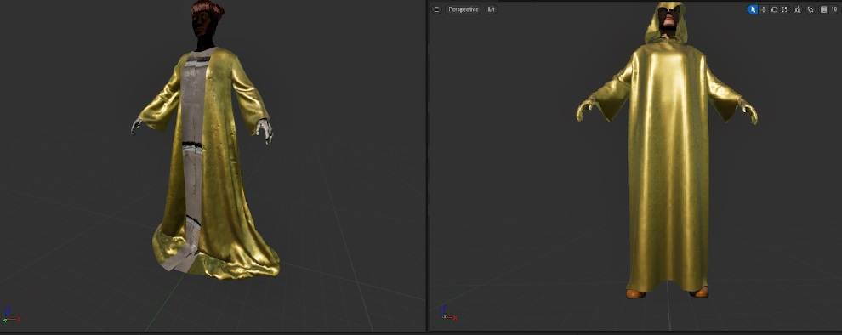
Figure 2 Stiff dress (left) and Smooth dress (right)

Phase 2: Importing to Unreal Engine
The next step was to export the two costumes as .FBX files and import them to Unreal Engine. After installing all Chaos Cloth components (plugins compatible with Unreal Engine for improved cloth simulations), we performed a series of settings to configure the proper parameters that determine cloth behavior and to attach the costumes to our metahuman character. Some of them were friction, density, weight, aerodynamic factors etc. Figure 3 shows a screenshot of Unreal Engine while tweaking the settings and simultaneously previewing the costume’s behavior in motion. After experimenting with various settings, we came up with a well responding configuration.

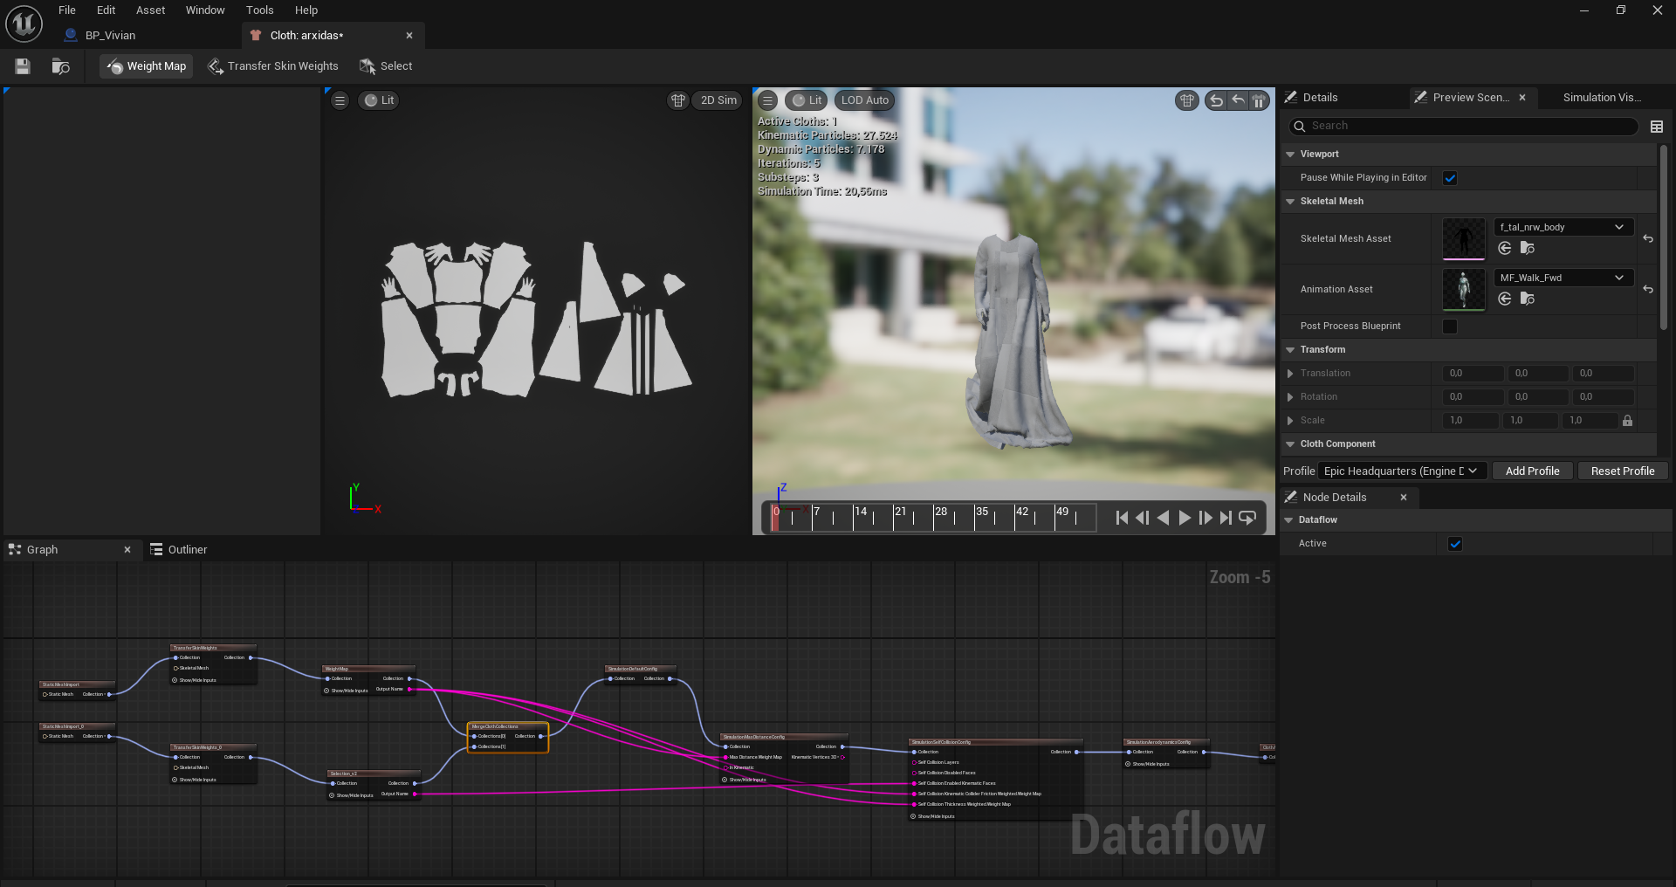
Figure 3 Configuring the cloth simulation parameters in Unreal Engine

Phase 3: Streaming from Rokoko
For the live motion capture session, the Rokoko Smart Suit Pro II (v2), a marker-free motion capture system designed to record whole-body movement was used. It employs inertial motion capture technology, and its strengths include portability, ease of connection and installation, and most importantly, real-time feedback. Since the compatibility of Rokoko and Unreal Engine is well documented we managed easily to stream live action from Rokoko into our metahuman while the costumes attached to our model maintained the simulation properties we set earlier.

  - Mini- Experiment
When all the above steps and technical issues were resolved, we were ready to proceed with our mini experiment. The aim of this experiment was i) to test the pipeline in terms of achieving real time cloth simulation with the given setup, ii) to explore the behavior of each costume and how the user reacts to them, iii) to discuss future applications in dance and costume design, after receiving this initial feedback.

Technical setup
For this experiment, we recruited a design student with no dance experience. The process was carried out in a space approximately 4*4 meters. The user was wearing the Rokoko suit while seeing themselves on a big projection screen (Figure 4, left) . The screen showed the metahuman wearing the costume which was responding to the user’s movement. A screenshot of the metahuman wearing the Stiff costume inside Unreal Engine can be seen in Figure 4, on the right.

The procedure
Initially, we explained the purpose of this experiment to the user- that they would be asked to perform some tasks; assisted them with wearing the suit and started the streaming into Unreal Engine. A group of experts in dancers, animation, design and motion capture were also in the room, and a conversation between them and the user took place. The whole procedure was coordinated by one of the authors, who was handling the technical part, asking the user to perform certain movements, and facilitating the discussion between user and the group of experts. The user was encouraged to use a think aloud protocol while doing the tasks.
Starting with the Stiff dress, the user was initially asked to move freely in space and explore their avatar. During this step, the user was hesitant to move too freely, and was mainly performing small, controlled movements. It was brought up by them and by the group that the behavior of the costume is a bit stiff in the lower part. However, some thought of this as an interesting feature although perceived as non-realistic cloth behavior. After approximately 2 minutes the user was encouraged to move more. “Do you want to try a kick or a turn?”, were prompts given by the facilitator. After a while the user felt more confident and started interacting more with their avatar. They particularly performed kicking movements, observing the flow of the dress. A short video of the interaction with the Stiff dress can be found here.
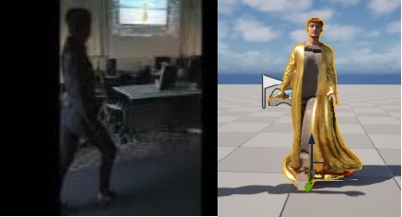
Figure 4 User moves dressed in Rokoko suit (left) while seeing their avatar moving on screen (right).

The same procedure was repeated with the second dress (Smooth dress) which had a more realistic behavior; it was draping in a smooth way. While trying out this dress, it was observed that the user was more engaged in movement. They moved at a faster pace and had a flow between their movements. Smooth costume’s behavior to movement was met with greater enthusiasm by both user and the group. The fact that the dress was smoothly moving along, encouraged the user to try turning and moving their parts more frequently, testing at the same time the cloth behavior since “it felt more natural”. However, some problems appeared during this trial- the costume sometimes “went out” of the character as if it was hanging only by their neck and behaved like a cape. This bug was greeted with enthusiasm by the user as they were moving more intensively during this phase, enjoying this odd behavior. A video with the Smooth costume can be found here.

- Results and Discussion
The proposed pipeline successfully demonstrated that real-time cloth simulation can be achieved within Unreal Engine using a combination of Metahuman avatars and Rokoko motion capture data. The system performed with sufficient responsiveness for live interaction, confirming its suitability for time-sensitive applications such as dance and interactive performance. While some parameter tuning remains necessary to refine physical accuracy, particularly regarding collision stability and material calibration- the responsiveness observed during testing suggests that the current setup can meet the temporal demands of choreographic exploration and costume prototyping.
A key finding relates to how virtual materials affected both perception and movement. Although the digital garments used metallic and stone-like textures, they moved softly and fluidly. This contrast between what the materials looked like and how they behaved created an interesting visual and physical paradox. It encouraged both the participant and the experts to think about how non-realistic visuals might change the way people move and respond. Previous work has shown that imagery and metaphor can influence movement behavior (Stergiou, 2019), and our results suggest that similar effects might happen when using digital materials. However, more research and targeted experiments are required to allow conclusions on this topic. Future studies could explore this further by testing how unusual combinations- like “soft metal” or “liquid stone”- affect movement and perception during performance.
Both digital costumes encouraged movement, but in different ways. The Stiff costume led to slower, more intentional gestures, while the Smooth costume encouraged flowing, continuous, and more exploratory movement. These differences reflect Dean’s (Dean 2012; Dean 2016) idea of somatic costume design, where the material qualities of a garment influence how the body moves and feels. In our case, digital cloth acted almost like a sensory interface that shaped the user’s movement even though they were not a dancer. For dance practice, this suggests real potential: by adjusting digital cloth settings, designers and choreographers can guide learning, improvisation, and creative exploration in a virtual space.
Interestingly, some technical problems became part of the creative process. When the Smooth dress detached and floated like a cape, or when the Stiff dress moved in an unnatural way, these glitches were not seen as errors. Instead, they were received with curiosity and enthusiasm. This response supports the idea that small technical surprises can encourage exploration and new ideas in performance and can spark dialogue between performers, designers, and technologists, turning technical imperfections into creative inspiration.
Overall, the results affirm that the proposed practice-based pipeline not only achieves functional real-time simulation but also supports embodied exploration and interdisciplinary dialogue. By merging somatic awareness, creative experimentation, and technical adaptability, the system opens new possibilities for designing expressive, performative digital garments that extend beyond visual realism toward experiential interaction.

- Conclusions and Future Work
This study has presented a practice-based workflow for integrating motion capture, digital garment creation, and real-time cloth simulation into a cohesive system for performance assistance. The results confirm the feasibility and creative potential of such a pipeline for both research and applied contexts in dance, choreography, and costume design. Future work will extend this framework to include professional dancers and costume designers engaging in co-creative, real-time scenarios. By involving multiple users, we aim to examine how different levels of movement expertise influence engagement with digital cloth and how simulation parameters can be tuned to match choreographic intent. The next phase will also incorporate physical costumes, enabling comparative studies between digital and real materials to explore the boundaries of embodiment and material perception. Another avenue involves developing custom digital tools to facilitate communication between choreographers and costume designers. These tools will focus on real-time visualization and parameter control enhancing collaborative decision-making during both design and rehearsal phases. Beyond creative performance, the pipeline holds potential for educational applications, enabling learners to experiment with materiality, movement, and design principles in hybrid physical–digital spaces. In conclusion, while the current prototype demonstrates only an initial step toward integrating real-time cloth simulation into performative practice, it highlights the transformative potential of digital materiality. By merging motion, fabric, and feedback in a shared digital space, this work contributes to a growing discussion on how technology can reframe embodiment, collaboration, and creative authorship in contemporary performance practices.

- References
Chen, H. N., Chiu, C. F., Shih, T. K., Lin, C. Y., Utaminingrum, F., & Hui, L. (2019, August). The design of real-time digital clothing projection system. In 2019 Twelfth International Conference on Ubi-Media Computing (Ubi-Media) (pp. 102-107). IEEE.
Choi, K. J., & Ko, H. S. (2005). Stable but responsive cloth. In ACM SIGGRAPH 2005 Courses (pp. 1-es).
Dean, S. E. (2012). Somatic movement and costume: A practical, investigative project. Journal of Dance & Somatic Practices, 3(1-2), 167-182.
Dean, S. E. (2014). Somatic costumes™: Traversing multi-sensorial landscapes. Scene, 2(1-2), 81-87.
Dean, S. E. (2016). Where is the body in the costume design process?. Studies in Costume & Performance, 1(1), 97-111.
Ilić, T., Banjanin, B., & Pinćjer, I. (2024). From Sketch to Animated 3D Model: Theatrical Costume Design. In International Symposium on Graphic Engineering and Design (pp. 291-300).
Lucero, C. (2025). Real-Time Motion Capture and Virtual Production: integrating Cloth Simulation into Real-time Performance Capture and Visualization. https://www.theseus.fi/handle/10024/892440
Porterfield, A., & Oliver, C. (2025, January). Using CLO3D to Facilitate Design Collaboration. In International Textile and Apparel Association Annual Conference Proceedings (Vol. 81, No. 1). Iowa State University Digital Press.
Smith, L. (2020). Costume as a somatic tool in dance education: A provocation. Journal of Dance & Somatic Practices, 12(2), 255-265.
Stergiou, M., & Vosinakis, S. (2022, June). Exploring costume-avatar interaction in digital dance experiences. In Proceedings of the 8th International Conference on Movement and Computing (pp. 1-6).
Stergiou, M., El Raheb, K., & Ioannidis, Y. (2019, October). Imagery and metaphors: From movement practices to digital and immersive environments. In Proceedings of the 6th International Conference on Movement and Computing (pp. 1-8).
Sung, N. J., Ma, J., Kim, T., Choi, Y. J., Choi, M. H., & Hong, M. (2025). Real-Time Cloth Simulation Using WebGPU: Evaluating Limits of High-Resolution. arXiv preprint arXiv:2507.11794.
Va, H., Choi, M. H., & Hong, M. (2021). Real-time cloth simulation using compute shader in Unity3D for AR/VR contents. Applied Sciences, 11(17), 8255.
Yu, T., Zheng, Z., Zhong, Y., Zhao, J., Dai, Q., Pons-Moll, G., & Liu, Y. (2019). Simulcap: Single-view human performance capture with cloth simulation. In Proceedings of the IEEE/CVF conference on computer vision and pattern recognition (pp. 5504-5514).

https://www.rokoko.com
https://docs.unrealengine.com/5.0/en-US/chaos-physics-in-unreal-engine/
https://www.marvelousdesigner.com/
https://www.youtube.com/watch?v=cDZ6PD3MoQQ&feature=youtu.be
https://www.youtube.com/watch?v=tSx4EISpBfs

