Transmedia Embodiment: A Review of Character Frameworks in Animation, Computer games and Interactive installations with Motion capture

Anthie Kolokotroni Panagiotis Kyriakoulakos
Phd researcher, University of the Aegean Assistant professor, University of the Aegean
a.kolokotroni@aegean.gr pank@aegean.gr

Abstract
In contemporary digital media, characters increasingly appear across multiple platforms, forming interconnected and coherent narrative worlds. This paper presents a theoretical review of character design frameworks in three digital media such as animated films, computer games and interactive installations using motion capture (MoCap) to shape transmedia narratives. Drawing on theoretical and design frameworks, this study examines how embodiment, physical, emotional, and virtual, is conveyed through the interpretation, gesture, and general movement of characters. Using examples from the film industry and practical research, the paper explores MoCap as a design and interpretation tool, enabling emotional realism and real-time interactivity. By analyzing various principles of animation, game interactivity, and interactive environments, the review identifies strategies for maintaining the coherence of digital characters when applied across different digital media and narratives. The findings contribute to advancing and strengthening transmedia character theory as well as digital storytelling and design practices.

Keywords: transmedia narratives, transmedia embodiment, digital characters, motion capture technology

- Introduction
The increasing convergence of digital media has led to new practices of storytelling and digital character design that no longer focus exclusively on individual platforms but instead emerge as transmedia experiences. Transmedia storytelling refers to narratives that unfold across multiple platforms, enabling audiences to engage through diverse entry points (Rajewsky, 2005). Within this framework, transmedia characters can be understood as digital figures whose personality traits and visual identity persist or purposefully evolve across media, transcending formats such as novels, films, games, anime, and comics (Kunz & Wilde, 2023).
In contemporary digital culture, digital characters are not limited to the medium in which they were first created, but can be adapted to animation, computer games, interactive installations, and emerging performance forms while maintaining a recognizable identity. This conceptualization of digital characters aligns with what Jenkins (2006) defines as transmedia storytelling, in which narrative worlds unfold across multiple channels, each contributing distinct elements to a broader fictional universe.
Within this context, the concept of embodiment, along with the emotional experience of perception and action in digital environments, becomes central to understanding how audiences perceive, interpret, and interact with digital characters (Dourish, 2001; Merleau-Ponty, 1962; Noë, 2004). Embodiment provides a framework for examining how movement, gesture, and bodily expressiveness contribute to character coherence and emotional engagement across media.
Despite the growing scholarly interest in transmedia narratives, existing frameworks often address characters in medium-specific ways. Much academic research has focused primarily on narrative expansion, franchising, and media convergence (Ryan et al., 2004), often overlooking how characters are physically and emotionally performed across platforms. Animation studies emphasize the “illusion of life” and aesthetic strategies of movement (Thomas & Johnston, 1995; Furniss, 2008), while game studies focus on immersion, agency, and player–character relationships (McMahan, 2003; Isbister, 2016). Similarly, interactive performance and installation studies examine liveliness, emotion, and spatial interaction (Dixon, 2007; Salter, 2010; Klich & Scheer, 2012). However, these perspectives rarely intersect, resulting in a fragmented understanding of how digital characters function consistently across different digital media.
At the same time, motion capture technologies are often treated primarily as technical tools within production pipelines rather than as interpretive and performative methodologies (Menache, 2010; Delbridge & Fairclough, 2020; Harvey et al., 2024). This reveals a research gap, as there is still no integrative perspective that situates embodiment and motion capture at the center of transmedia character design across platforms.
Addressing this gap, the present paper offers a comparative and theoretically grounded review of character frameworks in animation, computer games, and interactive installations, with particular emphasis on embodiment and motion capture practices. Τhis study synthesizes existing theoretical and practical approaches in order to identify recurring principles that support the coherence, expressiveness, and continuity of digital characters across media.
This review is structured around three analytical axes. First, it synthesizes theoretical approaches to transmedia storytelling and embodiment. Second, it examines how character frameworks differ across animation, computer games, and interactive installations, while identifying shared principles that emerge across these media. Third, it explores how motion capture functions both as a design tool and as a performative practice mediating between the human body and digital characters.
Based on this comparative synthesis, the paper addresses the following research questions:
- To what extent and in what ways do existing transmedia narrative frameworks incorporate embodiment into character design?
- In what ways do character frameworks in animation, computer games, and interactive installations differ, and what similarities can be identified?
- How does motion capture (MoCap) function not only as a tool for technical fidelity but also as a methodology for the design and performance of digital characters?
- How can an integrative perspective on transmedia embodiment contribute to understanding character coherence across different digital media?
The paper is divided into six sections. Following this introduction, the background section situates the discussion within transmedia narrative theory and embodiment studies. This is followed by a comparative analysis of character design frameworks in animated films, video games, and interactive installations. A dedicated section then focuses on motion capture, examining its role in shaping both realism and creative interpretation (Delbridge & Fairclough, 2020; Nirme et al., 2020). The final sections synthesize these perspectives and outline directions for future research on gesture, movement, and embodied performance in digital character design.
Overall, this paper argues that digital characters should be understood not merely as representational constructs but as embodied and interpretive entities that mediate between human performance, technological systems, and audience experience. By foregrounding embodiment within transmedia character studies, the paper contributes to ongoing theoretical discussions while also informing creative practices across animation, game design, and interactive media production.

- Background
The concepts of transmedia frameworks and embodiment theory together provide a basis for analyzing how digital characters are created, implemented, and perceived in contemporary digital media. Transmedia frameworks emphasize how narrative and characters span multiple platforms such as films, games, and interactive environments and installations, while maintaining the coherence and recognizability of the narrative. At the same time, embodiment theory emphasizes how personality, emotion, and appearance are conveyed through the body, whether physical, virtual, or emotional.
Combining the above perspectives, the idea of embodiment through digital media captures both the narrative and interpretive dimensions of digital characters.

  - Digital character frameworks
Several principles shape transmedia character design. Character consistency is essential, requiring that personality traits, design characteristics, and behavioral qualities remain stable across narrative (Lasseter, 1987; Wells, 1998). For instance, Woody in Toy Story (1996–today) maintains recognizable personality traits across films and video games. In addition, narrative continuity expands a character’s story across new platforms (Jenkins, 2006), as illustrated by Elsa in Frozen (2013), whose story was extended through Disney+ short films. Another key approach used by designers and theorists is kinesiological principles, which link physical bodily expression to symbolic and personality traits of digital characters. The stylized and exaggerated movement exemplified by Mr. Incredible in The Incredibles (2004) reflects Disney’s long-established “12 Principles of Motion” (Thomas & Johnston, 1995). These principles demonstrate how motion can contribute significantly to the personality and expression of a digital character.
These principles further reinforce the importance of character coherence across platforms, as discussed above. The Harry Potter franchise (1997–present) is an example of this, as the character’s personality and appearance characteristics are maintained across books, films, games, and performances. Finally, franchise identity reveals the way in which certain digital characters are designed from the outset with transmedia aspects, with the aim of their appearance in cultural and commercial domains. A typical example is the Minions characters (2015) created and implemented in animated films, advertisements, video games, toys and mobile applications (Johnson, 2013; Wasko, 2020).

  - Embodiment theory
The embodiment of digital characters focuses on the way in which identity, personality, and emotions are expressed through the body and appearance (Merleau-Ponty, 1962). In digital media, embodiment refers to how digital characters are presented through nonverbal communication such as gestures, posture, body movement, and face expressiveness. Characters function not only as visual constructs but also as embodied personalities, conveying emotions and symbolic elements.
Audiences respond with empathy to embodied expressions. Neuroscience suggests that observing a being—real or imagined—in action can trigger a physical sense of empathy through a process called embodied simulation (Singer & Lamm, 2009).
Similarly, in digital media, when digital characters move and express themselves, audiences can experience emotional responses comparable to those elicited by human actors. Thus, embodiment can influence the user’s emotional experience in a virtual environment (Suk & Laine, 2023) as well as provoke increased emotional responses in users (Gall et al, 2021).

- Digital character frameworks across digital media
The development of digital characters varies depending on the digital medium in which they are implemented and integrated, as each framework has different goals, methods, techniques and tools. Character design frameworks for animated films usually emphasize narrative and visual aesthetics, those for computer games on technical functionality and user agency, while interactive installations on embodied participation and spatial perception. Despite these differences, a common axis is the analysis and design of digital characters that can function in different environments, constituting a transmedia framework (Jenkins, 2006).
  - Animated films
In animated films, digital characters are constructed with a high emphasis on narrative coherence, visual storytelling, and aesthetics. The viewer remains essentially passive, which makes it necessary to enhance emotional identification with the digital character. The cinematic tradition, whether in classic 2D Disney works or in more sophisticated 3D productions, determines how the character acquires personality, expresses emotions and adds depth.
Recent studies point out that the quality and appeal of characters is linked as much to technical excellence as to their ability to express emotions and faithfully follow the narrative. More specifically, related research proposes a pipeline for quickly converting 3D models into animated ready characters, proposing 'Make-It-Animatable', a more technical framework that converts any 3D model into an animation-ready character with automatic rigging and skinning (Guo et al., 2025).
Another group is investigating how character image quality can be improved through deep learning, so that characters look more realistic. This framework focuses on techniques that improve the quality and style of character images for animation (Cao, 2025). Another research also studies how frame size (shot scale) and visual techniques affect viewers' perception of characters, their personality and emotions (Bálint & Rooney, 2018).

  - Computer games
In computer games, characters operate within interactive systems that emphasize player agency and real-time responsiveness. The video game theorist and researcher J. Juul ​​points out that the value of character in games comes from the balance between rules, interaction, and narrative. He then emphasizes that digital characters in games are not just representations, but dynamic elements that co-shape the game (Juul, 2005).
A significant degree of interactivity is added to game frameworks, as players manipulate avatars or interact with NPCs, actively shaping the experience.
One study presents a framework for companion behaviors that complement the player’s actions. More specifically, the NPC companion (non-player character) does not only imitate but acts to enhance the player's strategy, considering the game state and areas of interest (Scott & Khosmood, 2018). Another design framework called “EmoBeT” incorporates elements of psychology such as emotion, mood and personality so that NPCs make decisions not only based on the rules existing in the game's narrative but also on mental states (Belle et al., 2022). Finally, another group proposes a way to manage the narrative when characters participate in interactive scenarios. This framework concerns the construction of a plot/story based on the player's choices in each task of the computer game (De Lima et al., 2023).

  - Interactive installations
Interactive installations are a distinct field, where characters are integrated into open or conceptual systems, with an emphasis on real-time embodiment and spatial perception.
The user does not remain a spectator, but actively participates through movement and interactions, often determining the development of the work.
Many indicative installations show how characters acquire “life” in response to the behavior of the audience.
A classic framework examines different theoretical approaches to how a character that “lives” in an installation can be designed, based on the audience, physical movements, aesthetics and narrative. (Downie et al, 2001).
Other researchers also analyze how different aspects of technology (projections, surround sound, digital environments) can influence how audiences experience a performance. More specifically, they study different forms of immersion: sensory (through sound/image), spatial (through installations or stage environments), and mental/abstract (when narrative or aesthetic strategies keep the viewer engaged) (Klich & Scheer, 2012).
A more recent framework has developed a system that facilitates the design of digital characters that participate in dialogues or narration by combining AI, character and narration (Wampfler et al., 2025)
Interactive installations have many elements from theater and the performing arts, and there is a great connection of the character-viewer relationship. Unlike animated films or computer games, here the character becomes part of real life in an environment that requires active co-creation.

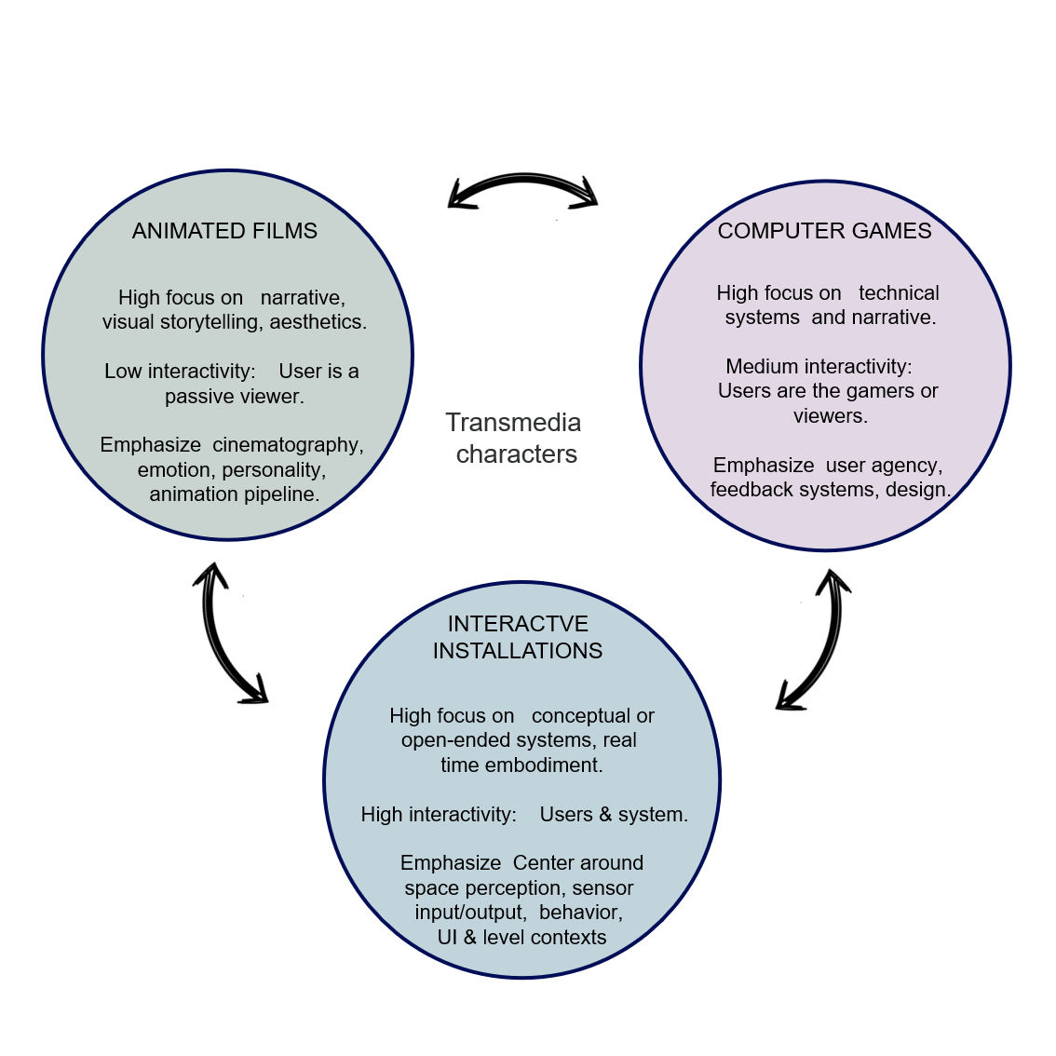
Figure 1. Dimensions of a Comparative Framework for Transmedia Characters

- Motion capture as design and performance tool
Motion capture (MoCap) is a key technology for modern media production, as it offers the ability to capture movements and expressions in 3D digital characters while also serving as a method for designing and producing animations, video games, and interactive and art installations. Motion capture technology offer:
- recording and reproducing realistic bodily movement
- optimization of creative workflows in productions and art projects
- supporting hybrid forms of creativity across multiple digital platforms.

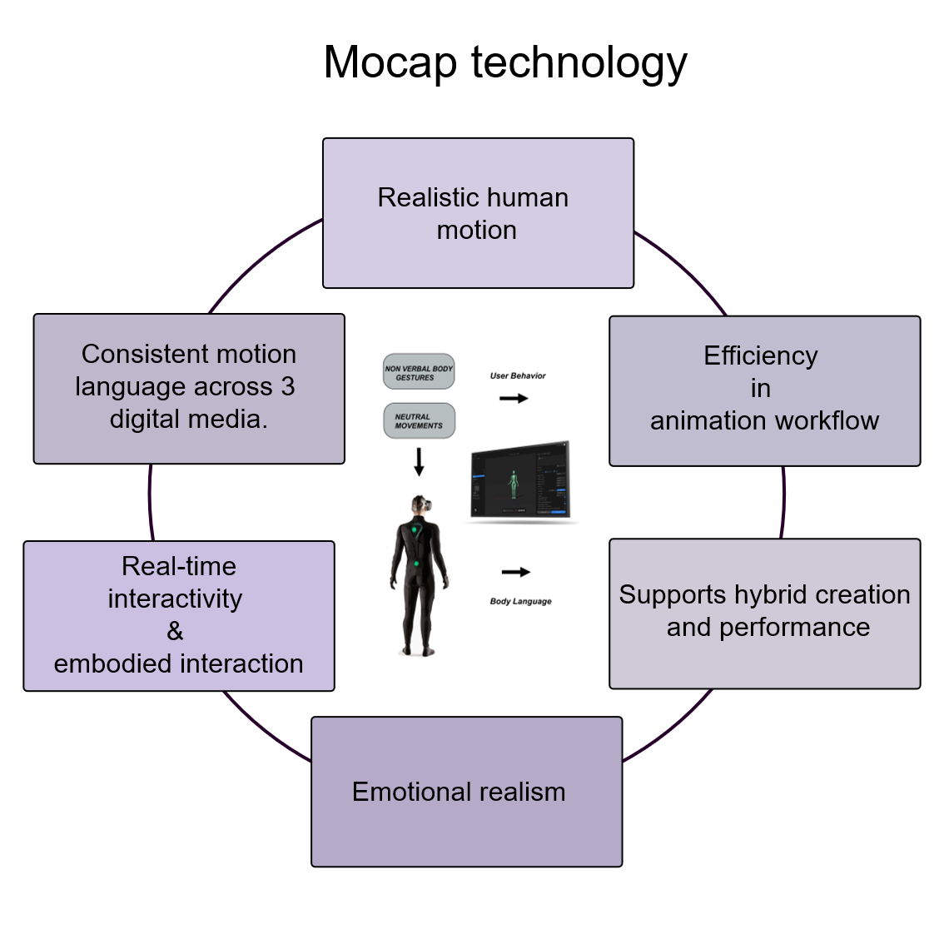
Figure 2. Key affordances and benefits of motion capture (MoCap) technology
Popat & Palmer examine the hybridity between technology and performance, showing how artists can use MoCap not only as a technical tool for animation, but also as an interpretive medium that enhances real-time expressiveness.
Designers often modify or exaggerate recorded data through keyframing, balancing realism with stylization. They use interactive installations and live digital puppetry, where performers embody avatars in real time, while computational layers enhance their gestures to expand expressiveness (Popat & Palmer, 2005).
A key contribution of MoCap is its ability to capture the complexity of realistic human movement. Unlike traditional keyframe animation, MoCap provides a direct reproduction of live performance, giving digital characters a better representation of kinetic and expressive qualities such as weight, rhythm, and kinesthetic fidelity (Habibillah et al., 2023; Menache, 2010; Smith et al., 2017). Apart from physical realism, motion capture technology also plays a significant role in conveying emotional realism. These systems include not only body but also facial recordings that preserve the nuances of expression, allowing virtual actors in games and animated films to communicate emotion with a high degree of subtlety (Saberi et al., 2021, Berry et al., 2022, Cheon, 2024). Equally important is the efficiency that MoCap offers animation pipelines. By translating live performance into reusable data, technology speeds up production schedules and reduces the labor-intensive demands of frame-by-frame animation (Mou, 2018). This efficiency allows for the rapid creation of complex sequences, while allowing animators to focus more on the creation and appeal of characters than on the technicalities of motion production and editing.
Furthermore, this technology offers real-time interactivity, enhancing embedded interaction in works and productions. In art installations and virtual reality environments, the immediacy with which a performer’s movements are reflected in digital form creates the sense of action and co-presence. Importantly, the data collected can be circulated across multiple platforms, ensuring a consistent language of movement in animation, computer games, and interactive art. This transmedia adaptability helps in the development of characters’ personalities for different digital media.
Motion capture (MoCap) is a key technology for modern media production, as it enables the recording and reproduction of embodied human movement while supporting expressive and interpretive character design.

- Transmedia frameworks
The study of narratives across media has grown significantly in recent years, as many theorists and researchers have sought to understand how narratives are extended, transformed, and adapted across multiple media platforms. There are various design and theoretical frameworks for conceptualizing these practices, with an emphasis on transmedia characters and transmedia narrative, which are presented in this section.
One of the most important frameworks is that of Henry Jenkins (2006) who presents the principles of cross-media storytelling. Η. Jenkins defined transmedia storytelling as a process in which “integral elements of a fiction are systematically dispersed across multiple delivery channels” with each medium contributing to the narrative. His work emphasizes world-building, user participation, and immersion in the narrative.
World-building allows stories to extend beyond the boundaries of a single medium, creating expansive fictional universes such as that of the protagonist ‘Harry Potter’ in the eponymous Harry Potter (1997) film series, which began as book and has expanded into films, video games, performances, virtual and performative environments, and table games. Equally important is audience engagement, where viewers/users do not simply consume content but actively participate in its interpretation, reconfiguration, and expansion. Jenkins’s framework thus highlights the creative corporation between producers and audiences in the creation of transmedia worlds. However, this framework primarily focuses on narrative and participatory structures, while offering limited insight into how characters are embodied and physically expressed across different media.
Later scholars such as Matthew Freeman (2017) have proposed a historicizing framework that relates transmedia practices to cultural and industrial approaches. Freeman’s work presents transmedia storytelling not only as a phenomenon of the digital age, but as a practice with history from earlier media forms. His framework examines how cultural, industrial, and technological contexts shape the extension of narratives across media. For example, shifts in media convergence, the rise of global franchises, and the interplay between cultural production and commerce have influenced the ways in which stories circulate across media. In conclusion, Freeman takes a historicizing approach to add depth to our understanding of transmedia storytelling. From a character-centered perspective, this framework helps explain why transmedia characters often undergo formal or performative adaptation while maintaining recognizability across platforms.
A more recent study on transmedia frameworks is presented by Kunz and Wilde’s Transmedia Character Framework (2023), which shifts the approach of the previous ones to one focused on character continuity. They argue that characters are often the most recognizable and emotionally understandable in transmedia worlds. This framework examines how character personality traits, identities, and appearances remain consistent—or evolve with purpose—across different media platforms. For example, a character like ‘Batman’ may be portrayed differently in comics, films, and video games, but still maintain a recognizable core identity that ensures continuity for the audience. Kunz and Wilde show that character’s act as a connecting link in transmedia narratives, bridging different platforms and keeping audiences engaged for a long time. This framework directly supports discussions of embodiment, as character continuity is sustained not only narratively but also through movement, gesture, and expressive performance across media.
Other researchers also contribute to these practices of transmedia narratives. Scolari (2009) describes online storytelling as a semiotic process where meaning is constructed across multiple texts, while Dena (Dena, 2009) highlights the role of design in the creation of multiplatform narratives. These contributions argue that different stories must be familiar enough to maintain continuity, but also flexible enough to adapt to new platforms and audience expectations.
Taken together, the above frameworks indicate that transmedia storytelling is not only concerned with narrative expansion but also with maintaining character coherence across media. More specifically, these approaches converge on a set of principles that shape transmedia characters, such as the continuity of core personality traits, the stability of visual and behavioral identity, and the adaptability of characters to the affordances of different media platforms.
Although embodiment is not always addressed within these frameworks, it emerges implicitly through practices related to movement, gesture, performative presence, and audience engagement. In this sense, embodiment operates as a connective layer between narrative continuity and character perception by the audience, supporting recognizability and emotional coherence across animation, computer games, and interactive installations.
By foregrounding these shared principles, this section presented a conceptual basis for examining embodiment not as an isolated aesthetic quality, but as a functional approach for transmedia character coherence.

- Conclusions and future work
Building on the synthesis presented above, this review highlights that transmedia characters function as embodied entities that combine human performance, technological systems, and audience interaction. In this sense, embodiment functions as a key mechanism through which characters maintain recognizability and emotional coherence across different digital media. By presenting various frameworks in animation, computer games, and interactive installations, the study highlights that different expressive approaches are used in each medium but at the same time recurrent strategies, such as continuity of character traits, consistency in movement and gesture, and adaptation to media-specific affordances, are employed to ensure coherence in character design within transmedia narratives.
Notably, it is demonstrated that motion capture is not simply a technical tool but a creative and interpretive methodology for animating characters. Across the reviewed frameworks, MoCap operates as a mediating practice that translates embodied human performance into digital character expression, supporting narrative continuity and audience perception across platforms. Positioning embodiment in transmedia narratives enhances theoretical integration while offering practical insights for creators using composite different platform productions.
Empirical and practical studies can show how transmedia characters are received by audiences and how MoCap supports collaboration among creators. With the new capabilities of artificial intelligence (AI), it is possible to create even more attractive and evolving characters. Future research may build on the synthesis presented in this review to further explore the integration of transmedia storytelling, digital character design, and motion capture practices across multiple media environments, potentially in combination with AI-based tools.

- Acknowledgments
This research work is carried out within the framework of the National Recovery and Resilience Plan Greece 2.0, funded by the European Union– NextGenerationEU (Implementation body: HFRI, project ID: 015668).

- References
Bálint, K., & Rooney, B. (2018). Shot scale and viewers’ responses to characters in animated films. In M. Taranger & J. Eder (Eds.), Emotion in animated films (pp. 162–180). Routledge. https://doi.org/10.4324/9780203731253-9
Belle, S., Gittens, C., & Graham, T. C. N. (2022). A framework for creating non-player characters that make psychologically-driven decisions. In Proceedings of the 40th IEEE International Conference on Consumer Electronics (ICCE) (pp. 1-7). IEEE. https://doi.org/10.1109/ICCE53296.2022.9730383
Berry, M., Lewin, S., & Brown, S. (2022). Correlated expression of the body, face, and voice during character portrayal in actors. Scientific Reports, 12(1), 8253 https://doi.org/10.1038/s41598-022-12184-7
Cao, W., & Huang, Z. (2025). Character generation and visual quality enhancement in animated films using deep learning. Scientific Reports, 15(1), 23409. https://doi.org/10.1038/s41598-025-23409
Cheon, E., & Xu, S. (2024, July). Creative precarity in motion: Revealing the hidden labor behind animating virtual characters. In Proceedings of the 2024 ACM Designing Interactive Systems Conference (pp. 3471–3484). ACM. https://doi.org/10.1145/3613904.3642092
Delbridge, R., & Fairclough, J. (2020). Performance capture: A guide for filmmakers, actors, and artists. Bloomsbury.
De Lima, E. S., Feijó, B., & Furtado, A. L. (2023). Managing the plot structure of character-based interactive narratives in games. Entertainment Computing, 47, 100590. https://doi.org/10.1016/j.entcom.2023.100590
Dena, C. (2009). Transmedia practice: Theorising the practice of expressing a fictional world across distinct media and environments (Doctoral dissertation, University of Sydney).
Dixon, S. (2007). Digital performance: A history of new media in theater, dance, performance art and installation. MIT Press.
Dourish, P. (2001). Where the action is: The foundations of embodied interaction. MIT Press. https://doi.org/10.7551/mitpress/7222.001.0001
Ferstl, Y., Neff, M., & McDonnell, R. (2021). ExpressGesture: Expressive gesture generation from speech through database matching. Computer Animation and Virtual Worlds, 32(e2016). https://doi.org/10.1002/cav.2016
Furniss, M. (2008). Art in motion: Animation aesthetics (2nd ed.). Indiana University Press.
Gall, D., Roth, D., Stauffert, J.-P., et al. (2021). Embodiment in virtual reality intensifies emotional responses to virtual stimuli. Frontiers in Psychology. https://doi.org/10.3389/fpsyg.2021.674179
Guo, Z., Xiang, J., Ma, K., Zhou, W., Li, H., & Zhang, R. (2025). Make-it-animatable: An efficient framework for authoring animation-ready 3D characters. In Proceedings of the IEEE/CVF Conference on Computer Vision and Pattern Recognition (pp. 10783–10792). DOI:10.1109/CVPR52734.2025.01007
Habibillah, A. Y., Prahara, A., & Murinto, M. (2023). Motion capture technique with enhancement filters for humanoid model movement animation. Mobile and Forensics, 5 (1), 36–43. https://doi.org/10.12928/mf.v5i1.6534
Harvey, E., Sandhaus, H., Jacobs, A. Z., Moss, E., & Sloane, M. (2024). The cadaver in the machine: The social practices of measurement and validation in motion capture technology. In Proceedings of the 2024 CHI Conference on Human Factors in Computing Systems (CHI ’24). ACM. https://doi.org/10.1145/3544548.3581025
sukIsbister, K. (2016). How games move us: Emotion by design. MIT Press. https://doi.org/10.7551/mitpress/9780262034265.001.0001
Jenkins, H. (2006). Convergence culture: Where old and new media collide. NYU Press.
Johnson, D. (2013). Media franchising: Creative license and collaboration in the culture industries. NYU Press.
Juul, J. (2005). Video games between real rules and fictional worlds. MIT Press.
Klich, R., & Scheer, E. (2012). Multimedia performance. Palgrave Macmillan.
Kucherenko, T., Nyatsanga, S., Henter, G. E., Ahuja, C., & Neff, M. (2023). A comprehensive review of data-driven co-speech gesture generation. Computer Graphics Forum. https://doi.org/10.1111/cgf.14852
Kunz, T., & Wilde, L. R. A. (2023). Transmedia character studies (1st ed.). Routledge. https://doi.org/10.4324/9781003298793
Lasseter, J. (1987). Principles of Traditional Animation Applied to 3d Computer Animation, Computer Graphics, ACM Siggraph Proceedings, Number 4, July 1987.
Ma, Y., Paterson, H. M., & Pollick, F. E. (2006). A motion capture library for the study of identity, gender, and emotion perception from biological motion. Behavior research methods, 38(1), 134-141. DOI: 10.3758/bf03192758
McMahan, A. (2003). Immersion, engagement, and presence: A method for analyzing 3D video games. In M. J. P. Wolf & B. Perron (Eds.), The video game theory reader (pp. 67–86). Routledge.
Menache, A. (2010). Understanding motion capture for computer animation and video games (2nd ed.). Morgan Kaufmann.
Merleau-Ponty, M. (1962). Phenomenology of perception. Routledge.
Mou, T. Y. (2018). Keyframe or motion capture? Reflections on education of character animation. EURASIA Journal of Mathematics, Science and Technology Education, 14(12), em1649. https://doi.org/10.29333/ejmste/97188
Mourot, L., Hoyet, L., Le Clerc, F., Schnitzler, F., & Hellier, P. (2022). A survey on deep learning for skeleton-based human animation. Computer Graphics Forum, 41(1), 122–157. https://doi.org/10.1111/cgf.14426
Nirme, J., Haake, M., Gulz, A., & Gullberg, M. (2020). Motion capture-based animated characters for the study of speech–gesture integration. Behavior Research Methods, 52(3), 1339–1354. https://doi.org/10.3758/s13428-019-01319-w
Popat, S., & Palmer, S. (2005). Creating common ground: Dialogues between performance and digital technologies. International Journal of Performance Arts and Digital Media, 1(1), 47–65. https://doi.org/10.1386/padm.1.1.47/1
Rajewsky, I. O. (2005). Intermediality, intertextuality, and remediation: A literary perspective on intermediality. Intermédialités / Intermediality, 6, 43–64. https://doi.org/10.7202/1005505ar
Ryan, M. L., Ruppert, J., & Bernet, J. W. (Eds.). (2004). Narrative across media: The languages of storytelling. U of Nebraska Press.
Salter, C. (2010). Entangled: Technology and the transformation of performance. MIT Press.
Saberi, M., DiPaola, S., & Bernardet, U. (2021). Expressing personality through non-verbal behaviour in real-time interaction. Frontiers in Psychology, 12, 660895. https://doi.org/10.3389/fpsyg.2021.660895
Scolari, C. A. (2009). Transmedia storytelling: Implicit consumers, narrative worlds, and branding in contemporary media production. International Journal of Communication, 3, 586–606.
Scott, G., & Khosmood, F. (2018). A framework for complementary companion character behavior in video games. arXiv. https://doi.org/10.48550/arXiv.1808.09079
Smith, H. J., & Neff, M. (2017). Understanding the impact of animated gesture performance on personality perceptions. ACM Transactions on Graphics (TOG), 36(4), 1-12.
Suk, H., & Laine, T. H. (2023). Influence of avatar facial appearance on users’ perceived embodiment and presence in immersive virtual reality. Electronics, 12(3), 583. https://doi.org/10.3390/electronics12030583
Thomas, F., & Johnston, O. (1995). The illusion of life: Disney animation. Disney Editions.
Wampfler, R., Yang, C., Elste, D., Kovacevic, N., Witzig, P., & Gross, M. (2025, August). A platform for interactive AI character experiences. In Proceedings of the Special Interest Group on Computer Graphics and Interactive Techniques Conference Papers (pp. 1–11). ACM.
Wasko, J. (2020). Understanding Disney: The manufacture of fantasy. John Wiley & Sons.
Wells, P. (1998). Understanding animation. Routledge, UK.
Zheng, C., Wu, W., Chen, C., Yang, T., Zhu, S., Shen, J., Kehtarnavaz, N., & Shah, M. (2020). Deep learning-based human pose estimation: A survey. IEEE Access, 8, 189117–189133. https://doi.org/10.1109/ACCESS.2020.3006996

