The World Flaw Approach
A Technique for Transmedia Character and World Design

Kurt McClung
Writer – Narrative Designer – Producer
Founder of Taliespin and Goldilocks Studios
kurt@taliespin.com

Abstract

The World Flaw Approach is a novel technique for transmedia character and world design ideal for writers and content designers seeking new perspectives to redefine their roles as professional creatives. The technique presented bridges character-centric approaches from cinema and television with world-centric practices used in video game narrative design, proposing that writers of the transmedia era start by crafting fictional worlds as thematic metaphors of real-world problems to foster debate among audience communities. The central paradigm shift is to envision the character and world as sharing a common thematic flaw, modeled as a fractal pattern. Both world and character are connected through shared toxic traditions, injustices, or divisive biases affecting individuals, factions, and environments on both macroscopic and microscopic scales. Change on one level invariably impacts the others.

When character flaws are defined in relation to the world’s metaphorical need for change, it becomes easier to imagine other media adaptations and thematic community events that extend beyond the original story and media format while keeping the IP’s signature traits intact. New protagonists emerge as anyone attempting to cope with the world’s flaw and can be created ad infinitum in new adventures. Additionally, the World Flaw Approach enables content creators and influencers downstream of its launch to organically relay the world’s fundamental metaphorical debate, allowing transmedia characters to engage with social media audiences and further the thematic discussion within fan communities. This methodology has been applied successfully on dozens of intellectual properties by the writer of this article and creative development teams of over two dozen studios throughout Europe and Asia. It is the fruit of reflection and practice during thirty years of work in content development and world doctoring for mainstream media. After a theoretical exposé of the various approaches that combined to form the World Flaw Approach, the article closes with a case study, tips and examples of how to implement the technique.

Keywords: Transmedia, Character Design, World Design, 360 Narrative Design, Creative Vision, Writers Roles, User-Generated Content, IP Signature

- Introduction – The Rediscovery of Thought-Provoking Ideas in Transmedia

Long before the advent of the term transmedia, Aristotle, in Poetics (Circa 353 BCE/1996), defined six key ingredients for a successful crowd-pleasing play: plot, characterization, style, spectacle, song, and thought-provoking ideas. This essential defense of fiction gave writers not only a practical guideline for their storytelling careers, but also a mantra – good writing proposes thought-provoking ideas. It is worth mentioning how this groundbreaking lecture on storytelling in dramatic theater came about, because it marks another time in history, like our own, when the role of poets was being questioned and their sensational sagas blamed for civic disengagement.

Plato’s mentor, Socrates, before his tragic demise for “corrupting the minds of Athen’s youth”, had labeled fiction as toxic, arguing in The Republic (Plato, 380 BCE/2007) that poets should be censored in the ideal city, reasoning that citizens influenced by emotions would make poor and erratic decisions. In sum he argued that fiction, was mimesis, a simulated copy of reality, and held neither artistic nor intellectual value. Worse, it could be used to sway the populace away from truth by subjecting their minds to the emotions of pity and fear. He singled out Homer in particular, regarded by many Athenians as both poet and quasi-historian, and declared his epic poems particularly dangerous to civic integrity. Were Socrates alive today, he would have likely advocated for the abolition of video games, a premium medium of simulated experience, interactive “mimesis” at its best, but let us not get ahead of ourselves. Returning to the debate in ancient Greece, Plato, a fan of epic poetry and theatre, was troubled by this irrefutable line of reasoning that he himself had penned. (Halliwell, 2002) In the hopes of rehabilitating Homer, he challenged his students to counter the argument and defend fiction. Aristotle, Plato’s best student, rose to the occasion and delivered a lecture that still serves as a cornerstone in the defense of fiction as a noble artform.

Aristotle refutes one of Socrates key arguments: fiction is “simulation”, a shadow of truth and has no value. Aristotle demonstrates in Poetics, (ca 355 BCE/1996) that emotionally charged stories hold educational value about the human condition. He argues that fictional characters could be considered extensions of a single lifetime, and much like gaining an extra life in a video game simulation, when spectators assimilate a fictional story, they can then add it to the sum of their own experiences. Vulgarly speaking, they would not have to sleep with their mother and kill their father to learn that stubborn loyalty leads to tragedy and horror. A good fictional character living through a tragic adventure can teach us through association and catharsis. According to Aristotle, in this respect, Sophocles (Sophocles, ca. 429–401 BCE / 2008) was a true master of tragedy, setting a very high bar for all poets that followed.

  - Socrates and Homer Were World Designers

The notion of a “transmedia world designer” was not yet a mainstream concept when Aristotle built his refutation to The Republic’s condemnation of poets. If it had been, perhaps the easier rebuttal would have been to argue that both Socrates and Homer were simply talented world designers presenting metaphorical arguments on a related debate. They both had masterfully painted their vision of how the real world of their celebrated civilization worked through metaphorical constructions. One proof of this is that the debate between their two points of view on human nature and politics had flooded the marble forums of avid communities across the Ancient World. In this World Designer 21st century perspective, Socrates’ discussions inspired the works of Plato, Aristotle and every other philosopher after them because those intriguing questions fueled debates that still intrigue. In the same light, Homer, via his epic poems and tragic themes, recited and adapted by thousands over the millennia, joins Socrates as one of the most successful transmedia writers of all time. They framed debates that journeyed beyond their initial media of predilection and inspired new content that could trace its roots back to the original metaphorical construction.

Let us reframe this debate between Socrates and Homer from a world designer’s point of view in today’s transmedia content arena. In Socrates’ blueprint for the ideal city, penned by Plato, only reason should prevail in all decision-making, hence poets had to go. One major societal flaw that needed fixing in Athens, in his educated opinion, was emotional manipulation championed by Sophists and incited by Homer. We could call poets and the teachers of sophistry the antagonists of his utopian world. The flaw in his Athens was systemic and linked directly to a flaw in human nature. Humans are apt to allow their emotions control of their decision-making process, and hence fall pretty to manipulation. Theatre and epic poetry echoed the cultural flaw echoed in the Agora, fostering division in the hearts and minds of its citizens. They were interrelated like a fractal pattern seen in the man and in his societal constructions. For Socrates’ protagonists to prevail, his philosopher king, makers and guardians of the perfect city would have to banish all emotion mongering storytellers.

Homer develops his worldview with a completely different societal flaw in mind. In the cultural beliefs at the time, whimsical gods affected human destiny, and anyone overlooking divine intervention was setting themselves up for a trepid existence. The periapices of such a life could be worthy of song, and recording these heroes’ brave actions was indeed how the epic poet earned his fame, but the worldview differs. Homer’s stories were centered around humans with passionate desires that captured the gods’ attention via chance, noteworthy actions or simply being “divinely” beautiful. As a direct counter argument to Socrates’ world vision, reasoning that the cosmic design allowed for complete human agency, could lead to tragic consequences. Ulysses, one of Homer’s major heroes, learns this often at his own expense despite his cleverness. Hector another of his emblematic heroes, accepts it.

“No man ever has escaped his fate once it has taken its first form, neither brave man nor coward.” - Homer, The Iliad, trans. Richmond Lattimore, Book 6, lines 488–489.

All an individual can control in Homer’s worldview is to live each hour of each day as if it were one’s last, making courageous choices that feel right. Homer advocates embracing one’s fate in a fated world and living with gusto. Plato’s Socrates believes that humankind can escape the whims of the gods and write its own destiny. Plato argues in The Republic that the state and fate of the city are shaped by the moral and intellectual qualities of its citizens. Through education, the cultivation of virtue, and the organization of social roles, the destiny of the city, for better or worse, depends on the collective choices of its inhabitants. Keep this thought in mind, for it is the mantra of the game designer that the actions of the player impact their world.

Modern poets might think that the debate over self-determination is stale and outdated, but we do not need to look far into the 21st century to see its stubborn presence. Dividing lines are being drawn throughout the world’s democratic states. One side challenges reason and science as a hubristic and faithless worldview, leading to an elite ruling-class system. The other side sees “blind faith” as a way of maintaining inequalities and forms of classist slavery. Ironically, debates on how individuals should organize their lives and community within the real world is often best illustrated in a fictional metaphorical setting, what our Ancient Greeks might have called a hypothetical construction. Plato’s The Republic remains today one of the most discussed utopian blueprints for a city-state. Ironically, in banishing poets from his utopian construct, Socrates was casting out one of the great transmedia world designers of all time. He banished himself.

  - A Call to Poets to Reclaim Aristotle’s Sixth Ingredient

Aristotle’s structural blueprint, outlined in Poetics, influenced poetry, theater, and opera throughout Europe and Arabia from the 11th century onward when it was revived and reembraced. In Arabia, it was applied to introduce moral elements into popular Middle Eastern poetry (Aubin, Arabic Poetics, Before and After the Arabic Poetics, 2014), and in Europe it conferred literary legitimacy by aligning works with Ancient Greek ideals. Dante, another extremely talented world designer, who gives us three worlds for the price of one in The Divine Comedy, was heavily influenced by Aristotle, who is credited with inspiring the structure of his mapping of hell in Inferno (Dante / J. Nichols 2005). Dante’s guide through hell is the legendary Greek poet, Virgil, and one of his most intriguing characters, Ulysses, is still fifteen centuries later, punished for immoral trickery in his opus. The ingredients recommended by Aristotle for writing successful fiction are followed closely by Dante, especially regarding thought-provoking ideas. What actions send someone to either hell, purgatory or heaven are the principal thematic stakes. A celebration of both Homerian and Socratic virtues, this ethical survival guide was written when Italy was one of the most politically treacherous places to live on the planet. The influence of Aristotle’s Poetics blueprint is so vast in Western theater and literature from the Renaissance to the modern era that it generated movements defining themselves in opposition to Aristotelean dogma, such as Brecht’s (1964) epic theater. The “unsuccessful” movement proves that it is nigh impossible to remove Poetics influence from any discussion on transmedia, because the observations made by Aristotle have become the tools we use to craft fictional stories, their characters and their worlds.

Despite Poetics’ pervasiveness, the importance of theme in modern fiction was deemphasized in 20th century main-stream media, which may make a World Flaw Approach, constructed around a core theme, seem idealistic at first glance. While Aristotle’s mere six ingredients seem manageable enough as a checklist for writing good fiction, the sixth element of “thought-provoking ideas” has become a “nice-to-have” and is no longer an obligation. Production teams in all major media have chosen to focus primarily on plot, characterization, spectacle, style, and music, while politically charged ideas are minimized in the interest of appealing to broader “neutral” audiences. This simplified recipe has produced commercially successful content during the broadband and digital ages of mass entertainment, but contemporary audiences, particularly younger generations, are now demanding clear thematic positions on issues such as diversity, climate change, and corporate responsibility. Hollywood films devoid of any clear message or real-world authenticity, however beautiful the spectacle may be aesthetically, are accused of propagating systemically grounded conservative messages by default, making them unwittily or wittingly works of old-guard propaganda. (Alford, 2010)

Communities today have built their own ethical agoras, evaluating the moral and thematic implications of media content created by their contemporary writers, lyricists, designers and artists. The old “poets” are also under scrutiny, and Aristotle’s views of the difference between the sexes have some communities debating his “cancelation” outright, the modern-day equivalent of banishment. (Callard, 2020) Young generations understand how thinkers and poets have shaped the civilization they have inherited the obligation to save. Systems that maintain the dysfunctionality of the real world are marked for modification. The disconnect between generations mirrors Socrates’ concerns about declining civic engagement in ancient Athens, and young minds are again asking uncomfortable questions. Fortunately, in today’s digital environment, activism through creative content can still both challenge and foster democratic debate, without relying on major mainstream news media to frame it. As a 15-year-old Greta Thunberg stated while distributing climate leaflets: “I am doing this because you adults are shitting on my future” (Smith, 2019).

Ms. Thunberg sheds ample light on a flaw in industrialized society and calls out those she sees as responsible. Yet how can she, or anyone for that matter, provoke change in “the faulty system” when news media seem embedded in a sophistic debate on definitions of “fake news” alongside accusatory pleas to “listen to scientists”? Reason has left the agora, and Socrates is shouting from his grave, “I warned you!” Therein lies the rub. The challenge every writer of successful transmedia age content must willingly shoulder is how to spark a productive discussion that can bring about change in the real world through critical thinking. Fiction can still be used today to carry cultural democratic debates as it has for thousands upon thousands of years. Ms. Thunberg’s plea to leaders is a call to adventure for writers. Can we imagine a fictional world that illustrates the problem of “adults shitting on children’s futures”? Can we craft protagonists and antagonists scarred by the current unjust situations in flawed societies, battling through adventures to get their futures back? If we can, we are likely to attract not only Greta to our spectacles, but a good many of her followers.

This article introduces a perspective for designing transmedia characters that explores philosophical questions metaphorically through fictional worlds. In an internet-driven reality where fact is often contested, fiction can function as a framework for stimulating democratic debate. Inserting Aristotle’s “thought-provoking” ingredient openly into the creative process as a question illustrated by a fictional world flaw allows creators to frame political and social issues in ways that remain engaging, accessible, and without deliberate bias. Aristotle’s other five ingredients are still vital for a successful work of fictional art, but this article is meant as an apology of the sixth.

A World Flaw Approach joins Aristotle and refutes Socrates’ argument against fiction a degree further, stating that not only does fiction possess educational value and can be beautiful, but its settings are also potentially hypothetical simulations for discussing political topics through the prism of a dramatic metaphor. The Republic has been used countless times as a touchstone for utopian and dystopian worlds. One need only watch Star Trek (1966), Star Wars (1977), The Walking Dead (2010) or The Hunger Games (2012, to see the influence the questions posed in the philosophical discussion have inspired. The Republic has also directly inspired the premise of this World Flaw Approach, in that it describes both an inward personal journey and an outward societal journey. If harmony is the goal, there cannot be a just city without citizens striving to be noble within it.

This article argues that transmedia-ready characters possess a shared-flaw thematic relationship to the world that gave them life. A transmedia world extends beyond its initial story, ideally accommodating multiple protagonists across multiple timelines. When the origin stories of main characters are grounded fractally they can in turn serve as templates, duplicated archetypally across narratives. In thematically coherent transmedia franchises, heroes, rivals, mentors, and villains all function as equal participants in the debate on how to repair the flawed world that forged their personalities and driving motivations. When characters confront and heal their own flaws, the world progresses toward healing as well. When a fictional world is healed, anchored in a metaphor, fans begin to imagine parallel potential in their own reality, and both the world and its characters become inspirational. Let us now consider how writers of character-driven techniques in linear fiction and world-driven techniques in interactive fiction have been working in parallel to bring about the advent of transmedia content design.

- The Art of Designing Transmedia Characters in Thought-Provoking Worlds

"You can’t see the forest for the trees."
- John Heywood (1546), Playwright

The concept of communicating credible character evolution within a story has existed since Cervantes wrote Don Quixote (1605/2000), challenging the belief that change in a character’s personality was impossible in a world defined by divine predestination. Again, we find an echo of Socrates’ and Homer’s positions on self-determination. If a human being can evolve during the time of a story, perhaps there is hope for society. Don Quixote and Sancho Panza both change their perspectives on their world by the end of their adventure, and even more importantly the way their world sees them. Cervantes invented the modern novel at a time when Spain was going through the greatest cultural war of their history (Philopedia, 2025). This literary demonstration that characters could evolve within their fictional world without divine intention or intervention would quickly take Europe and the Americas by storm.

Contemporary to Cervantes, Shakespeare was reinventing theater in Elizabethan England, continuing the tradition that fiction, whether comedy, tragedy, or historical drama, could convey political messages and broaden perspectives. Romeo and Juliet (1600/2016) was performed as a plea to spare the lives of youthful rebels being hung for their political passions. Hamlet (1600/2016) was written to illustrate the treachery in court politics during the years leading up to Elisabeth’s future succession. Shakespeare was targeting his England’s powerful, attempting to sway their minds through their hearts by crafting popular fiction with underlying messages. Playwrights had to avoid both eggs and the noose, but those dangers were considered part of the job description by their audiences whether noble or simple citizen. (Dutton, 2000) If a play did not provoke thought it was considered without merit. Spineless plays were soon forgotten.

Molière, also the risk-taking playwright, introduced satirical critiques of customs and traditions in the court of Louis XIV with the same hopes that persuading the powerful might alleviate the pains of the entire nation. The Sun King of France held tremendous power, but so did others in his court. The Misanthrope (1666/2022) was banned until rewritten, when through the prism of comedy, he criticized the hypocrisy of the corrupted clergy. In celebration of the 400th birthday of their most famous playwright, La Comédie Française performed the complete repertoire of Molière to sold out audiences for an entire year, attesting to how the central themes of women’s rights, class ascension, health care and the abuse of authority still resonate. (Masse, 2022)

Cervantes, Shakespeare and Molière lived in ages where poorly received stories could have dire consequences, yet they were unafraid to embed thought-provoking ideas into their narratives. Even though these great writers are often known today for their mastery in style, structure and technique within their languages of Spanish, English and French, their understanding of fiction’s power of persuasion is the main reason that makes their works classics beyond their own native tongues. If these men of genius were willing to risk their lives to imbed thought-provoking ideas into their plays, to “dream the impossible dream”, why in the 21st Century does it seem like an option for writers when crafting fiction for major media? Have we as a storytelling industry, going through tremendous challenges of climate-change, social-media manipulation and political unrest, orchestrated a collaborative censorship on thought-provoking ideas? The answer is neither a clear yes or no in this writer’s humble opinion, but the fact the question remains pertinent merits reflection.

2.1. Industrial Censorship of Thought-Provoking Ideas

Theater, since its onset, has had a long tradition of setting the cursors of morality for both the rulers and the common folk in any society, and with the birth of cinema in the 20th century, one could have hoped that script writers for the silver screen would continue to embrace the role of their nation’s moral conscience. Though Hollywood adopted Aristotle’s formula as a mantra, it was primarily to reduce the risk of bombing at the box-office. The pragmatic blueprint in Poetics was easily replicated, and cinema, a burgeoning storytelling industry, had little patience for experimental formats. (Jones, 2024) Rather than build off the tradition of thought-provoking theater, Hollywood put their energy into the spectacle and characterization. They replicated the structure of the literary “novel”, in fact they would industrially normalize it. (Cook, 2004) By default a character could change their destiny within the embedded rhetoric of the novel’s structural format. Internal change was deemed a sufficient message in and of itself. The 90-minute feature film was identified as the optimal length to convincingly depict the character change that Cervantes had proven possible for a pair of heroes. Whether a romantic comedy, buddy flick or detective story, the only flaws in need of changing were inside the characters, and their worlds would remain tragically the same. As the art of film became the industry of cinema, thought-provoking ideas no longer had a reserved seat. Strong societal-changing themes could be more trouble than they were worth.

An example of “thought-provoking censorship” can be found in the adaptation of Tennessee William’s (1955) play A Cat on a Hot Tin Roof to the silver screen by MGM (Brooks & Poe 1958). The theme of the play advances the debate on the acceptation of homosexuality in American culture, when the main antagonist’s character flaw is that he is blind to the psychological suffering of his gay best friend who has recently committed suicide. As Brick is led to understand this by his pestering wife, “The Cat” in the story, the echo of this flaw in homophobic American society frames the tragedy. Hollywood liked the characterizations of the play so much that they cast two superstars, Elizabeth Taylor and Paul Newman in the star roles. Afraid of a scandal, they rewrote the theme of the play, removing the homosexuality flaw. Instead, they gave Brick a case of Peter Pan Syndrome, a refusal to grow up and accept fatherly responsibilities. There would be no debate about changing a world, the change in character was all that would be treated. The reaction of Williams was to stand outside the movie theater on opening night shouting, “This movie will set the industry back 50 years. Go home!” (Williams, 1958) Character change was acceptable on the silver screen, societal change would have to wait.

The lack of strong thought-provoking ideas did not stop cinema from eclipsing other media in popularity and profitability. Radio, literature, and theater persisted, but writing, directing and acting talent migrated to both Hollywood and the 1920s Berlin. Cinema at first was an extension of the theatrical thematic traditions with films such as Citizen Cane, It’s a Wonderful Life, The Dictator, Lulu and Metropolis to name only a few. Alas, one of the metaphorical casualties of American cinema during the post WWII period was Aristotle’s sixth ingredient. The propaganda use of film in Nazi Germany, particularly under Joseph Goebbels, highlighted cinema’s potential to manipulate opinion and incite dehumanization. The powerful German language film industry was silenced, condemned to dubbing Ally films at the end of WWII. Directors and producers, German’s Silver-Screen poets, were effectively banished from film for five years in fear that fascism had been systemically ingrained into the psyches of the German people. (Schivelbusch, 1998) It was idealistic competition from the East Berlin’s (Soviet Controlled) film industry that forced the allies to lift the ban. Communism was by then considered even more dangerous than fascism by Western democracies, and particularly the United States of America.

The sixth-ingredient cinema silence was echoed in Hollywood where studios largely avoided politically charged themes after the war. This culminated in McCarthy-era purges of suspected communist influence, where it became dangerous to treat any theme that was not “Pro American”. Even so, Hollywood, with no longer any serious competition from Europe, became the global measuring stick of cinematic success. Tried and tested, under near monopolistic control, character transformation was emphasized over societal change. This is perhaps when character flaw arcs were seen as independent of the flaws within the world setting. Tennessee Williams frustration would be joined by that of hundreds of thought-provoking artists after the war, who either “sold out” or “went home” to other older media. Let us not forget that America was considered a utopia by its leaders, moviemakers and privileged citizens. Why would anyone want to fix anything in a society “living the dream” in the “greatest country on earth”? Any film that did try to provoke thought, however well done, was labelled an “Art Film” and removed from mainstream circuits.

This self-imposed thematic censorship was a dangerous evolution for transmedia content designers, as only when the two are connected, can the world setting and its characters travel beyond its initial medium and still be recognized. It is also a dangerous evolution for anyone trying to show through fiction that one can improve the systems that govern their community. Worlds that do not change in a story are assumed to not require changing, or that they are so powerfully in place they might as well be ruled by Homerian whimsical gods. The only hope for characters wanting to avoid tragedy is to hug the walls and go unnoticed. It would take the rising popularity of the Science Fiction, Superhero and Fantasy genres to bring the importance of a signature world back into the silver-screen picture. Even the commercial laden TV Media was occasionally producing series that raised thematic eyebrows: The Twilight Zone (1959), Star Trek (1965) and All in the Family (1971) sparked conversations at home and the office. Hollywood had also completely underestimated the potential of cross-media revenue streams of derivative products with meaningful worlds, a revenue stream they considered more promotional than a means of community identification. Georges Lucas ended up making more money from Star Wars toys than ticket sales. Transmedia was already there, lurking in the shadows.

2.2. Character-Driven Obstacles in Transmedia IP Design

In cinema of the latter half of the 20th century the overarching framework of characters defying fate was so ingrained in plot structures that these powerful writing techniques would eventually prove to be theoretical obstacles for building transmedia IP ecosystems. Scriptwriting experts had cemented character change as central to screenplay narrative. John Truby (The Anatomy of Story 2008) offers a seven-step methodology for structuring character revelation, emphasizing the protagonist’s realization that their worldly desires may differ from their true psychological needs. Linda Seger (Creating Unforgettable Characters, 1990) and Blake Snyder (Save the Cat, 2005) propose different yet complementary storytelling methodologies, emphasizing practical techniques and the need for characters to feel human. Snyder famously advises that heroes, especially the gruff ones, should “save a cat” in the first act to gain audience sympathy. Seger provides a more psychological approach, examining motivation, backstory, flaws, and conflicts. Her methodology was considered extremely actionable and pragmatic. All of these writing methodologies did not necessarily downplay theme, some them in fact leveraged it, but they were geared to create iconic characters first and foremost.

Dexter, the amazing character from Jeff Lindsay’s Darkly Dreaming Dexter (2002), exemplifies an iconic anti-hero that embraces Seger’s model. Readers, and later TV viewers, follow a serial killer striving to emulate normal human behavior while assassinating other serial killers according to a strict code. The thematic question of “is killing some people necessary at times?” is adeptly addressed. Alas, his Miami world does not undergo change, it remains perpetually rife with ever new terrible villains, no matter how many evil serial killers are dropped into the bay. The work is a powerful step towards the exploration of deeper themes and thought-provoking ideas, and one could argue that the Dexter world’s capacity to remain morally numb is what makes it an effective satire - the test of this IP’s transmedia worthiness will depend on the archetypal Dexter’s capacity to voyage into other media and carry on the World-Flaw debate, “Is killing humans sometimes just?” One can see why having only one Dexter and one Miami would need to be addressed to turn the IP into a transmedia sensation.

Georges Lucas would call upon a narrative structure rediscovered in the 20th century that integrated character change and world change in the same plot: the hero’s journey. Star Wars success would all but force Hollywood to revisit all their basic big-budget scripts. Thought-provoking ideas through societal metaphors and traditional heroic values were at the core of the Star Wars saga. Christopher Vogler defines the hero’s journey (The Writer’s Journey 1998), mapping character evolution through archetypal transformation. He was inspired by Joseph Campbell’s monomyth (The Hero with a Thousand Faces 1949) where the goal of the hero is to become the master of two worlds, their home of origin and the new world where in lies an elixir of healing. Campbell’s work was influenced by Carl Jung’s concept of the collective unconscious (Archetypes and the Collective Unconscious 1919/1970). Jung and Marie-Louise von Franz (The Feminine in Fairy Tales, 1972/1989) established the universality of archetypal characters across human cultures. Their theory is that all societies across the planet have story structures in common that help individuals navigate change internally in the psyche and externally in the community. Disney tapped into this “collective well” when adapting fairy tales for modern audiences. As Campbell observed, “All the gods, all the heavens, all the hells are within you”, and so we learn are all the character archetypes. Disney’s stories tapped into a magical thought-provoking premise of fairytales: heroes go through change to change their worlds. It should not be surprising in this respect that Disney Princesses is the most popular IP in the world after Pokémon. A good question to ask is if its transmedia success is due to this thought-provoking premise, heroes are made to change their worlds.

Even though the metaphorical world had been brought back to cinema with a vengeance, the writing techniques are character-centric and from a transmedia perspective can be limiting if used alone. When branching into interactive content, where character design is rarely the core creative driver, these methods may constrain narrative expansion, potentially painting creators into character-driven corners. Fortunately, other experts were knocking on the “simultaneous change” door that today defines successful transmedia properties. Robert McKee (Story, 1997) focused on the gap between characters’ expectations and outcomes. Internal and external conflicts gradually close this gap, producing character transformation which is a critical principle for linking world and character in transmedia storytelling. Even earlier, Lajos Egri (The Art of Dramatic Writing, 1946) emphasized character arcs based on flaws and dialectical oppositions, a clear reflection of Aristotle’s Poetics. Egri introduced a three-step premise-conflict-character approach, highlighting the interdependence of character and world. This observation would prove prophetic for transmedia designers.

In Hollywood characters drove the elevator pitch, the importance of seducing a well-known lead to assure commercial success was certainly a factor, but in transmedia, characters are not alone. This approach can box in transmedia creators, especially those who start with the setting as one often does when narratively framing a video game. Characters crafted solely for the original work may not be necessary or may even impede the expansion of a world’s thematic debate into other media. As the saying goes, “You can’t see the forest for the trees.” In transmedia ecosystems establishing an identifiable forest of heroes is essential so that any fan can imagine themselves a hero of the IP world. Videogames understood that setting and context was more important than characters from their early beginnings, though the techniques they would develop would also eventually paint them into different corners when trying to expand in transmedia.

- The Science of Designing Transmedia Worlds with Thought-Provoking Contexts

"You can’t see the trees for the forest."
- Inversely Inspired by John Heywood’s proverb (1546)

Though video game writing would eventually become synonymous with worldbuilding, this vision of narrative design did not initially guide the industry. Before video games could participate in the transmedia revolution, it had a few things to learn about crafting success within its own media that was driven more by technological breakthroughs than design discoveries. The media formats were constantly shifting and evolving as more powerful graphic-cards and processors were integrated into the production pipeline, making the writing of the ultimate game narrative an exercise in shooting at a constantly moving target. Two primary narrative design approaches would emerge to help deal with the high-tech chaos initially: let us call them Gameplay-First and Systems-First philosophies, and each would define its own genres of games. The two approaches would eventually marry on major productions of major IPs, but they have sbeen around long enough to create two competing schools of thought, their marriage forming a third that the writer of this article calls home.

The Gameplay-First approach is defined by those who privilege player agency through gameplay interaction over anything else – the fun is in controlling what happens, generally in real time. The Systems-First approach privileges the simulation of a reality through the game’s rule-coded systems and its objective primarily is to learn by making decisions that tweak the world. As all videogames became more popular the pressure to expand into other media would grow, but it would take time for them to cross over successfully. Though videogame worlds did not lack character in their interactive experiences, they did lack memorable characters. Characters were by design hollow vehicles for players’ imaginations to fill, which left more room for the spectacle. In the Gameplay-First Approach player fantasy was king, and as we will demonstrate, more room for thought-provoking ideas was found in the Systems-First philosophy. The Systems-First games ignored in some cases completely the individual character, relying simply on following the generic stories of a world in evolution.

3.1 The Gameplay-First Approach

A Gameplay-First Approach to narrative in games was born when animated Action Games decided to add story elements like those already present in text-based Adventure Games. Graphics were so amazing that the industry would eventually drop the word “computer” from their medium’s title and replace it with “video”. These first “videogames” with attempts at providing a narrative were called Action-Adventure Games. The first adventure game, Colossal Cave Adventure (1976), which gave its name to the ancestral genre, had planted the seeds for The Legend of Zelda (1986), where all the defining ingredients had been united in Action-Adventure and given the Gameplay-First Approach a powerful benchmark.

The poets writing the Gameplay-First stories were often the same programmers writing the code. The game story was designed around what the player could do “in-game” and the world was wherever that action took place. The context defined the story. These early Action-Adventure game studios were joined by First-Person Shooter game developers, who were also adding narrative context to their experiences. Maze War (1972), Spasim (1974), Wayout (1977) and Akuma no Shiro (1980) were steppingstones leading up to a first full-narrative benchmark, Ultima Underworld (1992). Now the Gameplay-First school had two profitable genres of game experience within the industry to validate their approach. A common North Star to note for both is player agency. Game-Play First game narrative maintains the illusion that player actions through the playable character move the story forwards. A return to deeper player characters and their motivations was beginning to be seen as a problem that needed to be addressed if the IP could ever hope to journey into other media. Gameplay-First designers found a plug & play solution from another media, table-top roleplaying games.

Game-Play First designs introduced a concept borrowed from table-top RPGs, most notably Dungeons & Dragons, of “leveling up” which is present today in nearly all videogames. This technique of mapping out “player progression” as an embedded narrative structure in and of itself. Player progression provided a magical way to simulate a character journey. The main character motivation was tied to quest achievement and the fantasy of becoming ever more powerful. Players focused on mastering necessary skills to “power through” the game’s content. Stories were still often pieced together at the end, the equivalent of writing the script of a movie only after shooting all the cool action scenes. The generated illusion of a story, at least at first, worked extremely well. These games were impressive, fun and success was still measured by the amount of adrenaline they generated. The hero’s story was said to emerge. The stories framing the player progression were more pretexts for the action than designed to induce any thought-provoking themes. Despite the addition of companions, mentors and true villains, characters rarely arced beyond the archetypal parameters of a melodrama. The worlds’ flaws were in most cases remedied with violence, and impact was two-dimensional: right or wrong, dead or alive, saved or destroyed. Sparking a societal debate was not the goal.

Any notion of crafting an original thought-provoking idea into a Gameplay-First videogame narrative seemed to never go beyond the ideation of the context, and those contexts were pre-defined by the setting genre they had borrowed from other media. In sum, action WWII games were leaning on the WWII movie genre for its ethical narrative framing, as were Western, Fantasy, Science Fiction and Crime games. “We do not need a message, or some deep character background in our games” was a very common thought during the early decades of Game-Play First game design. The spectacle and eventually the style and song, were the only Aristotelian ingredients necessary for a good game. Plot, characterization and thought-provoking ideas were just wasted budget, and they had positive sales figures to defend their philosophy.

The mantra went like this: players in Gameplay-First experiences imagined their own story from the movie or literary genre of the game. This was the equivalent of saying that any cross-media extension of the game was unnecessary, because the game had never pretended to be original content. For example, a racing game did not need a story because there were plenty of stories in other media about drivers, and you could always watch Formula 1 or NASCAR on TV if you needed more to ignite your imagination. Western Games borrowed story settings from a vast library of films, and all you did in a Gameplay-First game was shoot, collect a bounty and eventually ride horses. The designers of these games often boasted as having been “inspired” by Spaghetti Westerns where they took many of their early camera angles. This practice made it difficult to take a Gameplay-First world back into any of the media from whom it had “borrowed” the generic narrative context. Especially any contexts that were too specific to steal without the original writers filing a lawsuit for plagiarism. As Action, Action-Adventure and First-Person Shooter (commonly called FPS) videogames popularity grew, pressure would increase from fans to take them into other media, and the Gameplay-First “only” approach was marked for change.

As most of these game IPs were built on generic worlds and hollow characters, and the spectacle of unjustified violence was beginning to attract public scrutiny, it would become a tall task to imagine a feature film adaptation, let alone a series of novels or comic books, without a clear theme. Also, as videogames became mainstream, and their cultural impact became evident, they attracted journalistic critics from other media asking game studios and their publishers to take cultural responsibility for their industry. Traditional writers began to join development teams, hoping to defend the growing artform from parents worried that the minds of their children were being corrupted. As we have conjected earlier, Socrates at this juncture would have certainly been walking among them, pointing to his cup of poisoned wine. Initially the job of these “pro” writers was to add “story bits” to frame the violent action and combat sequences. Cinematic-style scenes were seen as rewards for completing levels. These new Game Writers did make some important structural breakthroughs. Player progression, their concept of “levelling up”, fit the Hero’s Journey structure like a glove. This narrative structure had proven so successful in cinema (Vogler, 1998) and here it worked just as well for videogames. The parallel narrative structure of tracing a novice’s initiation and acquisition of new powers to heroic status was the equivalent of discovering that all mammals on Earth shared strands of the same DNA.

The Hero’s Journey became the go-to structure of the gaming industry. Whether players embodied Jedi knights, dragon riders, or assassins, the core experience emphasized progression and empowerment. As games became more complex and settings and levels vaster, Gameplay-First designers continued their philosophy of maximizing player agency, allowing them to venture out into larger biomes and infinite levels. This endless frontier made it even more difficult to tell convincing stories where characters underwent change. Stories began to be more about how the world was impacted statistically by the players’ actions: how many monsters were killed, hostages rescued, and villainous plans thwarted. Backstories of “boss villains” were far richer than those of the player characters, and even then, they were rarely longer than a couple of paragraphs. Their characters were definitely not ready for a jump into transmedia.

The first major barrier to producing transmedia characters with a Gameplay-First approach came from the objective of player agency itself. Maturing players wanted characters capable of interacting freely with their worlds, but also wanted their actions to have lasting impact. They wanted change to stick and their actions to matter. Achieving this illusion of meaningful agency became the central design challenge. Ethical questions could no longer be ignored. “Why must characters kill so many monsters and people?” or “Could more diplomatic gameplay systems exist?”, were questions being asked by players, parents and game makers that had grown a conscious. Alas, attempts to incorporate persuasive dialogue gameplays were often cost-prohibitive when venturing beyond the linear script of an Action-Adventure or FPS videogame. Combat, “persuading adversaries with a gun”, was seen as a more economically viable mechanic and the industry was already good at it.

A form of compromise came in narratively framed dystopic worlds that justified in-game violence, crime and monster capturing, exemplified by franchises like Call of Duty, Grand Theft Auto, and the most popular IP on earth, Pokémon. Writers were now being tasked with creating coherent worlds that explained players’ repetitive actions and to assure that the behavior necessary to progress through the game was morally sound. Whether treatments were realistic, satirical, or fantastic, the foundations of a signature world were emerging, and they were original. Still, despite the fist of ethics pounding on the door, Aristotle’s sixth ingredient was left by the wayside. It was economically safer not to be asking too many questions: shoot first and ask questions later was literally the slogan. Fortunately for transmedia portability, other game-makers had been working on thought-provoking rhetoric in a completely different approach. They were not concerned with absolute player agency. They were worried about the game’s simulated rules. The messaging was embedded in their code. Their code defined the world.

3.2 The Systems-First Approach

In parallel to the Games-First approach, a Systems-First approach evolved from videogame adaptations of table-top games like Chess, Checkers, Go, and Snakes and Ladders, as well as every sport game from football to frisbee golf. The art of “simulation” had found its ultimate tool in computer programming and there were many a genius lending the medium its first letters of nobility. The great mathematician, Alan Turing, who deciphered the German Enigma code in WWII, is credited with writing the first chess play algorithm before there was even a computer on the planet capable of running it (Turing, 1953). The game would eventually be made after his tragic poisoned-apple suicide during a British homosexuality purge: the story that would also give Apple Computers the bite in its logo according to corporate legend. Decidedly, there were still societal injustices at the dawn of the computer age that were calling for change. The voice of Tennessee Williams was joined by a silent chorus.

In Systems-First games, commonly called Strategy or Simulation games, the rules defined how a world was governed, and player interactions focused on mastering these rules to achieve optimal outcomes. Examples of state-of-the-art videogames for in the modern eras include SimCity (1989), Civilization (1991), Heroes of Might & Magic (1995), The Sims (2000), Crusader Kings (2004), and Minecraft (2009), all owing thanks to their common ancestor, TACSIM (1970). The player character in these games is not incarnated in a defined player character per se with facial attributes and a bio. The player often has a god-like status and makes decisions from on high that affect the world: launching wars, arranging marriages, building castles, or changing laws to name just a few things one might do. These games were profitable but considered more niche than their Action, Action-Adventure and FPS cousins who enjoyed larger audiences, even though they had some serious pedigrees of their own firmly grounded in computer gaming. They were born from the first text-based sims which were initially played on paper printouts, military simulators and educational mainframes: War Games (1945) and Oregon Trail 1971).

The first military training simulation games were not about learning how to shoot targets or fly drones and airplanes, they were simulations of peacetime and wartime crisis scenarios. As computer graphics improved, they would evolve into strategic battle and tactical combat simulators, but their ancestor, RAND War Games, funded by the US Department of Defense (AKA the US Department of War) was worried about how to keep mutual nuclear destruction at bay. Some of these computer games simulated scenarios leading up or away from a nuclear holocaust during the Cold War as early as the 40’s and 50’s. They are credited for having helped shape Cold War doctrine as players learned from their decisions. The thought-provoking debates they were simulating gives the “Serious” to “Serious Games”: what more important world flaw could a person imagine than a nuclear Sword of Damocles hanging over ones head. RAND (2026) is still alive and kicking, working on serious debates as attested by an article found on their website, “How Do Games and Simulations Incorporate Will to Fight?’ The thought-provoking question is in the title.

Oregon Trail (1971) was an educational game developed by three Minnesota schoolteachers who wanted to teach their students how difficult it was to cross America in a Conestoga Wagon. Like military war games, it is considered a strategy simulation game, though its goal was to teach history. The results of every decision were printed out on paper in text format (Rawitsch with Heinemann & Dillenberger, 1971). Graphics and other gameplay features were added in later versions, but the original game was read like a simulated story. The game did not give one answer to their question, it gave a plethora of outcomes, including deaths by dysentery, drowning and hunger. Thoughts were provoked by this simulation in the minds of students as they contemplated decisions made in the past by American colonists. Positive relationships with Native Americans were added to the game because historical research by Rawitsch had shown that many settlers had reported help from the tribes they had encountered along the way. Simulation was not about telling a good story. It was about creating an educational copy of a world with accuracy.

In these Systems-First game designs players learn strategy, tactics, and logistics by engaging with their systemic rules, navigating sociological and environmental constraints to achieve more favorable results. Attention was given to world design, at least from a rule perspective. Systems were coded to simulate everything from weather, tides, seasons, reproduction frequency, city traffic and even the probability someone might fall in love in each environment and set of circumstances. Where Gameplay-First characters were designed to serve player actions, Systems-First gameplay designers were focusing on how the simulated world would react to player manipulation. One could say that Gameplay-First is all about Player Agency, Systems-First is all about World Discovery, especially what is going on in the world under the hood. Again, we see Aristotle’s initial argument to defend fiction arising in that the “mimesi”, the simulation of an extra life in a defined system, has educational value. One can pretend that they are a general sending troops to certain death, a goddess inspiring her people to survive the ice age, or the mayor of a city helping it survive 20th century urbanistic challenges. The player does not incarnate the football star in a Systems-First experience like in an Action game, they play the coach in a sport simulation, deciding which players will strategically make for the better team.

The ideologies game-designers code into their systems in their hypothetical constructions is also a “thought-provoking” opinion on how the real-world functions. These early Systems-First game designers in their efforts to simulate a reality, were making metaphorical decisions with every rule they coded. They were standing on the shoulders of traditional game-makers who had inspired thought and philosophies for millennia. Chess was not just a simulation of war or court politics, but a philosophical lesson that with just a few pieces an infinite array of possibilities could emerge. Snakes and Ladders, the oldest boardgame in recorded history, with a board found inscribed in Sanskrit, teaches us in its simulation of life, that if we keep rolling the dice we will eventually all get to the end no matter how many ups and downs we go through. The advent of computer code would push the limits of how many rules could be simulated exponentially, creating simulacres of worlds that seemed to approach the complexity of reality. It would only be a matter of time before the tremendous narrative potential of marrying Gameplay-First and Systems-First approaches would manifest.

3.3 The Dawn of Video Game World Design and Incorporation of Procedural Rhetoric

Development teams began designing systems that regulated world behavior while simultaneously defining gameplay interactions of the playable character. Early alignment of narrative framing that encompassed both gameplay and systems became essential. The field of World Design emerged, prioritizing detailed world creation both in lore, behavior and visual description before fully developing characters and their journeys. Systems designers established the laws, magic systems and overall constraints of the world, while 3C designers (an anachronym for Character, Camera and Control) proposed the main characters’ gameplay interaction, housed in character classes with their own set of skills. Character bios followed, allowing art and animation teams to then visualize the main characters, villains and “bosses”. Maps of where everything took place began to appear on studio walls.

These first incursions into a World-First Approach significantly enhanced game quality and player immersion. They also gave rise to a new role for writers of interactive content creators. The title of world designer was born. Writers in videogames also begun to call themselves narrative designers to encompass all their work tasks: world & lore design, in-game text writing and dialogued script writing. Creating characters, crafting intrigues and writing dialogues no longer covered the job description of writer completely. The Narrative Designer was also beginning to be seen as more of an expert story technician in charge of implementing content into the narrative experience. Outside writers from other media were now considered talent that needed training before they went off writing stories that could not be implemented. Narrative Directors began building teams with Interactive Writers, Narrative Designers and at least one specialized World Designer. Narrative teams began to reach double digits. It was time for videogames to find their own Game Design thinkers that understood the importance of incorporating Narrative Theory.

Game theorists began analyzing videogames as an artform in the early 2000’s. Jesper Juul (2005), in Half-Real: Video Games between Real Rules and Fictional Worlds, wrote:

“A video game is half-real: we play by real rules while imagining a fictional world. We win or lose the game in the real world but we slay a dragon (for example) only in the world of the game.”

This observation underscores the importance of game worlds as metaphorical mirrors of reality, a concept vital for transmedia expansion we shall explore later. It also brings back the ghost of Aristotle and his defense of dramatic fiction in Poetics. Juul is defending the value of “mimesis” in games.

Ian Bogost (2007), in Persuasive Games: The Expressive Power of Videogames, introduced a powerful term, procedural rhetoric, defining it as:

“The practice of using processes persuasively, just as verbal rhetoric is the practice of using oratory persuasively and visual rhetoric is the practice of using images persuasively.”

Procedural rhetoric demonstrates that game rules are as expressive as plot and character, offering a distinct form of communication. Bogost has been such a major proponent of the media specific power of procedural rhetoric he sparked a very controversial debate on the writer’s role in games (Bogost 2017). In an online article he asks if stories are needed at all in videogames. “Film, television, and literature all tell them better. So why are games still obsessed with narrative?” This question retraced old-school game design battlelines from Gameplay-First, Systems-First and the upstart World-First game designers from Japan to California and Europe to South America. It also illustrated that this question now mattered in the industry. Videogames had found their philosophical narrative agora, and the cultural debates could now begin. From a transmedia perspective, this argument was not only provocative but foundational in determining writers’ future roles.

It is worth taking a deeper dive into what Bogost’s definition of procedural rhetoric means in a celebrated example. Elizabeth Magie’s 1902 Landlord Game (which would become Monopoly) exemplifies the principle of procedural rhetoric, teaching players about the dangers of monopolies through its rules (Campion, Lizzie Magie and the History of Monopoly, 2023). Such approaches highlight how systems can encode meaning, education, and social commentary. Monopoly models a world where cornering the housing market in a neighborhood is not regulated. A half-dozen millionaires engage in business adventures at the start of the story. They then move about the city, purchase property and make deals until there is only one billionaire standing and all the others are bankrupt or in prison. The system explored forewarns of one of the greatest threats to capitalist societies and explains how it works. It is quite ironic that Elizabeth Magie sold the rights to most profitable boardgame on the planet for only $500.

As game designers gained recognition as meaningful world designers and their games were seen as cultural objects, collaboration emerged between literary-minded creatives and technically trained coders, fostering richer, more meaningful experiences. Players increasingly demanded games that contained purposeful, thought-provoking ideas. Traditionally still, scripted dialogue of characters appeared late in development, after systems and gameplay were established in a first-playable-prototype. Writers were brought after the game loop was declared fun and addictive. It was a challenge to embed meaning without altering game mechanics. Consequently, world designers, narrative designers and game designers had to share and shoulder responsibility for creating “meaningful worlds.” From hits like Baldur’s Gate (1998), Assassin’s Creed (2007) as well as The Witcher (2007) and Dragon Age (2009), worlds were now being developed alongside gameplay features by major studios. The schools of Gameplay-First and Systems-First were relegated to dueling silos within the studios, and the roles of the Game Directors was to bridge the two philosophies in a coherent experience, while allowing room for meaningful stories and memorable characters. This was no easy matter. External writers were occasionally brought in begrudgingly to help “shore up” the world imagined by the development team and make it presentable to producers. (Dansky, 2025)

To address this new challenge of creating worlds that combined character stories with procedural rhetoric, developers studied master worldbuilders such as Tolkien (Anton, 2016), with his invented languages, maps, and Silmarillion world bible, as well as fantasy and science fiction universes like Star Trek (1965), Dune (1965), Star Wars (1970), D&D’s Forgotten Realms (1987) The Wheel of Time (1990) and the Game of Thrones (1991). These analyses provided coherent blueprints for crafting open worlds. The tremendously successful The Legend of Zelda (1986), Halo (2001), World of Warcraft (2004) and Destiny (2014) bear testimony to name only a few. However, detailed world-building alone did not guarantee transmedia success. Extensive world design could even hinder character-driven storytelling for film or television adaptations, forming the inverse scenario of John Heywood’s proverb: “You can’t see the trees for the forest.” Overfocus on an overdeveloped world was not the only “negative” initial side-effect of the combined World-First Approach. Resistance from players, who had come to adore the Gameplay-First games and Systems-First Games saw the promise of player agency losing steam in these blockbusters and simulations were becoming all about simply surviving harsh environments. Player Agency was losing ground, and World Discovery was simply visual.

Another challenge arose when players rejected strong, pre-defined character arcs that “traditional writers” were “force-feeding” them, preferring to craft their own narratives. This led to the development of emergent narrative theory. Chris Crawford (2004) and Mateas & Stern (2005) formalized the concept, describing stories that dynamically arise from player interactions with systems. This Player-Driven approach emphasizes creative agency while preserving the overarching design vision. Game writers who facilitate these narratives are not adversaries but collaborators, balancing gameplay, world mechanics, and meaningful storytelling with the World Designers and Gameplay Designers. They were given a big boost when internet connectivity grew in bandwidth allowing the advent of MMO’s (Massively Multiplayer Online games) Text-based multiplayer online RPG had not yet entered into the videogame industry. The MUD Adventure Role-playing text-games, where stories were crafted by groups of players, now had the power of video too, and it would draw all major studio’s attention and its success nearly absorbing all and everything.

MMO’s from the onset of the first MMORPG, Neverwinter Nights (Daglo and Mataga, 1991) that cost 6 US dollars per hour to play, grew massively with the democratization of Internet leading to more profitable successors such as, Everquest (1999) and Eve Online (2003), production studios began questioning the need for anything other than a good World Bible and great multiplayer combat gameplay. These games and their followers seemed to throw away the idea that an overarching story was even necessary, and the only story that needed to be told was what had happened before the players got there. The World Bible became a Lore Bible, and World Designers were given their own rooms to put up maps and trees of family dynasties. Players were having too much fun just exploring the worlds and battling against each other, and the campaign stories got in the way. Communities began doing all the faction and guild content design outside the studios in community forums of what was happening during the game, and their stories were rich and infinite. Players were not just playing games for twenty to thirty hours to finish them - they were playing twenty to thirty hours a week in an online internalized-transmedia ecosystem in worlds defined by a multitude of imaginations. There was no clear single message that could define the cultural phenomenon, but it was new and amazing.

When major Action-Adventure game franchises like World of Warcraft and Grand Theft Auto joined the fray with their already popular gaming IP worlds, the MMORPG genre had taken over most hours of player gaming. At one point, the second largest WIKI in the world after Wikipedia was World of Warcraft’s (Handwiki, 2026), a living world bible of user-generated content. The loss of entertainment-time to these power-worlds sent chills down the spines of videogame studios. Hollywood TV and Cinema studio production floors were beginning to tremble as well. Would MMORPG’s absorb all other media eyeballs? Would transmedia be limited to a single gaming platform and a few coffee mugs and T-Shirts? Are new generations only going to be playing games? Pressure in studios to create mega-worlds became a major challenge, and games that normally took three years to craft began to take from five to seven or even more. This pressure bred difficult working environments and a lot of trench wars between creatives, grasping for straws to see where the entertainment industry was headed. The toxic atmosphere is illustrated well in a book by Richard Dansky whose opening argument is made in its title (Dansky, 2025), The Video Game Writer's Guide to Surviving an Industry That Hates You.

Today the stranglehold of MMORPG’s on player time has greatly diminished, thanks to the younger generations of gamers, who seem to want to spend more time with family and friends discussing who is responsible for heating up the planet. Game designers are back to building ten to thirty-hour narrative experiences in the hopes of getting them back. There have been a lot of casualties in the videogame industry in the last three years of the MMO aftermath, for both mobile and AAA studios who lost the race to control all entertainment. A period of soul-searching is upon us, and like in all such moments, writers are allowed to question themselves as to what kind of stories they would like to tell in an era where all media are open for new ideas. All writers specialized in any media are potential transmedia content creators, especially those who have been creating content for social media. How can our ideas be relevant in this new age. Can we build experiences that are both meaningful and expansive, stories that will travel beyond their initial media? A journey of writing collaboration will require revisiting the relationship between world design, character design and their expansive relationship with social media. The unifying concept of a thought-provoking theme needs to be reclaimed, because it is one way to build the bridge.

The “neutral theme” practice was doomed with the advent of social media. Not only have weak themes come under scrutiny by younger communities, but they have also forced major studios to abandon all content that does not embrace cultural issues for fear of being cancelled. Video Game Studios are being asked to assume their cultural media’s responsibilities and clearly express their artistic messaging. Remaking older games, movies and TV series will avoid public scrutiny for a while, but the future will be determined by creatives aligning on the messaging in their worlds. Even revisiting old IPs will require updating their messaging for today’s audiences. Transmedia offers a solution if partnerships can be forged between linear media studios, skilled in building character-driven stories, and video game studios, skilled at building worlds. A marriage of creative writing schools is in order, one between Character-Driven and World Driven narrative professionals. The World Flaw Approach is one technique that can be shared by all writers and serve as a common language. Before presenting the writing technique in detail, let us examine one final concept whose definition needs to be agreed upon: transmedia.

3.4. The New Frontier to Designing Transmedia IP Ecosystems

Theories on how to best transfer successful transmedia characters from one major medium to another are relatively recent. One could argue that the entertainment industry first needed a term to describe what Disney had been doing since the 1950s. With its theme parks, animated features, comics, toys, and TV shows working in concert, Disney built a Fairy Tale Empire while everyone else was just telling stories. Kids and families jumped from a ride at Disney Land to an animated feature with magical ease, asking for matching pajamas on their birthday. Early attempts to label the phenomenon used terms like multimedia and cross-media, but these did not fully capture the narrative coherency of Disney’s mysteriously coherent universe. These terms primarily described merchandize licensing deals and adaptations across media: books to films, comics to screens, and movies back to books and merchandise. These definitions evolved around animated character design, and little thought was given to the worlds these childish heroes were running around in apart from the titles of the films. The form was more vital than the content, or so it seemed.

An actionable term for writers and narrative designers emerged only with “transmedia,” popularized alongside the DC and Marvel cinematic and TV sagas and their massive promotional campaigns, which mobilized their comic-book fan communities dubbed IP ambassadors. Online fandom began driving expectations for cross-media adaptations of other fantasy world classics such as The Lord of the Rings (Tolkien 1954), Star Wars (Lucas 1977), and Harry Potter (Rowling 1997). Game of Thrones (Martin 1996) exemplifies the consequences of this new paradigm, as the TV adaptation of the books concluded before the book series, audiences are still waiting for the final tome. GOT audiences were divided, hoping for a better ending than the TV series provided them. These were not transmedia extensions of the books, they were cross-media adaptations. What was needed was a way to create more content for the IP without undergoing the dangers of an adaptation. The term “transmedia” became essential for industry stakeholders to articulate this objective. All the above properties today have successful spinoffs. Hollywood has begun to see the light.

Henry Jenkins (2006), along with Ryan and Scolari, defines transmedia storytelling as the expansion of a narrative world across multiple media platforms, where each medium contributes uniquely to the whole. The critical insight is that each medium should offer new dimensions or psychological depth for characters. Jenkins emphasizes maintaining character consistency across media while leveraging each platform’s strengths to encourage exploration and audience engagement. While Jenkins anticipated community-driven media, the industry took nearly a decade to catch up. This article proposes a slight refinement: successful transmedia storytelling requires maintaining the world’s consistency as its indigenous characters traverse multiple media. In this view, the world frames characters, and characters originate from the world, though not necessarily the same signature characters are showcased in every medium. What if the fractal pattern of their shared flaws, their mutual need for change, were leveraged as a thought-provoking glue as alternative stories are explored across other media? We can now begin to plant the transmedia inspired seeds of the World Flaw Approach.

Marshall McLuhan (1964), in Understanding Media, anticipated the Global Village, an interconnected world where audiences would actively shape and participate in content. McLuhan’s insights laid the groundwork for the participatory logic that Jenkins would later formalize. Yet, for decades, creators struggled to engage audiences accustomed to passive consumption. As McLuhan had predicted, technology would eventually give rise to the Social Media platforms that allow communities to participate in the IP’s development and expansion through user-generated content. Game world settings, with “hollow shell” characters would actually provide not only the model, but the intuited permission for fans to imagine their own stories. The question arises if characters were hollow shells, what would fans leverage to create new content? Would they copy the aesthetic style? Emulate the spectacle? Rewrite the music? Reimagine the plot? If the IP has no dominant theme, it becomes hard to recognize that the extended content belongs to the world.

Carlos Scolari (Transmedia storytelling, 2009) builds on Jenkins’ ideas, arguing that transmedia content development prioritizes world-building, with characters emerging from the world rather than driving it. How could characters emerge from a world like hollow shells (other than in a zombie movie)? Interesting characters can only arise from an interesting world. Scolari in fact demonstrates that the world and the characters are related in some manner. The world gives birth to the character, and therefor inherits all its strengths and frailties. If the character flaws are what makes them interesting, the flaws are also born from the world that shaped them.

Some of the most successful transmedia franchises originating from games began with strong “flawed” characters, inspired heavily by the heroic archetypes developed by Jung (1919/1970) and Von Franz (1979/1992) such as the explorer, warrior, creator, rebel and magician. Lara Croft: Tomb Raider’s (2001) star character was played on the silver screen by Angelina Jolie in a movie of the same name (2001). The Last of Us (2013), The Witcher (1986), Fallout (1997), and Pokémon (1995) all had very popular TV series, and they were already known for their excellent storytelling as video games. They all boasted well-developed and carefully crafted worlds. League of Legends’(2009) hit series Arcane (2021) was not only popular but critically acclaimed as a hallmark animation transmedia extension, the original story being inspired from the very lightly developed bios of the game characters. A tremendous amount of energy was spent developing a world around the characters - in the LoL (League of Legends) MMO there was only a battle map to frame the story world.

A Minecraft Movie (2025) represents a transmedia evolution of note: writers could not find a character to emulate in the world of Minecraft (2011), a Systems-First game, so they decided to create characters inspired by actual players. The crafter-creator archetype in this block-building game fit well. This clever decision marks a trend that had been predicted by many of the experts in transmedia: the fans would eventually be more and more prominent in the worlds they belonged to, even participating in their creation. In the movie, the real-world player is the star, played by Jack Black.

Marie-Laure Ryan (Narrative as virtual reality 2, 2013) offers another perspective. She agrees that the world is central to transmedia artifacts but emphasizes leveraging each medium’s unique narrative affordances: its handling of space and time. This aligns with McLuhan’s prediction of the Global Village, and also Bogost’s plea to stop trying to tell cinema stories in games. Ryan views transmedia as an intellectual expansion, where each medium adds something new, encouraging participatory content creation. Writers, fans, and developers contribute to a collective narrative, provided they respect the world’s internal coherence. Fan fiction, social media posts, and other contributions all become valid lenses to view the central world. Imagine now a defining signature flaw in the world, a central thematic debate, serving as a unifying focus for character and world design of a transmedia franchise. Again, Disney was a precursor. Many of its original characters, starting with Mickey Mouse, were designed so that children could easily draw and copy the characters, giving them a chance to create their own fan art. (Hosany, S., Prayag, G., Martin, D., & Lee, W. Y. 2013). For kids it is in the emulation of their heroes, for adults of today’s generations, it is about sharing the IP’s vibe and continuing the democratic debate inside like-minded communities, and in the best of all scenarios, finding solutions to our world’s problems. Transmedia, if nothing else, is a phenomenon where the creators and public participate.

- Transmedia: A New Responsibility for Writers and How to Embrace It

Transmedia is not only an opportunity to bring thought-provoking ideas back into mainstream media, but also a responsibility. It is the opinion of the writer of this article that it is also a necessity if original content is going to be deemed both financially and critically successful by 21st Century criteria. This is not only a plea for more ethically framed content. As story worlds and characters can now rapidly expand over dozens of media and tap into the creative talent of millions of fans, it appears to be a return to what storytelling is and always has been: the art of adding extra lives to the collective consciousness. Transmedia writing is akin to developing a multi-faceted playground where every attraction demonstrates how a hero can exert lasting positive change on their surroundings… or if it’s a dystopia, tear it all down.

If one accepts this calling, one good starting point is to examine real-world problems and imagine a flaw that could be shared by characters in a metaphorically flawed world. The essential skill for creators of a transmedia-ready IP is empathy. What real-world problem makes you wince? What injustice feels intolerable? What bias, convention, or tradition is causing harm? What looming danger is ignored? Which laws need revision? The fictional characters’ writers create in transmedia ecosystems suffer from this world flaw, which has left a need or weakness inside them. This pattern might also have affected the characters’ tribal customs and family codes, that developed aggressively with strictness to protect their loved ones from the world’s flaw. Healing individuals impacts factions, and impacting factions impacts the world. All good transmedia stories do this whether the writers got there by unwitting iteration, archetypal format emulation, or deliberate intention.

Consider for an instant Pixar’s Monsters, Inc. (2001), where this fictional world’s energy is harvested from the screams of frightened children. The main characters, expert “scarers,” working for an energy company, must confront and change the flawed system to achieve both personal and systemic transformation. This metaphorically echoes real-world fears around the energy crisis, rising gas prices, and frightened children trying to understand why their parents are constantly afraid. Similarly, the creators of Akira (1982) explored Japan’s 1980s “bubble economy” and its impact on marginalized children. Mark Twain’s Huckleberry Finn (1884) presents a child defying America’s institution of slavery, while Jane Austen’s novels portray women navigating the limitations of Regency England. Atwood’s The Handmaid’s Tale (1985) magnifies systemic oppression against women, providing a potent metaphor for historical and contemporary injustices. The critically acclaimed Sinners (2025) displays the flaws of forced cultural assimilation on both the world and its heroes, and how music can preserve cultural and personal identity. The fans of the movie had written hundreds of user-generated sequels within weeks of its release. These works provoke thought, even without prescribing moral behavior, by framing a clearly defined question for the audience to dissect. Whether they will embrace transmedia expansion will depend on their willingness to expand alongside the debates they have fostered, so long as a change in the real world has made the subject redundant. It is generally thought that Mark Twain helped end the American institution of slavery? Or does it still exist in another form? For Akira, are younger generations still sacrificed? Each world houses its debate. Does the energy crisis still inspire fear? Are women now treated equally? Is cultural identification still a sin?

Transmedia success is defined today by the size and implication of its community. Strong transmedia worlds do not tell audiences what to think, they spark debate through the world’s metaphor. Communities form around these discussions, defining the cultural value of the work, on social network platforms that the authors do not control. Creators need only stage discussion arenas with their stories where characters explore the central question. Fans will subscribe to the world if they find the IP meaningful and contemporary, a modern-day definition of cool. Younger people are not looking to escape the world they live in on social media; they are out to save it whether the rest of us want to or not. These enlightened generations of the 21st Century require all six of Aristotle’s ingredients to adhere to a fictional work and become not just a fan but its ambassador. The sixth ingredient is the most thought-provoking of all.

- The World-Flaw Approach: Using Fractality to Design a Transmedia Franchise

The World Flaw Approach also satisfies one of Plato’s concerns when asking Aristotle to defend fiction, could fiction be beautiful. Socrates asks, “how could a copy of something be more beautiful than the original?” Aristotle proved that a good story could be beautiful because it captured human nature, like a well-sculpted statue captures the essence of a human. In the World Flaw Approach we can answer this question mathematically, by integrating fractality in its design, a concept that all humans find beautiful subconsciously. When artistic elements within an artistic object demonstrate a relatedness on both large and small scales, observers feel like the whole belongs together. Fractality is a phenomenon as familiar to modern artists as mathematicians. In nature, a tree limb mirrors the branching pattern of the entire tree down to its tiniest twigs and its deepest roots. Snowflakes, snail shells, and river networks demonstrate fractal patterns that we humans perceive subconsciously as harmonious and aesthetically pleasing.

Implementing fractal design intentionally is a good trick to making something feel coherent.

Figure 1. Fractality in Nature: mountains in France (photo by the author)

The World Flaw approach proposes using this principle when designing transmedia characters and the world they live in. Starting with a tangible fractal flaw can help the IP resonate with communities; once they pick it up they can replicate the debate in fan fiction and on community forums, particularly when it is a flaw worth discussing. The relationship between a world flaw and a character flaw can be modeled fractally. When the world and characters echo the effects of a shared toxic system, a powerful metaphor emerges with an opportunity for catharsis and learning, mentioned as merits by Aristotle. By identifying a real-world flaw, amplifying it in a fictional world as a metaphor, and embedding the pattern it propagates in rigid faction codes and desperate character weaknesses, creators can frame a structured debate that resonates with audiences. Communities can intuitively understand these patterns and reproduce them in user-generated content.


Figure 2. Fractal Spiral (photo by the author)

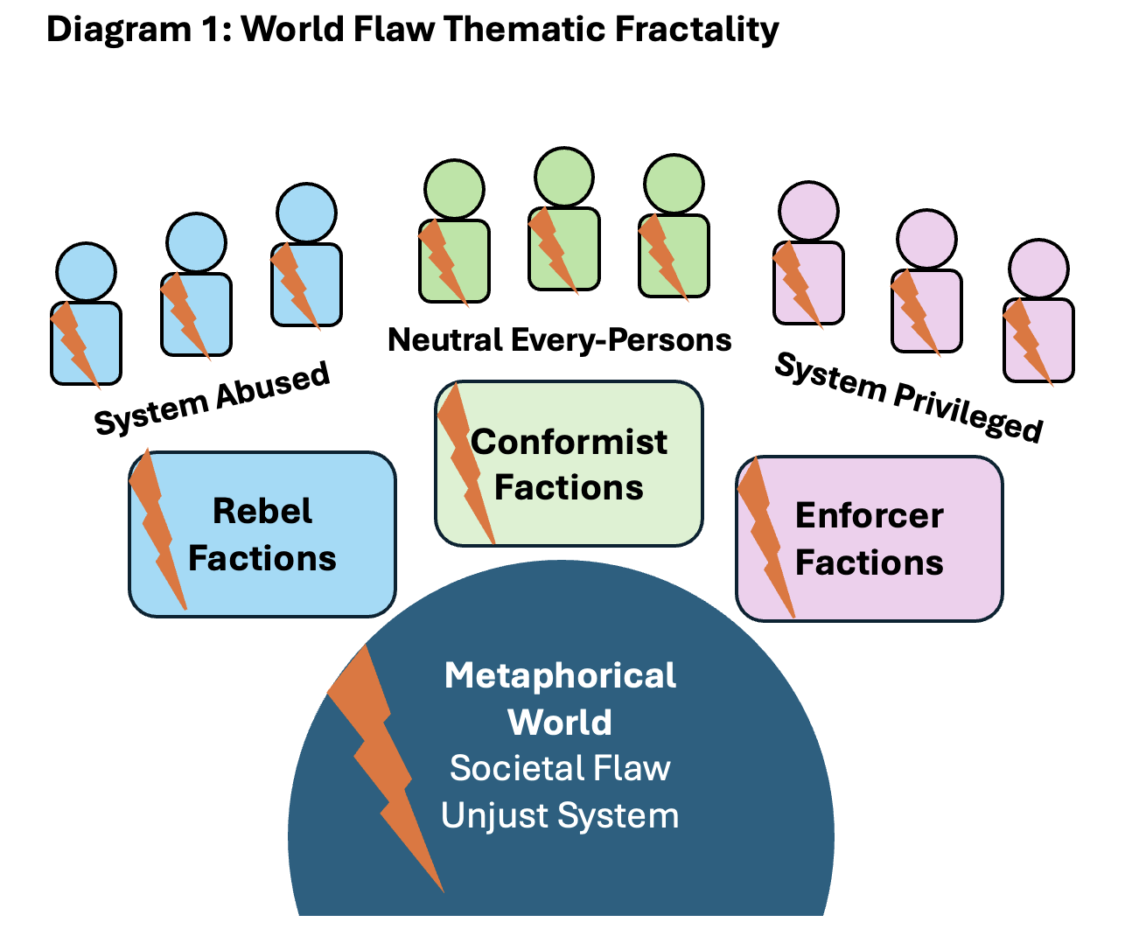
A good transmedia world thus functions as a metaphorical lens for real-world issues. To maintain fractal coherency, a metaphorical world should treat only one major flaw at a time. This primary theme defines the underpinnings of the IP, shaping all the characters’ needs and purposes, while guiding their journeys to heal the source of their own problems and their community’s. Defining the world’s toxic system first allows for coherent character creation arcs, and narrative pathways. When the world is clearly articulated in this manner, it becomes straightforward to develop characters whose conflicts and growth align with the central metaphor, creating a unified transmedia ecosystem. As tempting as it may be to build several themes into a story-world, the technique works best when there is only one major flaw that establishes a general thematic debate. Numerous problems can be treated, but when set up fractally, they will all lead back naturally to the main theme.

- Illustrating Examples of Fractal Flaw Patterns in Popular IPs

Examples of how the World Flaw Approach is illustrated in popular IPs are treated below as a world doctor might describe them when attempting to extend the story to other media. A case study follows tracking how the technique was implemented to craft the successful videogame IP, Ravenswatch, and assure that it would be transmedia ready from its onset.

6.1. Joker and Joker 2 on the Theme of Public Health Care

A compelling illustration of thematic fractality can be found in Joker (2019). Filmmakers placed an iconic DC character into a new parallel world defined by a specific flaw as a question: “What do you get when you cross a mentally ill loner with a society that abandons him and treats him like trash?” One tragic answer, as the film shows after delivering that line, is violence. The whole forms a critique of societal treatment of mental illness, particularly in the U.S. The success of the first film lies in its clear articulation of a world metaphor. The less successful sequel, Joker 2, illustrates the risk of blurring the metaphorical world’s defining question. Is it still about healthcare, or is it about the prison system, or the role of media in elevating sociopaths?

Director Todd Phillips acknowledged in a Film Stories Podcast (2024) that he did not intend to extend the character into a third film, noting that the sandbox world had been fully explored. This is an honest answer from Phillips as a creative, but a pitiful answer for the fans who were hoping to see Joker become a powerful transmedia franchise, nesting itself within the DC Universe and perhaps inspiring new takes on other popular villains. What might have been done from a World Flaw perspective, is to treat the obvious mental illness in the Joker’s girlfriend, Harley Quinn, who was infatuated by a murderer. If Harley Quinn’s mental illness was poorly treated by an incompetent doctor exploiting the wealthy classes of Gotham City or caused by experimental medication from a greedy pharmaceutical company, other facets of the same Health Care System world flaw could have been explored through the weakness she incarnated.

6.2. The Lord of the Rings, the Rings of Power and a Shifting World Flaw of Heroism

Similarly, in Tolkien’s Middle-Earth, the setting of The Lord of the Rings film trilogy and The Rings of Power TV Series, the defining toxic flaw shifts between the two adaptations. The original books and films seem to ask, “Is the fight against evil every person’s concern, even the smallest of hobbits?” One might argue that the flaw being illustrated is that power corrupts, but from a world building perspective, that is not what Tolkien spends most of his pages describing, nor does Peter Jackson during twelve hours of screen-time. The world’s flaw manifests in its vast diversity of races and cultures caught up in a precarious and tainted system of unequal power distribution. Middle Earth was not organized to resist evil as it comes knocking on the doors of every town, castle and shire. Certain heroes are expected to share more responsibility in wartime than others. In the original trilogy, we see how every character’s personal needs are defined by this power distribution flaw. Positive change comes when each agree to do what they can to save their world despite their differences. Every fan of the franchise could participate in this debate by becoming a heroic elf, hobbit, dwarf or human. Dungeons & Dragons answered perfectly in another media the world flaw premise, with an unofficially licensed role-playing game. In D&D character races and classes were all differently proportioned in gameplay. (MacLeod, 2019) The fun of D&D is playing as a group, each player doing their part. The procedural rhetoric of D&D echoes that of Tolkien’s debate perfectly.

The Rings of Power TV series (Amazon, 2023), while faithful in production values, struggles to preserve this central debate, with the main protagonists depicted as superhuman, leaving the everyman-and-woman narrative nearly absent. Despite respecting the lore and the world coherency, the thematic resonance of the original works is diminished, as they choose to go with “power corrupts”. This thematic angle is more a statement or moral than a question to debate. It must be said that the writers were not allowed to work within the parameters of The Lord of the Rings timeline, but fans still expected something Tolkienesque. Jackson’s adaptation to screen of The Hobbit in another cinematic trilogy, which was much less successful, fell prey to a similar shifting in theme with “wealth corrupts” emerging from the smokey fog. Another path for an adaptation of The Hobbit echoing the same toxic flaw of The Lord of the Rings could be “every dwarf has a role during a conflict”. The trick would have been to spend more time on the characters’ struggles to reclaim their “clan heritage” that had been stolen by a dragon. In the end of the story what is found, other than gold, is the treasure of clan-hood, each doing their part, no matter how small or how tall. In this way, the thematic feel of Tolkien’s universe had a better chance to echo throughout all three extensions of the transmedia IP. Communities pick up thematic resonance through the debate when it follows a fractal pattern.

6.3. The Last of Us and a World Flaw of Love Versus Logic

There are ever more good examples of thematic flaw fractality coming from videogame franchises who now work with professionals from TV and cinema to expand their reach. The Last of Us has maintained its toxic World Flaw throughout its expansion and second rendition. Though the TV Series is nearly an exact adaptation of the Videogame story, and does not qualify as a transmedia development technically, there are episodes that have expanded the narrative while respecting the world’s signature, and in particular the debate that it proposes. The world has gone to zombie hell, and it seems that the only way to save it is to sacrifice a young teenager who holds the cure within her brain. Fatherly love enters the picture, and the choice to trade her life for those of millions is much more difficult to make when the protagonist sees the girl as his daughter. This debate on “when is the sacrifice of a human acceptable?” is echoed in Episode 3 of season 1, where a gay couple decides to kill themselves out of love because one of them is suffering from cancer. The episode premise was taken from a mere anecdote in the videogame. The thematic debate is continued here in a transmedia addition, and the episode was accepted as not only canonical content generating tremendous discussions in the fan community. As stated in a Rolling Stones review of the episode, “This is the most convincing argument yet that The Last of Us is a show about humans first, and gory creatures a very, very distant second.” (Sepinwall, 2023)

6.4. Ravenswatch - Cultural Assimilation Bias World Flaw Applied to Character Design

The following case study demonstrates how the World Flaw Approach was implemented on a major indie videogame title, with the express goal of creating a world-setting that could house dozens of transmedia friendly characters.

Ravenswatch (2024), a video game by Passtech Studios and Nacon was developed by the author of this article and a creative core team where the World Flaw Approach was used from its inception. The studios previous two games, Masters of Anima and The Curse of the Dead Gods were also tight collaborations in Narrative and World Design. While all three projects employed the World Flaw Approach and received positive critical reviews, Ravenswatch has been chosen here because content is still being developed post launch and the community is still active at the time this article is written. Let us start from the beginning of the mandate to Narratively Frame and Design an original IP World for PassTech studios, contracted by its founder, Sylvain Passot.
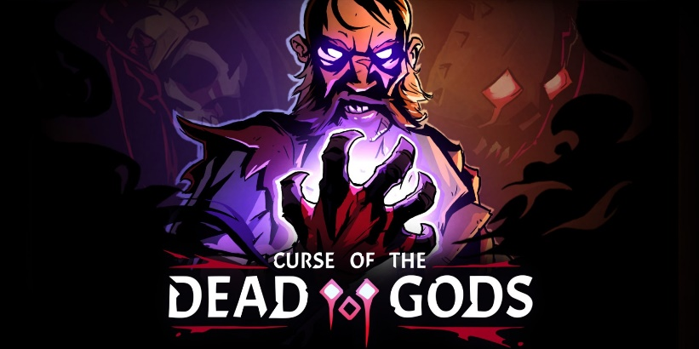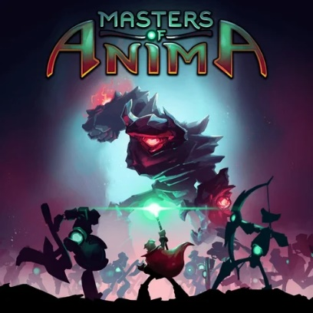
Figure 3 a, b. Curse of the Dead Gods ©2021 and Masters of Anima ©2018 are properties of Focus Entertainment (All illustrations by Valentin André-Terramorsi and the Studio PassTech)

Passtech’s lead game designer and creative director, Adrien Crochet, knew what experience he wanted to build and had a very clear vision of the game he wanted to make. He proposed to set a multiplayer rogue-lite gameplay within a dark fairytale setting. He wanted to revisit popular legendary characters and give them curses as a twist that could be used to give them original combat styles. At the onset we began world development looking for a real-world issue to frame the adventures thematically. One came to mind that was very hot in 2020 within gamer communities, cultural diversity and integration. As the work evolved, this began to manifest via a debate between assimilation through “normalization” or “accepting differences”?

The narrative framing of the fictional world of Reverie emerged. Fairy-tale heroes and literary legends cursed by the witch Baba Yaga must first accept their affliction (their difference) and transform them into powers (strengths) to defend their nightmare-invaded story-world. How to represent world’s flaw metaphorically went through several iterations, until the game design itself proposed a poetic solution. The invading nightmares’ main goal narratively speaking would be to turn every fairytale creature into a zombie or ghost without character or personality. They would have already “normalized” many well-known fairytale settings at the game’s start in the World Lore. In the Three Little Pigs setting pigs are now zombies, in the Legends of King Arthur setting, all the knights have been turned to wraiths and Arthur a headless horseman. The Nightmares invading Reverie are trying to rid the world of all hope of community and leave in their wake only fear and brainless desolation. This metaphorical angle also provided a fractal pattern in reaction for character flaws and story arcs of familiar fairytale heroes on journey’s to accept their differences and avoid assimilation.

Working on the first four playable characters of the game saga, Little Red Riding Hood, Beowulf, the Pied Piper and the Snow Queen, we asked ourselves how we could narratively frame the character’s game powers as curses they want to be rid of so they could go back to being “normal”. This motivation has a fractal relationship with the world flaw, “Normal is better than different. Being different is seen as a curse.” We started with the little red-caped Scarlet. In Ravenswatch, Baba Yaga has cursed Scarlet with lycanthropy, and she now transforms into a werewolf at night. We learn during the game that she was the one who has now tragically eaten her own grandmother. All Scarlet wants to do is remove this curse until after many battles with monsters, she realizes that being a werewolf can also allow her to defend others in Reverie. This difference has made her more powerful, and her uniqueness is complimentary to the Ravenswatch cast who recruit her as a guardian. In her final chapter, she accepts her curse as a blessing, her difference as a power. This refusal to accept her “abnormality” and wanting to “return to normal” reflects a flaw inherent in the metaphorical world which has remained locked in a sort of perpetual childhood refusing to grow-up.

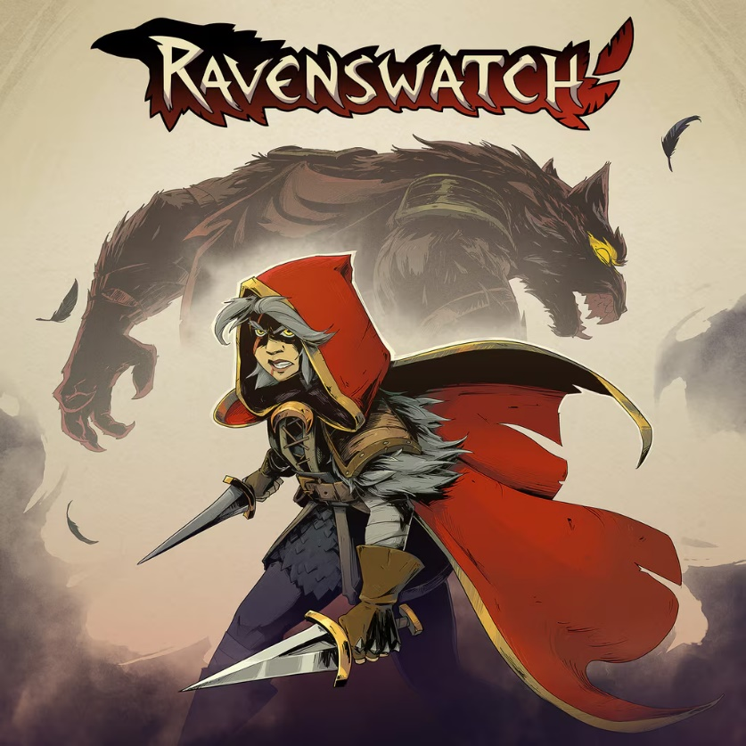
Figure 4. Ravenswatch ©2024 is a property of Nacon (All illustrations by Valentin André-Terramorsi and the Studio PassTech)

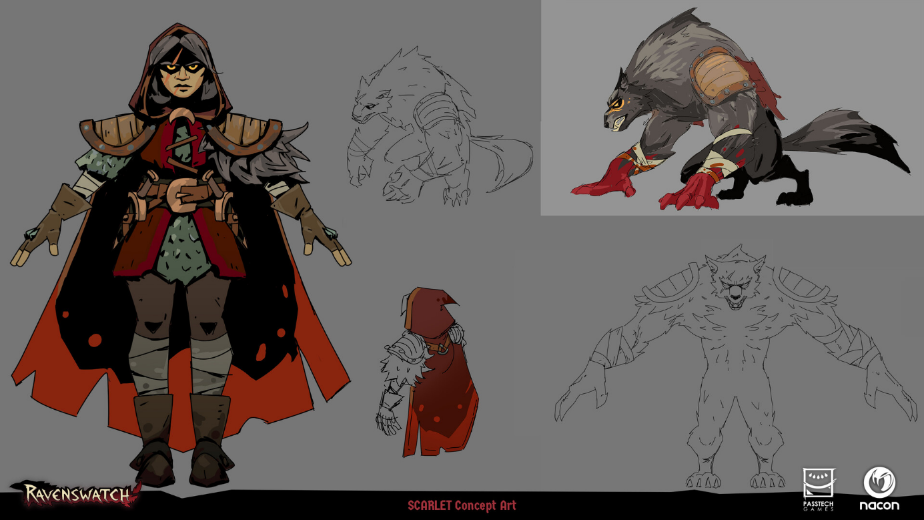
Figure 5. Ravenswatch Scarlet Study. Ravenswatch ©2024 is a property of Nacon (All illustrations by Valentin André-Terramorsi and the Studio PassTech)

Each character was developed by a team of two writers, a narrative designer and the creative director with final validations being made by the creative director. Iterations on character design never passed more than three proposals and often were good by the second pass. The Fractal Flaw in character design became an exercise in figuring out which gameplay style would fit with which fairytale or legendary hero’s curse. The next step was defining a character story where they would learn to accept the curse as a blessing as they developed their ultimate powers in-game.

We applied this same technique to the other characters maintaining a serious “adult” tone. Beowulf is cursed with having to raise the pup of the innocent dragon he slew. He eventually realizes that this new role of being a father is a blessing. Snow, who froze her own sister to death, realizes that her power to freeze can be used to redeem herself and repair her world. The Pied Piper can no longer play songs that enchant humans, his music is repulsive and only pleases vermin. As his story unfolds, he realizes that his music can save children rather than leading them astray. The World Flaw now fractally patterns the character flaws in that it in “growing up” one must learn to not only accept their differences but transform them into powers.

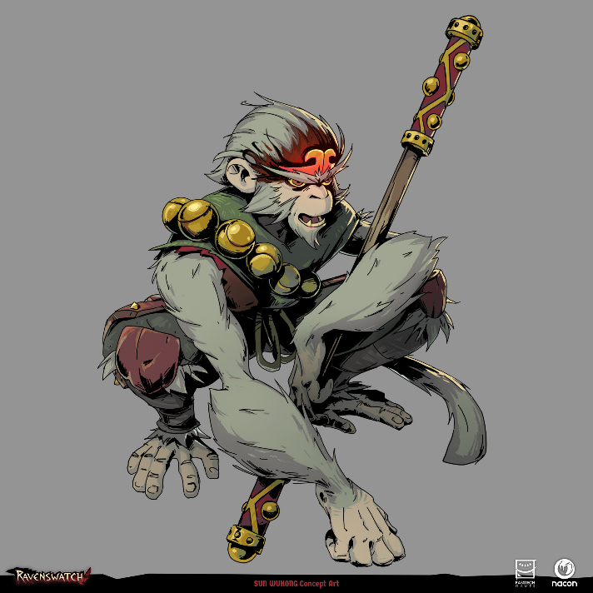
Figure 6. Sun Wukong Character Design. Ravenswatch ©2024 is a property of Nacon (All illustrations by Valentin André-Terramorsi and the Studio PassTech)

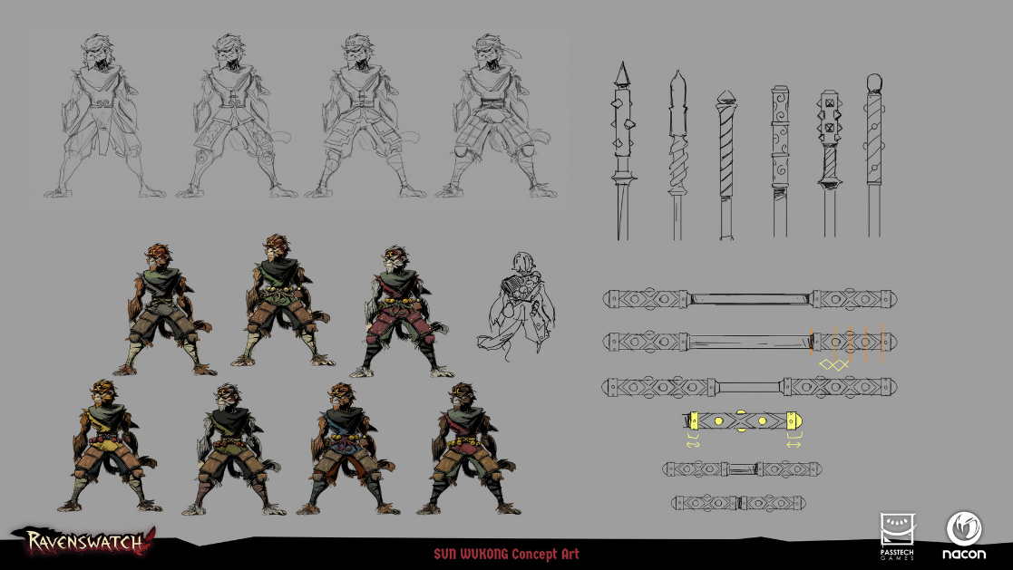
Figure 7. Sun Wukong Study. Ravenswatch ©2024 is a property of Nacon (All illustrations by Valentin André-Terramorsi and the Studio PassTech)

After the first four characters were created, two more characters were designed every few months, repeating the pattern flaw echoed in the world, applying curses to the likes of Aladdin, Romeo & Juliet, Melusine and Merlin. Learning from the experience, which we consider a best-practice scenario, taught us much. Firstly, a very clear understanding of the initial media format, and in this case the Lead Game Designer knew exactly what type of game he wanted to make. The Creative Vision must be clearly communicated. Secondly, we learned that constant realignment is required as more than ten people collaborated to develop and design the world and characters from a literary, gameplay, animation and art design perspective. The flaw in the character needs to resonate with the power the character develops, and directly allow them to battle the monsters perturbing the world, or they become incoherent with the World Setting. The world and the characters must constantly take cues from one another and remain relevant to the overall theme. The players arrive to fight these nightmares and restore a new semblance of “normal that champions diversity”, while accepting that nothing will ever truly be the way it was in the new status quo. The theme of diversity and inclusion is never stated outright; it is the debate on accepting or refusing to accept a curse that draws all the attention.

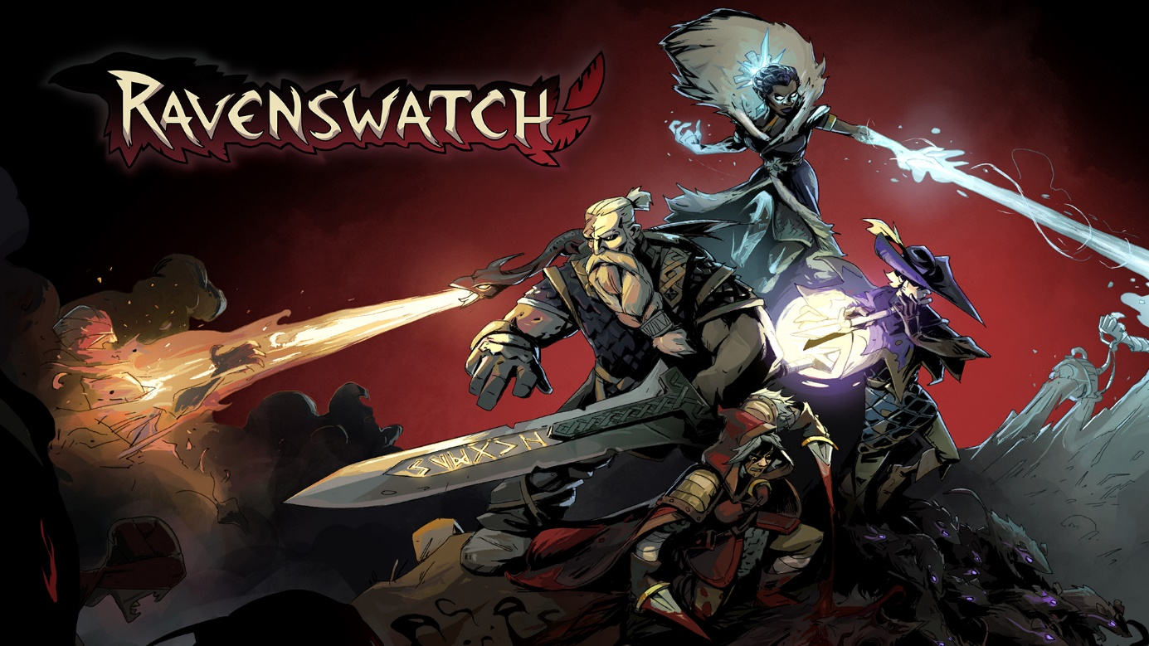
Figure 8. Team Apeurance. Ravenswatch ©2024 is a property of Nacon (All illustrations by Valentin André-Terramorsi and the Studio PassTech)

The community has expanded the IP through fan-generated content, exemplifying the participatory potential of this approach in transmedia storytelling. The game has sold to date over a million copies worldwide. The advantage to having started with this approach is that the studio can now go out and solicit partnerships with transmedia partner studios in animation, TV and cinema, confident that the world metaphor is geared up for it. A contract has recently been signed to develop a table-top RPG of Ravenswatch that will illustrate how players can create their own cursed characters in this afflicted world forced into normality. Only time will tell, but the seeds have been planted for transmedia expansion of the world of Reverie and its characters across all media.
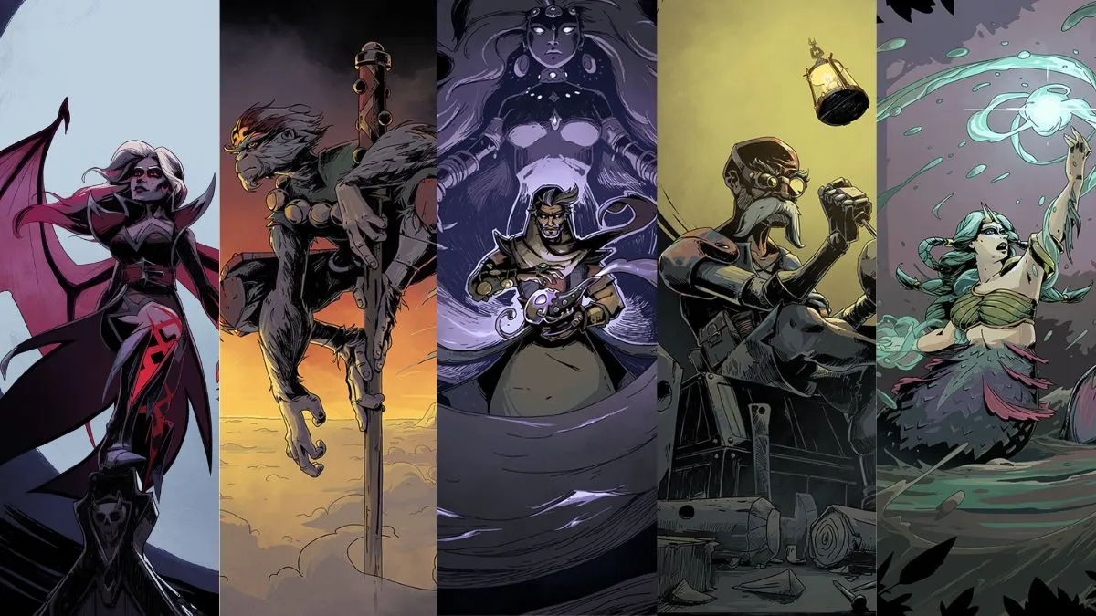
Figure 9. Team Distinct Presentation. Ravenswatch ©2024 is a property of Nacon (All illustrations by Valentin André-Terramorsi and the Studio PassTech)

7. Learning for World Doctors

The Ravenswatch Case Study and world doctoring examples above highlight the importance of understanding the thematic debate of an intellectual property (IP) during development, and before adaptations or sequels. This author has applied the World Flaw Approach on dozens of transmedia IP endeavors on both Creative Alignment and on Original IP Development. Some key learnings when applying this technique have emerged during collaborations.

7.1. Rules to Follow When Using Fractal Flaws in Transmedia Content Creation

1) The World’s flaw must be clearly defined as a systemic problem.
This problem cannot just be a villain who is mean or a rival who has had a bad life. Antagonists may have different ways of dealing with the flaw and their flawed philosophy is what defines them for story purposes. The hero of the story should discover and champion a different philosophy for dealing with the same flaw pattern. This can only happen if the flaw is defined as a systemic problem that affects everyone of narrative importance in the world. Some may benefit individually from this flaw, perhaps even the hero, but once the injustice is revealed and misery is identified, a journey of change is inevitable. No one can be happy if a part of the community is enslaved or suffering, or if they are fine with this, we have the premise of a tragedy or satire.

2) Character Powers should respond to the world’s flaw in a direct manner.
The powers that leading characters will acquire in their journeys to change the world should be designed to empower them as agents of change who impact the world flaw. The journey itself to acquire the powers changes them internally. These powers can be magical, innate, learned or technological, but whether they can see through walls or have become good at detecting a lie, they empower a path for affecting change. Whatever the power, it was ideally born from the world flaw, as if the world is secretly looking for a champion to heal it. A world that is closed might need a hero who can walk through walls to fix it. A world imprisoned by obscurantism could need a hero good at detecting lies.

3) Build Narrative Loops around the Fractal Flaw.
Communities are good at recognizing a pattern, and the ultimate expression emerges in the Narrative Loop encased in stories. When set up properly, the fractal change works like a motor: Characters go on Journeys to acquire Powers to expose an unjust System that impacts the World. When the world is changed ever so slightly, that takes us back to the Characters are changed by their success or failure during the loop. They then continue on their journey, changing plans if necessary, one mission after the other until they learn what is truly needed to fix the world flaw. This is the simulation of an iterative process where everyone learns both from mistakes and successes. Both the macro and the micro vision of the flaw are treated simultaneously when using a storytelling change motor. We find ourselves again thanking Plato’s The Republic: you cannot fix the city without fixing the soul of its citizens.

7.2. Limitations of Using Fractal Flaw Patterns
While the World Flaw Approach provides a robust framework for developing transmedia franchises, it is not without limitations. Understanding these constraints is crucial for creators aiming to apply this methodology effectively.

1) Dependence on Audience Engagement
A central assumption of the World Flaw Approach is that there exists an audience interested in exploring the chosen societal debate through fiction or a metaphorical construct. Without a receptive public, even a meticulously designed world with powerful characters may fail to generate meaningful engagement. Writers must critically assess whether the thematic flaw they have chosen resonates with contemporary audiences and whether it will inspire debate and participation.

2) Creative Paradigm Shift
Many writers and creators are accustomed to character-first storytelling, where the narrative revolves around an individual protagonist. Shifting to a World-First paradigm can initially feel counterintuitive, particularly for those with extensive experience in character-driven media. The challenge lies in imagining a flawed world compelling enough to generate characters and arcs, rather than simply retrofitting a world around pre-existing characters. Experience shows that once this paradigm shift is embraced, designers often find that imagining a world in need of repair is no more difficult than creating a character in need of transformation.

3) Balancing Thematic Depth and Accessibility
Designers must balance the world’s thematic flaw with accessibility. A flaw that is too abstract or esoteric may alienate potential audiences, while one that is overly simplistic risks trivializing the real-world issue it seeks to explore. Striking the right balance is essential for fostering both engagement and thought-provoking debate. A recommended technique for strumming the right chord is asking the core development team to find a world flaw together that affects them in their real lives: something that generates stress or emotional pain. It is very likely if three people on a core team are sensitive to a theme, it will resonate with others and find an audience. Everyone on the core team should find the fractal flaw relatable and significant. If this is not obtained, keep brainstorming until a societal flaw that federates the developers around it is found. This is the first step to federating a community once the work is launched.

4) Transmedia Coherence Across Media for IP Owners
Maintaining coherency across multiple platforms is inherently complex. As stories, characters, and gameplay expand into new media, creators must ensure that the world’s flaw and patterned character arcs remain consistent. Deviations can dilute the thematic focus and confuse audiences, undermining the fractal pattern that forms the backbone of a successful transmedia IP. It is generally the responsibility of the IP owners to assure that a continuity manager is employed to manage partnerships with creative teams from other media expansions, and a community manager to provide encouragement and determine User-Generate Content boundaries with the community. This can pose a budgetary challenge, but if coherency is not managed with the fractal flaw in mind, expansions can rapidly spiral out of control and subsequent adaptations damage the collective transmedia IP. An obvious example of this is if the IP is treating an ecological theme, such as forest pollution, but merchandizing lunchboxes are fabricated using non-sustainable plastics, the community will sound the alarm of dissonance. The same is true when adapting the IP to other media. If the debate suddenly moves from pollution to forest fashion concerns and treating poorer animals the same as richer ones, the original and new content will have lost their fractal relationship, and even if there are fans of the new take, the communities will likely divide and eventually diminish. As a rule of thumb, initial revenue from license contracts should earmark 50% of those sums to pay someone to oversee IP coherency.

In summary, while the World-Flaw Approach offers a powerful methodology for creating transmedia narratives, success depends on careful execution, audience resonance, and rigorous attention to thematic coherency across all media forms including merchandizing. Understanding these limitations allows creators to anticipate challenges and strategically design worlds and characters that can sustain meaningful engagement.

9. Conclusion

The World Flaw Approach is a theoretical descendant of Aristotle’s Poetics and dozens of contemporary methodologies in writing from theorists in literature, cinema, videogames and transmedia. Its main objective is to revive the importance of reviving theme in fictional storytelling by demonstrating how thought-provoking ideas can serve as a narrative bridge between them and communities, eager to continue the discussion they provoke on social media.

The World Flaw Approach advocates starting design with a societal issue or thematic question expressed as a systemic world flaw, then building a metaphorical world, characters, and narratives around it. Characters may propose answers, but the community ultimately drives the discussion, particularly in participatory social media contexts. In this sense, fiction becomes an instrument for initiating critical debate, offering a space for reflection on issues central to human experience. Herein lies a mantra for writers, creatives and world designers of the transmedia age: the success of transmedia storytelling lies not in definitive answers but in fostering engagement and dialogue around a problematic, a democratic extension of narrative itself. As one of our civilization’s first great world designers might have put it, “understanding a question is half an answer.” In a well-built transmedia world, the number of answers is only limited by the size of the community fanbase.

References
Alford, N (2010). Reel Power, Hollywood Cinema and American Supremacy – Pluto Press September 2010
Anton, A. (2016). The Influence of J.R.R. Tolkien on Modern Video Gaming, [Blog]. The Artifice
Aristotle. (1996). Poetics (M. Heath, Trans.). Penguin Classics. (Original work ca. 335 BCE)
Atwood, M. (1985). The Handmaid’s Tale. McClelland & Stewart.
Aubin, N. (2014) Arabic Poetics, Before and After the Arabic Poetics. [Thesis], Yale Universtiy
Bogost, I. (2007). Persuasive games: The expressive power of videogames. MIT Press.
Bogost, I. (2017). Video Games Are Better Without Stories, [Online Post], The Atlantic
https://www.theatlantic.com/technology/archive/2017/04/video-games-stories/524148/
Brecht, B. (1964). Brecht on theatre: The development of an aesthetic (J. Willett, Ed. & Trans.). Hill and Wang.
Callard, A. (2020). Should We Cancel Aristotle? New York Times. July 21, 2020 https://www.nytimes.com/2020/07/21/opinion/should-we-cancel-aristotle.html
Campbell, J. (1949). The hero with a thousand faces. Pantheon Books.
Campion, S (2023). Lizzie Magie and the History of Monopoly. [Blog] British Library
Cervantes, M. (1605/2000). Don Quixote, Penguin Classics
Crawford, C. (2004). Chris Crawford on interactive storytelling. New Riders.
Cook, D. A. (2004). A history of narrative film (4th ed.). W. W. Norton.
Cromwel, T. (2014). The Pocket Lawyer for Comic Book Creators. Focal Press
Daglo D. (1991). Neverwinter Nights [Videogame] AOL
Dansky, R. (2025). The video game writer's guide to surviving an industry that hates you. CRC Press.
Dutton, R. (2000). Licensing, censorship and authorship in early modern England. Palgrave Macmillan.
Halliwell, S. (2002). The Aesthetics of Mimesis: Ancient Texts and Modern Problems, Princeton University Press, https://chooser.crossref.org/?doi=10.2307%2Fj.ctt7rn67
HandWiki. (n.d.). WoWWiki. In HandWiki. Retrieved (2026), from https://handwiki.org/wiki/WoWWiki
Heywood, J. (1546). Proverbs.
Homer. (ca 750 BCE) The Iliad of Homer. Translated by Richmond Lattimore. Chicago: University of Chicago Press, 1951
Hosany, S., Prayag, G., Martin, D., & Lee, W. Y. (2013). Theory and strategies of anthropomorphic brand characters from Peter Rabbit, Mickey Mouse, and Ronald McDonald, to Hello Kitty. Journal of Marketing Management, 29(1). DOI: 10.1080/0267257X.2013.764346
Jenkins, H. (2006). Convergence culture: Where old and new media collide. New York University Press.
Jones, B. (2024), Is Three Act Structure Still Very Important to Screenwriters? [Blog], Industrial Scripts
Jung, C. (1919/1970). Archetypes and the Collective Unconscious, Princeton University Press
Juul, J. (2005). Half-real: Video games between real rules and fictional worlds. MIT Press.
Lindsay, J. (2002). Darkly dreaming Dexter. Doubleday.
Lucas, G. (1977). Star Wars [Movie], Lucas Film
MacLeod, J. (2019) Tolkien and Dungeons & Dragon [Blog], The Artifice- September20th 2019 https://the-artifice.com/tolkien-dungeons-dragons/
Martin, R.R. (1991) A Game of Thrones, Bantam Spectra – Harper Collins Voyager
Masse, P (2022) At 400, Molière Still Matters - Quillette [Press] https://quillette.com/2022/04/19/at-400-moliere-still-matters/
Mataga C. (1991) Neverwinter Nights [Videogame] AOL
McClung, K., Crochet, A., Frances, K. (2025). Ravenswatch [Video game], Passtech, Nacon.
McKee, R. (1997). Story: Substance, structure, style and the principles of screenwriting. HarperCollins.
McLuhan, M. (1964). Understanding media: The extensions of man. McGraw-Hill.
Molière. (1666/2022). The Misanthrope [Play]. Molière: The Complete Richard Wilbur Translations, The Library of America
Pearce, C. (2009). Communities of play: Emergent culture in multiplayer games and virtual worlds. MIT Press.
Philipps, T. (2024, Podcast). Film Stories Podcast [Audio podcast episode].
Philopedia. (2025). Spanish Golden Age. https://philopedia.com/periods/spanish-golden-age/
Plato. (2007). The Republic (C.D.C. Reeve, Trans.). Hackett. (Original work ca. 380 BCE)
RAND (2026) How Do Games and Simulations Incorporate Will to Fight? [Website Post].
https://www.rand.org/ard/projects/will-to-fight/gaming.html
Rowling, J.K. (1997) Harry Potter, Bloomsbury
Ryan, M.-L. (2013). Narrative as virtual reality 2: Revisiting immersion and interactivity in literature and electronic media. Johns Hopkins University Press.
Seger, L. (1990). Creating unforgettable characters. Henry Holt & Co.
Shakespeare, W. (1600/2016). Hamlet [Play]. Romeo and Juliet [Play]. The Arden Shakespeare, Bloomsbury
Schivelbusch W. (1998). In a Cold Crater: Cultural and Intellectual Life in Berlin 1945-48, University of California Press
Scolari, C. A. (2009). Transmedia storytelling: Implicit consumers, narrative worlds, and branding in contemporary media production. International Journal of Communication, 3, 586–606.
Sepinwall, A. (2023) ‘The Last of Us’ Presents an Achingly Beautiful Gay Love Story, Rolling Stone [Review]. January 29, 2023 https://www.rollingstone.com/tv-movies/tv-movie-recaps/the-last-of-us-season-1-episode-3-recap-hbo-nick-offerman-murray-bartlett-gay-love-1234667212/
Smith, A. (2019) Greta Thunberg: ‘They see us as a threat because we’re having an impact’, [Interview], The Guardian
Snyder, B. (2005). Save the cat! The last book on screenwriting you'll ever need. Michael Wiese Productions.
Sophocles. (2008). The Three Theban Plays (R. Fagles, Trans.). Penguin Classics. (Original works ca. 429–401 BCE)
Tolkien, J. R. R. (1954). The Lord of the Rings. George Allen & Unwin.
Tolkien, J. R. R. (1977). The Silmarillion. George Allen & Unwin.
Truby, J. (2008) The Anatomy of Story: 22 Steps to Becoming a Master Storyteller, Farrar, Straus and Giroux
Turing, A. (1953) "Digital Computers applied to Games" Faster Than Thought: A Symposium on Digital Computing Machines, Bowden - Sir Isaac Pitman & Sons
Twain, M. (1884). Adventures of Huckleberry Finn, Chatoo and Windus / Charles L. Webster & Co.
Von Franz, M.-L. (1972/1993). The Feminine in Fairy Tales. Shambhala.
Vogler, C. (1998). The writer’s journey: Mythic structure for writers. Michael Wiese Productions.
Williams, T. (1955/2009) Cat on a Hot Tin Roof. Penguin Classics.
Williams, T. Cat on a Hot Tin Roof (1958). (n.d.). In Wikipedia. Retrieved January 2026, from https://en.wikipedia.org/wiki/Cat_on_a_Hot_Tin_Roof_(1958_film)

