A-Robot: Educational Augmented Reality Game For Teaching Problem Solving To Elementary School Children

Abstract
Within the parameters and guidelines of the University of the Aegean’s Department of Product and System Design Studio 7a course, which calls for students to design a prototype version of an interactive system, we have created a Serious Game that utilises Augmented Reality technologies and Unplugged Programming practices in order to develop Problem Solving abilities for K11 and K12 education in Greece. This project is primarily based on previous work done by A. Gardeli and S. Vosinakis, a student and a professor of our Department respectively on (Gardeli, A., & Spyros, V. (2017). Creating the computer player: an engaging and collaborative approach to introduce computational thinking by combining ‘unplugged’ activities with visual programming. Italian Journal of Educational Technology, 25(2), 36-50. doi:10.17471/2499-4324/910).
The following document outlines our Research Methodology, Design Methods and Practices, Conclusions and Future Direction and Improvements.

Keywords: STEM, Augmented Reality, Serious Game, Unplugged Programming, Education, Computational Thinking, Computer Science, Collaborative Learning, Problem Solving

1. Introduction
Critical Thinking and Problem Solving are the most vital skills required for succeeding in STEM fields. Properly assessing the situation and defining the problem space of an issue leads to selecting the proper course of action in one’s attempts to effectively deal with it. Public School curricula globally fail to impart students with those skills and Greece is no exception (Smyrnaiou Z., Petropoulou E., Sotiriou M., 2015). This is in part due to outdated teaching tools (Logo) and methods that rely on simulating real programming (Scratch). As close to programming as these methods are, students often fail to grasp the reasoning behind and to acquire Computational Thinking skills.
Serious Games aimed at teaching children a variety of abilities and to supplement existing teaching methods have seen a rise over the past decade (Susi T., Johannesson M., Backlund P., 2007) and are believed to be more successful in engaging students over more traditional methods (Girard C., Ecalle J., Magnant A., 2012). Institutes such as the Foundation of the Hellenic World often exhibit Serious Games for students, but outside of teacher initiative, the Greek Public School course plan does not employ contemporary methods, opting for a curriculum that has been unchanged and in effect for decades instead.
There has been extensive research on the subject of Serious Games in STEM education. A method that has been prevalent is “Unplugged Programming”. Common practices of past eras revolved around “pseudo-coding” and other approximations that aim at familiarising students with real-world programming languages and environments. Unplugged Programming takes the students away from the computers and instead has them solve problems and play with objects in the physical world. The goal is to instill Computational Thinking practices and Programming logic through simple games and activities without any programming knowledge required (Bell T., Alexander J., Freeman I., Grimley M., 2009). Unplugged Programming lowers the barrier to entry for students that are unfamiliar with the field and eases concerns they might have about its complexity, addressing the issues STEM disciplines face as difficult to approach.
Our primary objective for this project is to iterate on the work done by Gardeli A. and Vosinakis S. and design a Serious Game that can be implemented in any Greek K11 and K12 classroom. Due to the project’s description as it was given, we are expected to use Augmented Reality and tangible elements.
Our approach relies on clarifying the problem space through field research, in order to collect any relevant data that our desktop research efforts could not. The students’ knowledge and expertise in Technology and Programming related subjects is vital in how we design the game itself. We expected a low level of familiarity with these type of technologies and teaching methods, but our research shows that over the years and with the advent of smartphones and the mainstream attention that the internet has accumulated, the expertise levels of students on these fields has risen dramatically (Plowman L., McPake J., 2013).
Another constraint is the average Greek Elementary School’s budget. The spending capacity a school has at its disposal will affect the scope of the project in terms of materials and devices required to run the game. The aim is for 4-5 devices and sets of accompanying materials (AR markers, game boards etc) per school. We expect it to be an achievable goal, at the very least with borrowed devices brought by the students themselves.

2. Research and Design Methods
2.1 Interview
The first logical step in comprehending the problem space we will have to design for is approaching a knowledgeable party. Through our professors we came in contact with Mr. Farassopoulos N., Headmaster of Ano Syros’ elementary school. Moreover, he would often take on the role of the educator in his school’s technology course in addition to his administrative duties.
Going in to the interview, we were expecting a school’s budget to be sufficient to cover whatever expenses our envisioned application would require. That was not the case however, as we were told that a school’s monthly budget for equipment could be as low as one thousand euros and has to be allocated from stationary to sports equipment. This presented us with one of the most defining restrictions we had to work with. Affordability.
An educational game the school afforded (with some PTA assistance) was a robot kit. The students were called to assemble and program a robot to move around the classroom. There was a reportedly immense level of student engagement that corroborates with our desktop research conclusions. Mr. Farassopoulos believes it was due to the novelty of the activity and the variety of tasks involved. The main issue was how to keep the rest of the class occupied while one group of students was handling the kit. It was again a problem due to the prohibitive cost of such equipment. The takeaway from this was the effectiveness of the robot to keep students with different interests and skills engaged through the entirety of the activity.
A brief but important topic of discussion were the course hours. Computer and Communication Technologies only has one hour per week allocated in the curriculum. That severely limits the scope of activities that can be held each week. Oftentimes students have to stop and pick up from where they left off next week or simply move on to the next lesson. Such experiences are undesired both by educators and the students.
Lastly, we asked a few general questions to gather information on our target demographic.We mainly focused on the children’s programming skill levels, general interests and other educational games or tools they have been shown in school.

2.2 Scenarios and Personas
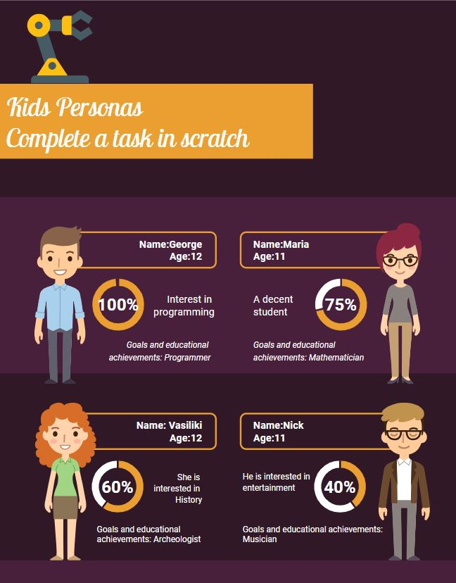
Using the information we collected from our desktop research, questionnaires and the interview with Mr. Farassopoulos, we created 4 indicative personas of students based on interests and programming skills.

We put them in Scenarios that called for them to complete a series of tasks in Scratch.
- Program a 2D character to move in a square
- Program a 2D character to move in a circle using Loop commands
- Program a 2D character to move in a direction depending on a key prompt
Success rate was tied to familiarity with computational thinking, affordances from video games or mobile device use and previous Scratch experience.
Personas with Scratch familiarity would find many of the tasks trivial, while inexperienced ones would struggle. On the other hand, every persona would quickly grasp how to interact with the program, due to their exposure to other technologies.
We were faced with a predicament. Making something that can be engaging for more experienced children, while not alienating children with different interests.

2.3 User Research
Research on our user base was primarily based on existing work that we compiled during our desktop research. According to a study by the University of Edinburgh, today’s children are digital natives, although they do not fully comprehend the technologies they interact with. Due to their familiarity with mobile devices, they are quick to grasp interactions and semantics that come with phone and tablet-based applications.
The studies however, did not have data on children in Greece, so we handed out questionnaires to children of our target demographic (K11 and K12) and conducted two small interviews with family members that belong to that group in order to make a correlation between the data we had and the results of our findings. We’d like to add here that the number of research participants in these findings are small (14 questionnaires and 2 interviews) and predominantly from one region (Athens) so may not be accurate,
The familiarity with technology in children persists in Greece, much like in the rest of Europe with all users having at least one device at home and used daily. Outside of school, only 2/14 children have played an educational game and even within class time, 11/14 have used some form of programming application (Scratch, Logo). All children have played video games at least once, with the most popular being Fortnite and Minecraft. No children had reported using an AR application in the past.

2.4 Design Brief
After analysing all accumulated data, we proceeded to draft our Design Brief and catalogue the Design Limitations and Restrictions. The Design Brief is as follows:

“Our Project’s objective is to design a working prototype for an Augmented Reality Serious Game with Tangible elements. It will be an educational game for 5th and 6th grade elementary school students in Greece that follows the course guidelines of the Computer and Communication Technologies course. The game’s primary objective is to impart students with the problem solving skills necessary to further their studies in middle school and beyond.
The game will be a mobile application for Android-supported smartphones and tablets with AR-capable cameras. The activity is expected to be carried out in Greek classrooms under clear light on school desks by teams of 4-5 students each. Each team will have one device, one game board and all necessary AR markers. AR markers may be cards depicting Obstacles, Items, Characters, Objectives and Moves. Additional stationery (pencils, sheets of paper etc) are expected to be on hand.
The game will require the team to prepare an obstacle course, using different types of AR Marker cards. Then, they will be called to write down the moves required to solve it and by using specific AR cards for movement they will have to follow their written moves. After successfully completing their obstacle course, the teams will challenge each other’s courses and attempt to complete them by repeating the process minus preparing their own course. In the end, teams will compare the moves they executed and the team with the most efficient series of moves is declared the winner.”

The Design Limitations and Restrictions we’ve been given and discovered are as follows:
- The Activity Time is limited by the allocated course time of thirty minutes
- The Game Board cannot exceed the surface area of a school desk (40cm x 120cm)
- Due to the project requirements it must utilise Augmented Reality
- The AR Markers must be easily detectable by the camera.
- The depictions on the AR Markers must be designed to be understood at a glance by the users.
- The depictions on the AR Markers and the application UI must be appropriate for the age group.

2.5 Development Cycle
The game’s development was split into two parallel stages - In-Engine work and Graphic Design. The objective was to save time by progressing independently of each other’s work.
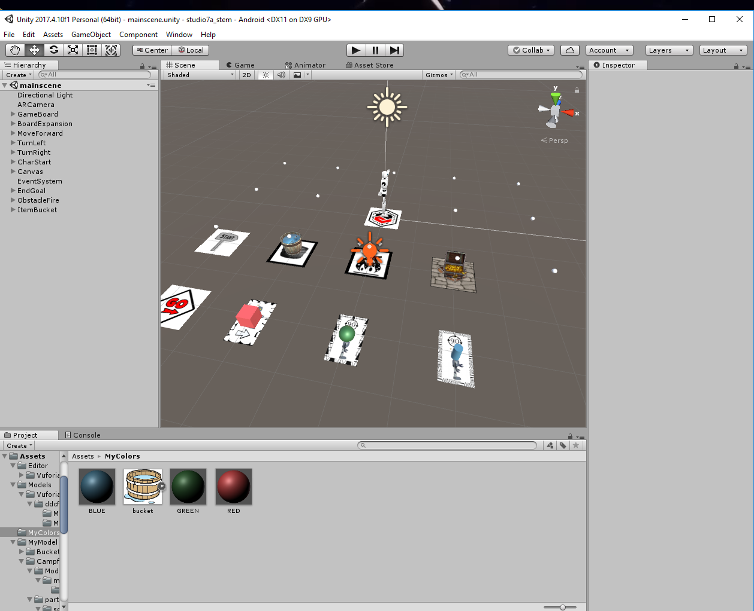
In-Engine work was done using Unity in combination with the Vuforia and Android SDKs.
Every object on the scene is a child of an ImageTarget - Vuforia’s special images that can be detected by the camera. So long as the ImageTarget is properly detected, the object tied to it is shown on the screen.
The Character that represents the players is can move on a 3x5 grid with the use of special “Move Cards”. The camera detects the cards and whenever the user presses the “Move” button, the Character follows the commands that are displayed on the cards - either “Move Forward” or “Turn”. The order of the commands depends on the cards’ proximity to a special “Movement” marker.
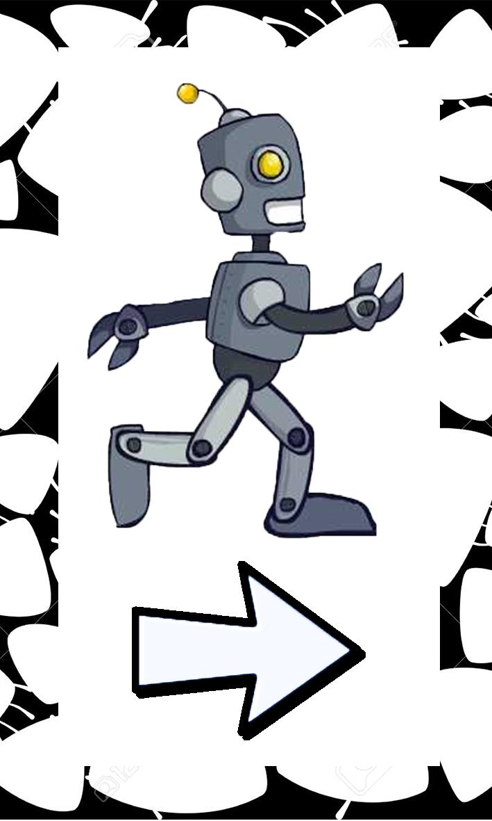
In this prototype version, we have one Obstacle (fire), one Item (water bucket), a Starting Position and an End Goal (Treasure). If the Character moves to a position occupied by an object, they interact with it. The Fire will return the Character to the start unless they have picked up the bucket, in which case they extinguish it. And finally, reaching the Treasure completes the obstacle course.

Graphic Design was one of the biggest obstacles during the development cycle. Vuforia’s AR Camera detects points where there are clear colour differences and compares them to the application’s database for any matching ImageTargets. Any Targets that resemble one another can lead to erratic behavior on the application’s side. This meant that for Targets with the same function (e.g. Move Forward cards), we would have to design them unique enough where they don’t have similar points, but without making them as different as to confuse the users. To somewhat work around that limitation we added patterned borders to those cards, but the patterns themselves had to be semi-randomised and non-repeating or it would clash with the aforementioned restrictions. A previously planned Impassable Obstacle feature was taken out of this prototype for those reasons.

2.6 A-Robot finalised
Once the prototype was in a working state, we made a draft that details the project, its goal and the activity.
“A-Robot is an Augmented Reality Serious Game that aims to assist in cultivating Problem Solving abilities to K11 and K12 students. Such skills are will be necessary for future STEM-related courses the students will encounter in the future, but in their adult lives as well.
The activity takes place in classrooms equipped with standard Greek school desks by groups of 3-5 students equipped with one smartphone or tablet per group.
The users are tasked to guide a virtual robot from the Start Card to the Treasure Card with the use of Movement Cards. Special Obstacle Cards paired with Item Cards increase the Obstacle Course’s complexity. All card imagery is clear enough to help users infer their use while still being AR-Camera friendly.
The Activity is split into three phases. Initially, users prepare a level by placing Cards on the board. In phase two they document any moves the robot is required to follow in order to reach the Treasure with a simple pseudo-flowchart. On the third phase the users have to follow their flowchart by placing the Movement Cards in the correct order. If they encounter an error, they have to identify and correct it. Once the level is complete, the groups trade Obstacles Courses with each other and attempt to clear them efficiently, using as few moves as possible.”

2.7 User Testing
With the prototype now in a working state and after a number of internal QA tests, we conducted two testing sessions. After a brief preview of the actions the users could take, we had them complete a series of tasks with the objective of guiding them through an approximation of the activity in order to gather feedback.
Our primary concerns were focused around the semantics behind each card’s illustration, the users’ expectations on Character interactions with Items and Obstacles and the expected use of each ImageTarget.
The first testing session involved 3 teams of 3 students from our university each. A session manager would explain the basics behind the activity interactions and phases and then would present them with a brief tutorial level that showcased all interactions. Upon completion of the tutorial, the teams would have to create their own obstacle course and then write down the moves required to clear it. Finally, they would follow the steps they’d written and complete the level. Once the level was proven to be solvable, it would be used as the next team’s tutorial level. At the end of the session, a small questionnaire was filled by each participant.
The feedback we collected from the first session allowed us to improve upon our game’s design by changing a few of the ImageTargets to be more clear in terms of their use. Once the new designs were completed, we conducted the second and final testing session, only this time the users would be children of our target age group.
The second testing session involved two children completing the aforementioned tasks on single person teams. Following the activity’s completion, a small interview would be held in order to gather feedback on the activity interactions, ImageTarget design and any relevant experiences the users might have had in the past.

3. Results and Discussion
The following sections details the results and conclusions we arrived at after analysing the data from the two User Testing sessions that we held. As a foreword, we would like to highlight that our target sample was extremely small and as such the validity of our findings can be called into question.

3.1 Recruitment
The first session’s users were recruited on-site at the University of the Aegean’s Department of Product and System Design computer labs. They included two teams of three second-year students each and one team of sixth-year students. The former teams were assigned a “beginner” role while the latter team were our “experts” for this test based on previous experience.
The second session’s users were children of the University’s faculty members. A 6th Grade and a 7th Grade student, aged 11 and 12 respectively. Both come from backgrounds that include heavy involvement and experience with applications relevant to this project and as such can be considered experienced users.
3.2 Statistics and Data Analysis
After careful analysis of our data, we concluded that the improved version used on the second testing is showing potential as a valid working prototype. The task completion metrics between the first and second session show significantly higher positive results.
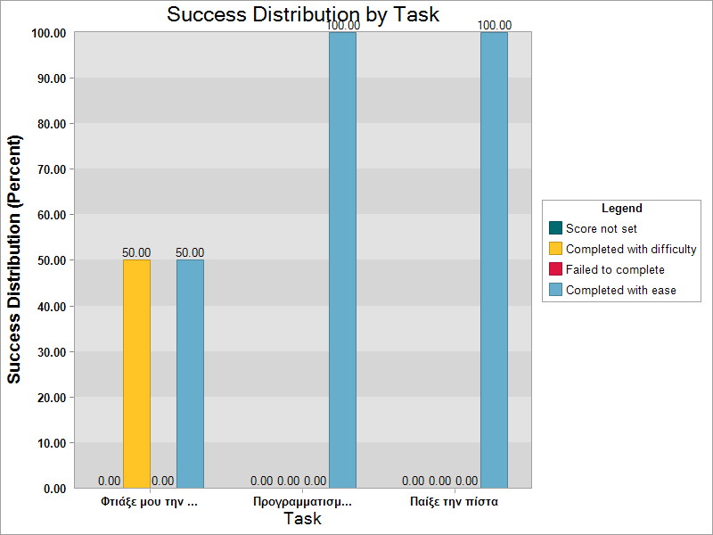
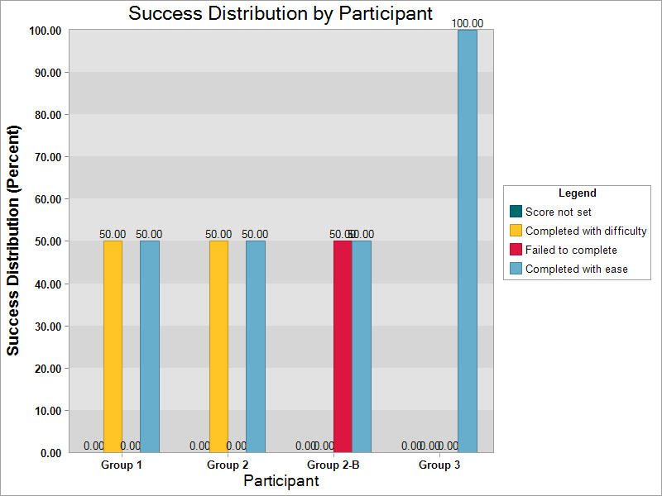
On the left graph we can see the total percentage for every task completed on the first test’s per group. On the right, we can see the breakdown of each individual task’s completion metric for both of the second test’s users.
Groups 1 and 2 had relatively low experience with computational thinking practices and programming, while Group 3 can be considered a group of experts. Group 2B findings are taken after Group 2 was called back in the testing to complete an advanced course which Group 3 prepared. We can infer from the graph that basic levels can be challenging for people unfamiliar with games of this type, while still being easy to understand. Experienced users however face no difficulties in any of the task, unless presented with more complex courses as is evident from Group 2’s second test.
Testing on our target users however has shown them to possess a much higher affinity for tasks of this type, completing them almost effortlessly. Difficulty came from creating a level that can be completed, but even then there were very few errors made. The Move documentation and subsequent completion of the course based on it are the focus point of the game, for it is where the user’s problem solving skills are brought into effect.
The semantics behind the second test’s ImageTargets and the intent behind every design were clear to the users and we received positive feedback on their implementation. The activity times ranged between 4’30’’ and 6’00’’, well within our targeted values. The vast majority of users had little experience with VR with only 2/11 having used relevant applications in the past. On the other hand, all participants had mobile and/or tablet devices at home and in frequent (almost daily) use.
High amount of attention was given to the cumbersomeness of holding the device (in this case tablet) during the activity. It was expected from our end that the users would alternate roles throughout the activity, but that was proven false. User engagement levels were consistently high during each step of the activity, which corroborated with our data findings over the novelty of the technology playing a major role in children engagement with relevant education games.

3.3 Discussion
Early concerns for this project were focused around our expected children skill level with computational thing. We envisioned a more baseline game akin to Scratch, geared towards teaching programming. Our findings made us conclude that focus should be given to more practical skills that the current curriculum does not teach that are still relevant to STEM education.
Problem solving is a skill that can be applied from tasks such as creating complex algorithms to making a shopping list. The underlying complexity comes from identifying all variables in a given problem space and executing the most efficient solution. It cultivates critical thinking and judgment - two necessary traits for any member of the society.
Diverting our focus from trying to teach programming practices to providing children with an entertaining and engaging way to challenge themselves and their peers was perhaps the greatest success of this project.
As for the application itself we had to face difficulties that were caused by the engines and APKs we were employing. Perhaps in a future implementation we can look for alternatives to Vuforia and find something less restrictive. A lot of features had to be cut from the final prototype due to time constraints and we would love to revisit those outside of the Studio 7a course time limitations.
Our User Testing is perhaps one of the most glaring holes in our study. The first testing was done by a sufficient number of subjects of the wrong target group, while the second testing was done by an insufficient number of subjects of the correct target group.
The first test was vital to the final prototype’s design and the success of the second test relied on it. The positive feedback we received on the affordances each ImageTarget’s design provided were the greatest part of that success. The users faced little difficulty with completing the tasks given and the overall excitement and engagement was well within our desired levels. The segments that required problem solving were seen as a helpful step in the obstacle course’s completion and were not seen as a negative experience.
Our target testers are considered to be on the experienced side of the spectrum, so perhaps presenting them with more options (more obstacles/items etc) in the future would give them a bit more of a challenge.
As for the budgetary concerns, we believe to have successfully kept the required costs low. If we were to assume students could bring their devices from home, all that is required to run the game is to print out the AR markers.
We are overall pleased with the results of our study and the state of the prototype. It has fulfilled its purpose as a low-budget engaging serious game with computational thinking elements and it has immense potential for future improvements.
If we were to take this project a step further, we would revise the study by performing tests on a higher sample of users and preferably in a classroom environment to perfectly replicate the real activity.

Acknowledgments
We would like to thank our professors Alifieris C., Vosinakis S., Gavalas D., Zisis D., Koutsambasis P., Kyriakopoulos P., Rigopoulou E. and Stavrakis M. for their invaluable assistance and insight. Gardeli A. for her work on the subject matter and help she has provided us. Farassopoulos N. for his role in the interview. All 11 of our final test users and any others that assisted us in testing earlier implementations. And one final thank you to Erianna P. for compiling our test session data.
References
Yuen, Steve Chi-Yin; Yaoyuneyong, Gallayanee; and Johnson, Erik (2011) "Augmented Reality: An Overview and Five Directions for AR in Education," Journal of Educational Technology Development and Exchange (JETDE): Vol. 4 : Iss. 1 , Article 11. DOI: 10.18785/jetde.0401.10
Chaudron, S, Plowman, L, Beutel, ME, ernikova, M, Donoso Navarette, V, Dreier, M, Fletcher-Watson, B, Heikkilä, A-S, Kontríková, V, Korkeamäki, R-L, Livingstone, S, Marsh, J, Mascheroni, G, Micheli, M, Milesi, D, Müller, KW, Myllylä-Nygård, T, Niska, M, Olkina, O, Ottovordemgentschenfelde, S, Ribbens, W, Richardson, J, Schaack, C, Shlyapnikov, V, Šmahel, D, Soldatova, G & Wölfling, K 2015, Young children (0-8) and digital technology - EU report. Publications Office of the European Union, Luxembourg.
Gardeli, A., & Spyros, V. (2017). Creating the computer player: an engaging and collaborative approach to introduce computational thinking by combining ‘unplugged’ activities with visual programming. Italian Journal of Educational Technology, 25(2), 36-50. doi:10.17471/2499-4324/910
Wouters, P., van Nimwegen, C., van Oostendorp, H., & van der Spek, E. D. (2013, February 4). A Meta-Analysis of the Cognitive and Motivational Effects of Serious Games. Journal of Educational Psychology. Advance online publication. doi: 10.1037/a0031311
Carson J. (2007) “A Problem With Problem Solving: Teaching Thinking Without Teaching Knowledge” The Mathematics Educator: Vol 17, No. 2, 7-14
Smyrnaiou Z., Petropoulou E., Sotiriou M. (2015) “Applying Argumentation Approach in STEM Education: A Case Study of the European Student Parliaments Project in Greece” American Journal of Educational Research: Vol. 3, No. 12, 1618-1628. DOI: 10.12691/education-3-12-20
Susi T., Johannesson M., Backlund P. (2007) “Serious Games - An Overview” School of Humanities and Informatics University of Skövde, Sweden
Girard C., Ecalle J., Magnany A. (2012) “Serious games as new educational tools: how effective are they? A meta-analysis of recent studies” Blackwell Publishing Ltd Journal of Computer Assisted Learning DOI: 10.1111/j.1265-2729.2012.00489.x
Horn M. S., Solovey E. T., Crouser R. J., Jacob R. J.K (2009) “Comparing the Use of Tangible and Graphical Programming Languages for Informal Science Education” CHI 2009 ~ Software Developers and Programmers
Mayo M. J. (2009) “Video Games: A Route to Large-Scale STEM Education?” www.sciencemag.org Vol. 323
Sanders M. (2009) “STEM, STEM Education, STEMmania” The Technology Teacher December/January 2009
Billinghurst M., Hirokazu K., Poupyrev I. “Tangible Augmented Reality”
Bell T., Alexander J., Freeman I., Grimley M. “Computer Science Unplugged: school students doing real computing without computers” University of Canterbury
Lydia Plowman & Joanna McPake (2013) Seven Myths About Young Children and Technology, Childhood Education, 89:1, 27-33, DOI: 10.1080/00094056.2013.757490

