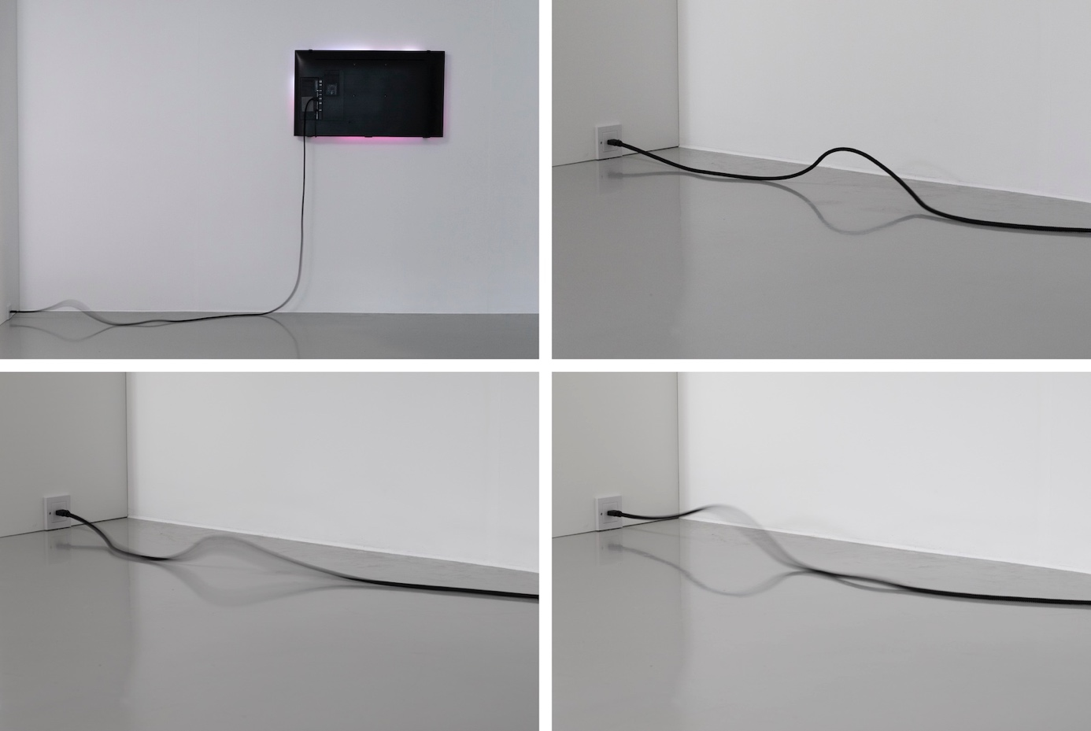

Snakable, Samuel Bianchini, robotic cable and inverted TV, 2020

From animation to animacy
How to design behaviors for non-anthropomorphic robotic artworks?

Since abstract robotic objects do not a priori possess expressive capabilities through their form, how can they be given a behavioral nature, or even a personality, if not through their animation, their quality of movement, which must then be studied, formalized, implemented, and experimented with using an iterative methodology that is simultaneously practical, reflexive, and multidisciplinary, combining philosophy, robotics, art, design, cognitive science, and anthropology? For the past twelve years, research and creations on such "behavioral objects" have been developed by a multidisciplinary team supported by EnsadLab's Reflective Interaction group. Initiated and coordinated by Samuel Bianchini and Emanuele Quinz, this work aims to produce reflections and theories in close dialogue with practical experiments, with implementations and public performances of such objects. Returning to practice, this same work also allows us to establish conceptual and material conditions for developing these behavioral objects. This is what Samuel Bianchini will do based on numerous examples of artworks of this nature and workshops devoted to them.
How can such objects be animated? How can we design and implement a form of animacy that, in turn, will stimulate the attribution of a living character to these objects? How can we try to make these objects subjects, or at least “proto-subjects”? This temptation of the living, which has become an attempt, defines these objects: they seem to struggle to be alive and reveal this permanent ordeal. This constitutes the very essence of their implementation, which has become “bringing to life.” Thought of in the form of “behavior,” this proto-living dimension of objects is necessarily material, “embodied,” because we are talking here about tangible agents that act in our social space. It is also contextual: it is based on a dynamic relationship with the environment. Far from being recorded, it is also the result of a permanent encounter between these agents and the circumstances in which they must operate. If this becoming alive can be appreciated in a situation and in real time, it can also be constituted over time, thanks to accumulated experience. The latter then calls for learning processes that allow for the gradual construction of adaptive faculties. This is how forms of intelligence can also be summoned—artificial, certainly, but also material, even natural, as long as this intelligence is also embodied.
Using numerous artistic examples, Samuel Bianchini will present this original approach to the design of such behavioral objects, objects whose struggle to exist in the world seems to accomplish this form of "ontological theater" proposed by Andrew Pickering.

