10 Top P A I N T I N G Brief DESCRITIONS

Brief description of the ten most famous paintings in the world

According to arte100cia the ten most famous paintings in the world are one of the most important charts in the art world. These are the artworks which have left their mark on the art world.

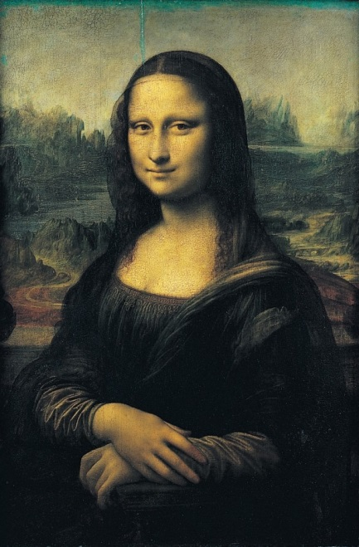

The Mona Liza
Leonardo da Vinci “Mona Lisa”, 1503-06
The most famous painting in the world is “Mona Lisa” by Leonardo da Vinci.

Mona Lisa was painted by Leonardo da Vinci in Florence. The painting is called “Gioconda” as well because Mona Lisa was married for Francesco Bartolomeo del Giocondo. The artwork was created between 1503 and 1506 and was painted on wood. The size (L x W) of the painting is: 53 x 77cm (20.87″ x 30.31″) and is exposed in the Louvre in Paris. The most enigmatic of the portrait is that when you look at her face it seems Mona Lisa smiles, but when you look into her mouth, she does not smile.
-----------------------------------------------------------------------------------
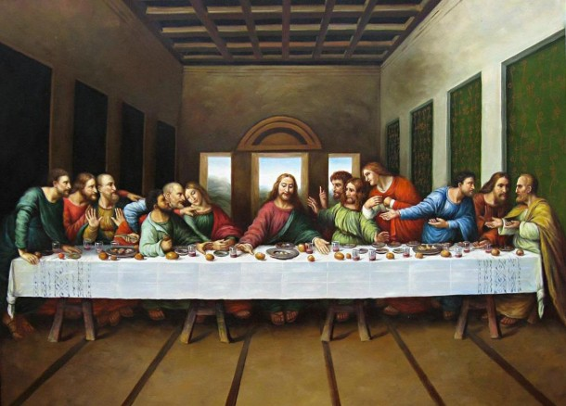

The Last Supper
Leonardo da Vinci “The Last Supper”, 1495-97

The second most famous painting is “The Last Supper” by Leonardo da Vinci which is exposed in the refectory of the monastery of Santa Maria delle Grazie in Milan. The artwork is created between 1495 and 1497. The size (L x W) of the painting is: 80 x 460cm (31.50″ x 181.10″). Figures are in real size. The view is amazing and it is considered as one of the most important artwork in the art history. This mural tells three stories, and it makes the painting very important and unique.
-----------------------------------------------------------------------------------
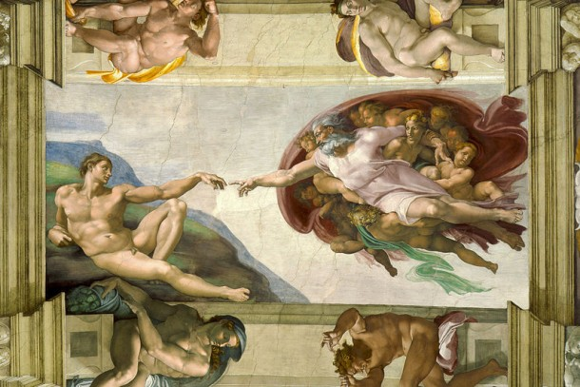

Creation of Adam
Michelangelo “Creation of Adam”, 1511

The third artwork is the “Creation of Adam” by Michelangelo.
The painting is painted around 1511 and it is currently exposed in the Sistine Chapel in the Vatican. This painting tells the story of man creation: God creates man from dust. Michelangelo painted the man on the ground neither grass or rocks. God is presented as filled with majestic angels. Adam’s hand is lying lifeless on his knee and gives the feeling of not breathing.
-----------------------------------------------------------------------------------
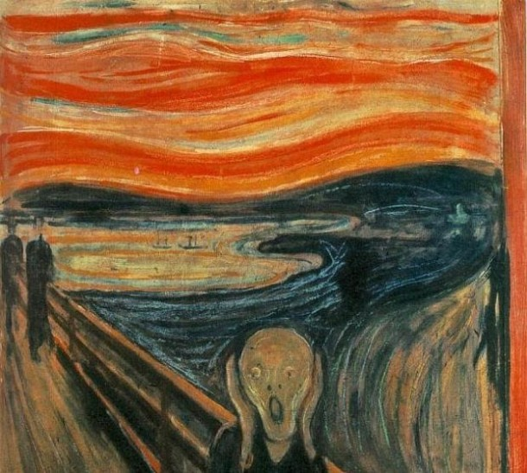

The Scream
Edvard Munch (Edward Munk), “The Scream”, 1893

The fourth painting is “The Scream” by Edward Munch.
There are several paintings with this name, but the most famous one is exposed in the National Gallery of Norway. It was painted in 1893 with size (L x W): 89 x 73.5cm (35.04″ x 28.94″). Munch has used mix technique: oils, tempera and pastel on cardboard. The painting recreates loneliness, suffering and despair.
-----------------------------------------------------------------------------------
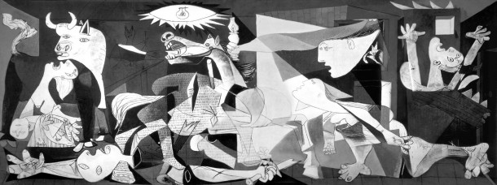

Guernica [ /gwair-ni-kuh/ ; Spanish: /ger-nee-ka/ ]
Pablo Picasso “Guernica”, 1937

The fifth artwork is “Guernica” by Pablo Picasso.
Guernica is considered for the most important artwork of the twentieth century, as it is an appeal about the bombing of civilians in the town of Guernica by the Germans. It is an oil canvas painting with size (L x W): 350 x 780cm (137.80″ x 307.09″). The artwork is exposed in the Reina Sofia museum in Madrid since 1992.
-----------------------------------------------------------------------------------
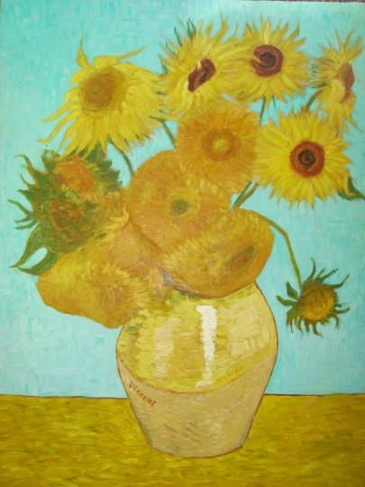

Sunflowers
Vincent van Gogh “Sunflowers”, 1888

The sixth painting is Van Gogh’s Sunflowers.
It is an oil canvas painting with size (L x W): 93 x 72cm (36.61″ x 28.35″). It was painted in 1888; now it is exposed in the Neue Pinakothek museum in Munich. Its bright colors are warm and bring delight to the visitors. Some of the sunflowers are almost wither; others are fully blooming and others are started to wither. There are seven versions of the painting Sunflowers, but now there are only six because one was destroyed during World War II in Japan.
-----------------------------------------------------------------------------------
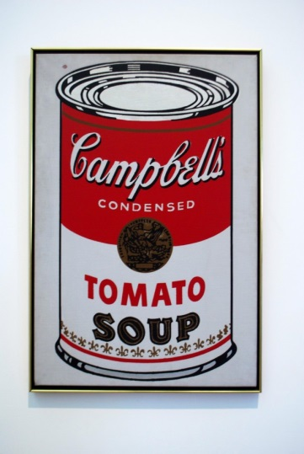

Campbell's Tomato Soup
Andy Warhol “Campbell’s Tomato Soup”, 1964

The seventh painting is the “Campbell’s Tomato Soup” by Andy Warhol.
The painting has an interesting history: the idea for the artwork is bought by Warhol on a party – he paid 50 $ for Campbell’s Soup cans idea. Warhol is perhaps the most important artist in the United States in the twentieth century.
-----------------------------------------------------------------------------------
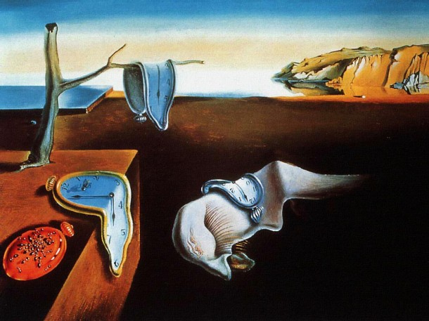

The Persistence of Memory
Salvador Dali “the Persistence of Memory”, 1931

The eighth painting is “The Persistence of Memory” by Salvador Dali.
It is an oil canvas painting painted in 1931 with size (L x W): 33 x 24cm (12.99″ x 9.45″).
-----------------------------------------------------------------------------------
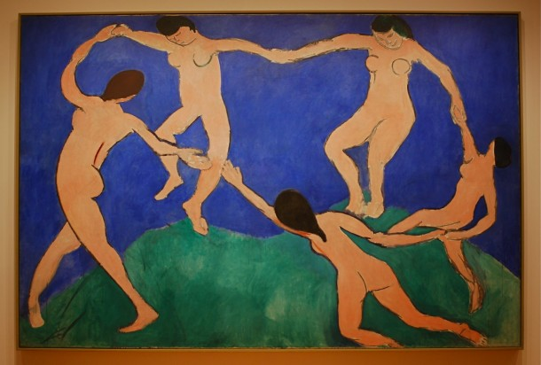

The Dance
Henri Matisse, “The Dance”, 1910

The ninth artwork in the chart of the most famous paintings in the world is “The Dance” by Henri Matisse.
It is an oil canvas painting with size (L x W): 260 x 389cm (102.36″ x 153.15″). It is painted in 1910 and now it is exposed in the Hermitage in St. Petersburg. The painting represents 5 people male and female, dancing naked over mountains in the sky, which makes them look like giants. The first version was painted in 1909 and it is now in MoMA in New York.
-----------------------------------------------------------------------------------
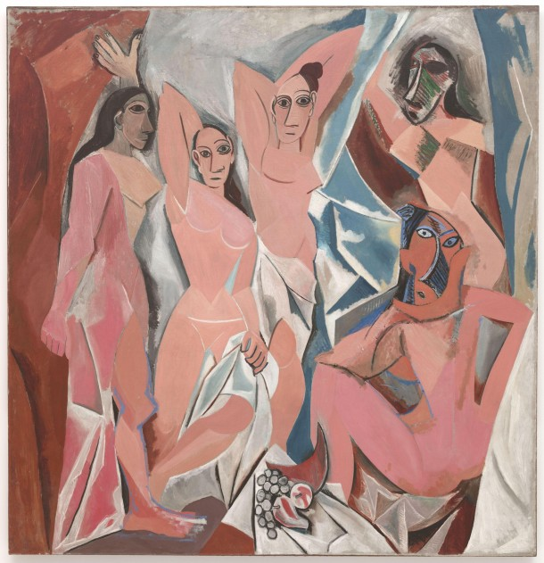

Les Avignon
Pablo Picasso, “Les Demoiselles d’Avignon”, 1907

The last tenth is “Les Demoiselles d’Avignon” by Pablo Picasso.
It is the first cubism painting by Picasso painted in 1907 with size (L x W): 243 x 233cm (95.67″ x 91.73″). The painting is now exposed in the MoMA in New York. This painting is an example for the influence of African art in the art world.

site: http://artcocktail.mallforarts.com/2012/06/brief-description-of-the-ten-most-famous-paintings-in-the-world/

