Title

Author 1 Name+Surname ,1, Author 2 Name+Surname ,*

1 Intelligent Systems Lab, Cultural Technology and Communication, University of the Aegean, Greece

**Abstract:** Abstract here.

**Keywords:** KW1; KW2,…

1. Introduction (Heading 1)

**1.1. Problem statement (indicative)**

During recent years, ………………..

**1.2. Proposed solution – objectives (indicative)**

………………………….

1.2.1 Sub-categories (indicative)

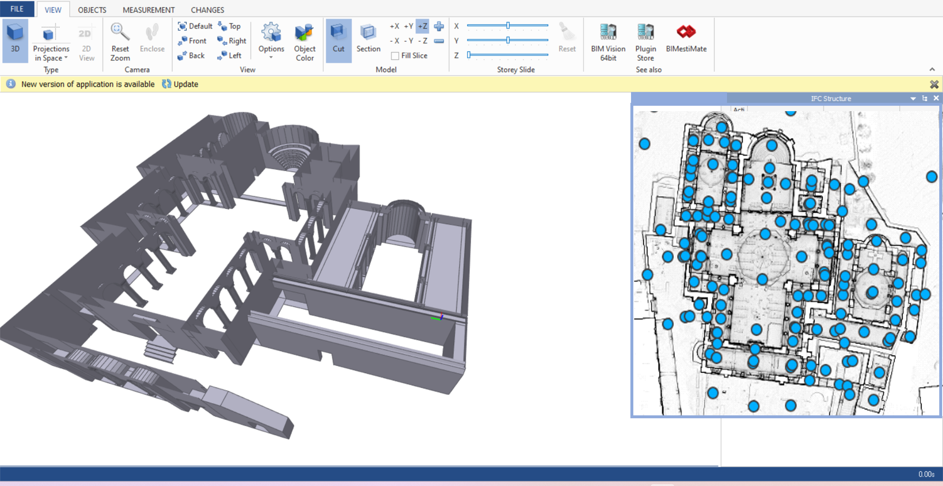

Figure 1. Text here.

……

References

1. Chen, L., Hoang, D., Lin, H., & Nguyen, T. (2016). Innovative methodology for multi-view point cloud registration in robotic 3d object scanning and reconstruction. Applied Sciences, 6(5), 132. https://doi.org/10.3390/app6050132
2. Sangyoon Park, Sanghyun Yoon, Sungha Ju, Joon Heo, BIM-based scan planning for scanning with a quadruped walking robot, Automation in Construction, Volume 152, 2023, 104911, ISSN 0926-5805, https://doi.org/10.1016/j.autcon.2023.104911
3. P. Kim, J. Park, Y. Cho, As-is geometric data collection and 3D visualization through the collaboration between UAV and UGV, in: Proceedings of the International Symposium on Automation and Robotics in Construction (ISARC) 36, n2019, pp. 544–551, https://doi.org/10.22260/ISARC2019/0073. Banff, Canada, 21–24 May.